1. Zenity taking input from user

- user_input=$(zenity –entry)

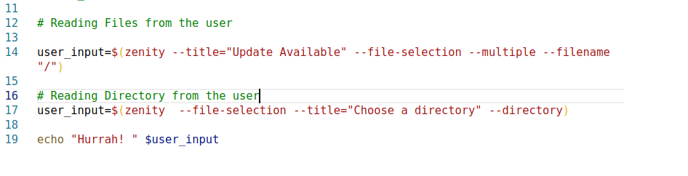
- zenity --info --text="Software Update Available." --width=500

