Variational Autoencoders

Muhammad Rashid
Faculty of Computer Science & Engineering
Ghulam Ishaq Khan Instiute of Engineering Sciences & Technology
Topi, Pakistan
rashid4379@gmail.com

Muhammad Asif
Faculty of Computer Science & Engineering
Ghulam Ishaq Khan Instiute of Engineering Sciences & Technology
Topi, Pakistan
asifgikian@gmail.com

Abstract— In just few years, Variational Autoencoders (VAEs) have emerged as one of the most popular approaches to unsupervised learning of complicated distributions. VAEs are appealing because they are built on top of standard function approximators (neural networks) and can be trained with stochastic gradient descent. VAEs have already shown promise in generating many kinds of complicated data, including handwritten digits, faces, house numbers, CIFAR images, physical models of scenes, segmentation, and predicting the future from static images.
Keywords—: variational autoencoders, latent space, neural networks

Introduction (Heading 1)
Autoencoders

Autoencoders (AE) are neural networks that aims to copy their inputs to their outputs. They work by compressing the input into a latent-space representation, and then reconstructing the output from this representation. This kind of network is composed of two parts:
- Encoder: This is the part of the network that compresses the input into a latent-space representation. It can be represented by an encoding function h=f(x).
- Decoder: This part aims to reconstruct the input from the latent space representation. It can be represented by a decoding function r=g(h).

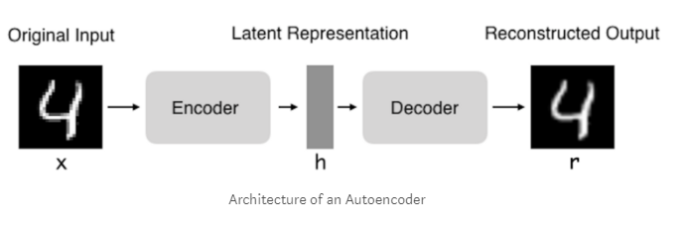
Types of autoencoder:
Following are the types of autoencoders:
- Vanilla autoencoder
- Multilayer autoencoder
- Convolutional autoencoder
- Regularized autoencoder
In this paper will go through variational autoencoder. According to the concept of autoencoders, the autoencoder can thus be described by the function g(f(x)) = r where you want r as close as the original input x.
Autoencoders are learned automatically from data examples. It means that it is easy to train specialized instances of the algorithm that will perform well on a specific type of input and that it does not require any new engineering, only the appropriate training data. However, autoencoders will do a poor job for image compression. As the autoencoder is trained on a given set of data, it will achieve reasonable compression results on data like the training set used but will be poor general-purpose image compressors. Compression techniques like JPEG will do vastly better.
Autoencoders are trained to preserve as much information as possible when an input is run through the encoder and then the decoder but are also trained to make the new representation have various nice properties. Different kinds of autoencoders aim to achieve different kinds of properties. We will focus on four types on autoencoders.
Desire — To generate new, similar, data from existing data.

Literatrure Review
One of the most popular such frameworks is the Variational Autoencoder, the subject of this tutorial. The assumptions of this model are weak, and training is fast via backpropagation. VAEs do make an approximation, but the error introduced by this approximation is arguably small given high-capacity models. These characteristics have contributed to a quick rise in their popularity [1].
The difficulty of learning a task for a given machine learning approach can vary significantly depending on the choice of the data representation. Having a representation that is well suited to the task and data domain can significantly improve the learning success and robustness of the chosen model [2].

Methodology
Autoencoders are learned automatically from data examples. It means that it is easy to train specialized instances of the algorithm that will perform well on a specific type of input and that it does not require any new engineering, only the appropriate training data.

A variational autoencoder (VAE) provides a probabilistic manner for describing an observation in latent space. Thus, rather than building an encoder which outputs a single value to describe each latent state attribute, we'll formulate our encoder to describe a probability distribution for each latent attribute. our input data is converted into an encoding vector where each dimension represents some learned attribute about the data. The most important detail to grasp here is that our encoder network is outputting a single value for each encoding dimension. The decoder network then subsequently takes these values and attempts to recreate the original input.
Variational Autoencoders (VAEs) have one fundamentally unique property that separates them from vanilla autoencoders, and it is this property that makes them so useful for generative modeling: their latent spaces are, by design, continuous, allowing easy random sampling and interpolation. It achieves this by doing something that seems rather surprising at first: making its encoder not output an encoding vector of size n, rather, outputting two vectors of size n: a vector of means, μ, and another vector of standard deviations, σ.
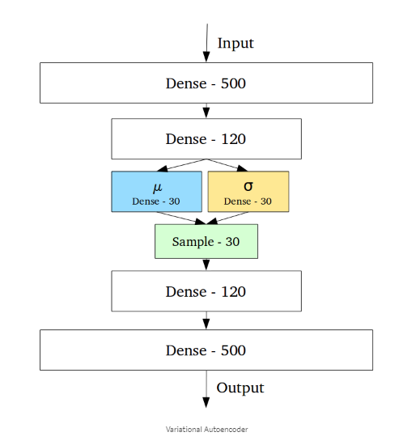

They form the parameters of a vector of random variables of length n, with the ith element of μ and σ being the mean and standard deviation of the ith random variable, Xi, from which we sample, to obtain the sampled encoding which we pass onward to the decoder:
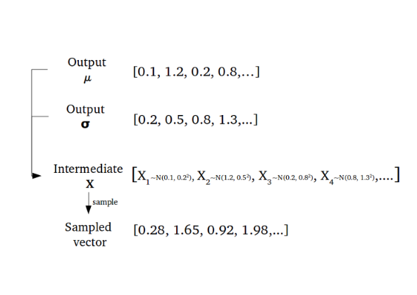
This stochastic generation means, that even for the same input, while the mean and standard deviations remain the same, the actual encoding will somewhat vary on every single pass simply due to sampling.
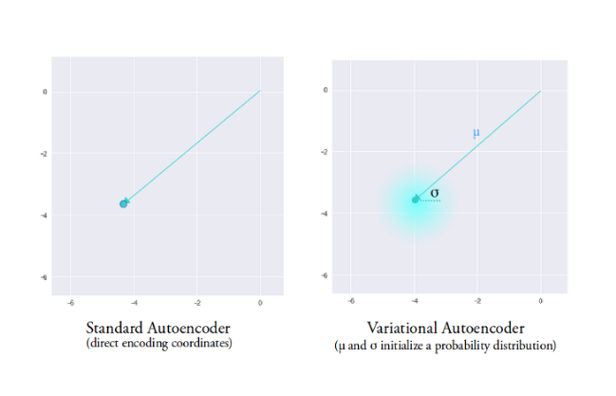
Intuitively, the mean vector controls where the encoding of an input should be centered around, while the standard deviation controls the “area”, how much from the mean the encoding can vary. As encodings are generated at random from anywhere inside the “circle” (the distribution), the decoder learns that not only is a single point in latent space referring to a sample of that class, but all nearby points refer to the same as well. This allows the decoder to not just decode single, specific encodings in the latent space (leaving the decodable latent space discontinuous), but ones that slightly vary too, as the decoder is exposed to a range of variations of the encoding of the same input during training.[3] The model is now exposed to a certain degree of local variation by varying the encoding of one sample, resulting in smooth latent spaces on a local scale, that is, for similar samples. Ideally, we want overlap between samples that are not very similar too, to interpolate between classes. However, since there are no limits on what values vectors μ and σ can take on, the encoder can learn to generate very different μ for different classes, clustering them apart, and minimize σ, making sure the encodings themselves don’t vary much for the same sample (that is, less uncertainty for the decoder). This allows the decoder to efficiently reconstruct the training data.

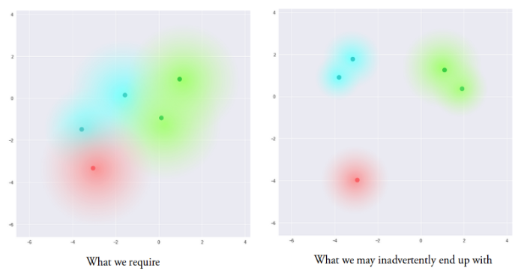
What we ideally want are encodings, all of which are as close as possible to each other while still being distinct, allowing smooth interpolation, and enabling the construction of new samples. To force this, we introduce the Kullback–Leibler divergence (KL divergence) [4] into the loss function. The KL divergence between two probability distributions simply measures how much they diverge from each other. Minimizing the KL divergence here means optimizing the probability distribution parameters (μ and σ) to closely resemble that of the target distribution.
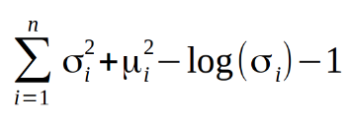
For VAEs, the KL loss is equivalent to the sum of all the KL divergences between the component Xi~N(μi, σi²) in X, and the standard normal [5]. This loss encourages the encoder to distribute all encodings (for all types of inputs, eg. all MNIST numbers), evenly around the center of the latent space. If it tries to “cheat” by clustering them apart into specific regions, away from the origin, it will be penalized.
Now, using purely KL loss results in a latent space results in encodings densely placed randomly, near the center of the latent space, with little regard for similarity among nearby encodings. The decoder finds it impossible to decode anything meaningful from this space, simply because there really isn’t any meaning. Optimizing the two (reconstruction loss and KL divergence loss) together, however, results in the generation of a latent space which maintains the similarity of nearby encodings on the local scale via clustering, yet globally, is very densely packed near the latent space origin. the equilibrium reached by the cluster-forming nature of the reconstruction loss, and the dense packing nature of the KL loss, forming distinct clusters the decoder can decode. This is great, as it means when randomly generating, if you sample a vector from the same prior distribution of the encoded vectors, N(0, I), the decoder will successfully decode it.
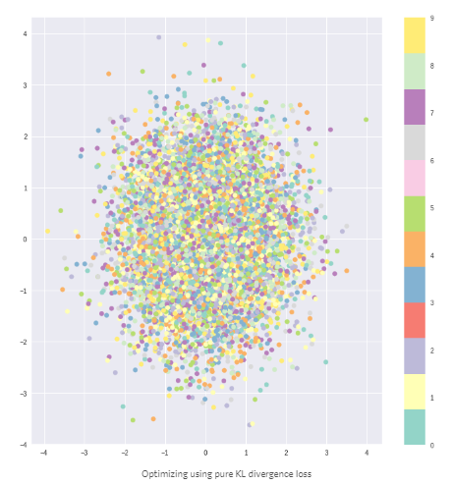[3]
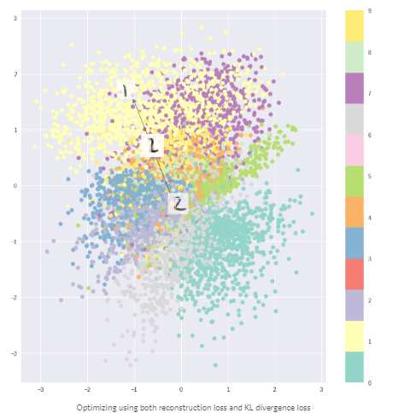
[3]
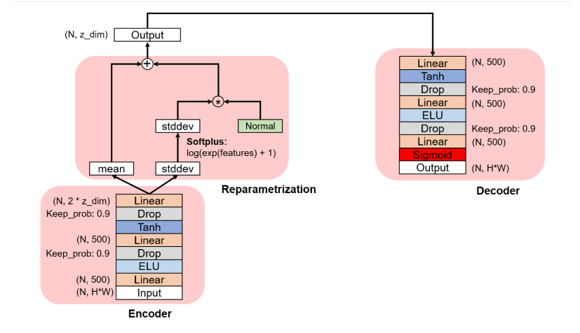

(VAE Architecture use in this paper)

Experimental results

We trained generative model of images from the MNIST dataset and in testing/inferencing phase found following result on MNIST dataset in Fig1
Training Results:

2-D Latent Space
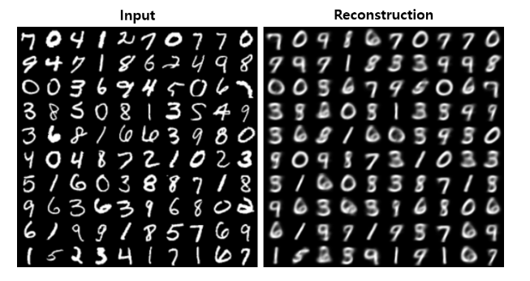

5-D Latent Space

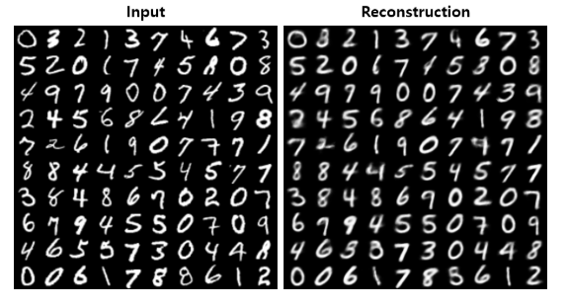
10-D Latent Space
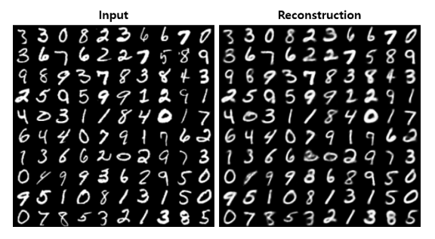

10-D Latent Space
Test 1

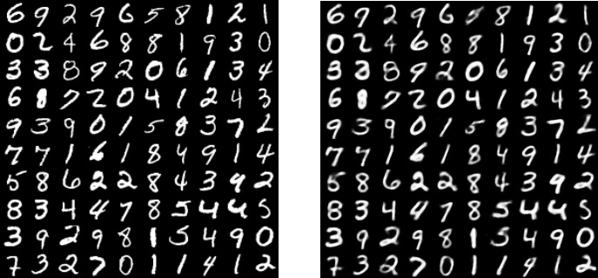

Test 2

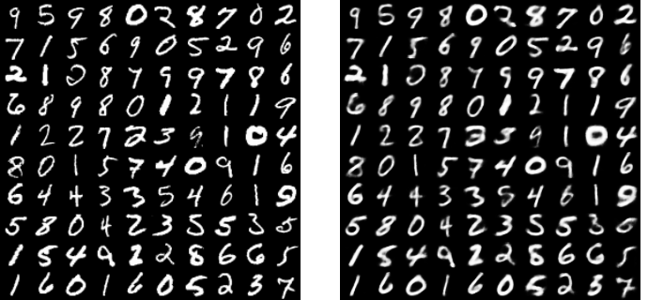

Conclusion:
VAEs can work with dataset of type sequential or non-sequential, continuous or discrete, labelled or unlabeled which proves that they are very powerful generative networks. It can be used to produce synthetic text. More than enough improvements had been done in VAEs, we can replace fully connected dense encoder-decoder with convolutional-deconvolutional encoder-decoder pair to produce synthetic human faces datasets.

References

- DOERSCH, C. (2019). [online] Arxiv.org. Available at: https://arxiv.org/pdf/1606.05908.pdf [Accessed 9 May 2019].
- Higgins, I., Matthey, L., Pal, A. and Mohamed, S. (2019). [online] Pdfs.semanticscholar.org. Available at: https://pdfs.semanticscholar.org/a902/26c41b79f8b06007609f39f82757073641e2.pdf [Accessed 9 May 2019].
- Jordan, J. (2019). Variational autoencoders.. [online] Jeremy Jordan. Available at: https://www.jeremyjordan.me/variational-autoencoders/ [Accessed 9 May 2019].K. Elissa, “Title of paper if known,” unpublished.
- Kurt, W. (2019). Kullback-Leibler Divergence Explained. [online] Count Bayesie. Available at: https://www.countbayesie.com/blog/2017/5/9/kullback-leibler-divergence-explained [Accessed 9 May 2019].]..
- Gaussians, K. (2019). KL divergence between two univariate Gaussians. [online] Cross Validated. Available at: https://stats.stackexchange.com/questions/7440/kl-divergence-between-two-univariate-gaussians [Accessed 9 May 2019].
.

