Lesson #9: Vulnerable Dependencies

Part 1) Goal and Vulnerability Summary
This lesson is about vulnerable dependencies in the backend Lambda function of DVSA. The main affected component is the order-manager Lambda that is called from the REST API flow. The security impact is that the function used packages with known vulnerabilities, including one critical issue in node-serialize. This is dangerous because the backend trusts third-party code that is already known to be unsafe.

Part 2) Why This Works / Root Cause
The root cause is weak dependency management. The project still had node-serialize in package.json even after Lesson 1 fix, and the code still used node-jose only for base64url decoding. Because old and risky packages stayed in the Lambda package, npm audit reported known vulnerabilities in the deployed backend path.

Part 3) Environment and Setup
- Local DVSA repository, backend/functions/order-manager
- AWS services used: API Gateway, AWS Lambda, AWS Console
- Target backend component: order-manager Lambda function
- Tools used: terminal, rg, npm ls, npm audit, code editor, zip, AWS Console

Part 4) Reproduction Steps
1. Go to backend/functions/order-manager and search the code with rg to find node-jose and node-serialize.
2. Open order-manager.js and package.json to confirm the dependency usage and dependency list.
3. Run npm ls node-serialize node-jose to show both packages are installed in this Lambda folder
4. Run npm audit and record the findings. The audit showed a critical vulnerability in node-serialize and more issues related to node-jose
5. Edit order-manager.js. Replace const jose = require('node-jose') with const base64url = require('base64url'), then replace jose.util.base64url.decode(...) with base64url.decode(...).
6. Remove the vulnerable packages with npm uninstall node-serialize node-jose, then install the replacement with npm install base64url.
7. Run npm ls and npm audit again. After that, zip the fixed Lambda package and upload it manually in AWS Console, then deploy the updated code.

Part 5) Evidence and Proof
FIGURE 1: Source code search showing usage of vulnerable dependencies.
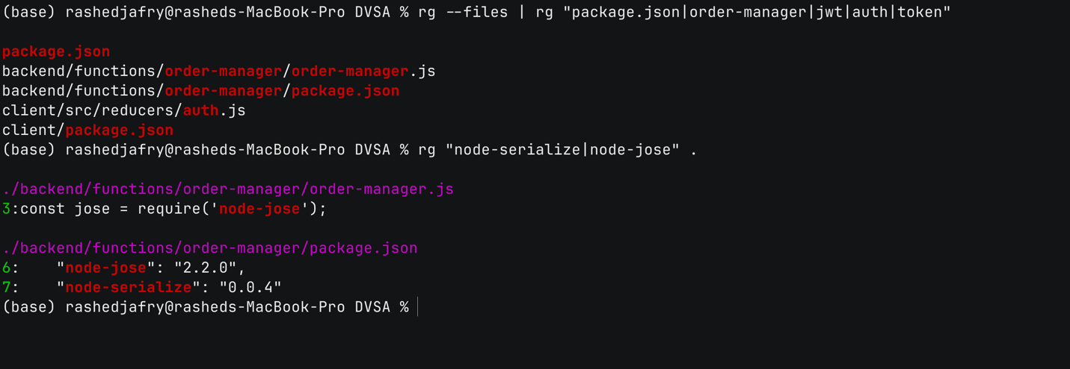

FIGURE 2: Backend Lambda code importing vulnerable dependencies.
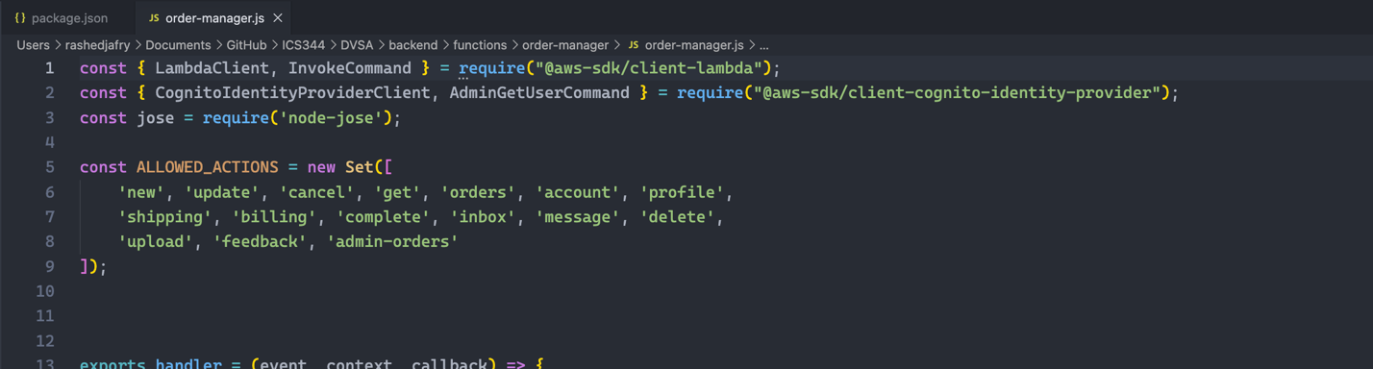

FIGURE 3: package.json listing vulnerable dependencies.
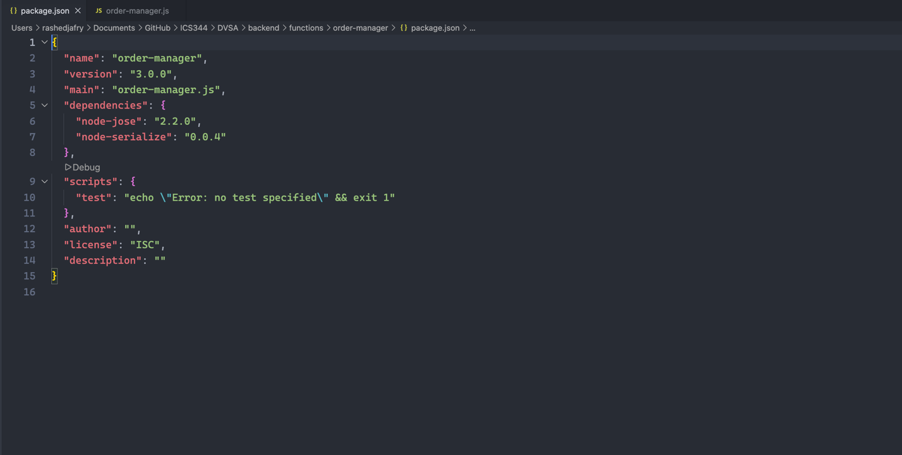

FIGURE 4: Installed dependency tree showing node-serialize and node-jose.
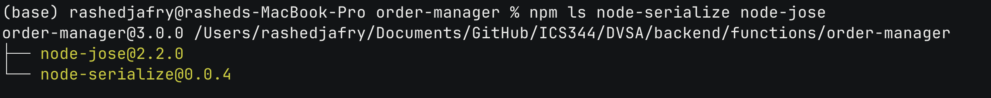

FIGURE 5: npm audit output showing the vulnerability findings.
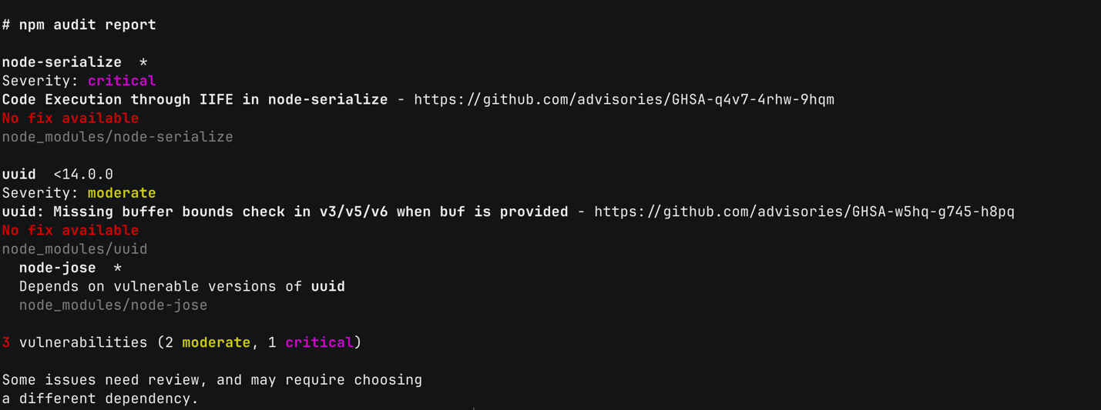

The main proof is the npm audit result from the real order-manager folder. It showed node-serialize with a critical issue and node-jose depending on a vulnerable uuid version. This proves the vulnerable packages were part of the backend Lambda package and not only dead files.

Part 6) Fix Strategy / Probable Mitigation
The fix belongs in the order-manager Lambda package. The correct security improvement is to remove the unused risky dependency node-serialize and stop using node-jose for simple decoding. I replaced the decoding logic with the smaller base64url package and removed both vulnerable packages from the Lambda package. This mitigation fixes the root cause because the backend no longer depends on the known vulnerable libraries.

Part 7) Code / Config Changes
File / resource changed: backend/functions/order-manager/order-manager.js
Also changed: backend/functions/order-manager/package.json and package-lock.json
Before:
const jose = require('node-jose');
var auth_data = jose.util.base64url.decode(token_sections[1]);
package.json contained "node-jose": "2.2.0" and "node-serialize": "0.0.4".
After:
const base64url = require('base64url');
var auth_data = base64url.decode(token_sections[1]);
package.json removed node-jose and node-serialize, and added base64url.

FIGURE 6: order-manager.js showing vulnerable dependency usage.
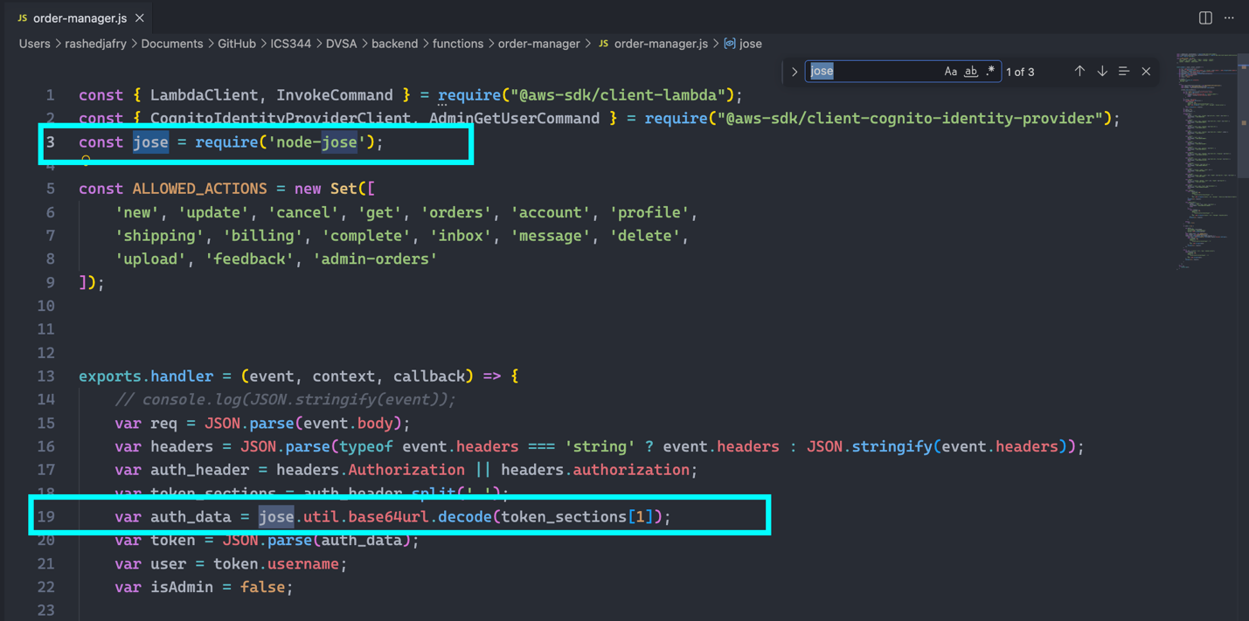

FIGURE 7: order-manager.js showing the dependency fix.
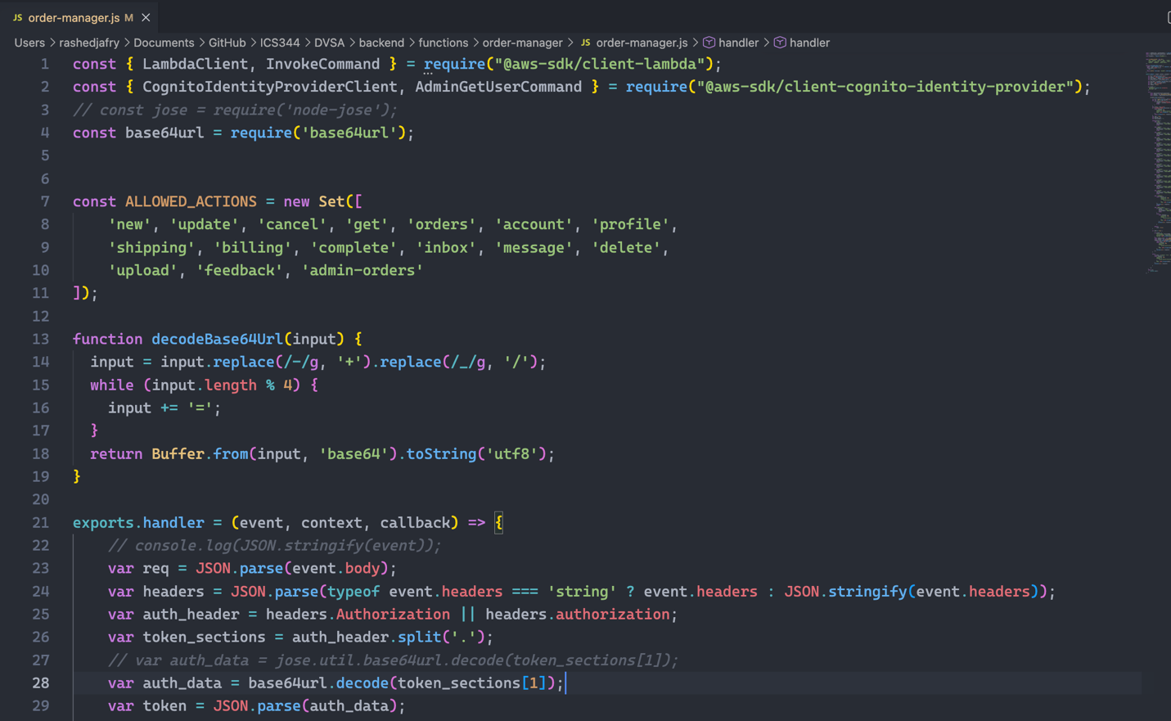

FIGURE 8: package.json after removing vulnerable dependencies.
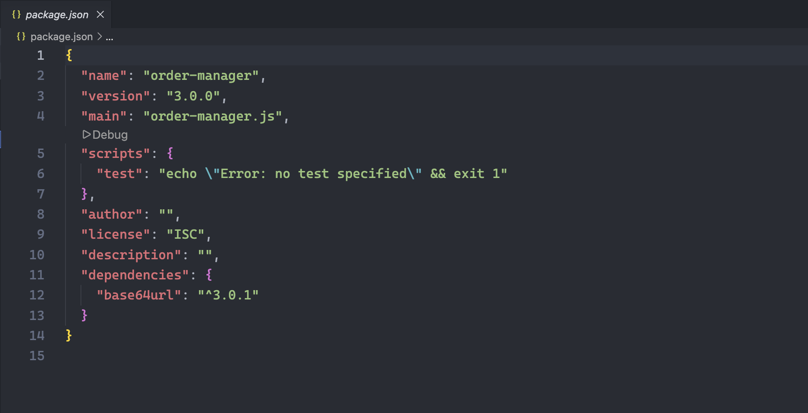

Part 8) Verification After Fix
After the change, npm ls no longer showed node-serialize or node-jose in the order-manager package. The previous audit findings related to these packages were removed, and the updated zip file was deployed to the Lambda function in AWS Console. The normal DVSA flow still worked after deployment.

FIGURE 10: Dependency tree after removing vulnerable packages.
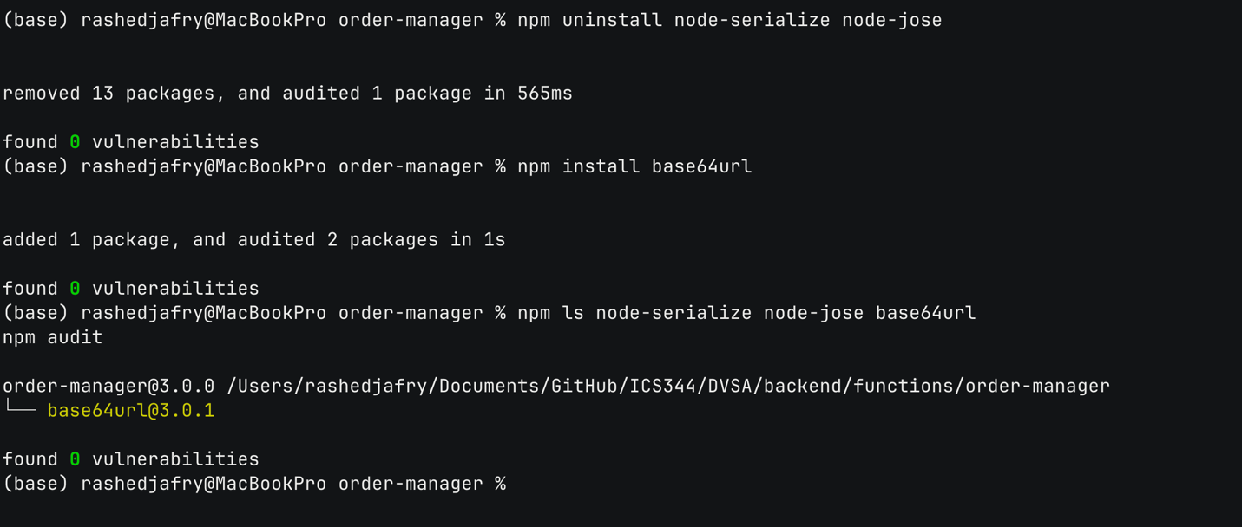

FIGURE 11: Zipped remediated Lambda package for manual deployment.
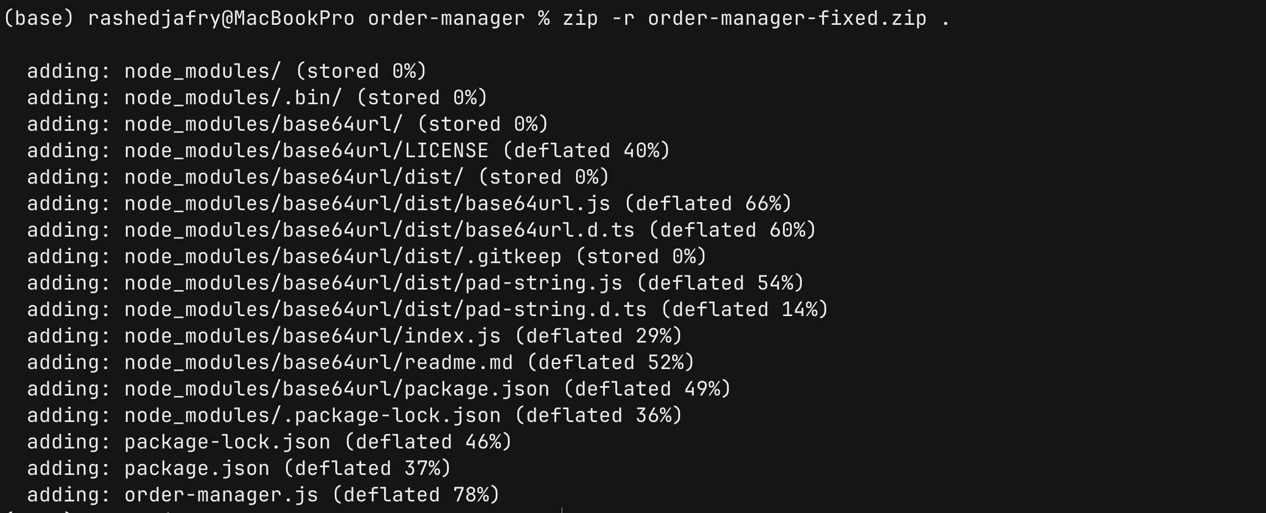

FIGURE 12: Target Lambda function in AWS Console.
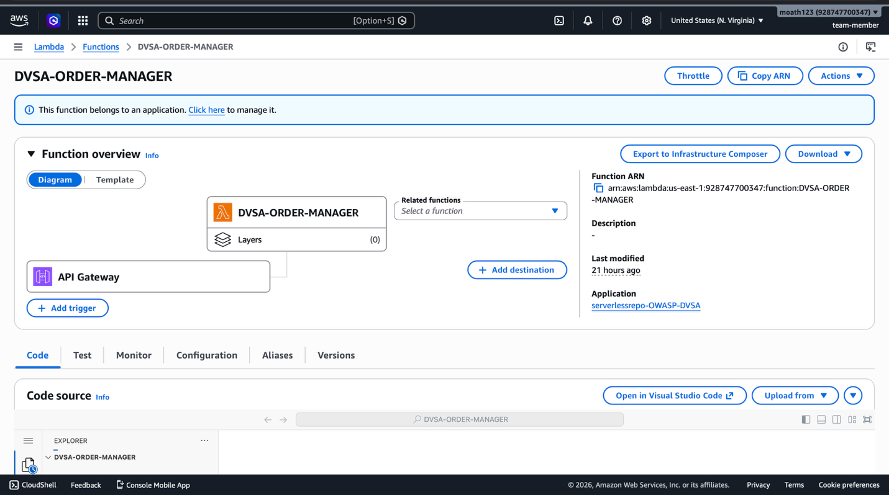

FIGURE 13: Successful deployment of updated Lambda code
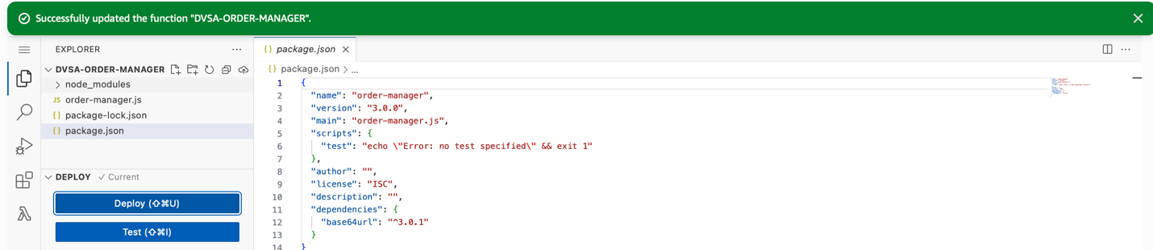

Part 9) Structured Operation and Security Analysis

Table A — Intended logic, artifacts, and behavior comparison
Vulnerability | Intended Rule(s) | Artifacts Used to Infer Rule | Normal Behavior Evidence | Exploit Behavior Evidence
Vulnerable Dependencies | Lambda package should use maintained and safe dependencies only. | order-manager.js, package.json, npm ls, npm audit, AWS Console | Normal order-manager flow and successful Lambda deployment | npm audit showed critical and moderate issues in installed backend packages

Table B — Deviation analysis, fix, and verification
Vulnerability | Why This Is a Deviation | Deviation Class | Fix Applied (Where) | Post-Fix Verification | Optional Latency Before / After Logging
Vulnerable Dependencies | The backend kept known vulnerable packages in a live Lambda package. | Misconfiguration | Removed node-serialize and node-jose from order-manager package; replaced decode call in order-manager.js | npm ls and npm audit were cleaner, and Lambda deployed successfully | Not measured

9.1 Intended Logic and Security Rule(s)
The intended logic is that the user sends a request to DVSA, API Gateway forwards it to the order-manager Lambda, and the Lambda processes the request using trusted code and dependencies. The correct outcome is normal order processing with safe backend libraries. The security rule is that the backend must not include dependencies with known critical vulnerabilities.

9.2 Evidence Sources and Behavior Trace
The main evidence came from source code search, package.json, npm ls, npm audit, the zip package, and AWS Console. In normal case, the Lambda package is expected to process requests correctly. In the vulnerable case, npm audit proved the Lambda package included unsafe dependencies. After the fix, the dependency list changed, the audit findings for these packages were removed, and the function was deployed again.

9.3 Deviation Analysis and Classification
This behavior is a deviation because the application should not keep vulnerable packages in a live backend function. The audit output is the proof of this deviation. I classify it as misconfiguration because the issue came from package management and not from intended business logic.

9.4 Explainable Fix and Post-Fix Validation
The wrong assumption was that old packages can stay in the project without risk if the code mostly works. The fix was applied in order-manager.js and its package files by removing node-serialize and node-jose, then using base64url for the needed decode operation. Post-fix validation was done with npm ls, npm audit, zip deployment, and a normal application test.

Part 10) Takeaway / Lessons Learned
The main problem was trusting old third-party packages in a serverless backend. This is important in Lambda because every deployment package becomes part of the attack surface. A good security principle here is to remove unused dependencies, keep packages updated, and use the smallest safe library needed for the task.

