Machine Learning Classification of Coronary Artery Disease: Model Optimization,
Real-World Impact, and Ethical Evaluation

Jude Adenuga, Pranathy Anumula, Rashidah Carr, and Gino Varghese
School of Computer and Information Sciences, University of the Cumberlands
PhDAI 733: Python Application for Analytics in AI
Dr. Karriem Perry
October 18, 2026

Machine Learning Classification of Coronary Artery Disease: Model Optimization,
Real-World Impact, and Ethical Evaluation
Coronary artery disease is the largest component of cardiovascular disease, the leading cause of death worldwide (World Health Organization, 2024, 2025). Its definitive test, coronary angiography, is invasive and costly, so cardiologists decide who needs it from a first-line workup of symptoms, a resting electrocardiogram (ECG), basic blood tests, and an exercise stress test (Gulati et al., 2021). Our project asks whether a model built only from that workup can estimate each patient’s probability of significant coronary narrowing well enough to help a clinic decide who should go to angiography first. In Part 1 we built that model on the 297 complete Cleveland patients in the UCI Heart Disease dataset (Janosi et al., 1988). The initial Random Forest identified 21 of 28 diseased test patients. Tuning its tree settings for recall did not help, leaving eight diseased patients missed.
Part 1 closed with three next steps that define the scope of Part 2: adding a baseline and competing models compared on a measure that does not depend on the decision threshold, tuning that threshold directly, and testing the model on the other three hospitals in the dataset. This report develops four claims in turn. Tuning improves every model, yet four quite different algorithms converge on nearly the same score, so the choice of algorithm matters less than the decision threshold. Lowering the threshold from .50 to .42 catches more diseased patients on unseen data at an acceptable cost in false alarms. The model’s errors fall unevenly across age and hospital. Taken together, these results make the model suitable for prioritizing referrals under a clinician’s control, not for ruling disease out. Throughout the report, recall (the share of diseased patients the model flags) is also called sensitivity, its clinical name, and specificity is the share of disease-free patients the model correctly leaves unflagged.
Data and Preparation
Part 2 pools all four hospital files in the UCI dataset, from Cleveland (303 patients), Budapest (294), Zurich and Basel (123), and the Long Beach VA (200), for 920 patients described by the same 11 first-line predictors used in Part 1. The fluoroscopy vessel count and the thallium scan remain excluded because both arrive late in the diagnostic pathway, after the point at which a referral model would be used. Pooling introduces two difficulties that shape every later result. The first is prevalence. Disease is present in 36% of Hungarian patients but in 94% of Swiss and 75% of VA patients, a spread that reflects how sick patients already were when they were referred. The second is completeness. Cleveland has no missing values, whereas the ST slope is missing for 309 patients (34%) and the VA lacks blood pressure, peak heart rate, ST depression, and exercise angina for roughly a quarter of its patients. Missing values were filled with each hospital’s own median or most common value so that one hospital’s norms would not be imposed on another. Two hospitals had also recorded missing cholesterol as 0, including all 123 Swiss patients, and those zeros were left as recorded.
Exploring the pooled data repeated the Part 1 patterns at a larger scale. Asymptomatic chest pain carried the highest disease rate (79%), exercise-induced angina raised the rate from 36% to 81%, and diseased patients reached a lower peak heart rate on the stress test (a median of 125 against 150 beats per minute). The sample is 79% male, with disease in 63% of men and 26% of women, and 178 of the 194 women come from Cleveland and Hungary. An 80/20 split stratified on the outcome produced 736 training and 184 test patients, 55% of whom had disease in each set, with every hospital represented in the test set.
Hyperparameter Tuning
Part 1 tuned the forest on recall at the default .50 threshold, a target that mixes two separate decisions: how well the model ranks patients and where the cutoff sits. Part 2 separated them by scoring every grid search on the area under the receiver operating characteristic curve (ROC-AUC), which measures ranking quality across all thresholds, and by tuning the threshold afterward. Four classifiers were compared. Logistic regression is the standard clinical prediction model, the Random Forest carries over from Part 1 (Breiman, 2001), and gradient boosting and XGBoost (Chen & Guestrin, 2016) build trees in sequence so that each tree corrects the errors of the last. Using scikit-learn (Pedregosa et al., 2011), GridSearchCV with five-fold stratified cross-validation on the training set searched 108 configurations in 540 fits. The search covered regularization strength for logistic regression, the number of trees, depth, and leaf size for the forest, and learning rate, depth, and row or column sampling for the two boosting models. A majority-class baseline that predicts disease for every patient set the floor.
Table 1 shows that tuning improved every model while also drawing the four together. XGBoost gained the most, about .040, once the search settled on very shallow trees (depth 2) and a slow learning rate. The Random Forest gained about .015 once its trees were capped at a depth of 5, which keeps them from memorizing noise in a training set of 736 patients. Logistic regression gained only .002 because its default settings were already close to the best ones. After tuning, the four models finished within .007 of one another, and all four sit far above the baseline’s .500. XGBoost scored highest at .8719, but its lead over the Random Forest (.8716) was only .0003, which is smaller than the variation between cross-validation folds. The team therefore kept the Random Forest as the final model, since it scored the same, its full evaluation was already complete, and its feature importances were already reported. A reasonable objection is that logistic regression, at .8700, would be easier to explain to clinicians. That trade-off is real and consistent with evidence that machine learning methods rarely outperform logistic regression on clinical prediction tasks (Christodoulou et al., 2019), so a logistic model remains a sound alternative for future work.
Table 1
Cross-Validated ROC-AUC Before and After Tuning
Model | Default ROC-AUC | Tuned ROC-AUC | Gain | Selected settings
Majority-class baseline | .5000 | n/a | n/a | Predicts disease for every patient
Logistic regression | .8682 | .8700 | .0018 | C = 0.1, L2 penalty
Random forest (final model) | .8568 | .8716 | .0148 | 100 trees, maximum depth 5
Gradient boosting | .8531 | .8653 | .0122 | 100 trees, depth 3, learning rate 0.05, row subsample 0.8
XGBoost | .8321 | .8719 | .0398 | 200 trees, depth 2, learning rate 0.03, column subsample 0.8
Note. Values are mean ROC-AUC across five stratified folds of the 736 training patients. ROC-AUC = area under the receiver operating characteristic curve. A value of .50 means no ability to rank diseased above disease-free patients.
The decision threshold was then tuned as a hyperparameter in its own right. Out-of-fold probabilities for the training patients were swept from .20 to .79, and the cutoff that maximized the F1 score for the disease class was .42, where cross-validated recall reached .921 and precision .767. The F1 criterion weighs missed diagnoses and false alarms equally, so a clinic that weighs missed diagnoses more heavily could justify a lower cutoff still. These cross-validated scores are also slightly optimistic for two reasons. The same folds both chose and scored the settings (Varma & Simon, 2006), and missing values were filled before the split, which let test patients’ values shape the hospital medians used in training (Kaufman et al., 2012).
Final Model Evaluation
The tuned Random Forest was evaluated once on the 184 held-out patients. As Table 2 shows, it reached a test ROC-AUC of .920, above both its cross-validated .872 and the Part 1 Cleveland forest’s .884, although the Part 1 figure comes from a different 60-patient test set. At the default .50 threshold the model caught 92 of 102 diseased patients (recall .902) with 20 false alarms. At the tuned .42 threshold it caught 95 (recall .931), so missed diagnoses fell from 10 to 7 while false alarms rose from 20 to 29 and specificity fell from .756 to .646. Accuracy and F1 both dipped slightly, from .837 to .804 and from .860 to .841, which is the expected cost of moving the cutoff toward recall. In clinical terms, the lower threshold sends 3 more diseased patients per 184 to further testing in exchange for 9 more unnecessary referrals. Most clinics would accept that trade, since a missed referral carries far graver consequences than an extra test. The test ROC-AUC above the cross-validated estimate should not be read as proof of superior performance, because a single 184-patient split carries sampling variation and the imputation step may flatter every score.
Table 2
Held-Out Test-Set Performance of the Part 1 and Part 2 Random Forests
Model (threshold) | ROC-AUC | Accuracy | Recall | Specificity | Precision | F1 | Missed | False alarms
Part 1 forest, Cleveland only (.50) | .884 | .800 | .750 | .844 | .808 | .778 | 7 of 28 | 5
Part 2 forest, four sites (.50) | .920 | .837 | .902 | .756 | .821 | .860 | 10 of 102 | 20
Part 2 forest, four sites (.42) | .920 | .804 | .931 | .646 | .766 | .841 | 7 of 102 | 29
Note. The Part 1 row comes from 60 Cleveland test patients and the Part 2 rows from 184 test patients drawn from all four hospitals, so the rows are not a direct comparison. Missed = diseased patients not flagged (false negatives). False alarms = disease-free patients flagged (false positives).
Breaking the test set down by group shows where those errors fall (Table 3 and Figure 1). By hospital, ranking was strong at Cleveland (.922) and Hungary (.919), the two sites with a real mix of diseased and disease-free patients, but weaker at Switzerland (.778) and the VA (.759). The Swiss figure rests on a single disease-free test patient, so it says almost nothing, while the VA result reflects 9 false alarms among its 10 disease-free patients. Every hospital also contributed training patients, so these per-site results show how the pooled model behaves at each site. They do not show how it would perform at a hospital it has never seen, which means they answer Part 1’s third next step only in part. By age, recall fell to .842 for patients aged 45 and under (3 of 19 missed), confirming the Part 1 prediction that younger diseased patients look low risk to the model. Specificity collapsed to .154 for patients over 60, where 11 of 13 disease-free patients were flagged. By sex, ranking was similar (.908 for men and .894 for women), and only 1 of 8 diseased women was missed.
Table 3
Test-Set Performance by Sex, Age, and Hospital at the .42 Threshold
Group | n | Diseased | Recall | Specificity | ROC-AUC | Missed | False alarms
Sex
Men | 149 | 94 | .936 | .564 | .908 | 6 | 24
Women | 35 | 8 | .875 | .815 | .894 | 1 | 5
Age
45 and under | 41 | 19 | .842 | .818 | .969 | 3 | 4
46 to 60 | 95 | 48 | .938 | .702 | .915 | 3 | 14
Over 60 | 48 | 35 | .971 | .154 | .875 | 1 | 11
Hospital
Cleveland | 55 | 26 | .885 | .655 | .922 | 3 | 10
Hungary (Budapest) | 64 | 22 | .864 | .786 | .919 | 3 | 9
Switzerland (Zurich, Basel) | 28 | 27 | 1.000 | .000 | .778 | 0 | 1
Long Beach VA | 37 | 27 | .963 | .100 | .759 | 1 | 9
Note. Specificity at Switzerland rests on one disease-free test patient and at the VA on ten, so those values are unstable.
Figure 1
ROC Curves for the Final Random Forest on the Test Set, Overall and by Hospital
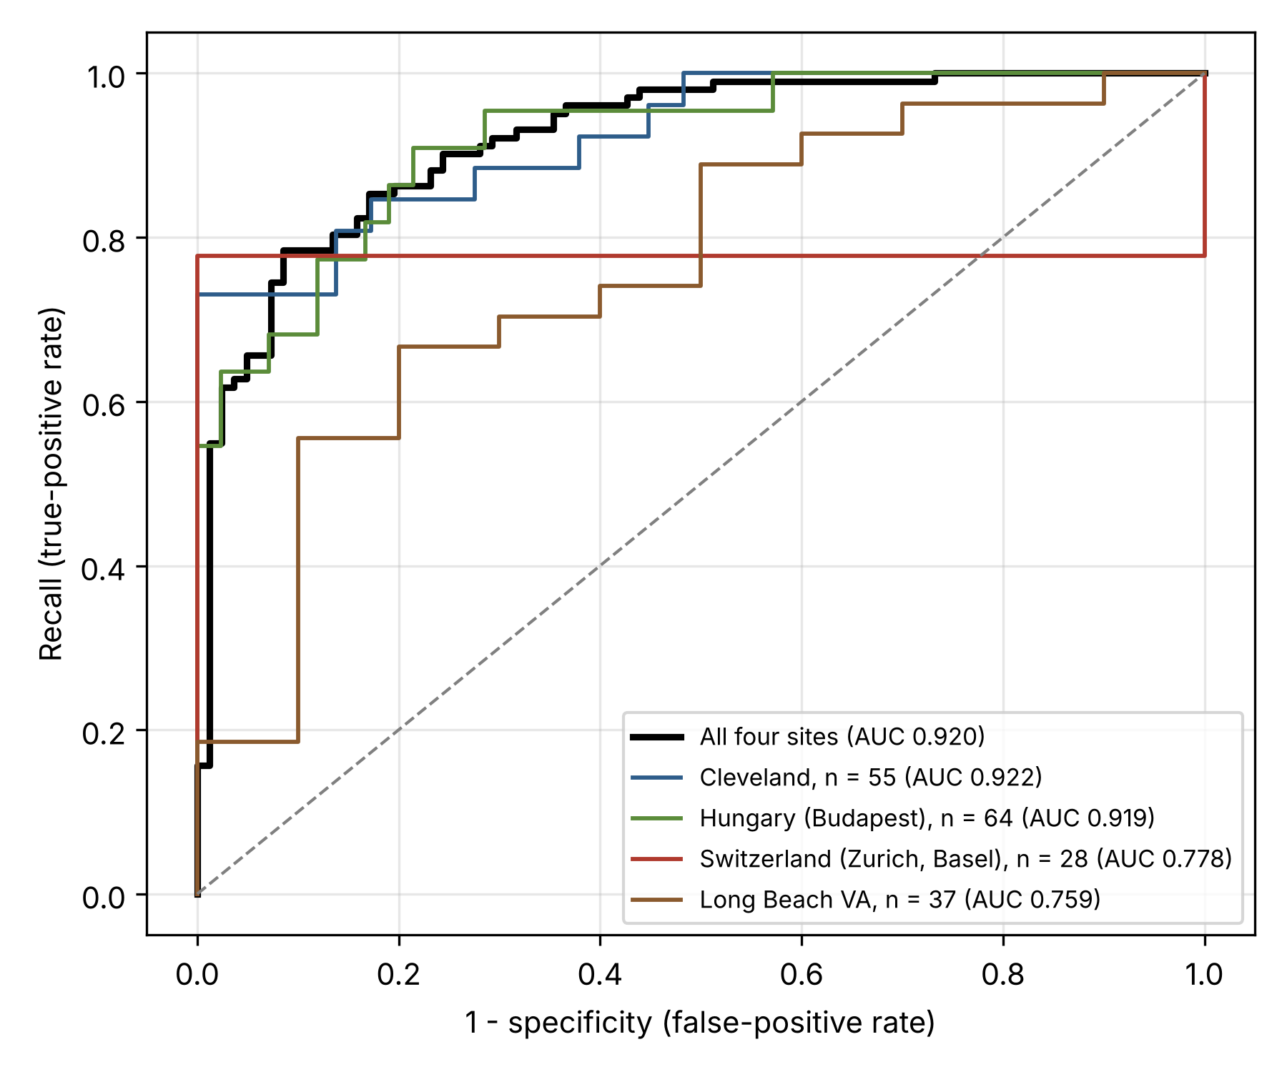
Note. The dashed diagonal marks a model with no ability to separate diseased from disease-free patients. AUC = area under the curve.
The forest’s feature importances rank asymptomatic chest pain first (19.5%), followed by exercise-induced angina (13.7%), ST depression (12.9%), and peak heart rate (11.0%). These are the stress-test findings cardiologists weigh in practice, and they are the same variables the exploratory charts flagged. Cholesterol ranks fifth (10.1%), higher than its clinical role would suggest, and part of that weight may come from the placeholder zeros that mark the two high-prevalence hospitals. Sex accounts for 5.5% of the importance.
Ethical Considerations
Three biases in the data limit what the model can fairly claim. The sample is 79% male, so the model learned from 459 diseased men but only 50 diseased women, nearly all of them from Cleveland and Hungary. Coronary disease has long been under-recognized in women, in part because their symptoms often differ from the classic male presentation (Garcia et al., 2016), and a model trained on this sample risks carrying that pattern forward. Every patient was also referred for angiography, which builds the referral decisions of four clinics from the 1980s into the data. The 79% disease rate among asymptomatic patients is the clearest sign, since an asymptomatic patient reached angiography only after another test came back abnormal. Data quality differs by hospital as well. The cholesterol zeros at the two high-prevalence hospitals let the model partly learn where a patient was treated, a recording artifact and not a property of the patient.
The subgroup results turn these risks into measurements. By sex, the model ranks men and women about equally well. Its lower precision for women (58% against 79% for men) reflects their lower disease rate more than over-flagging, as evidenced by the fact that it flagged 19% of disease-free women against 44% of disease-free men. The clearer gaps are by age, with younger diseased patients missed most often and older disease-free patients flagged almost universally. These groups are small, and a single woman moves female recall by 12.5 points, so the team treats the gaps as warning signs to monitor. That approach follows fairness research that favors measuring each group’s error rates directly over simply removing a sensitive attribute from the model (Mehrabi et al., 2021). Transparency is the other concern. A Random Forest offers no coefficient that explains an individual score, so its global importances show what drives the model overall but not why a particular patient was flagged. Per-patient explanations such as SHAP values would be needed before clinical use, and the model is proposed strictly as decision support that never makes the referral decision itself. On data protection, the UCI data were de-identified before release and are fetched at run time without being stored in the team’s GitHub repository. A deployed version would process identifiable health information under HIPAA in the United States and the GDPR in Europe, requiring minimum-necessary access, audit logging, and human review of automated decisions that affect patients.
Real-World Application
The use this evidence supports is ranking patients who have completed a first-line workup so that a cardiology clinic can schedule angiography in order of risk. The score would be computed inside the electronic health record as soon as the stress test result is filed, using only fields the workup already captures, and shown to the cardiologist together with the findings that drove it. Table 4 shows how a three-tier schedule would have sorted the 184 test patients. The high-risk tier held 43% of patients but 72% of all disease (73 of 102), so ordering the angiography list by score would bring most diseased patients to the front of the queue. Patients in the low-risk tier would go to a non-invasive test first, such as CT coronary angiography or stress imaging, consistent with the testing pathways in the current chest pain guideline (Gulati et al., 2021).
Table 4
Test Patients Sorted Into Three Risk Tiers by the Final Model
Risk tier (predicted probability) | Patients | With disease | Disease rate | Suggested next step
High (.70 and above) | 79 | 73 | 92% | Earliest angiography slots
Intermediate (.42 to .70) | 45 | 22 | 49% | Angiography scheduled in score order
Low (below .42) | 60 | 7 | 12% | Non-invasive test first
Note. Tiers are applied to the 184 held-out test patients. The .42 boundary is the tuned decision threshold.
The low tier also shows why the model is not a rule-out test. About 12% of its patients (7 of 60) still had significant disease, a rate far too high to justify sending them home without further testing. The model therefore changes the order and type of testing while leaving both the clinician and the confirmatory test in the pathway. Keeping a clinician who can review the basis for each score also places the tool within the category of clinical decision support software described in federal guidance (U.S. Food and Drug Administration, 2022).
Deployment would depend on three conditions that the results make necessary. The first is local validation. The model flagged 9 of 10 disease-free VA patients, so each adopting hospital would need to test it on several hundred of its own past patients, confirm recall by sex and age band, and adjust the threshold or recalibrate the probabilities where needed (Van Calster et al., 2019). The second is clean data capture. The pipeline would have to record missing measurements as missing, not as 0, given how placeholder values let hospital identity leak into this model. The third is ongoing oversight. The clinic would track recall, specificity, and the share of patients flagged each quarter, because referral patterns change over time, and it would report the model’s development and validation according to the TRIPOD statement (Collins et al., 2015) so that a clinical governance committee could judge it like any other prediction tool. Under those conditions, cardiologists would gain a consistent and explainable ordering of their referral list, quality leaders would gain a measurable target in missed diagnoses by group, and high-risk patients would reach angiography sooner.
Team Collaboration and Documentation
Part 2 kept the Part 1 structure, in which each member owned a stage of the analysis, and extended it to the new work. One member expanded the dataset to all four hospitals and built the tuning and evaluation pipeline, another added XGBoost as a fourth candidate, and the remaining members integrated the sections, added the baseline and age-band checks, and wrote the framing, ethical analysis, real-world application, and conclusion. The shared Google Colab notebook remained the single working copy. It reads every data file from UCI at run time, so each member reproduced identical results without exchanging data, and GitHub tracked changes to the notebook and report. Outlook email and Blackboard messages remained the channels for assigning tasks and agreeing on interpretations before they entered this report.
The biggest decision the team made together was to keep the Random Forest as the final model after XGBoost edged ahead of it. When XGBoost was added late in the project, its cross-validated ROC-AUC of .8719 placed it first, and the selection code chose it automatically. Accepting that result would have replaced the model behind every finding in the threshold, test-set, fairness, and feature-importance analyses, all of which had already been completed and interpreted for the Random Forest. The team weighed that cost against what XGBoost offered and found the gain too small to matter. Its lead of .0003 was smaller than the variation between cross-validation folds, so the two models were statistically indistinguishable, while the Random Forest had a complete and consistent evaluation behind it. The team therefore agreed to keep the Random Forest and to show the decision openly, with the full comparison left in view. The tuning cell prints XGBoost as the top-scoring model, then states that the Random Forest was selected by the team, and the accompanying text explains why. Recording the decision this way lets any reader see both the evidence and the judgment applied to it, which is the kind of traceable, collaborative choice the team aimed for throughout the project.
Final Thoughts and Conclusion
Each of the three next steps from Part 1 produced a clear answer. Compared against a majority-class baseline on ROC-AUC, four tuned models finished between .865 and .872, so the choice of algorithm mattered far less than Part 1 assumed, even though tuning lifted every model above its default settings. Tuning the decision threshold proved to be the lever Part 1 was missing. At .42 the Random Forest caught 95 of 102 diseased test patients (93% recall), compared with 92 at the default .50, at a cost of 9 additional false alarms. Expanding to all four hospitals tripled the test set and produced a test ROC-AUC of .920, with strong ranking at Cleveland and Hungary and far weaker specificity at the two high-prevalence hospitals.
These results place the model where its evidence supports it, as a prioritization aid within a clinician-led referral pathway and not as a test that rules disease out. Its main limitations follow from the data. Missing values were filled before the train-test split, two hospitals recorded missing cholesterol as 0, the female sample is small, and all four datasets date from the 1980s. Every hospital also contributed training patients, so the results do not yet show how the model would perform at a new hospital. The most valuable next steps would be to fill missing values inside the training pipeline and treat placeholder zeros as missing, to train on three hospitals and test on the fourth as a true external check, to add per-patient explanations, and to validate the model on recent patients from a hospital’s own records before any clinical use.
References
Breiman, L. (2001). Random forests. Machine Learning, 45(1), 5–32. https://doi.org/10.1023/A:1010933404324
Chen, T., & Guestrin, C. (2016). XGBoost: A scalable tree boosting system. In Proceedings of the 22nd ACM SIGKDD International Conference on Knowledge Discovery and Data Mining (pp. 785–794). Association for Computing Machinery. https://doi.org/10.1145/2939672.2939785
Christodoulou, E., Ma, J., Collins, G. S., Steyerberg, E. W., Verbakel, J. Y., & Van Calster, B. (2019). A systematic review shows no performance benefit of machine learning over logistic regression for clinical prediction models. Journal of Clinical Epidemiology, 110, 12–22. https://doi.org/10.1016/j.jclinepi.2019.02.004
Collins, G. S., Reitsma, J. B., Altman, D. G., & Moons, K. G. M. (2015). Transparent reporting of a multivariable prediction model for individual prognosis or diagnosis (TRIPOD): The TRIPOD statement. Annals of Internal Medicine, 162(1), 55–63. https://doi.org/10.7326/M14-0697
Garcia, M., Mulvagh, S. L., Merz, C. N. B., Buring, J. E., & Manson, J. E. (2016). Cardiovascular disease in women: Clinical perspectives. Circulation Research, 118(8), 1273–1293. https://doi.org/10.1161/CIRCRESAHA.116.307547
Gulati, M., Levy, P. D., Mukherjee, D., Amsterdam, E., Bhatt, D. L., Birtcher, K. K., Blankstein, R., Boyd, J., Bullock-Palmer, R. P., Conejo, T., Diercks, D. B., Gentile, F., Greenwood, J. P., Hess, E. P., Hollenberg, S. M., Jaber, W. A., Jneid, H., Joglar, J. A., Morrow, D. A., . . . Shaw, L. J. (2021). 2021 AHA/ACC/ASE/CHEST/SAEM/SCCT/SCMR guideline for the evaluation and diagnosis of chest pain. Circulation, 144(22), e368–e454. https://doi.org/10.1161/CIR.0000000000001029
Janosi, A., Steinbrunn, W., Pfisterer, M., & Detrano, R. (1988). Heart disease [Data set]. UCI Machine Learning Repository. https://doi.org/10.24432/C52P4X
Kaufman, S., Rosset, S., Perlich, C., & Stitelman, O. (2012). Leakage in data mining: Formulation, detection, and avoidance. ACM Transactions on Knowledge Discovery from Data, 6(4), Article 15. https://doi.org/10.1145/2382577.2382579
Mehrabi, N., Morstatter, F., Saxena, N., Lerman, K., & Galstyan, A. (2021). A survey on bias and fairness in machine learning. ACM Computing Surveys, 54(6), Article 115. https://doi.org/10.1145/3457607
Pedregosa, F., Varoquaux, G., Gramfort, A., Michel, V., Thirion, B., Grisel, O., Blondel, M., Prettenhofer, P., Weiss, R., Dubourg, V., Vanderplas, J., Passos, A., Cournapeau, D., Brucher, M., Perrot, M., & Duchesnay, É. (2011). Scikit-learn: Machine learning in Python. Journal of Machine Learning Research, 12, 2825–2830.
U.S. Food and Drug Administration. (2022). Clinical decision support software: Guidance for industry and Food and Drug Administration staff. https://www.fda.gov/regulatory-information/search-fda-guidance-documents/clinical-decision-support-software
Van Calster, B., McLernon, D. J., van Smeden, M., Wynants, L., & Steyerberg, E. W. (2019). Calibration: The Achilles heel of predictive analytics. BMC Medicine, 17, Article 230. https://doi.org/10.1186/s12916-019-1466-7
Varma, S., & Simon, R. (2006). Bias in error estimation when using cross-validation for model selection. BMC Bioinformatics, 7, Article 91. https://doi.org/10.1186/1471-2105-7-91
World Health Organization. (2024, August 7). The top 10 causes of death. https://www.who.int/news-room/fact-sheets/detail/the-top-10-causes-of-death
World Health Organization. (2025, July 31). Cardiovascular diseases (CVDs). https://www.who.int/news-room/fact-sheets/detail/cardiovascular-diseases-(cvds)

