|  |  |  |
| --- | --- | --- |
| **KMO and Bartlett's Test** | | |
| Kaiser-Meyer-Olkin Measure of Sampling Adequacy. | | ,930 |
| Bartlett's Test of Sphericity | Approx. Chi-Square | 19334,492 |
| df | 253 |
| Sig. | ,000 |

KMO=0,93>0,6

H0: all the correlations are not significant

H1: there are significant correlations

Sig=0,000 => H1

So, these variables could be used for factor analysis.

|  |  |  |
| --- | --- | --- |
| **Communalities** | | |
|  | Initial | Extraction |
| Statiscs makes me cry | 1,000 | ,435 |
| My friends will think I'm stupid for not being able to cope with SPSS | 1,000 | ,414 |
| Standard deviations excite me | 1,000 | ,530 |
| I dream that Pearson is attacking me with correlation coefficients | 1,000 | ,469 |
| I don't understand statistics | 1,000 | ,343 |
| I have little experience of computers | 1,000 | ,654 |
| All computers hate me | 1,000 | ,545 |
| I have never been good at mathematics | 1,000 | ,739 |
| My friends are better at statistics than me | 1,000 | ,484 |
| Computers are useful only for playing games | 1,000 | ,335 |
| I did badly at mathematics at school | 1,000 | ,690 |
| People try to tell you that SPSS makes statistics easier to understand but it doesn't | 1,000 | ,513 |
| I worry that I will cause irreparable damage because of my incompetenece with computers | 1,000 | ,536 |
| Computers have minds of their own and deliberately go wrong whenever I use them | 1,000 | ,488 |
| Computers are out to get me | 1,000 | ,378 |
| I weep openly at the mention of central tendency | 1,000 | ,487 |
| I slip into a coma whenever I see an equation | 1,000 | ,683 |
| SPSS always crashes when I try to use it | 1,000 | ,597 |
| Everybody looks at me when I use SPSS | 1,000 | ,343 |
| I can't sleep for thoughts of eigen vectors | 1,000 | ,484 |
| I wake up under my duvet thinking that I am trapped under a normal distribtion | 1,000 | ,550 |
| My friends are better at SPSS than I am | 1,000 | ,464 |
| If I'm good at statistics my friends will think I'm a nerd | 1,000 | ,412 |
| Extraction Method: Principal Component Analysis. | | |

|  |  |  |  |  |  |  |  |  |  |
| --- | --- | --- | --- | --- | --- | --- | --- | --- | --- |
| **Total Variance Explained** | | | | | | | | | |
| Component | Initial Eigenvalues | | | Extraction Sums of Squared Loadings | | | Rotation Sums of Squared Loadings | | |
| Total | % of Variance | Cumulative % | Total | % of Variance | Cumulative % | Total | % of Variance | Cumulative % |
| 1 | 7,290 | 31,696 | 31,696 | 7,290 | 31,696 | 31,696 | 3,730 | 16,219 | 16,219 |
| 2 | 1,739 | 7,560 | 39,256 | 1,739 | 7,560 | 39,256 | 3,340 | 14,523 | 30,742 |
| 3 | 1,317 | 5,725 | 44,981 | 1,317 | 5,725 | 44,981 | 2,553 | 11,099 | 41,841 |
| 4 | 1,227 | 5,336 | 50,317 | 1,227 | 5,336 | 50,317 | 1,950 | 8,476 | 50,317 |
| 5 | ,988 | 4,295 | 54,612 |  |  |  |  |  |  |
| 6 | ,895 | 3,893 | 58,504 |  |  |  |  |  |  |
| 7 | ,806 | 3,502 | 62,007 |  |  |  |  |  |  |
| 8 | ,783 | 3,404 | 65,410 |  |  |  |  |  |  |
| 9 | ,751 | 3,265 | 68,676 |  |  |  |  |  |  |
| 10 | ,717 | 3,117 | 71,793 |  |  |  |  |  |  |
| 11 | ,684 | 2,972 | 74,765 |  |  |  |  |  |  |
| 12 | ,670 | 2,911 | 77,676 |  |  |  |  |  |  |
| 13 | ,612 | 2,661 | 80,337 |  |  |  |  |  |  |
| 14 | ,578 | 2,512 | 82,849 |  |  |  |  |  |  |
| 15 | ,549 | 2,388 | 85,236 |  |  |  |  |  |  |
| 16 | ,523 | 2,275 | 87,511 |  |  |  |  |  |  |
| 17 | ,508 | 2,210 | 89,721 |  |  |  |  |  |  |
| 18 | ,456 | 1,982 | 91,704 |  |  |  |  |  |  |
| 19 | ,424 | 1,843 | 93,546 |  |  |  |  |  |  |
| 20 | ,408 | 1,773 | 95,319 |  |  |  |  |  |  |
| 21 | ,379 | 1,650 | 96,969 |  |  |  |  |  |  |
| 22 | ,364 | 1,583 | 98,552 |  |  |  |  |  |  |
| 23 | ,333 | 1,448 | 100,000 |  |  |  |  |  |  |
| Extraction Method: Principal Component Analysis. | | | | | | | | | |

We have 4 factors and they explain 50,3% of the initial variables’ variation.

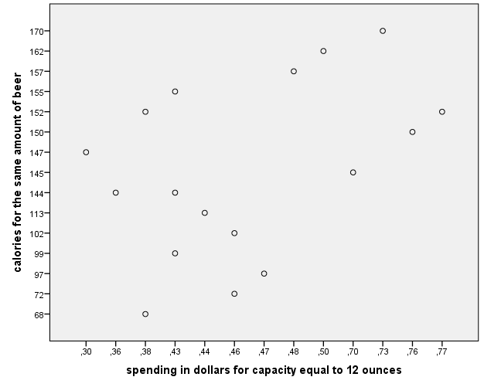

|  |  |  |  |  |  |  |
| --- | --- | --- | --- | --- | --- | --- |
| **Agglomeration Schedule** | | | | | | |
| Stage | Cluster Combined | | Coefficients | Stage Cluster First Appears | | Next Stage |
| Cluster 1 | Cluster 2 | Cluster 1 | Cluster 2 |
| 1 | 5 | 12 | ,009 | 0 | 0 | 9 |
| 2 | 10 | 17 | ,029 | 0 | 0 | 4 |
| 3 | 2 | 3 | ,043 | 0 | 0 | 13 |
| 4 | 8 | 10 | ,064 | 0 | 2 | 7 |
| 5 | 7 | 13 | ,080 | 0 | 0 | 8 |
| 6 | 1 | 15 | ,117 | 0 | 0 | 8 |
| 7 | 8 | 9 | ,206 | 4 | 0 | 14 |
| 8 | 1 | 7 | ,219 | 6 | 5 | 12 |
| 9 | 5 | 11 | ,233 | 1 | 0 | 11 |
| 10 | 14 | 16 | ,313 | 0 | 0 | 14 |
| 11 | 4 | 5 | ,487 | 0 | 9 | 16 |
| 12 | 1 | 6 | ,534 | 8 | 0 | 13 |
| 13 | 1 | 2 | ,820 | 12 | 3 | 15 |
| 14 | 8 | 14 | 1,205 | 7 | 10 | 15 |
| 15 | 1 | 8 | 4,017 | 13 | 14 | 16 |
| 16 | 1 | 4 | 6,753 | 15 | 11 | 0 |

17-14=3 clusters

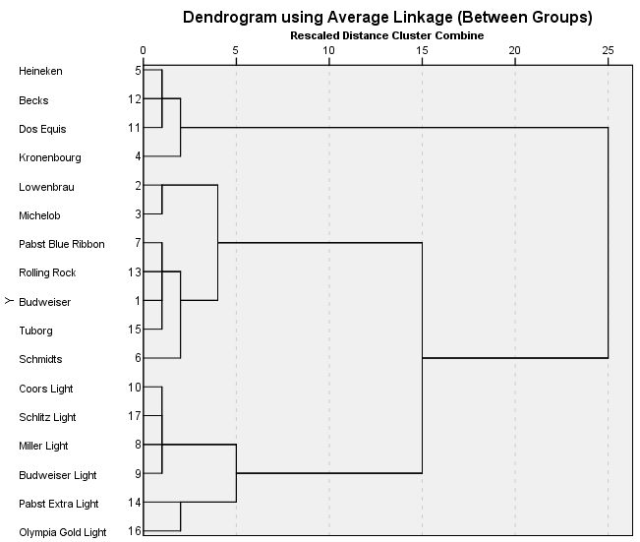

|  |  |  |  |  |
| --- | --- | --- | --- | --- |
| **Report** | | | | |
| Average Linkage (Between Groups) | | Mean | N | Std. Deviation |
| 1 | Memory for numbers | 10,00 | 4 | ,000 |
| Mathematical skills | 10,00 | 4 | ,000 |
| Readiness for direct dialogues | 9,00 | 4 | ,000 |
| Ability to prepare algorithms | 10,00 | 4 | ,000 |
| Speech confidence | 10,00 | 4 | ,000 |
| Team Spirit | 9,50 | 4 | ,577 |
| Resourcefulness | 9,25 | 4 | ,500 |
| Copperation | 9,75 | 4 | ,500 |
| Recognition by others | 10,00 | 4 | ,000 |
| Ability to persuade | 9,50 | 4 | ,577 |
| 2 | Memory for numbers | 10,00 | 4 | ,000 |
| Mathematical skills | 10,00 | 4 | ,000 |
| Readiness for direct dialogues | 4,25 | 4 | ,500 |
| Ability to prepare algorithms | 10,00 | 4 | ,000 |
| Speech confidence | 4,75 | 4 | ,500 |
| Team Spirit | 4,50 | 4 | ,577 |
| Resourcefulness | 3,75 | 4 | ,500 |
| Copperation | 4,25 | 4 | ,957 |
| Recognition by others | 4,25 | 4 | ,500 |
| Ability to persuade | 4,25 | 4 | ,957 |
| 3 | Memory for numbers | 4,20 | 5 | ,447 |
| Mathematical skills | 4,80 | 5 | ,447 |
| Readiness for direct dialogues | 10,00 | 5 | ,000 |
| Ability to prepare algorithms | 4,40 | 5 | ,548 |
| Speech confidence | 10,00 | 5 | ,000 |
| Team Spirit | 4,40 | 5 | ,548 |
| Resourcefulness | 10,00 | 5 | ,000 |
| Copperation | 4,00 | 5 | ,707 |
| Recognition by others | 3,80 | 5 | ,837 |
| Ability to persuade | 10,00 | 5 | ,000 |
| 4 | Memory for numbers | 4,80 | 5 | 1,095 |
| Mathematical skills | 4,40 | 5 | ,894 |
| Readiness for direct dialogues | 4,00 | 5 | 1,000 |
| Ability to prepare algorithms | 4,00 | 5 | ,707 |
| Speech confidence | 4,20 | 5 | ,837 |
| Team Spirit | 10,00 | 5 | ,000 |
| Resourcefulness | 4,40 | 5 | ,548 |
| Copperation | 10,00 | 5 | ,000 |
| Recognition by others | 10,00 | 5 | ,000 |
| Ability to persuade | 5,00 | 5 | ,707 |
| Total | Memory for numbers | 6,94 | 18 | 2,879 |
| Mathematical skills | 7,00 | 18 | 2,808 |
| Readiness for direct dialogues | 6,83 | 18 | 2,875 |
| Ability to prepare algorithms | 6,78 | 18 | 3,001 |
| Speech confidence | 7,22 | 18 | 2,901 |
| Team Spirit | 7,11 | 18 | 2,784 |
| Resourcefulness | 6,89 | 18 | 2,908 |
| Copperation | 7,00 | 18 | 3,029 |
| Recognition by others | 7,00 | 18 | 3,125 |
| Ability to persuade | 7,22 | 18 | 2,713 |