Course: Data Analysis (task № 3)

Students’ Name and Surname ___Rashid Ali______________________________________

Please do the tasks below.

1. Open top-managers.sav file. Do the test to understand whether the mean ages of top-managers (variable q21) differ significantly in organizations of different industries (variable qotrasl). Formulate the hypotheses. Interpret the results of analysis. Do the post-hoc analysis and interpret the results (if applicable). Could we consider the results of analysis as reliable?

Tests of Normality
 | Kolmogorov-Smirnovª |  |  | Shapiro-Wilk
 | Statistic | df | Sig. | Statistic | df | Sig.
age | .088 | 301 | .000 | .966 | 301 | .000
a. Lilliefors Significance Correction

As the Sig << 0.05, therefore, the age is not distributed normally.

Non Parametric Test
K Independence test (Kruskal-Wallis)

Ranks
 | Industry | N | Mean Rank
age | Oil-producing | 3 | 38.50
age | Coal | 5 | 172.70
age | Ferrous metallurgy | 5 | 201.80
age | Non-ferrous metallurgy | 6 | 144.92
age | Chemical, Petrochemical | 5 | 137.60
age | Engineering, metal | 115 | 174.56
age | Wood | 22 | 142.48
age | Pulp and Paper | 2 | 140.00
age | Textile | 16 | 149.56
age | Sewing | 27 | 155.59
age | Shoe | 6 | 244.58
age | Food | 89 | 116.35
age | Total | 301

Test Statistics^{a,b}
 | age
Chi-Square | 37.027
df | 11
Asymp. Sig. | .000
a. Kruskal Wallis Test
b. Grouping Variable: Industry

H0 = No difference between means of age and industry
H1 = There is difference between age and industry
Significance is less than 0.05
H0 is reject and H1 is accepted.
So, there is statistically significant difference between means of age and industry

2. Open world_data.sav file.
2.1. Do the simple regression analysis. Select the appropriate variables. Write down the regression equation. Assess the goodness-of-fit of the model. Do the diagnostics of the model. Are the residuals normally distributed? Delete the cases than have standardized residuals greater than 3. Will this improve the model?

Population (Population in thousands) and Birth Rate (Birth rate per 1000 people)

Model Summary
Model | R | R Square | Adjusted R Square | Std. Error of the Estimate
1 | .039ª | .002 | -.008 | 147298.258
- Predictors: (Constant), Birth rate per 1000 people

R square = 0.002. Only 0.2% population variation is explained by the model.

ANOVAª
Model |  | Sum of Squares | df | Mean Square | F | Sig.
1 | Regression | 3536467977.263 | 1 | 3536467977.263 | .163 | .687^{b}
1 | Residual | 2321555119950.187 | 107 | 21696776821.964
1 | Total | 2325091587927.450 | 108
a. Dependent Variable: Population in thousands
b. Predictors: (Constant), Birth rate per 1000 people

The model is not significantly better than mean in predicting Population.

Coefficientsª
Model |  | Unstandardized Coefficients |  | Standardized Coefficients | t | Sig.
 |  | B | Std. Error | Beta | t | Sig.
1 | (Constant) | 59724.597 | 32903.202 |  | 1.815 | .072
1 | Birth rate per 1000 people | -462.938 | 1146.663 | -.039 | -.404 | .687
a. Dependent Variable: Population in thousands

Equation:

Population= 59724.597 + (-462.938*Birth rate)

Normality of Residuals:
Tests of Normality
 | Kolmogorov-Smirnovª |  |  | Shapiro-Wilk
 | Statistic | df | Sig. | Statistic | df | Sig.
Standardized Residual | .361 | 109 | .000 | .296 | 109 | .000
a. Lilliefors Significance Correction

The sig<0.05, so the residuals are not normally distributed.

Standardized Residual

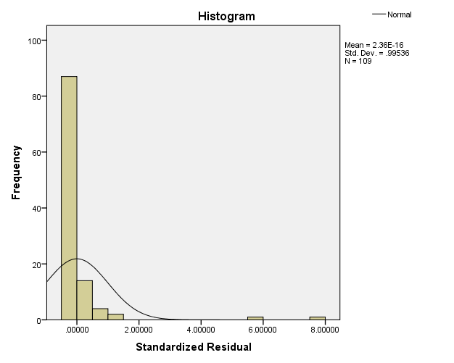

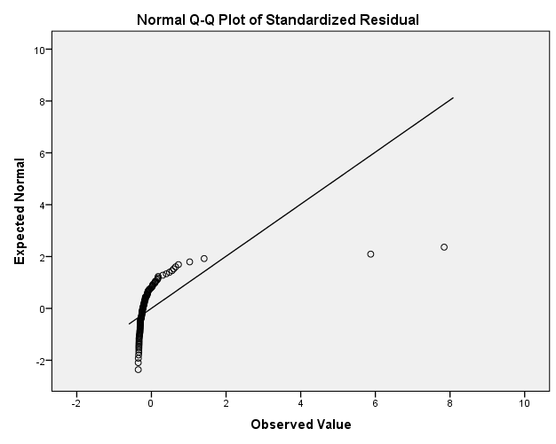

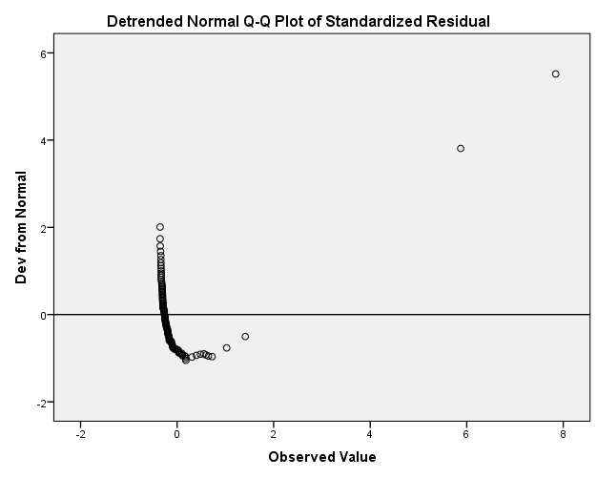
There are two values of standardized residuals which are greater than 3.

Model Summary^{b}
Model | R | R Square | Adjusted R Square | Std. Error of the Estimate
1 | .079ª | .006 | -.003 | 43600.779
a. Predictors: (Constant), Birth rate per 1000 people
b. Dependent Variable: Population in thousands

R Square = 0.006, the value of R Square increased, and only 0.6% population variation is explained by the model.

ANOVAª
Model |  | Sum of Squares | df | Mean Square | F | Sig.
1 | Regression | 1265083800.430 | 1 | 1265083800.430 | .665 | .416^{b}
1 | Residual | 199607935006.243 | 105 | 1901027952.440
1 | Total | 200873018806.673 | 106
a. Dependent Variable: Population in thousands
b. Predictors: (Constant), Birth rate per 1000 people
The model is not significantly better than mean in predicting Population

Coefficientsª
Model |  | Unstandardized Coefficients |  | Standardized Coefficients | t | Sig.
 |  | B | Std. Error | Beta | t | Sig.
1 | (Constant) | 36022.513 | 9769.592 |  | 3.687 | .000
1 | Birth rate per 1000 people | -277.167 | 339.764 | -.079 | -.816 | .416
a. Dependent Variable: Population in thousands

Equation:

Population= 36022.513 + (-277.167*Birth rate)

So, the model didn’t improve.

2.2. Do the multiple regression analysis using at least two predictors. Select the appropriate variables. Write down the regression equation. Assess the goodness-of-fit of the model. Are all the gradients and intercepts of the model statistically significant? Do the diagnostics of the model. Are the residuals normally distributed? Test the multicollinearity.

Model Summary^{b}
Model | R | R Square | Adjusted R Square | Std. Error of the Estimate
1 | .661ª | .437 | .426 | 4907.830
a. Predictors: (Constant), Population in thousands, Birth rate per 1000 people
b. Dependent Variable: Gross domestic product / capita

R square = 0.437, 43.7% GDP variation is explained by the model.

ANOVAª
Model |  | Sum of Squares | df | Mean Square | F | Sig.
1 | Regression | 1981532816.079 | 2 | 990766408.040 | 41.133 | .000^{b}
1 | Residual | 2553200725.884 | 106 | 24086799.301
1 | Total | 4534733541.963 | 108
a. Dependent Variable: Gross domestic product / capita
b. Predictors: (Constant), Population in thousands, Birth rate per 1000 people

As the sig<0.05 so the my model is significantly better than mean in predicting GDP

Coefficientsª
Model |  | Unstandardized Coefficients |  | Standardized Coefficients | t | Sig.
 |  | B | Std. Error | Beta | t | Sig.
1 | (Constant) | 15008.835 | 1113.053 |  | 13.484 | .000
1 | Birth rate per 1000 people | -343.796 | 38.235 | -.656 | -8.992 | .000
1 | Population in thousands | -.005 | .003 | -.112 | -1.540 | .127
a. Dependent Variable: Gross domestic product / capita

Equation:

GPD= 15008.835+ (-343.796*Birth rate per 1000 people) + (-0.005*population in thousands)

Tests of Normality
 | Kolmogorov-Smirnovª |  |  | Shapiro-Wilk
 | Statistic | df | Sig. | Statistic | df | Sig.
Standardized Residual | .105 | 109 | .005 | .954 | 109 | .001
a. Lilliefors Significance Correction

The sig<0.05, so the residuals are not normally distributed.

Standardized Residual

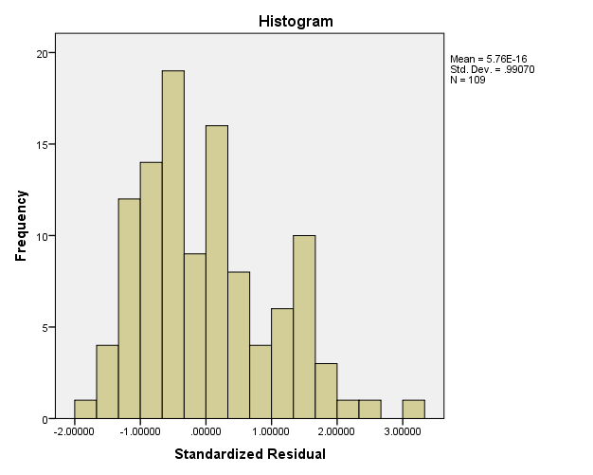

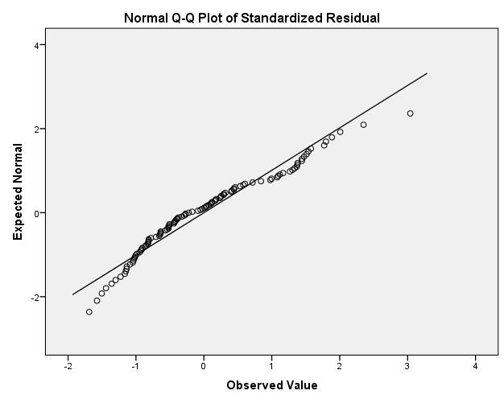

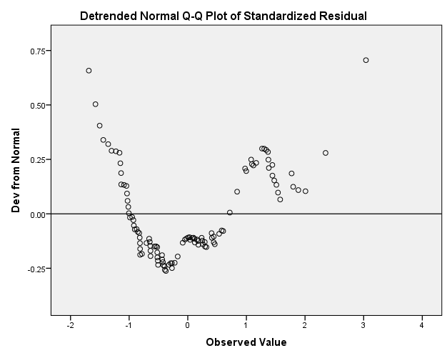

Coefficientsª
Model |  | Collinearity Statistics
 |  | Tolerance | VIF
1 | Birth rate per 1000 people | .998 | 1.002
1 | Population in thousands | .998 | 1.002
a. Dependent Variable: Gross domestic product / capita

Collinearity Diagnosticsª
Model | Dimension | Eigenvalue | Condition Index | Variance Proportions
 |  |  |  | (Constant) | Birth rate per 1000 people | Population in thousands
1 | 1 | 2.060 | 1.000 | .04 | .04 | .06
1 | 2 | .845 | 1.561 | .01 | .02 | .93
1 | 3 | .095 | 4.649 | .95 | .94 | .02
a. Dependent Variable: Gross domestic product / capita

As the value of tolerance is greater than 0.2, so there is no multicollinearity.

