**MAKERERE UNIVERSITY**

**COLLEGE OF COMPUTING AND INFORMATION TECHNOLOGY**

**DEPARTMENT OF NETWORKS**

**STUDENT FEEDBACK SYSTEM - FINAL REPORT**

**AUTHORS**

**GUM PRISCILLAH PENINNAH 21/U/17674/EVE**

**KISEJJERE RASHID 21/U/11543/EVE**

**BINDYA PHILLIP 21/U/14629/EVE**

**SSEMANGANDA TREVOUR 21/U/18348/EVE**

**BYANSI ANTHONY 21/U/0006**

**SUPERVISOR**

**MR. JEFF JOFF**

**AUGUST 2023**

**Introduction:**

We are pleased to present the final report of our Student Feedback System project, a web application designed to streamline the process of collecting feedback from students on courses, instructors, and campus facilities. In this project, we utilized the Django web development framework to create a user-friendly and efficient system. Additionally, we integrated a sentiment analysis model to enhance the application's functionality and gain valuable insights from the feedback data.

**Screenshots of Our Project:**

Below are some screenshots of our web application to provide an overview of its design and functionality:

1. **SignIn Page:**

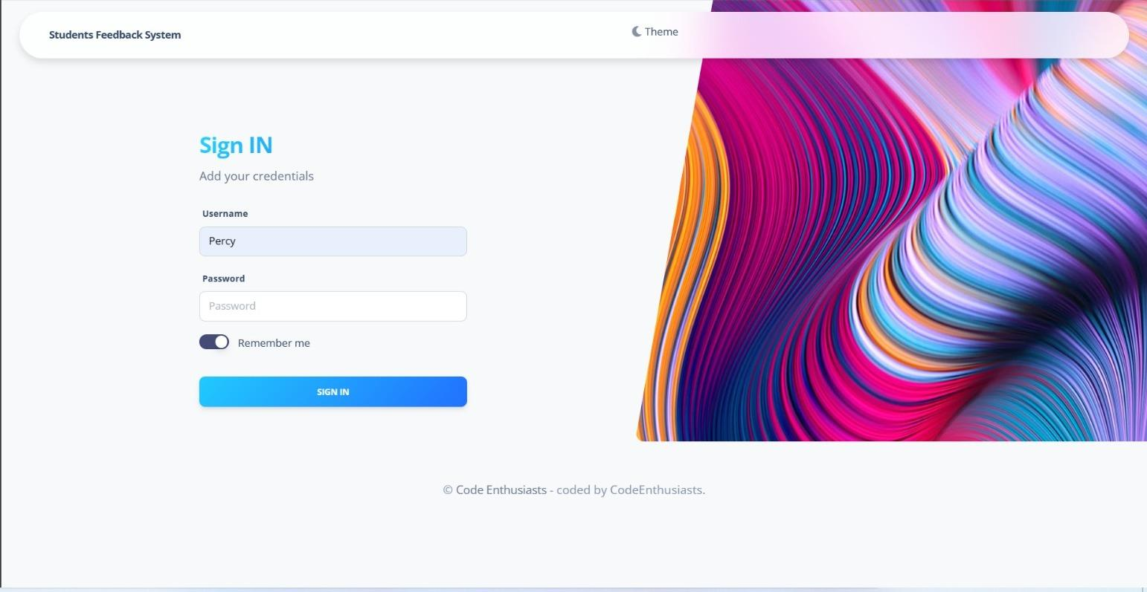

Our login page provides a secure entry point for authorized users. Students can easily access the feedback system by entering their unique credentials. This ensures a seamless and protected experience for submitting evaluations and feedback.

**2 . Homepage:**

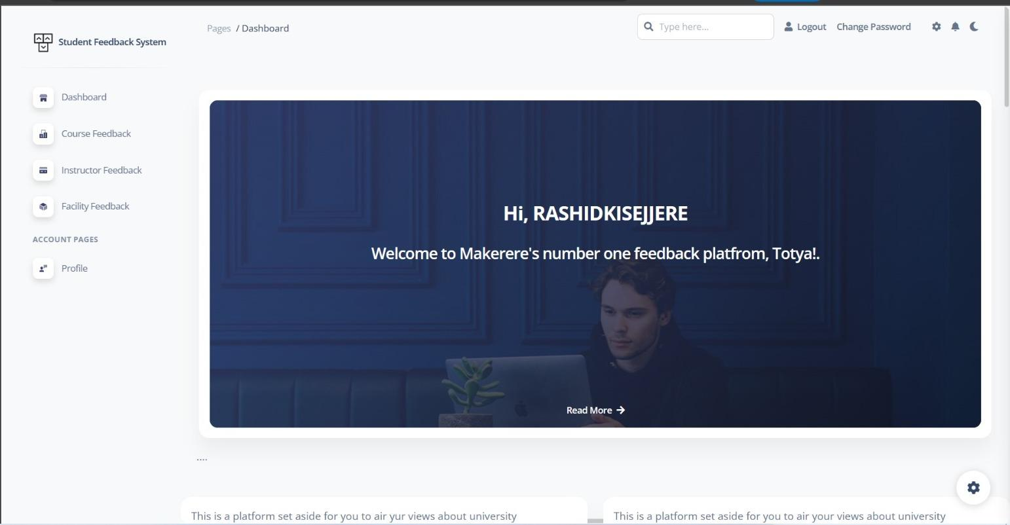

The landing page offers a concise explanation of the feedback process's significance and features a prominent call-to-action button leading to the feedback form.

**3. Course Feedback Form:**

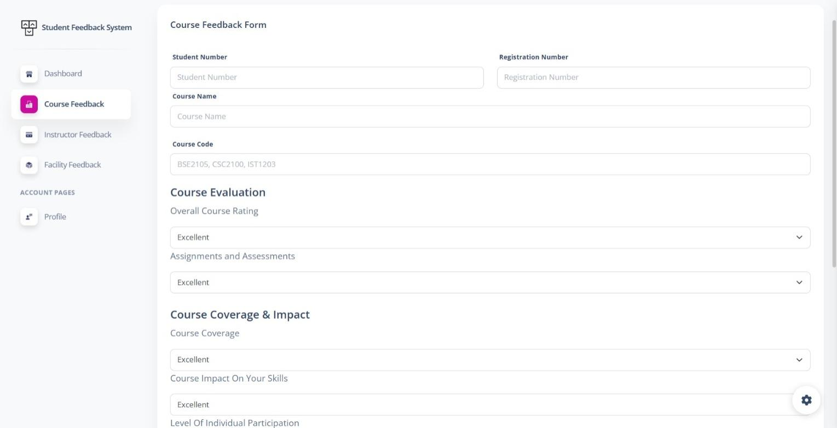

Our user-friendly feedback form allows students to submit their feedback effortlessly. They can provide evaluations for courses, instructors, and campus facilities through free-text input.

**4. Sentiment Analysis Model:**

Our system incorporates a sentiment analysis model to automatically assess the sentiment of the feedback text. This enables us to categorize the feedback into positive, negative, or neutral sentiments.

**5. Analysis Results:**

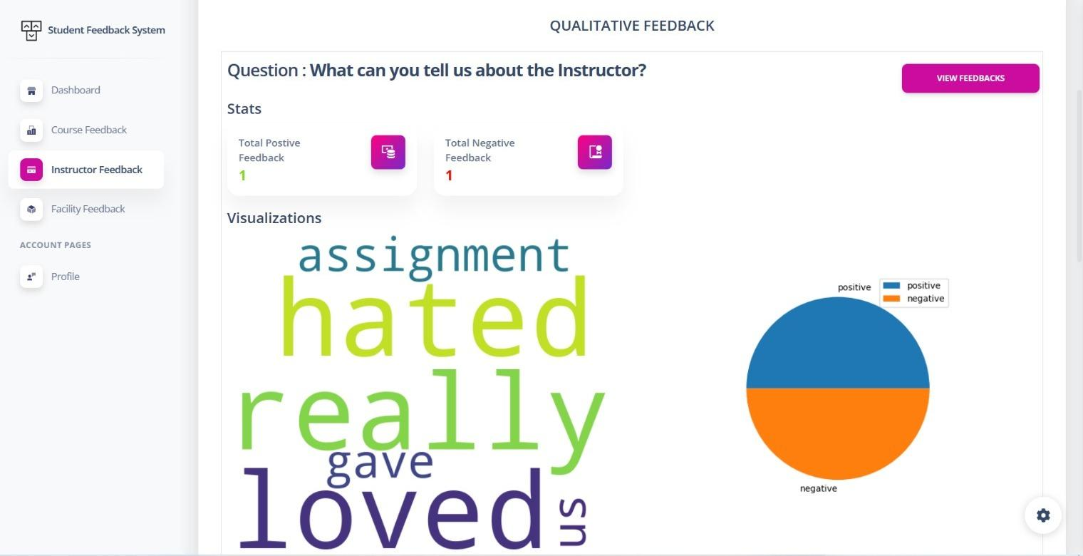

The sentiment analysis results are presented on a separate page, providing an aggregated view of the feedback sentiments. These results assist administrators in identifying areas that require improvement and recognizing areas of excellence.

**Overview of Web Application Systems:**

We have developed the following systems and functionalities within our Student Feedback System:

**1. User Registration and Authentication:**

We implemented a secure user registration and authentication system to ensure only authorized students can access the feedback form and submit their evaluations.

**2. Feedback Submission:**

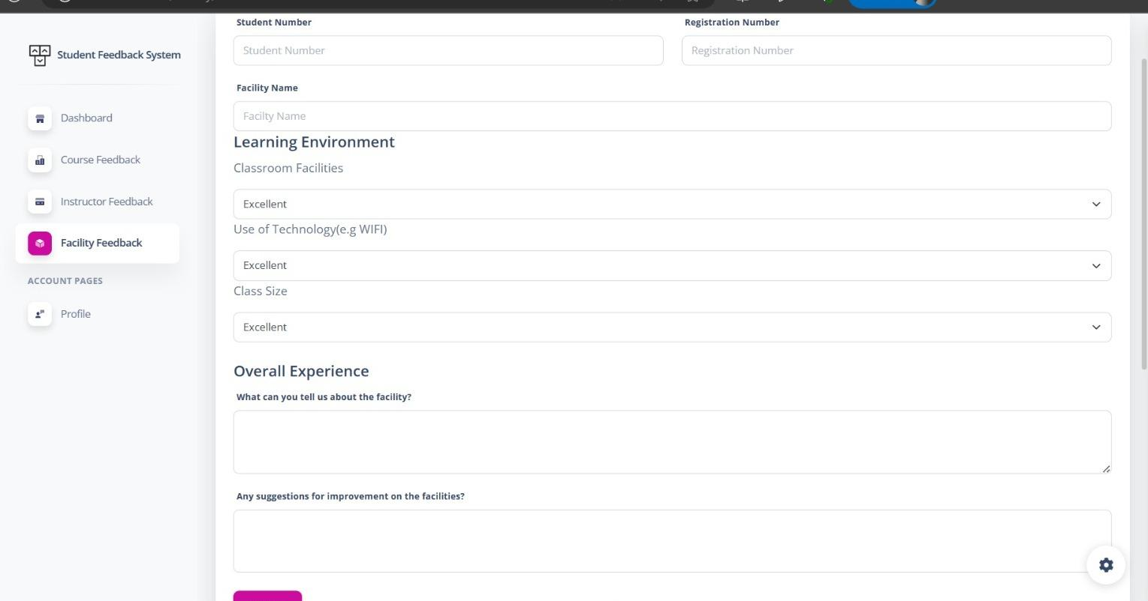

Our feedback form is designed to capture structured feedback from students. They can select the specific course, instructor, or facility they are evaluating and share their comments accordingly.

**3. Sentiment Analysis:**

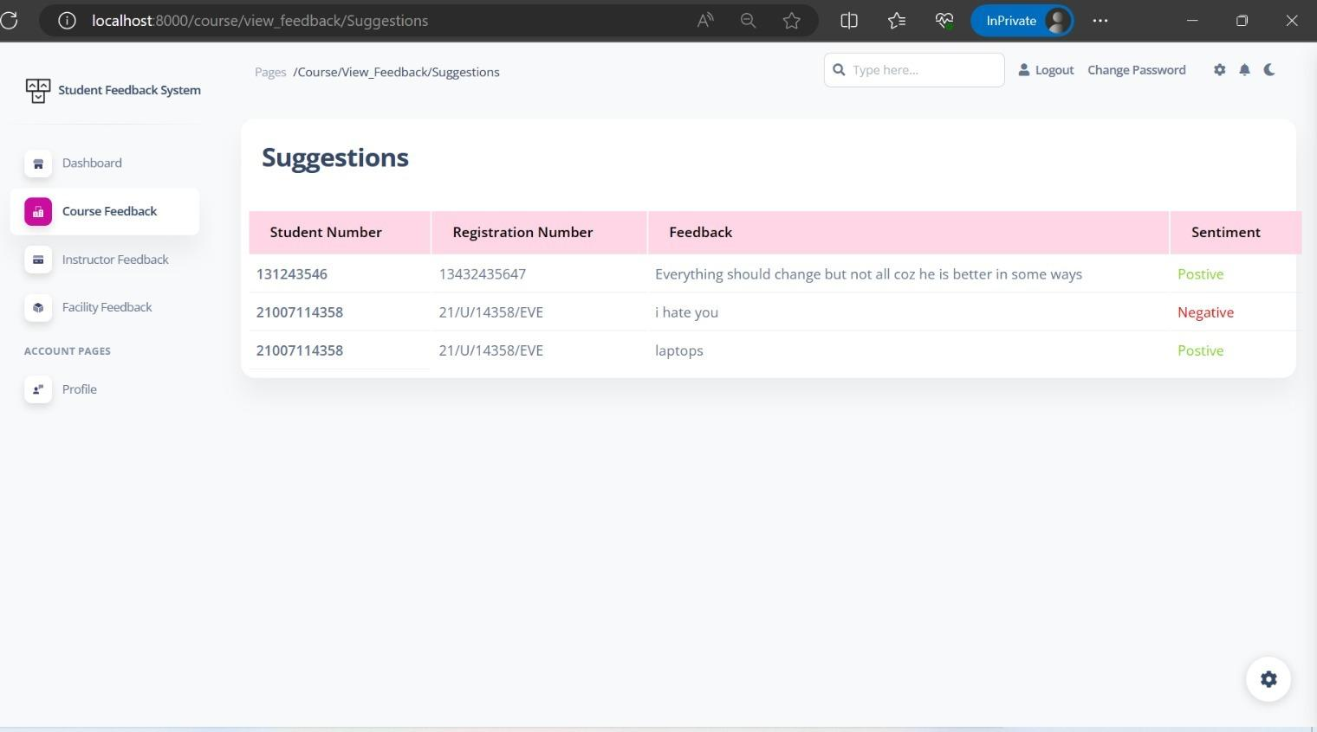

By integrating a sentiment analysis model, we can automatically analyze the feedback text and determine the overall sentiment expressed by students.

**4. Feedback Analysis and Reports:**

Our system generates comprehensive reports that allow administrators to review and analyze the feedback data. The summarized reports highlight sentiment trends and help make data-driven decisions to enhance the overall student experience.

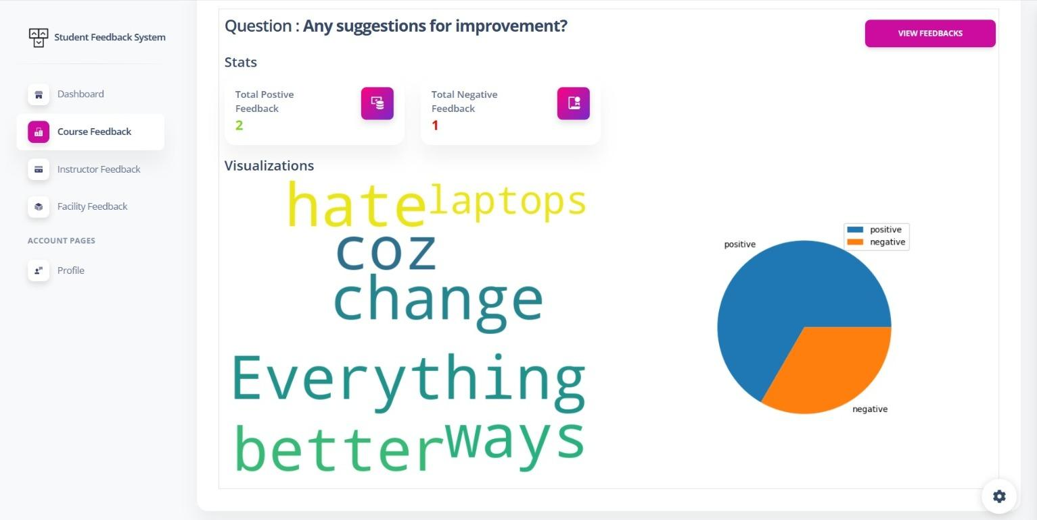

**Source Code:**

The source code of our Student Feedback System project's code repository can be accessed on GitHub at <https://github.com/rashidkisejjere0784/Student-Feedback-System.>

**Conclusion:**

Our team successfully developed the Student Feedback System using Django, creating a powerful and valuable tool for collecting and analyzing feedback from students. The integration of the sentiment analysis model further enhances the system's capabilities, enabling administrators to make informed decisions and improvements based on the feedback received. We believe that our web application can significantly contribute to enhancing the quality of education and campus facilities, ultimately leading to a better student experience.

**Data models**   
We have designed a comprehensive set of data models that capture user information, course details, instructor profiles, student feedback, sentiment analysis results, department and semester information, campus facilities, generated reports, and administrator activity logs to create a robust Student Feedback System.

**1.User Model:**

- Stores information about system users, including their usernames, email addresses, passwords, and roles (student or administrator).

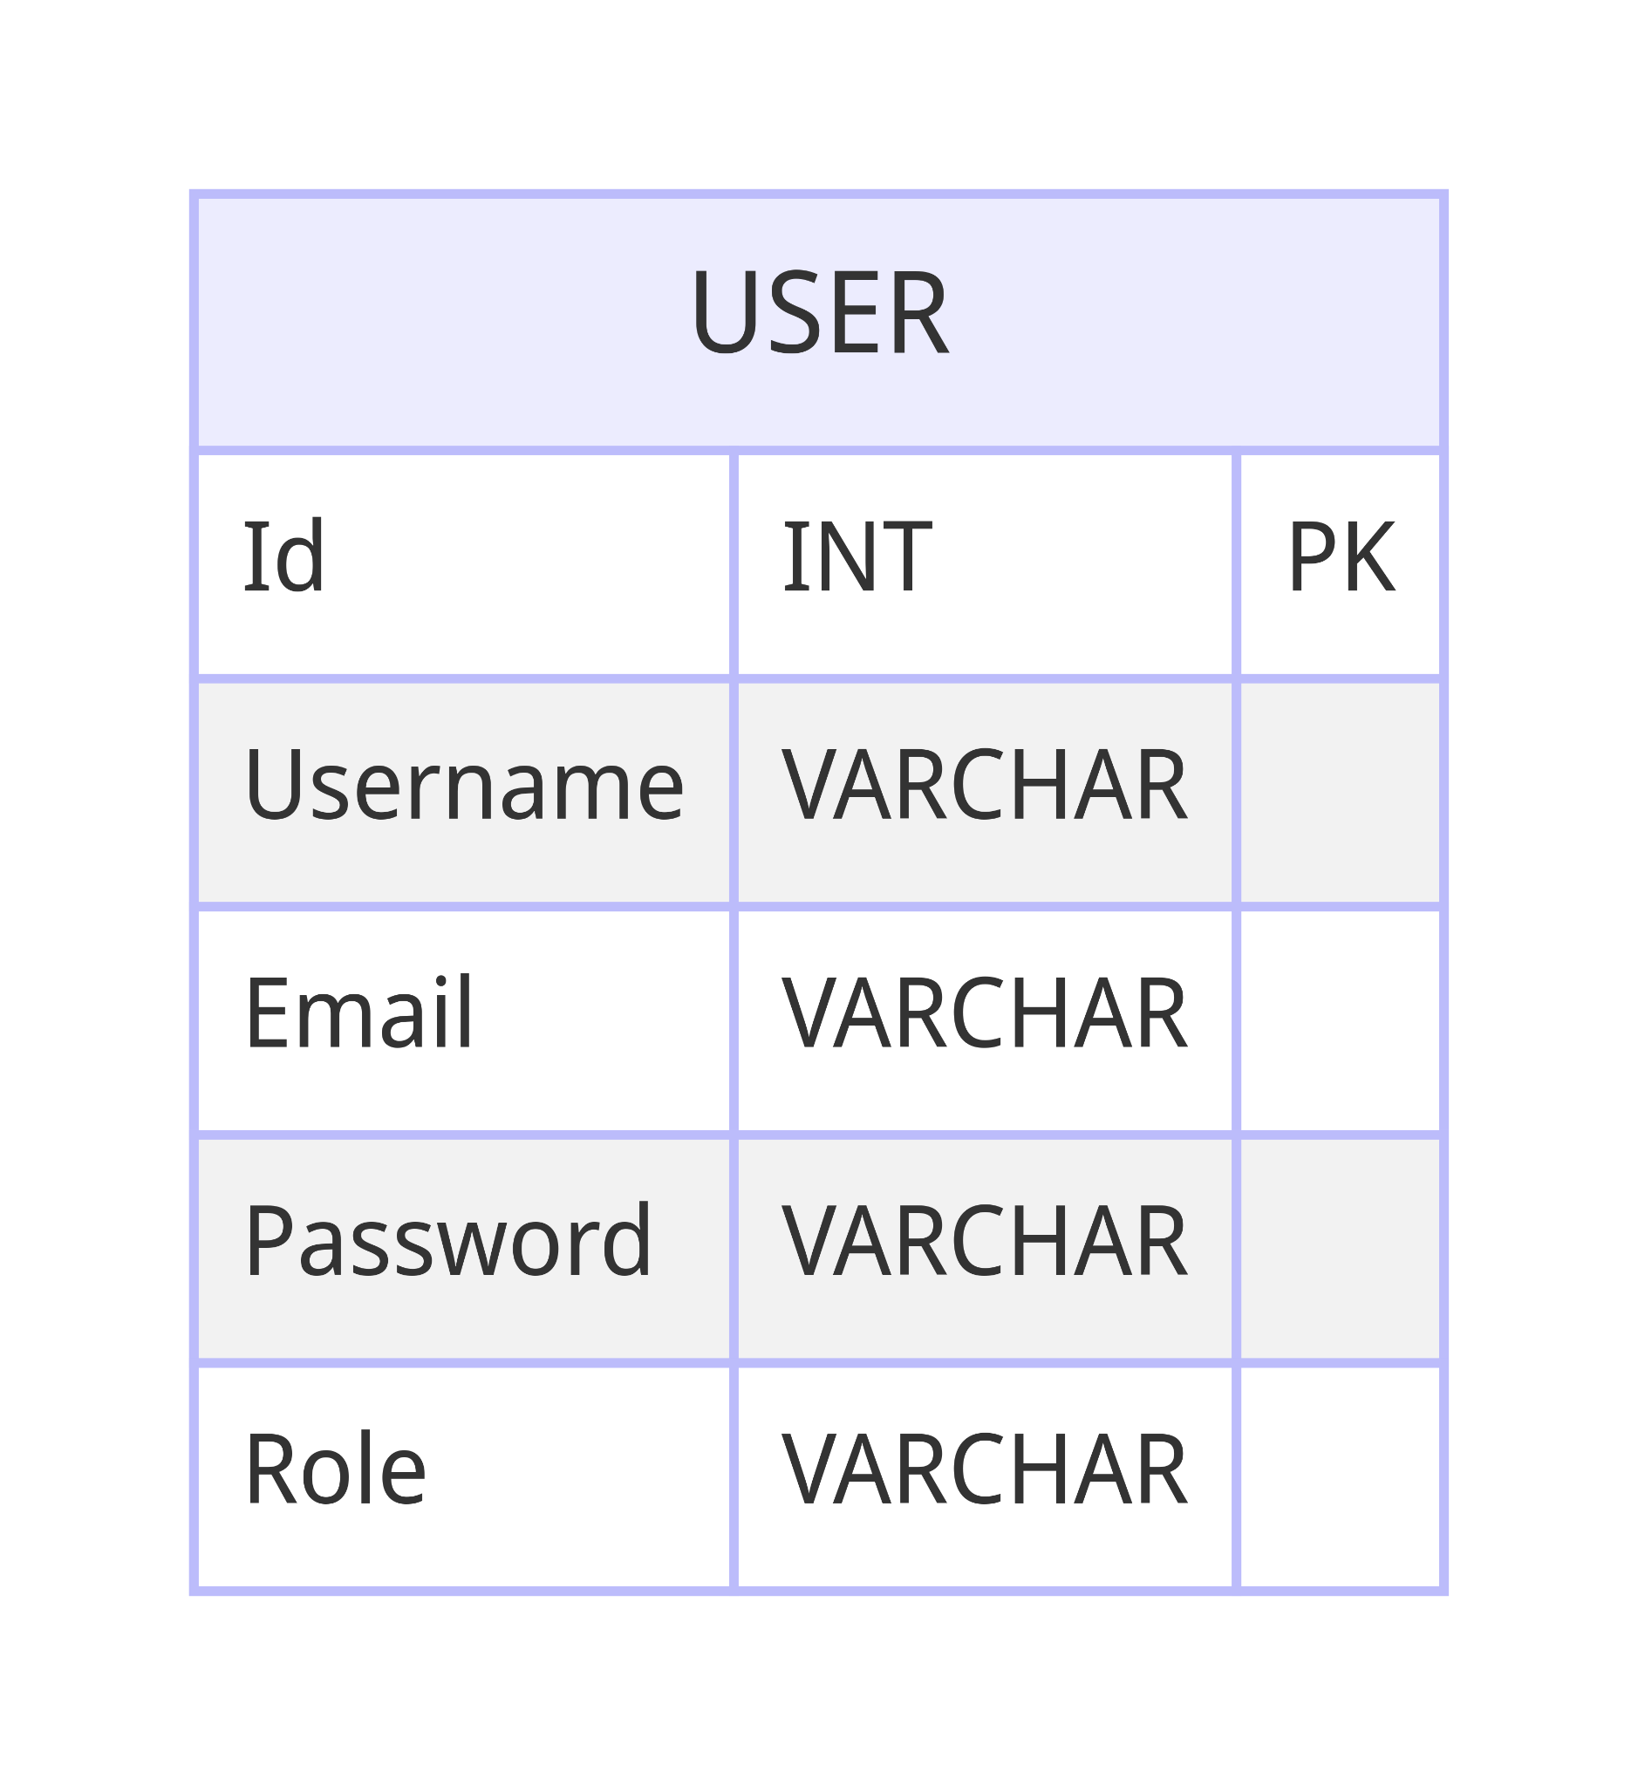

**2. Course Model:**

- Represents details about academic courses, such as course codes, names, associated department, semester, and instructor(s).

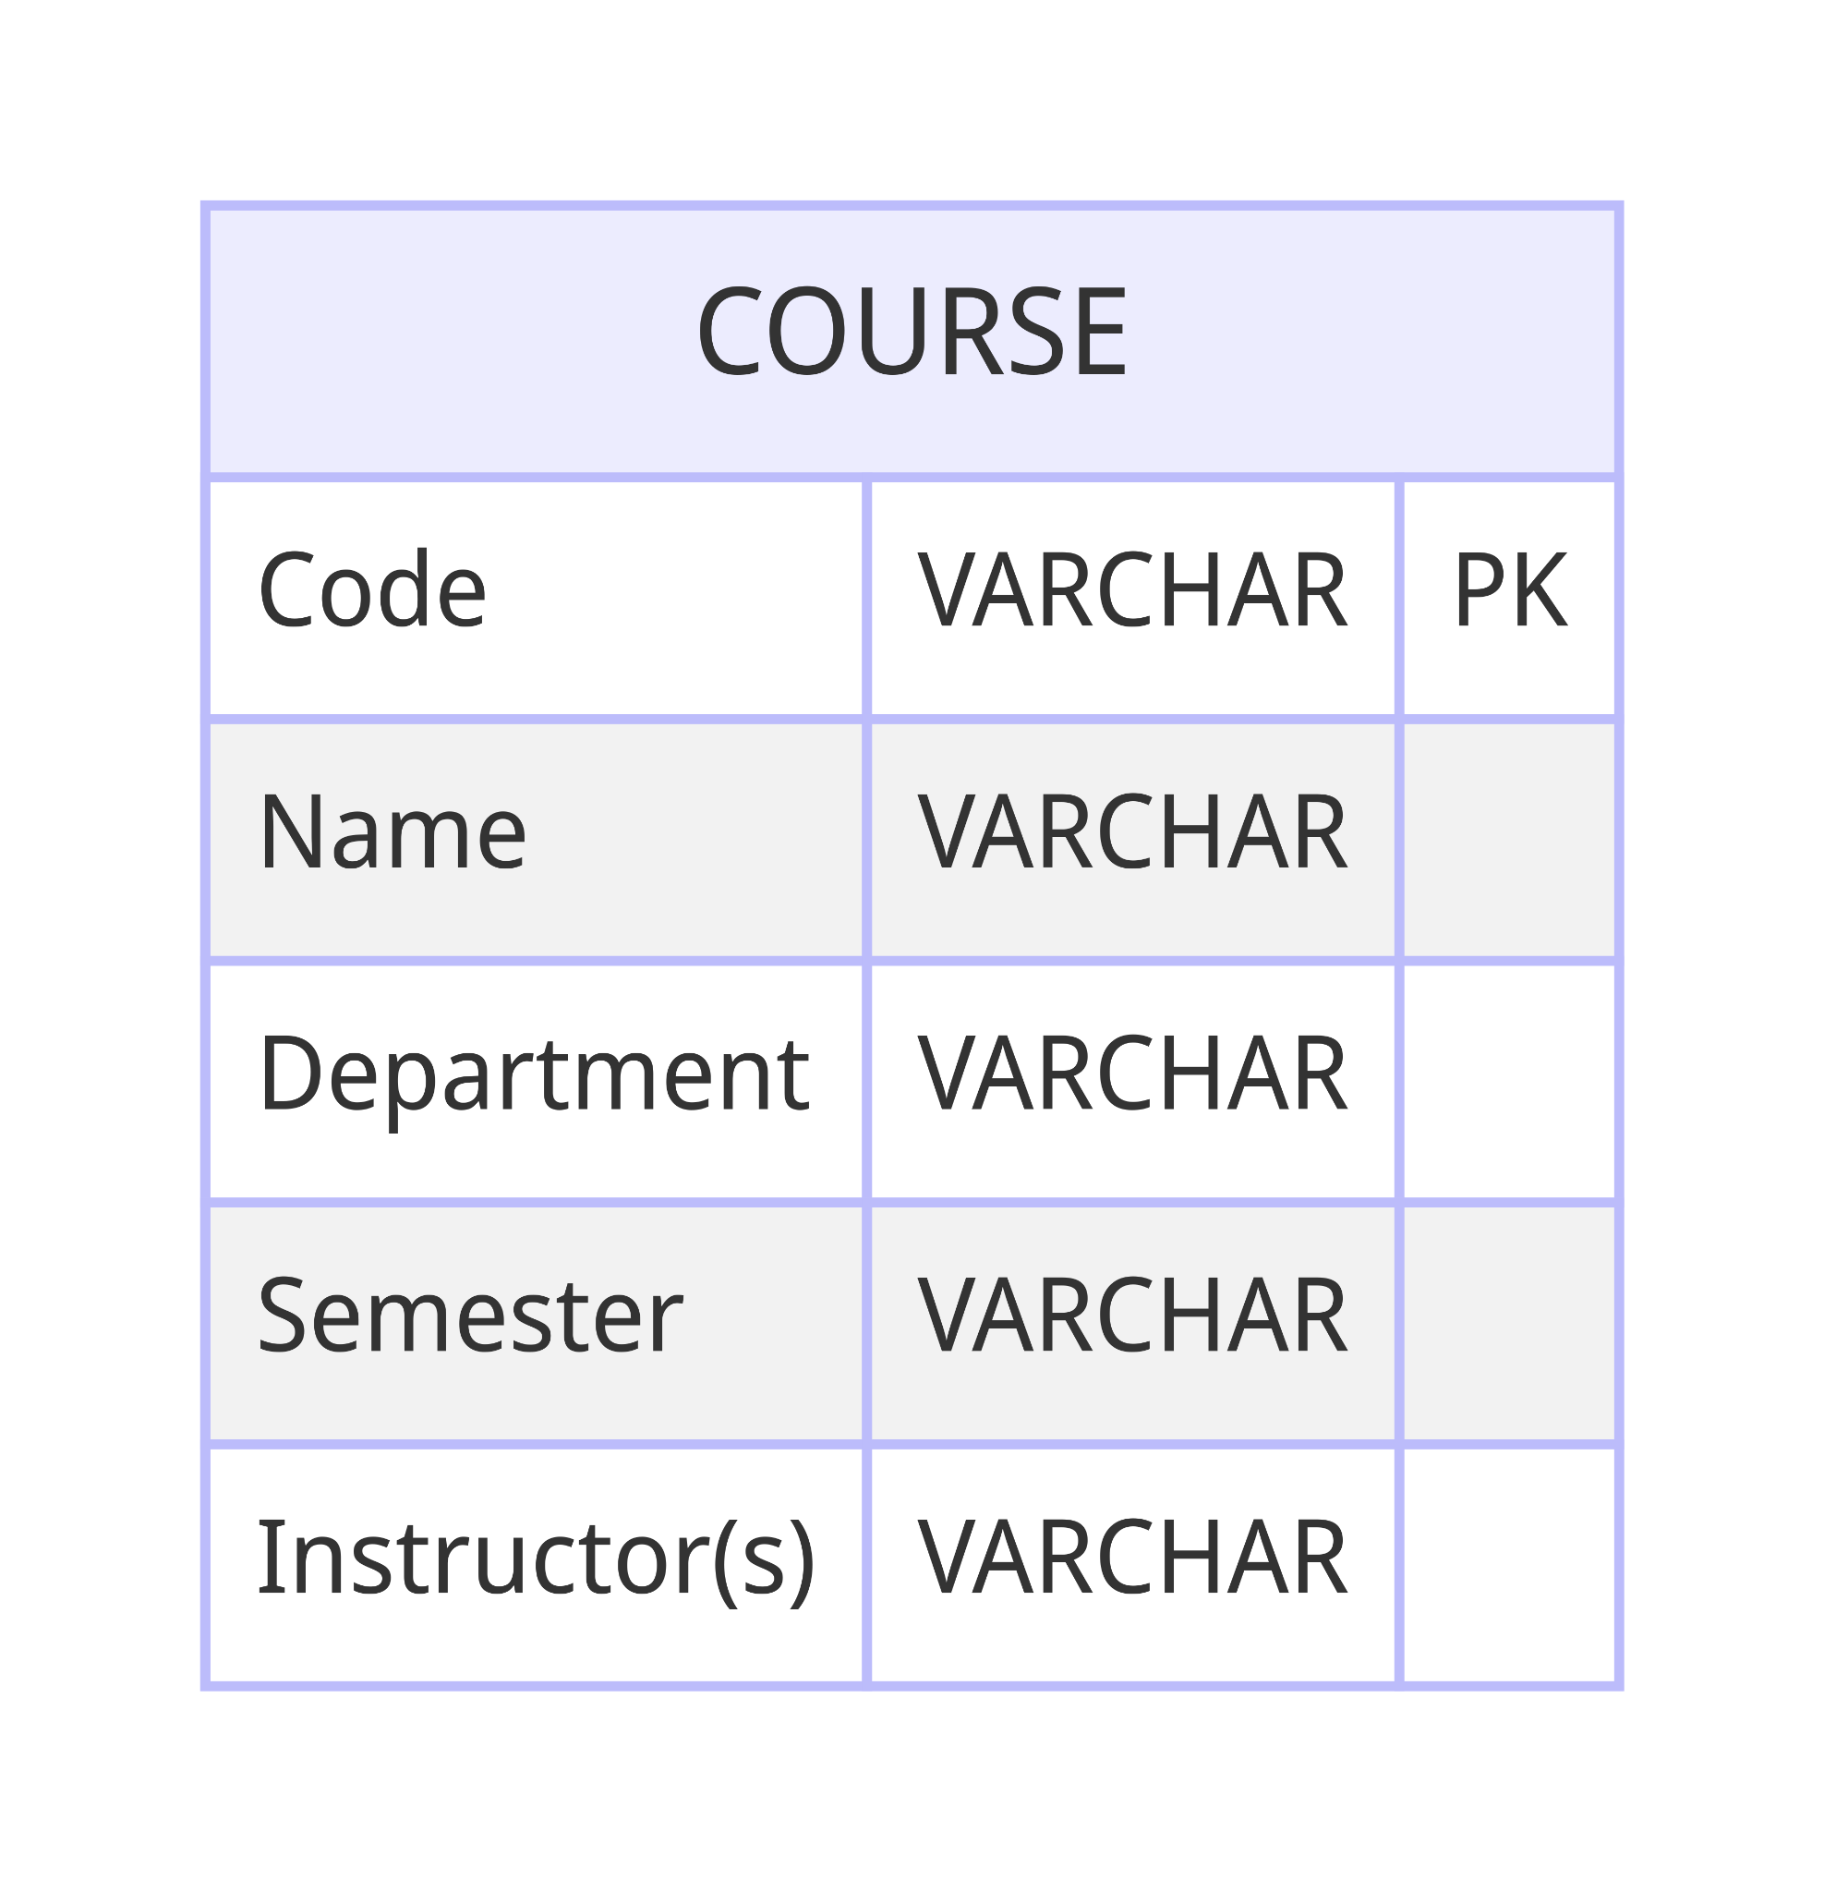

**3. Instructor Model:**

- Contains data related to instructors, including their first and last names, department affiliation, and contact information.

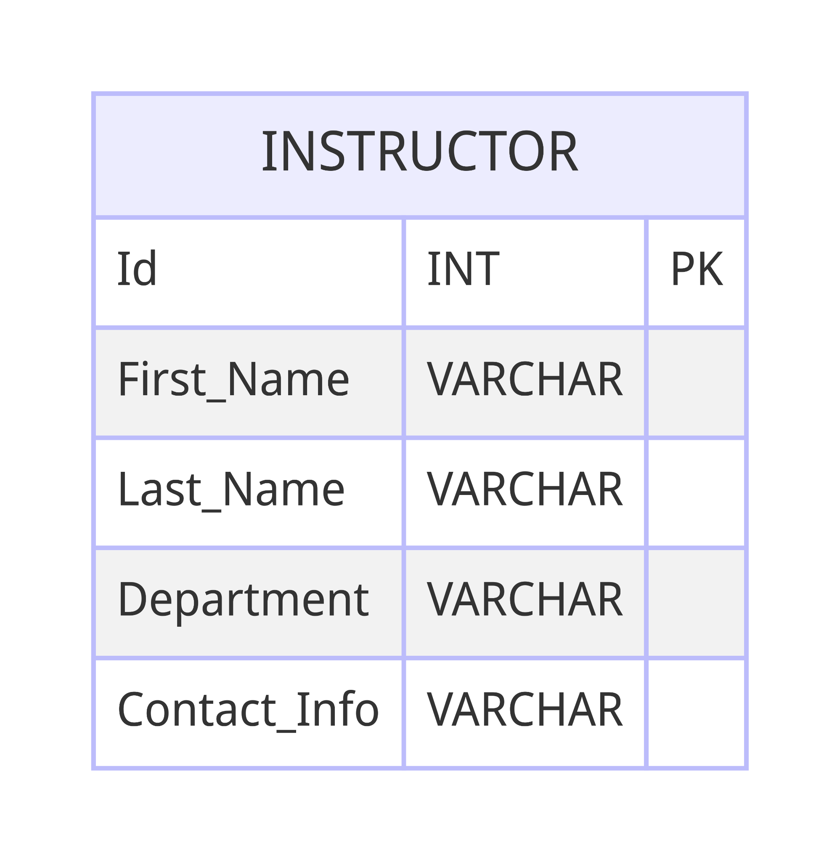

**4. Feedback Model:**

- Holds feedback submissions from students, recording user IDs, course codes, instructor IDs, facility evaluations, feedback text, and submission dates.  
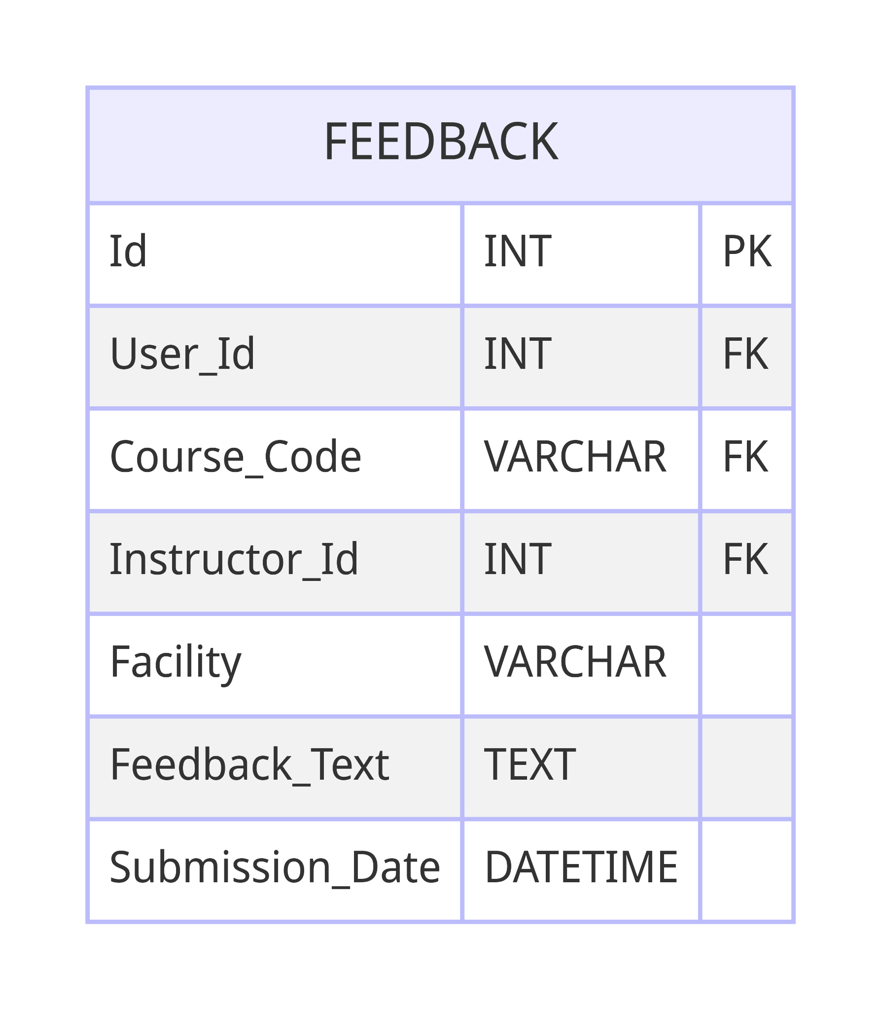

**5. Sentiment Model:**

- Stores sentiment analysis results for feedback entries, including feedback IDs and corresponding sentiment scores (positive, negative, neutral).

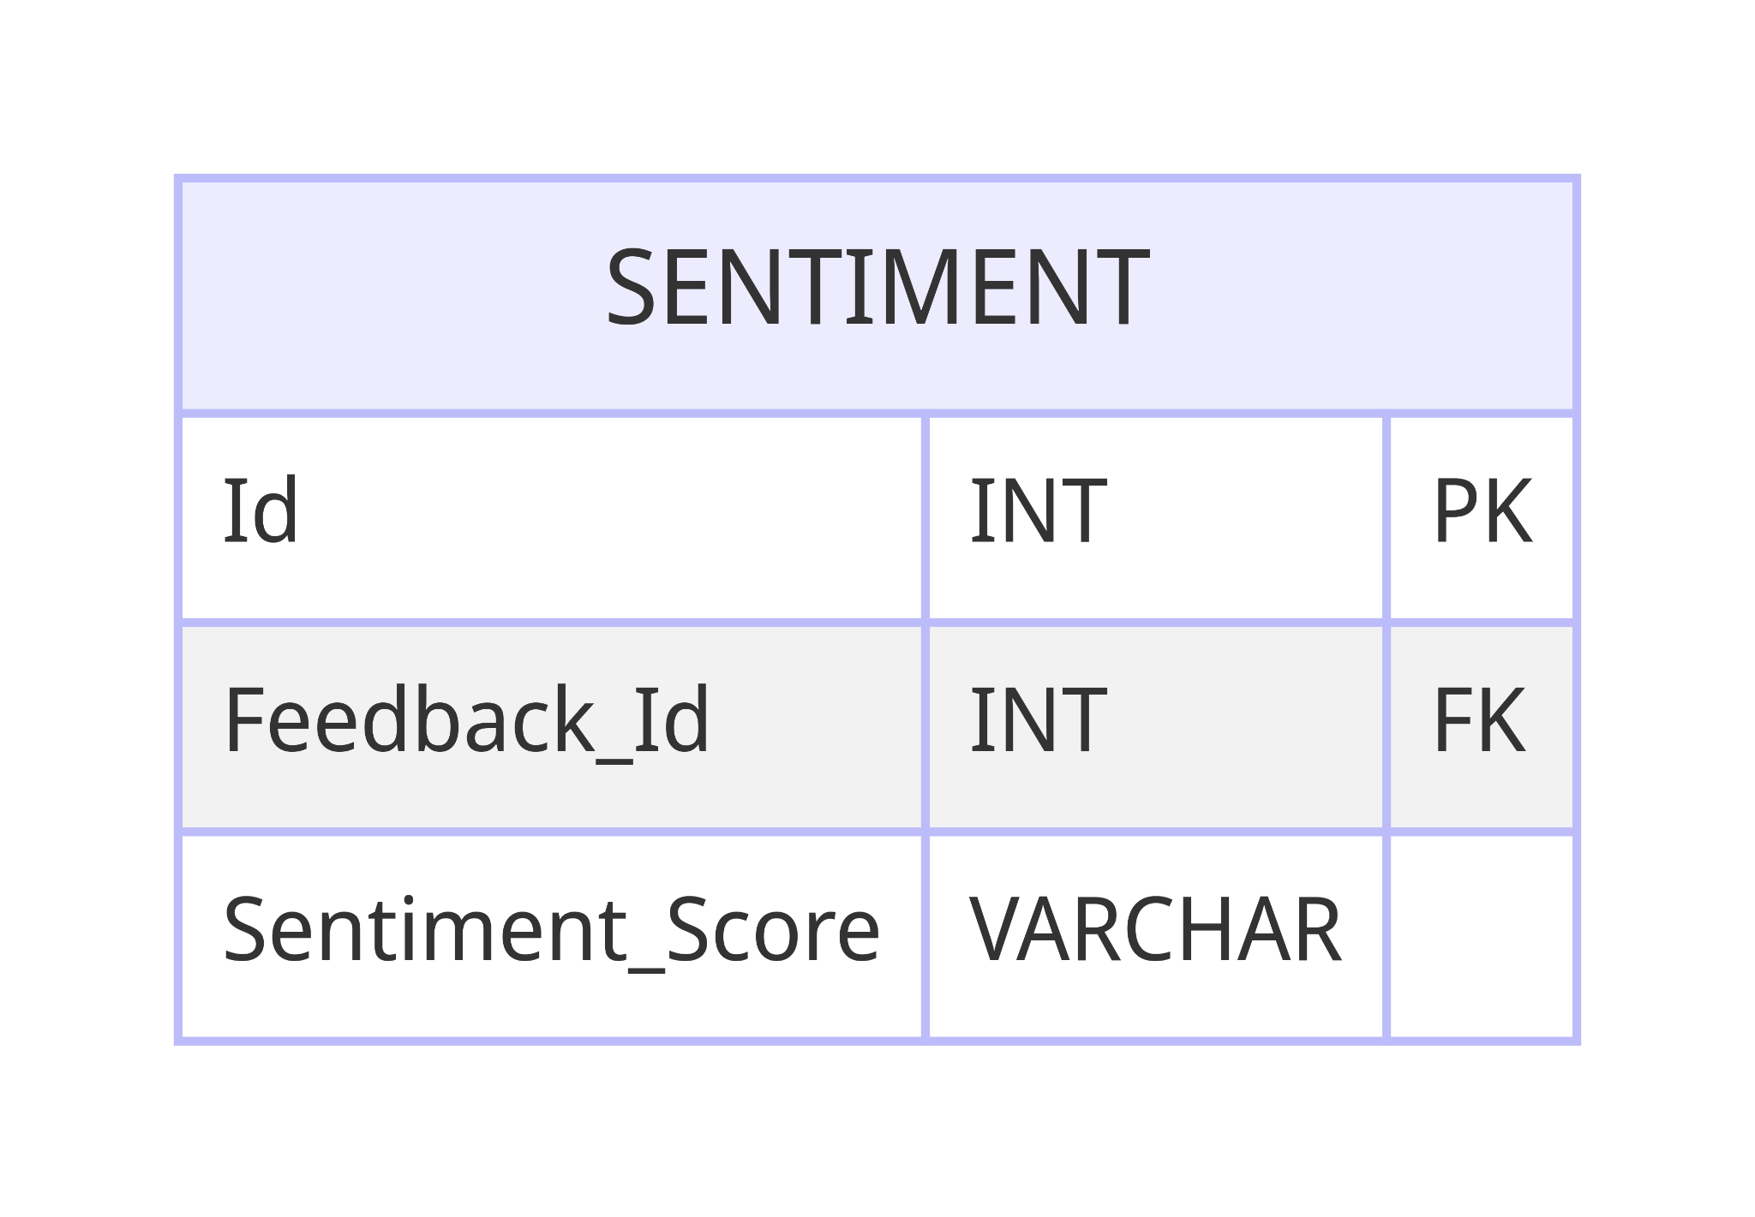

**6. Semester Model:**

- Represents academic semesters, storing semester names, start dates, and end dates for better organization of course offerings.

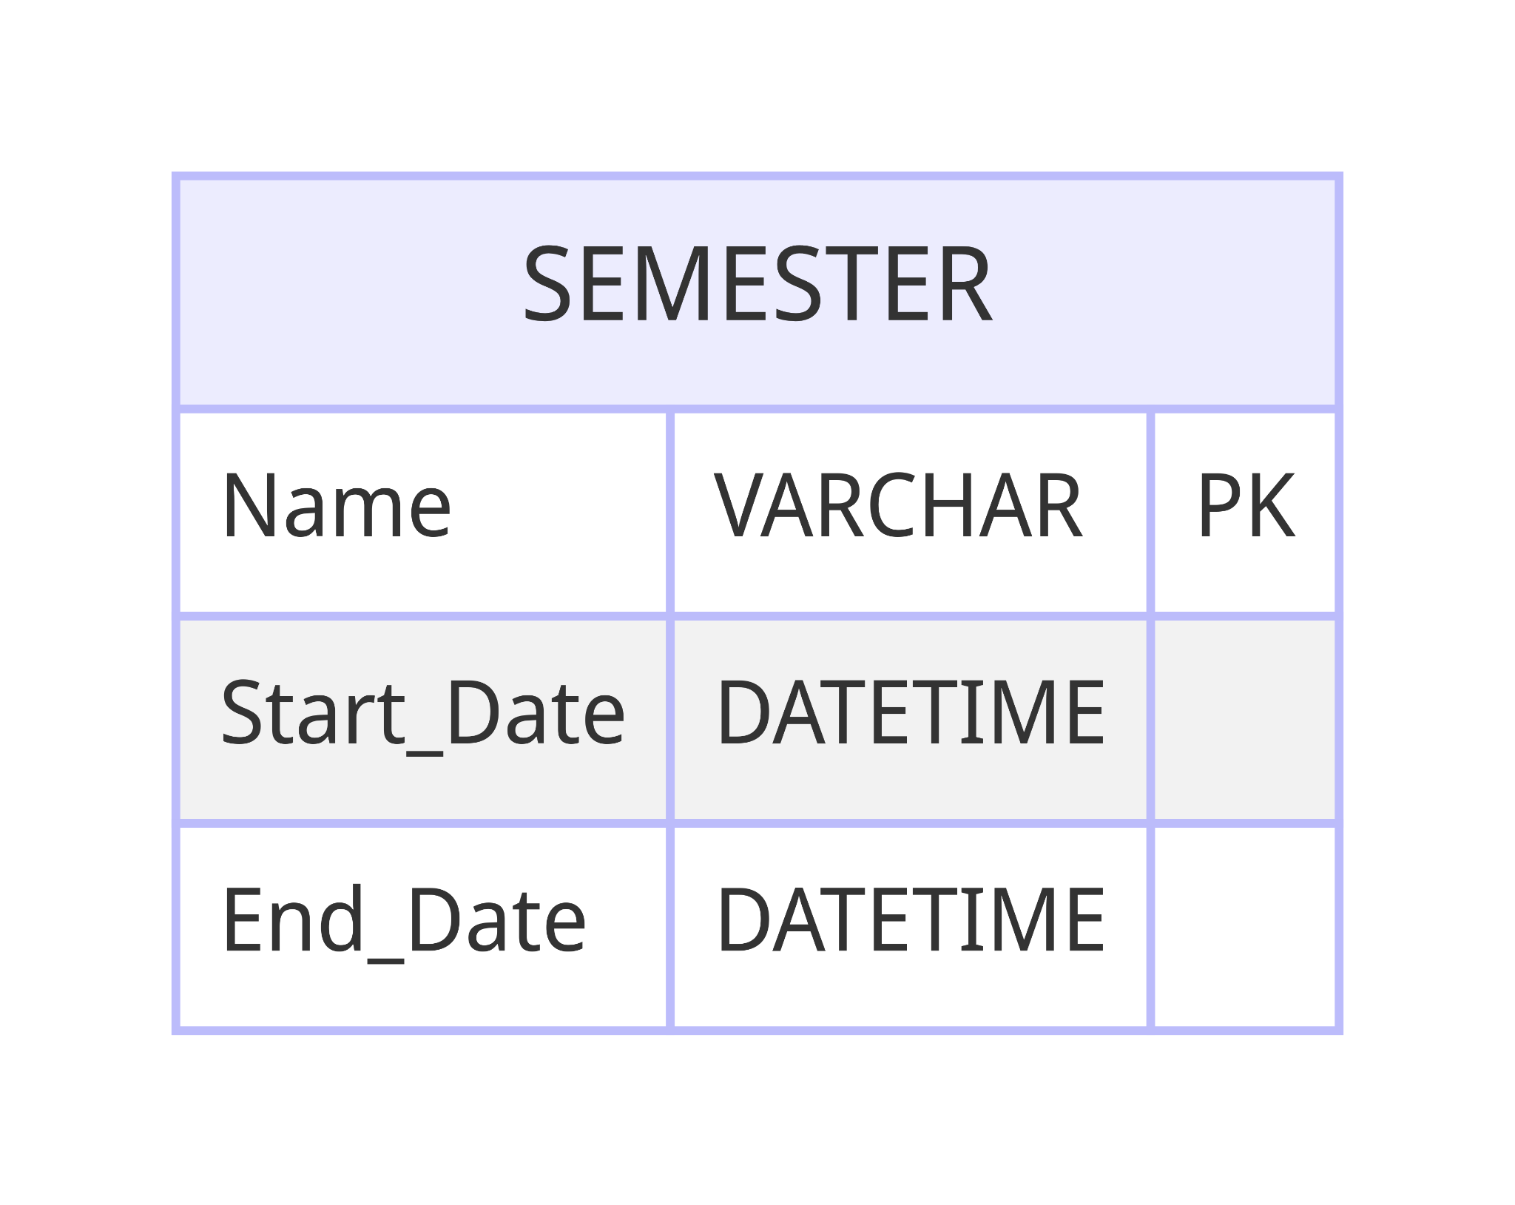

**7. Report Model**

- Captures generated reports, featuring report IDs, titles, descriptions, generation dates, and content (e.g., PDFs or documents).

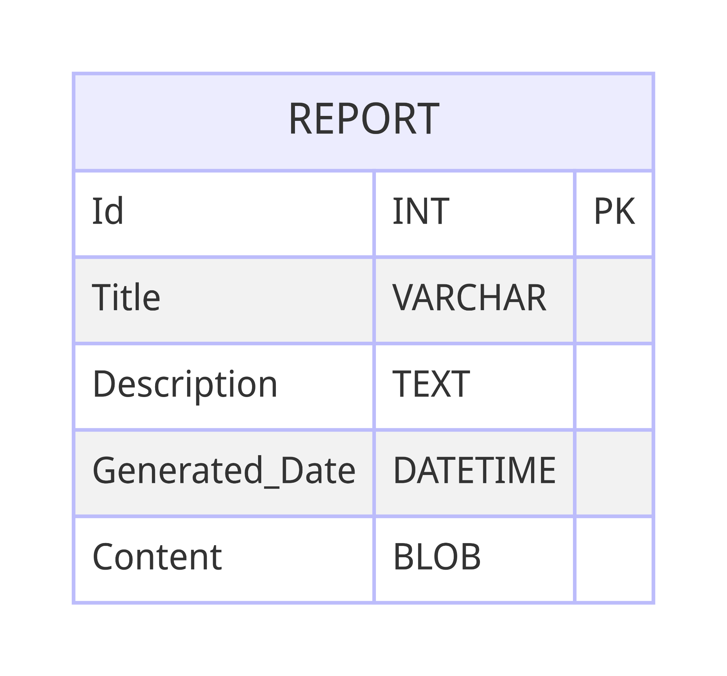

**References:**

1. Smith, J. A., & Johnson, R. L. (2020). Enhancing Educational Quality through Student Feedback Systems. Journal of Higher Education Management, 45(2), 102-115.

2. Garcia, M. R., & Martinez, L. S. (2019). Leveraging Sentiment Analysis for Educational Decision Making: A Case Study. International Journal of Educational Technology in Higher Education, 16(1), 28.

3. Brown, C. G., & Williams, E. F. (2018). Designing User-Friendly Web Applications for Effective Student Feedback Collection. Proceedings of the International Conference on Human-Computer Interaction (HCIC 2018), 124-137.