Supplementary Information
DeSurv identifies a replicable tumor–stroma prognostic architecture in pancreatic cancer through survival-supervised matrix factorization
Amber M. Young, Alisa Yurovsky, Xianlu Laura Peng, Jen Jen Yeh, Didong Li, Naim U. Rashid
\phantomsection
\listoffigures
\phantomsection
\listoftables

Supplementary Methods

Model details
Let $X∈R_{≥0}^{p×n}$ denote the nonnegative gene expression matrix with $p$ genes and $n$ subjects. DeSurv approximates $X≈WH$ with $W∈R_{≥0}^{p×k}$ and $H∈R_{≥0}^{k×n}$, and links the shared program matrix $W$ to survival via an elastic-net–penalized Cox model. Supervision is placed on the program matrix $W$, the basis that transfers to new cohorts, whereas the sample loadings $H$ serve only to reconstruct the training expression matrix; new samples are therefore scored by projection onto the learned programs, $Z=W^{⊤}X$, rather than by re-estimating loadings.
Let $y∈R_{>0}^{n}$ be the observed survival times, $δ∈\{0,1\}^{n}$ the event indicators, and $Z=W^{⊤}X∈R^{k×n}$ the sample-wise factor scores. We write $Z_{i}$ for the $i$th column of $Z$, and $n_{\text{event}}=\sum_{i=1}^{n}{δ_{i}}$. For convenience we recall the DeSurv loss from Equation 1 in the main text and rewrite it as
$$\begin{matrix}L\left(W,H,β\right) & = \\ & \left(1−α\right)\left(\frac{1}{2∥X∥_{F}^{2}}∥X−WH∥_{F}^{2}+\frac{λ_{H}}{2nk}∥H∥_{F}^{2}\right) \\ − & α\left(\frac{2}{n_{event}}ℓ\left(W,β\right)−λ\left\{ξ∥b∥_{1}+{1−ξ}/2∥b∥_{2}^{2}\right\}\right), b=D_{Z} β,\end{matrix}$$
where $∥⋅∥_{F}$ is the Frobenius norm, $β∈R^{k}$ are the Cox coefficients on the raw factor scores, and $D_{Z}=diag​\left(sd\left(Z_{1⋅}\right),…,sd\left(Z_{k⋅}\right)\right)$ is the diagonal matrix of the sample-wise standard deviations of the $k$ rows of $Z=W^{⊤}X$ evaluated at the current $W$. The elastic-net penalty therefore acts on the coefficients of the standardized scores, $b=D_{Z}β$. The inverse map $β=D_{Z}^{−1}b$ is defined only on the retained, nondegenerate score rows, those whose sample standard deviation exceeds the numerical floor stated in Update for $β$ below, and a row falling below that floor is dropped with its coefficient set to zero. This is the objective the implementation evaluates at every acceptance test and records at every outer iteration, with $sd\left(Z\right)$ recomputed from each accepted $W$ (Update for $W$ below), so $D_{Z}$ changes across iterations rather than being fixed once. The reported $λ$ and $ξ$ are the nominal values passed to the optimizer and are to be read together with this standardization convention. The Cox log-partial likelihood $ℓ\left(W,β\right)$ is
ℓW,β=i=1nδiZi⊤β−logj:yj≥yi​expZj⊤β.
The inner sum runs over the risk set $\{j:y_{j}≥y_{i}\}$ of subjects still at risk at the observed time $y_{i}$; tied event times are handled by the Breslow approximation in DeSurv’s own Coxnet-style coordinate-descent routine for the $β$ update (below). Hyperparameters satisfy $α∈[0,1)$, $λ_{H}≥0$, $λ≥0$, and $ξ∈\left[0,1\right]$. The constants $1/\left(2∥X∥_{F}^{2}\right)$, $λ_{H}/\left(2nk\right)$ and $2/n_{\text{event}}$ normalize the component losses, the reconstruction, loadings-penalty and survival terms in that order, before $α$ sets their relative contribution. The elastic-net mixing parameter $ξ$ is the argument nu in the DeSurv package. The implementation also carries an optional ridge penalty on $W$, $λ_{W}∥W∥_{F}^{2}/\left(2pk\right)$, held at $λ_{W}=0$ in every reported fit and pinned to the same value throughout the Bayesian-optimization search; it is omitted from the display above.

Optimization Algorithm

Block coordinate descent scheme
Optimization proceeds by block coordinate descent (BCD; Algorithm [alg:desurv]). Each outer iteration updates $H$, proposes an update to $W$ with the accompanying normalization and coefficient rescaling, and then updates $β$. The outer loop stops when the cosine change of both $W$ and $H$ falls below the tolerance $tol$. For a matrix $A$ we define the cosine change between successive iterates as one minus the cosine similarity of the vectorized iterates, [ 1 - \cos!\big(\mathrm{vec},A^{(t)},, \mathrm{vec},A^{(t+1)}\big) = 1 - \frac{\langle \mathrm{vec},A^{(t)},, \mathrm{vec},A^{(t+1)}\rangle} {\lVert A^{(t)} \rVert_F , \lVert A^{(t+1)} \rVert_F}, ] clipped to $\left[0,2\right]$, so the criterion measures the change in direction of the whole iterate and is invariant to a common rescaling of it. Both quantities must fall below $tol$ in the same iteration. The objective value is recorded once per outer iteration, after the $β$ update, and that recorded series ends with the last outer iteration and does not include the post-loop $β$ refit, whose objective is stored separately.
DeSurv block coordinate descent
Input: $X∈R_{≥0}^{p×n}$, survival times $y∈R_{>0}^{n}$, event indicators $δ∈\{0,1\}^{n}$, tolerance $tol$, maximum iterations $maxit$, supervision parameter $α$, rank $k$, penalties $λ_{H}$, $λ$, and $ξ$
Output: Fitted DeSurv parameters $\left(W,H,β\right)$
Initialize $W^{\left(0\right)},H^{\left(0\right)}$ with positive entries (e.g., $W^{\left(0\right)},H^{\left(0\right)}∼Uniform\left(0,maxX\right)$)
Initialize $β^{\left(0\right)}=0$ (the value used in all reported fits)
$eps_{W}=∞$, $eps_{H}=∞$, $t=0$
while ($eps_{W}>tol$ or $eps_{H}>tol$) and $t<maxit$ do
(H-update)
Update $H^{\left(t+1\right)}$ from $H^{\left(t\right)}$ using the multiplicative rule in Eq. [eqn:Hupdate],
holding $W^{\left(t\right)}$ and $β^{\left(t\right)}$ fixed.
(W-update)
Update $W^{\left(t+1\right)}$ from $W^{\left(t\right)}$ using the hybrid multiplicative rule in Eq. [eqn:W_update],
holding $H^{\left(t+1\right)}$ and $β^{\left(t\right)}$ fixed, and perform backtracking to ensure
$L$ does not increase.
($β$-update)
Update $b^{\left(t+1\right)}$ by cyclic coordinate descent on the centered and
standardized scores (Eq. [eqn:beta_update]), initialized from the
current raw coefficients read through the current $D_{Z}$, holding
$W^{\left(t+1\right)}$ and $H^{\left(t+1\right)}$ fixed, stopping when the largest scaled
coefficient change falls below ${10}^{−6}$ or after 500 passes, and
accepting the proposal only if it does not increase the penalized
survival loss (otherwise a damped step toward it, or the previous
$b$ retained); set $β^{\left(t+1\right)}=D_{Z}^{−1}b^{\left(t+1\right)}$ on the retained rows.
(Convergence)
$eps_{W}=1−cos​\left(vec W^{\left(t\right)},vec W^{\left(t+1\right)}\right)$,
$eps_{H}=1−cos​\left(vec H^{\left(t\right)},vec H^{\left(t+1\right)}\right)$
Record $L\left(W^{\left(t+1\right)},H^{\left(t+1\right)},β^{\left(t+1\right)}\right)$ in the objective series
$t=t+1$
end while
Refit $β$ on the final $W$ by the same routine, giving $β_{refit}$ (this is the only $β$ estimate when $α=0$)
The objective after the refit is stored separately and is not part of the recorded series
$\hat{W}=W^{\left(t\right)},\hat{H}=H^{\left(t\right)},\hat{β}=β_{refit}$

Update for $H$
Conditional on $W$, the loss $L\left(W,H,β\right)$ reduces to a convex quadratic function of $H$. We adopt the standard NMF multiplicative update with $ℓ_{2}$ penalty:
$$H←max​\left(H⊙\frac{W^{⊤}X}{W^{⊤}WH+\frac{∥X∥_{F}^{2}}{nk} λ_{H}H+ε_{H}},ε_{H}\right),$$
where $⊙$ denotes elementwise multiplication, all divisions are elementwise, and $ε_{H}>0$ is a small floor to prevent entries from becoming exactly zero. This update is equivalent to a majorization–minimization step and guarantees a nonincreasing reconstruction term conditional on $W$^{1,2}. The $ε_{H}$-floor ensures that iterates remain in the interior of the nonnegative orthant, which keeps the multiplicative $H$-update numerically well-defined.

Update for $W$
For $W$, we construct a hybrid multiplicative update that balances the contributions of the NMF and Cox gradients. Let [ \nabla_W \mathcal{L}{\mathrm{NMF}}(W,H) = \frac{1}{\lVert X \rVert_F^2}(W H - X)H^\top, ] and let [ G\ell(W,\beta) = \frac{2}{n_{\mathrm{event}}}\nabla_W \ell(W,\beta) ] denote the scaled log-partial-likelihood gradient, where $∇_{W}ℓ\left(W,β\right)$ is the gradient of the Cox log-partial likelihood with respect to $W$. $G_{ℓ}$ is not the gradient of the penalized survival component $L_{Cox}$ of Model details, whose penalty depends on $W$ through $D_{Z}$. A closed-form expression for $∇_{W}ℓ$ is
∇WℓW,β=i=1nδixi−j:yj≥yi​xjexpxj⊤Wβj:yj≥yi​expxj⊤Wββ⊤,
where $x_{i}$ denotes the $i$th column of $X$.
We define a gradient-scaling heuristic
$$ζ^{\left(t\right)}=\frac{{∥\left(1−α\right)∇_{W}L_{NMF}\left(W^{\left(t\right)},H^{\left(t+1\right)}\right)∥}_{F}+ε_{ζ}}{{∥α G_{ℓ}\left(W^{\left(t\right)},β^{\left(t\right)}\right)∥}_{F}+ε_{ζ}},$$
with a numerical stabilizer $ε_{ζ}={10}^{−12}$ in each norm, and clip $ζ^{\left(t\right)}$ to avoid extreme values: $ζ^{\left(t\right)}←min\left(ζ^{\left(t\right)},ζ_{max}\right)$ with $ζ_{max}={10}^{6}$ in all experiments; below we write $ζ$ for $ζ^{\left(t\right)}$ where the iteration index is not needed. The proposal rescales the weighted reconstruction and survival gradients using this norm-based factor, subject to its numerical stabilizer $ε_{ζ}$ and the cap $ζ_{max}$, before the additional factor $α$ below controls the relative Cox contribution. Because the Cox gradient entering $ζ$ is already weighted by $α$, the additional explicit factor of $α$ in the $W$ update below makes the scaled Cox contribution approximately $α$ times the weighted reconstruction-gradient norm when the cap is inactive, up to the numerical stabilizer; the two factors of $α$ in that update are therefore not a duplication.
In the reported consensus fit, $ζ$ decreased from $0.71$ after the first iteration to $0.059$ at convergence, and the scaled Cox contribution was then 1.6% of the reconstruction term in the numerator. The cap was reached only at initialization, where $β=0$ makes the Cox gradient itself zero, so the cap contributed no update; across the 100 single-run endpoints $ζ$ ranged from $0.003$ to $0.031$ and was never capped (the $ζ$-trace script, Table [tab:scripts], reconstructs the production optimization path from the cached seed fits and checks it against the cached final fit to a declared tolerance).
The multiplicative factor for $W$ is then
$$R^{\left(t\right)}=\frac{\frac{\left(1−α\right)}{∥X∥_{F}^{2}}XH^{\left(t+1\right)⊤}+α ζ^{\left(t\right)} \frac{2α}{n_{event}} ∇_{W}ℓ\left(W^{\left(t\right)},β^{\left(t\right)}\right)}{\frac{\left(1−α\right)}{∥X∥_{F}^{2}}W^{\left(t\right)}H^{\left(t+1\right)}H^{\left(t+1\right)⊤}+ε_{W}},$$
$R^{\left(t\right)}$ is clamped elementwise to $\left[0.2,5\right]$ before use, which bounds the change of any entry of $W$ in a single step, and the proposed update is
$$W^{\left(t+1\right)}=max​\left(W^{\left(t\right)}⊙R^{\left(t\right)},ε_{W}\right),$$
with a small floor $ε_{W}>0$. When $α=0$, this reduces to the standard multiplicative update for NMF¹; for $α>0$, the Cox gradient perturbs the update in a direction that decreases the supervised loss.
The proposal uses the reconstruction and Cox log-partial-likelihood derivatives only. It does not differentiate the $W$-dependent penalty on the standardized-score coefficients $b=D_{Z}β$, so it is not the gradient of the full objective $L$, and candidate acceptance is instead evaluated using the full objective.
Because the combined multiplicative step does not, by itself, guarantee a nonincrease in the full loss $L$, we embed it in a backtracking line search.
$W$ update with backtracking
Input: $W$ at the previous iteration $t$, $W^{\left(t\right)}$; the multiplicative update term at the current iteration $R^{\left(t\right)}$, the max number of backtracking updates $max_bt$, the initial step $s_{0}∈(0,1]$, the backtracking factor $γ∈\left(0,1\right)$
Output: $W^{\left(t+1\right)}$
$s=s_{0}$
b = 1
$flag_accept=FALSE$
while $b≤max_bt$ do
$W_{cand}^{\left(t+1\right)}=max​\left(W^{\left(t\right)}⊙\left[\left(1−s\right)+sR^{\left(t\right)}\right], ε_{W}\right)$
(Column normalization)
Compute $D=diag​\left(∥W_{\left(:,1\right)cand}^{\left(t+1\right)}∥_{2},…,∥W_{\left(:,k\right)cand}^{\left(t+1\right)}∥_{2}\right)$
and set $W_{cand}^{\left(t+1\right)}←W_{cand}^{\left(t+1\right)}D^{−1}$, $H_{cand}^{\left(t+1\right)}←DH^{\left(t+1\right)}$, and $β_{cand}^{\left(t\right)}←Dβ^{\left(t\right)}$
if $L\left(W_{cand}^{\left(t+1\right)},H_{cand}^{\left(t+1\right)},β_{cand}^{\left(t\right)}\right)≤L\left(W^{\left(t\right)},H^{\left(t+1\right)},β^{\left(t\right)}\right)$ then
$W^{\left(t+1\right)}=W_{cand}^{\left(t+1\right)}$
$H^{\left(t+1\right)}=H_{cand}^{\left(t+1\right)}$
$β^{\left(t\right)}=β_{cand}^{\left(t\right)}$
$flag_accept=TRUE$
break
end if
$s=sγ$
$b=b+1$
end while
if $flag_accept=FALSE$ then
$W^{\left(t+1\right)}=W^{\left(t\right)}$
end if
In all reported fits $s_{0}=0.5$, $γ=0.5$ and $max_bt=10$ (the values passed by the package’s R wrapper to the optimizer). The column normalization inside the line search is described in Normalization of $W$ below; it is applied to each candidate before the objective is compared, so the accepted update is the normalized one. The score standard deviations $D_{Z}$ that enter the penalty (Model details) are recomputed from each candidate, as $sd\left(Z_{j⋅}\right)$ with $Z=W_{cand}^{⊤}X$, and are carried forward only when that candidate is accepted; a rejected candidate leaves $W$, $H$, $β$ and $D_{Z}$ at their previous values.

Update for $β$
Conditional on $\left(W,H\right)$, the loss in $β$ reduces to a convex elastic-net–penalized Cox problem in the standardized-score coefficients $b=D_{Z}β$; the common factor $α>0$ multiplies both the log-partial-likelihood and the penalty in the joint loss (main-text Equation 1) and is dropped here, as it does not affect the minimizer, [ \min_{b \in \mathbb{R}^k} \left{ -\frac{2}{n_{\mathrm{event}}},\ell(W, D_Z^{-1} b) + \lambda\left( \xi \lVert b \rVert_1 +\frac{1-\xi}{2} \lVert b \rVert_2^2 \right) \right}, ] with $D_{Z}$ held at the value implied by the current $W$. The coefficients reported throughout the manuscript are the raw-score coefficients $β=D_{Z}^{−1}b$ on the retained rows. We update $b$ by cyclic coordinate descent following³. Let ${\tilde{z}}_{i}=D_{Z}^{−1}\left(Z_{i}−\overset{‾}{Z}\right)$ denote the centered and standardized score vector of sample $i$, with $Z_{i}$ the $i$th column of the raw scores $Z$ and $\overset{‾}{Z}$ the vector of row means, and write ${\tilde{η}}_{i}={\tilde{z}}_{i}^{⊤}b$, which equals $Z_{i}^{⊤}β$ up to an additive constant common to all samples. The update for coordinate $r$ has the closed form
br=S​1neventi=1nwηizi,rvηi−j≠r​zi,jbj,λξ1neventi=1nwηizi,r2+λ1−ξ,
where $S\left(a,τ\right)=sign\left(a\right)max\left(\left|a\right|−τ,0\right)$ is the soft-thresholding operator, $w{\left(\tilde{η}\right)}_{i}$ and $v{\left(\tilde{η}\right)}_{i}$ are the standard local quadratic-approximation weight and working response for sample $i$ in the Cox log-partial likelihood³, and $z_{i,r}$ denotes the standardized score of factor $r$ in sample $i$, the $r$th entry of ${\tilde{z}}_{i}$. After the sweeps, the raw-score coefficients are recovered as $β=D_{Z}^{−1}b$ on the retained rows.
The sweeps operate on centered and standardized scores, the parameterization in which $L$ is defined. The $k$ rows of $Z$ are centered and scaled to unit standard deviation across samples, rows whose standard deviation falls below ${10}^{−12}$ are dropped and assigned coefficient zero, the sweeps estimate $b$, and the estimates are divided back by the same standard deviations to give the reported $β=D_{Z}^{−1}b$ on the retained rows. Each update is initialized from the current raw coefficients, taken after the $W$-normalization step and read through the current $D_{Z}$. Centering the scores changes the linear predictor by a common additive constant, which cancels from the Cox partial likelihood. Given that parameterization, the implemented update departs from an exact conditional minimization of $L$ in two ways, which we state explicitly because Equation 1 of the main text, reproduced as $L$ above, is the objective the algorithm evaluates and records. First, the quadratic approximation entering Eq. [eqn:beta_update] carries likelihood weight $1/n_{event}$, whereas the log-partial likelihood in the objective carries weight $2/n_{event}$; relative to that likelihood weight the penalty seen by the coordinate sweeps is therefore effectively $2λ$, so the sweeps target a more strongly penalized subproblem than the conditional restriction of $L$. Second, the sweeps are iterated until the largest scaled coefficient change falls below ${10}^{−6}$ or 500 passes have been taken, and the resulting proposal is accepted only if it does not increase the penalized survival loss; otherwise a damped step toward it is taken (backtracking factor $0.9$, at most 30 steps), or the previous $β$ is retained. That acceptance safeguard makes the $β$ update non-increasing in the evaluated objective, and it does not establish convergence to a conditional or joint optimum. The $β$ block is therefore an approximate, monotone conditional update rather than an exact conditional minimizer of $L$. The acceptance safeguards prevent accepted $W$ and $β$ updates from increasing the evaluated objective; they do not establish convergence to an optimum. The reported fits are exactly those produced by this procedure. After the outer loop terminates, $β$ is refit once on the final $W$ by the same routine under the same tolerance and pass limit (Algorithm [alg:desurv]); this refit is the reported $\hat{β}$, and it is the only $β$ estimate when $α=0$. The objective after that refit is stored separately and is not part of the recorded outer-loop series.

Normalization of W
Within each candidate $W$ update, we normalize the columns of $W$ as $W←WD^{−1}$, and adjust $H$ and $β$ as [ H \leftarrow D H, \qquad \beta \leftarrow D \beta, ] where $D$ is the diagonal matrix containing the column Euclidean norms of the candidate $W$. Because $D$ has positive diagonal entries, these compensating rescalings preserve the reconstruction $WH$, the collapsed gene-weight vector $Wβ$ and hence the linear predictor $X^{⊤}Wβ$, and also the standardized-score coefficients $b=D_{Z}β$, because $D_{Z}$ is rescaled by $D^{−1}$ exactly as $β$ is rescaled by $D$. With $λ_{H}=λ_{W}=0$, as in every reported fit, normalization alone therefore leaves the displayed objective unchanged. Each normalized candidate is nonetheless evaluated under the full objective within the backtracking procedure for the $W$ update rather than assumed loss-invariant. Normalization prevents degeneracy in the scale-nonidentifiable factorization and keeps columns of $W$ comparable in magnitude and interpretable as gene programs.

Supervision on (W) versus (H)
Classical nonnegative matrix factorization (NMF) is non-identifiable: for any invertible matrix (R) with (W R \ge 0) and (R^{-1} H \ge 0), the factorization ((W, H)) can be transformed to ((W R, R^{-1} H)) without changing the reconstruction error, yielding multiple valid solutions^{4–6}. Although normalizing columns of (W) or rows of (H) resolves the trivial scaling ambiguity, nonnegative mixing transformations persist, so factorizations started from different initializations need not agree^{7–9}. This applies to DeSurv as well: individual restarts of the reported model are dispersed, and the final fit is obtained by a consensus procedure over many restarts (Stability of the recovered gene programs).
In DeSurv, survival supervision enters through the projection $Z=W^{⊤}X$ in the partial log-likelihood, so that both component losses have a gradient with respect to the programs. The update for $W$ combines the weighted reconstruction gradient with the scaled log-partial-likelihood gradient $G_{ℓ}$ through the rescaled multiplicative construction of Equations [eq:supp-zeta] to [eqn:W_update], so the gene-program definitions are shaped directly by their association with survival. That construction is a proposal direction and not the gradient of the full objective, which depends on $W$ additionally through the penalty on $b=D_{Z}β$ (Update for $W$).
Related supervised-NMF methods instead place the survival term on the sample side. CoxNMF maximizes a Cox partial likelihood whose covariates are the columns of (H)¹⁰, and SurvNMF jointly learns the factorization and a Cox model on the sample-side latent matrix, which its own transposed notation writes as (W)¹¹. Because the risk score under either formulation is a function of the sample loadings rather than of the gene-program basis, a new sample needs loadings of its own. SurvNMF documents such a step, obtaining them for held-out samples by a constrained least-squares fit; that step holds the gene basis fixed and needs neither relearning of the basis nor validation survival outcomes, so it is an additional fitting step at transfer rather than a leak. CoxNMF’s published description does not specify a new-sample scoring procedure.
With supervision applied to the sample loadings (H), the Cox term has no direct gradient with respect to the gene-program matrix (W); survival can nevertheless influence (W) indirectly through the alternating reconstruction updates involving (H). The distinction concerns where supervision enters the objective, not a guarantee that sample-side supervision leaves the basis unchanged; related considerations arise in supervised topic models¹².
Supervising (W) also provides a practical advantage for portability: because (W) defines gene-level programs, new samples can be scored directly by the projection (Z_{\text{new}} = W^\top X_{\text{new}}). Supervising (H) would not yield such a mapping: obtaining sample loadings for external datasets would require an additional sample-specific estimation step, a nonnegative least-squares (NNLS) problem for each new sample. SurvNMF uses constrained least squares for held-out samples; CoxNMF does not describe new-sample scoring in the cited source (Supplementary Table [tab:architecture]). Estimating loadings with a fixed basis does not require relearning the gene programs or using validation survival outcomes.
Supervising through (W) is therefore intended to shape the gene programs toward prognostic directions and to yield signatures that can be scored unchanged in new cohorts; whether they do so is an empirical question addressed in Part II.
Supplementary Table [tab:architecture] places DeSurv beside the unsupervised factorization it extends, the two published survival-supervised factorizations, and the two conventional supervised predictors used as comparators, by where survival enters each method, what object is learned, and what must happen when a new sample arrives. It records architecture only; it does not rank the methods.
p{2.2cm}>{}p{4.1cm}>{}p{4.1cm}>{}p{4.1cm}>{}p{4.1cm}>{}p{4.1cm}}
Method | Learned representation | Where survival enters | Gene-program basis directly supervised? | New-sample scoring | External latent-variable re-estimation?
Standard NMF | Gene programs $W$ and sample loadings $H$ | Not in the factorization; Cox fitted afterwards on projected scores (Methods) | No | In this study, projection onto the fixed $W$, as for DeSurv (Methods) | No (projection)
DeSurv (this work) | Gene programs $W$, sample loadings $H$ and Cox coefficients $β$ on $Z=W^{⊤}X$ | Cox partial likelihood on $Z=W^{⊤}X$; its gradient acts on $W$ (Methods) | Yes | Projection $Z={\tilde{W}}^{⊤}X_{\text{new}}$ with $\tilde{W}$ frozen (Methods) | No
CoxNMF | Basis $W$ (genes) and coefficients $H$ (samples), with Cox coefficients $β$ on $H$ | Cox partial likelihood whose covariates are the columns of $H$ (published objective) | No: the Cox term does not depend on $W$ (published objective) | Not described in the source | Not described in the source
SurvNMF | Sample-side latent matrix and feature matrix (the former is denoted $W$ in SurvNMF’s transposed notation; full text) | Cox model fitted jointly on the sample-side latent matrix (full text) | No: the Cox term is on the sample side (full text) | Held-out loadings re-solved by constrained least squares (HALS) with the feature matrix fixed (full text) | Yes, for held-out samples; reported for simulated data only (full text)
Supervised principal components | Principal components of genes passing a univariate Cox score threshold | Gene screening by Cox score before the components are formed (Methods) | No: components are unsupervised on the screened genes | Fixed linear map over the screened genes (Methods) | No
Penalized Cox regression | One coefficient vector over genes (a single linear predictor) | Directly: the objective is the penalized Cox likelihood (Methods) | No gene programs are learned | Fixed linear predictor (Methods) | No
Where survival supervision enters, and what a new sample requires, for DeSurv and five comparators. Cells for DeSurv, standard NMF, supervised principal components and penalized Cox regression are taken from the Methods of this manuscript; CoxNMF cells from its published objective function and SurvNMF cells from its full text; both works are cited in the text of this section. ``Not described in the source’’ means the cited work does not state the behavior; no other cell is inferred. The table records architecture and does not rank the methods. Note: CoxNMF does not describe a procedure for scoring new samples. The implication that sample-side loadings would need to be obtained for new samples follows from its published objective and is an inference, not a reported implementation.

Cross-validation procedure
Algorithm [alg:cv] describes the cross validation procedure with $F$ folds and $R$ initializations. We define the C-index using comparable pairs $P=\{\left(i,j\right):y_{i}<y_{j}, δ_{i}=1\}$ and linear predictors ${\hat{η}}_{i}$:
c=1Pi,j∈P​1ηi>ηj+121ηi=ηj.
Cross-validation for DeSurv pipeline
Input:
Number of folds $F$
Number of initializations $R$
Observed data ($X$, $y$, $δ$)
Hyperparameters $k$, $α$, $λ$, $ξ$, $λ_{H}$, and number of top genes per factor $n_{top}$
Output: The cross-validated C-index
Divide subjects into $F$ folds.
for $f=1$ to $F$ do
Split data into training and validation $\left(X_{\left(−f\right)},y_{\left(−f\right)},δ_{\left(−f\right)}\right)$, and $\left(X_{\left(f\right)},y_{\left(f\right)},δ_{\left(f\right)}\right)$ sets
for $r=1$ to $R$ do
set.seed$\left(r\right)$
Apply Algorithm [alg:desurv] with inputs $\left(X_{\left(−f\right)},y_{\left(−f\right)},δ_{\left(−f\right)}\right)$, and $\left(k,α,λ,ξ,λ_{H}\right)$
Obtain $\hat{W}$ and $\hat{β}$ as output from Algorithm [alg:desurv]
Restrict $\hat{W}$ to the top $n_{top}$ genes per factor (by factor-specificity score) and compute the estimated linear predictor on this support:
$
{} = X_{(f)}^T{W}{}
$
Compute C-index, denoted ${\hat{c}}_{\left(f\right)r}$, according to Equation [eqn:cindex]
end for
end loop over $r$
Compute average C-index across initializations:
$
{c}{(f)} = {1}{R}{r=1}^{R{c}{(f)r}}
$
^{end for}
^{end loop over} $f$
Compute final cross-validated C-index:
$
^{{c} = {1}{F}{f=1}}F {c}_{(f)}
$
Final estimate $\hat{c}$

Bayesian Optimization
We treat hyperparameter tuning as a black-box optimization problem over a bounded domain. Let $ψ$ collect the tuned parameters (at minimum $ψ=\left(k,α,λ,ξ\right)$, and optionally discrete choices such as the signature size $n_{\text{top}}$). For a given $ψ$ we run the cross-validation procedure in Algorithm [alg:cv], averaging the C-index across folds and random initializations to form the objective [ \hat{c}(\psi) = \frac{1}{F} \sum_{f=1}^F \hat{c}_{(f)}(\psi). ] Because $\hat{c}\left(ψ\right)$ is expensive to evaluate and non-differentiable with respect to $ψ$, we use Bayesian optimization (BO) to adaptively select candidate configurations.
We place a Gaussian-process (GP) prior on the response surface $f\left(ψ\right)∼GP\left(0,k\left(ψ,ψ′\right)\right)$ with a Matérn kernel and automatic relevance determination length-scales. Continuous parameters are rescaled to $\left[0,1\right]$ and penalties are optimized on a log scale; integer-valued coordinates (e.g., $k$ or $n_{\text{top}}$) are proposed in the continuous space and rounded inside the evaluator. Following an initial batch of evaluations, the GP is refit each time a new observation is added and used to guide acquisition.
At iteration $t$, let $μ_{t}\left(ψ\right)$ and $σ_{t}\left(ψ\right)$ denote the GP posterior mean and standard deviation, and let $f_{⋆}$ be the best observed score. We select new candidates by maximizing expected improvement (EI), [ \operatorname{EI}(\psi) = \left(\mu_t(\psi) - f_\star - \kappa\right)\Phi(Z(\psi)) + \sigma_t(\psi)\phi(Z(\psi)), \quad Z(\psi) = \frac{\mu_t(\psi) - f_\star - \kappa}{\sigma_t(\psi)}, ] where $Φ$ and $ϕ$ are the standard normal cdf/pdf and $κ≥0$ controls the exploration margin. EI is evaluated over a candidate pool sampled from the bounded search region, and the maximizer is evaluated next. The loop continues until the iteration budget is exhausted or the improvement plateaus.
For the PDAC application, the objective was the mean 5-fold cross-validated Harrell C-index (Algorithm [alg:cv]), with five-fold cross-validation constructed separately within cohort and stratified by event status under a fixed seed (123); each configuration was evaluated from 30 random initializations, as in the definition above. Cross-validation fits used a stopping tolerance of ${10}^{−5}$ on the cosine change of $W$ and of $H$, looser than the ${10}^{−7}$ used for the restart and final fits, under the same cap of 4,000 outer iterations. The bounded search domain was $k∈\left[2,12\right]$, $α∈\left[0,1\right]$ (the proposal bounds; the model domain is $α∈[0,1)$, package validation clips proposals at $α≥1$, and the largest evaluated value was $0.986$), $λ∈\left[{10}^{−3},{10}^{3}\right]$ (optimized on a $\log_{10}$ scale), $ξ∈\left[0,1\right]$, and $n_{\text{top}}∈\left[50,300\right]$, with the loadings ridge penalty fixed at $λ_{H}=0$. Bayesian optimization used an initial design of 50 evaluations followed by 100 GP-guided iterations (150 total evaluations), maximizing expected improvement over a candidate pool of $4,000$ points sampled from the bounded domain at each step with an exploration margin $κ=0.01$. The unsupervised comparator fixed $α=0$ and tuned the remaining coordinates identically.
For model selection, we take the highest observed $\hat{c}\left(ψ\right)$ as the best observed configuration; because the search is a finite, stochastic exploration of a black-box surface, this is not a claim of a global optimum. When fold-level standard errors are available, we apply a one-standard-error rule for $k$: for each rank we retain the configuration with the highest observed mean cross-validated C-index, set the threshold one fold-level standard error below the best observed configuration’s mean, and select the smallest rank whose retained configuration meets it.
Two details of this rule matter for reading the reported numbers. First, the comparison is between the best configuration observed at each rank: the highest mean cross-validated C-index anywhere in the search was $0.655$ at $k=7$ (fold-level standard error $0.011$), and the best configuration observed at $k=3$ reached $0.646$, above the threshold of $0.644$. Second, the final model is a hybrid of the two: the rule fixed $k=3$, while the remaining hyperparameters ($α=0.334$, $λ=0.349$, $ξ=0.056$, $n_{\text{top}}=270$) were retained from the overall best configuration at $k=7$. The final configuration was therefore not itself a point evaluated in the search, and neither number above is its cross-validated performance. We therefore ran a sensitivity check on rank selection using the same training data and the selected non-rank hyperparameters, the fixed-hyperparameter grid of Cross-validated C-index across factorization rank. That grid is an exhaustive rank-by-supervision search over $k∈\{2,3,…,12\}$ and $α∈\{0,0.05,…,0.95\}$ holding $λ$, $ξ$ and $n_{\text{top}}$ at the selected model’s values, and the statements here are restricted throughout to $n_{\text{top}}=270$. Applying the same one-standard-error rule to it also selects $k=3$, its best configuration being at $k=9$ with mean C-index $0.671$ and standard error $0.009$, and $k=3$ the smallest rank whose best configuration reaches the resulting threshold $0.662$. That corroborates the selected rank without evaluating the final configuration itself, whose nearest evaluated neighbor is the slice of the same grid at the selected rank. At $k=3$ and $α=0.35$ the five-fold cross-validated C-index was $0.656$ (standard error $0.010$), which clears the Bayesian-optimization threshold of $0.644$ but not this grid’s own one-standard-error threshold of $0.662$, and which is a nearby supervision level rather than the selected configuration. The final DeSurv model is refit at the selected parameters using the consensus-based initialization (Consensus initialization for the final model), and the BO-chosen $n_{\text{top}}$ is used to truncate each program for downstream analysis.
The parameter $n_{\text{top}}$ determines the gene support used for projection and, in the final consensus procedure, the gene sets from each restart that enter the consensus initialization. After factorization, the support is restricted to the union of the $k$ programs’ top-$n_{\text{top}}$ gene sets, ranked within each program by specificity score $s_{ij}$ (Supplementary Information, Section [sec:gene-program-correlation]), giving the truncated matrix $\tilde{W}$; each sample’s score for program $j$ is then ${\tilde{W}}_{j}^{⊤}x$, the $j$th column of $\tilde{W}$ applied to that shared support. Genes outside the union still shape the factorization but do not enter the linear predictor. This union construction is the convention used by the cross-validation objective and by the primary external-validation scoring. BO selects $n_{\text{top}}$ jointly with $k$, $α$, $λ$, and $ξ$ by optimizing cross-validated C-index. Each comparator search selects its own $n_{\text{top}}$. The primary factorization comparison used a common number of top genes per program when constructing each model’s scoring union, the supervised model’s $n_{\text{top}}=270$ (Supplementary Table [tab:tab-cindex-comparison]), with the tuning-selected values reported alongside it; total union size can still differ with rank and overlap among programs. When $α=0$ (no survival supervision), survival does not enter the factorization objective; it is used for the post hoc Cox fit and for tuning $n_{\text{top}}$, which sets the projection support and, through the consensus initialization, can still influence the final unsupervised fit indirectly.
Supplementary Fig. [fig:fig-si-bo-tuning] illustrates the tuned response surface for the two coordinates of primary interest in the PDAC training cohort: the cross-validated C-index over factorization rank $k$ and supervision strength $α$. Performance is high across a broad region at intermediate supervision and moderate rank, with a second high region at $k≥9$ and $α≈0.2$–$0.3$, and degrades toward the unsupervised corner ($α=0$), consistent with a benefit of survival supervision; the second region is consistent with the flat rank dependence of the supervised curve in Section [sec:cvk]. This is an empirical model-selection sensitivity surface, not a simulation result.
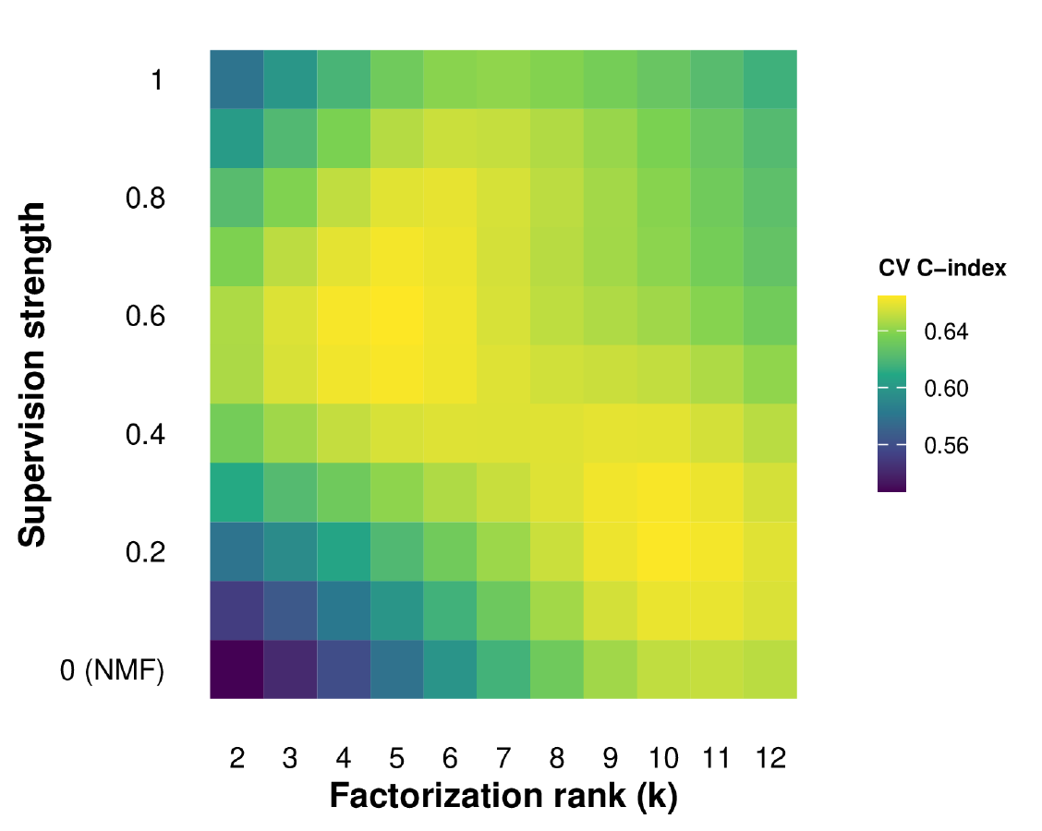
Bayesian-optimization tuning surface for DeSurv in the PDAC training cohort (TCGA + CPTAC). Gaussian-process–predicted mean cross-validated C-index over factorization rank ($k$) and supervision strength ($α$; $α=0$ corresponds to the unsupervised limit). The response surface shows a broad region of high cross-validated performance at intermediate supervision and moderate rank, a second high region at $k≥9$ and $α≈0.2$–$0.3$, and discrimination degrading toward the unsupervised ($α=0$) boundary.

Consensus initialization for the final model
The final DeSurv model at the selected hyperparameters was initialized from a consensus of multiple independent runs to reduce sensitivity to random starts. We first fit $R=100$ DeSurv models to the training data from independent random nonnegative initializations at the selected $\left(k,α,λ,ξ,n_{\text{top}}\right)$ (seeds 1–100). For each run, the top $n_{\text{top}}$ genes of every learned program were extracted by factor-specificity score, and a gene-by-gene consensus matrix was accumulated across runs, recording how often each pair of genes appeared together among the top genes of the same program.
Genes appearing in the top sets of fewer than $⌈0.3R⌉$ of the $R$ runs were treated as inactive and excluded from clustering. Because the consensus is constructed from gene-by-gene co-occurrence across restarts, it is invariant to factor-label permutations and does not require explicit alignment of factor labels across runs. The consensus matrix over the remaining genes was partitioned into $k$ groups by agglomerative hierarchical clustering (average linkage), and each cluster defined one column of the initial gene-program matrix $W_{0}$; inactive genes and otherwise-empty entries were set to a small positive floor ($\sqrt{ϵ_{\text{mach}}}$) to preserve strict positivity. The initial loadings $H_{0}$ were obtained by nonnegative least squares given $W_{0}$ and the training expression matrix, and the initial Cox coefficients $β_{0}$ were set to zero. This consensus seed used only training-cohort data and was applied solely to initialize the single final refit after hyperparameter selection; it used no validation-cohort data and therefore introduced no information leakage.

PDAC Datasets
We analyzed PDAC cohorts from TCGA-PAAD and CPTAC-PDAC as training data^{13,14}. External validation used independent cohorts from Dijk, Moffitt, PACA-AU (array and RNA-seq), and Puleo^{15–18}. Training models were fit on the combined TCGA and CPTAC expression matrices after harmonizing gene identifiers; validation datasets were processed with the same gene set and transformations before projection, scoring and downstream validation analyses.
Dataset-specific inclusion and preprocessing steps were as follows. For TCGA-PAAD, we excluded samples lacking tumor grade and mapped features to gene symbols. For CPTAC, we retained samples annotated as PDAC by histology. For Dijk, all 90 samples passed quality-control filters and were retained. For Moffitt, only primary tumor specimens were kept. For PACA-AU array and RNA-seq, we retained primary PDAC tumors and collapsed duplicated gene symbols by median. Puleo required no additional dataset-specific filtering beyond survival QC.
Across cohorts, samples without valid survival outcomes (nonpositive time, missing time, or missing event indicator) were removed. Expression matrices were analyzed on a log scale: RNA-seq cohorts as log$​_{2}$(TPM + 1); microarray cohorts in platform-normalized log-scale intensities. For each training cohort (TCGA-PAAD and CPTAC) separately, genes were ranked in descending order of mean expression and, independently, of variance; the 3,000 genes with the lowest sum of these two ranks were retained, selecting genes that are both highly expressed and highly variable. The intersection of these two gene sets yielded 1,970 genes used for model training. Validation datasets were restricted to this same 1,970-gene set.
A within-sample rank transformation was then applied to every dataset to mitigate platform and scale effects. Specifically, for each sample the expression values across the 1,970 retained genes were replaced by their ascending ranks (ties resolved by average ranks), so that every sample carries the same nonnegative rank distribution over the shared gene set; ranks are inherently nonnegative and therefore preserve NMF compatibility. Validation cohorts were rank-transformed by exactly the same per-sample procedure before projection, with no use of validation outcomes.
Table [tab:cohorts] summarizes the cohorts, platforms, sample sizes after quality control, and patient-level metadata used in this study. Overall survival time and event indicators were available for all cohorts. PurIST¹⁹ and DeCAF²⁰ molecular classifications, applied to bulk expression data as described in those references, were used as covariates in the covariate-adjusted external validation analysis. Gene expression data and molecular classifications for the validation cohorts were originally compiled for the DeCAF study²⁰; training data were obtained directly from GDC.
Cohort | Platform | $N$ | Events | Role | Accession | Metadata | Reference
TCGA-PAAD | RNA-seq | 144 | 75 (52%) | Training | GDC (TCGA-PAAD) | OS, PurIST, DeCAF | Raphael et al. (2017)
CPTAC | RNA-seq | 129 | 64 (50%) | Training | GDC (CPTAC-3) | OS, PurIST, DeCAF | Cao et al. (2021)
Dijk | RNA-seq | 90 | 81 (90%) | Validation | E-MTAB-6830 | OS, PurIST, DeCAF | Dijk et al. (2020)
Moffitt | Microarray | 123 | 83 (67%) | Validation | GSE71729 | OS, PurIST, DeCAF | Moffitt et al. (2015)
PACA-AU (array) | Microarray | 63 | 38 (60%) | Validation | GSE36924 | OS, PurIST, DeCAF | Bailey et al. (2016)
PACA-AU (RNA-seq) | RNA-seq | 52 | 31 (60%) | Validation | EGAS00001000154 | OS, PurIST, DeCAF | Bailey et al. (2016)
Puleo | Microarray | 288 | 181 (63%) | Validation | E-MTAB-6134 | OS, PurIST, DeCAF | Puleo et al. (2018)
Training total | 273 | 139 (51%)
Validation platform profiles total | 616 | 414 (67%)
Combined unique-patient validation set | 570 | 388 (68%)
Summary of PDAC cohorts used in this study. $N$ denotes the number of samples after all quality-control filters (histology, survival validity, dataset-specific exclusions). Patient-level metadata: OS = overall survival (time and event indicator); PurIST = tumor subtype classification (Rashid et al. 2020); DeCAF = CAF subtype classification (Peng et al. 2026). Expression data and molecular classifications for the validation cohorts were originally compiled for the DeCAF study (Peng et al. 2026). Events denotes the number of overall-survival events (deaths) with the corresponding event rate; outcome frequency was lower and more homogeneous in the training cohorts (50–52%) than across the validation cohorts (60–90%, pooled 67%), a case-mix difference relevant to the interpretation of external-validation performance.

Survival Analysis
Survival analyses used overall survival time with event indicators as provided by each cohort. For fitted DeSurv models, sample-level program scores are the raw projections $Z={\tilde{W}}^{⊤}X$ onto the frozen support, and the linear predictor is $\hat{η}=Z^{⊤}\hat{β}$ with the trained coefficients; no re-estimation and no standardization enters the score itself. The frozen support is the union of the $k$ programs’ top-$n_{\text{top}}$ gene sets, and $\tilde{W}$ is $\hat{W}$ restricted to those rows, so every column keeps its own weights on the whole union and a gene entering the union through one program still contributes to the other programs’ scores with its own weight. This union construction defines the primary external-validation scores, including the headline pooled hazard ratio, the leave-one-dataset-out estimates, the classifier-adjusted risk-score analyses, the per-factor forest estimates and the cohort-specific estimates of Table [tab:het-ci]. Other analyses use explicitly identified alternative constructions, named where they occur. Full-support scores over all analyzed genes are used for the training-data contribution analysis (Reconstruction and Survival Contribution per Factor) and for the frozen-axis comparator analysis whose subsampling stability is reported in Stability of the recovered gene programs. Per-program masks, each column zeroed outside its own top-$n_{\text{top}}$ set, are used for the tuned supervised-comparator analysis (Robustness to tuned supervised comparators and compartment attribution) and for descriptive checks such as Cohort handling in the training objective below. Both of those supervised-comparator constructions, the one on the full shared support and the one on per-program masks, additionally refit unpenalized Cox coefficients on the training scores rather than carrying $\hat{β}$ forward. Throughout, projection denotes multiplication by this fixed gene-weight matrix; the truncated columns are not renormalized, so the term does not imply an orthogonal geometric projection. The Cox coefficients $\hat{β}$ were estimated during model fitting from the full-support scores $W^{⊤}X$ over all analyzed genes; for cross-validation and external scoring they were carried forward unchanged and applied to scores from the truncated basis $\tilde{W}$, and were not refit after truncation (Algorithm [alg:cv]). The elastic-net penalty set the trained coefficient for D2 to exactly zero, so $\hat{η}$ is a weighted sum of the D1 and D3 scores. Prognostic performance was summarized using the concordance index as defined above (Cross-validation procedure). When multiple datasets were pooled, Cox models were stratified by dataset to allow cohort-specific baseline hazards.
For a fixed fitted predictor and scoring support, the manuscript uses the following reporting scalings. Every linear predictor built on the union support is the same linear functional of expression up to a positive constant, and the map from scaling to reported quantity is as follows. (i) During cross-validated tuning the collapsed weight vector $\tilde{W}\hat{β}$ is scaled to unit $ℓ_{2}$ norm (main text, Methods); this changes $\hat{η}$ by a positive constant only. (ii) Primary risk-score hazard ratios, namely the headline pooled estimate, the covariate-adjusted estimates of main-text Table [tab:hr-adjusted] and the leave-one-dataset-out estimates, divide $\hat{η}$ by its standard deviation over the pooled, de-duplicated validation set, so they are per pooled standard deviation. (iii) Two further analyses standardize to zero mean and unit standard deviation within groups, and the grouping differs between them. The per-factor forest estimates (main-text Fig. [fig:val]a) and the D1 classifier-adjustment analysis (Variance partition of the D1 score) standardize within each of the five platform datasets, whereas the between-cohort slope analysis, its interaction test and the cohort-specific hazard ratios of Table [tab:het-ci] standardize within each of the four patient cohorts, so these are per within-dataset and per within-cohort standard deviation respectively. Hazard ratios under (ii) and (iii) are not interchangeable. Within a given cohort or dataset, centering and positive rescaling of a fixed score leave its C-index unchanged; this does not equate different predictors and does not preserve pooled rankings across groups standardized differently. Analyses that use a different gene support, listed above, are not scalings of this functional and are reported as separate quantities.
Two further conventions apply to the primary combined external C-index and its confidence interval. The combined C-index is the event-weighted mean of the four cohort C-indices rather than a concordance computed over pooled patients, so no concordance pair is formed across cohorts. Its confidence interval is a percentile interval from a stratified nonparametric bootstrap that resamples patients with replacement within cohort ($B=1,000$ replicates, seed 1), so resampling preserves cohort membership (Between-cohort heterogeneity and C-index confidence intervals).

Independence of discovery and validation
DeSurv is trained with survival supervision only; it never uses PurIST, DeCAF, or any molecular subtype label during factorization or hyperparameter selection. The PurIST and DeCAF subtype calls were fixed before the DeSurv analysis (loaded as precomputed per-cohort annotations) and enter only as covariates in the adjusted Cox models, not as inputs to DeSurv. All rank and hyperparameter selection (including the one-standard-error rule) was performed by cross-validation entirely within the TCGA and CPTAC training data; no external validation cohort was used for training or tuning. Validation-cohort expression enters only at scoring, a fixed-basis projection ($Z={\tilde{W}}^{⊤}X_{\text{new}}$) that uses no validation outcome, and validation-cohort survival outcomes were used only for the final, out-of-sample performance evaluation.

Cohort handling in the training objective
The training Cox objective was fit to the pooled TCGA-PAAD and CPTAC samples without a cohort term; cross-validation folds were constructed within cohort with stratification by event status. Because survival shapes $W$, a cohort effect associated with both expression and survival could in principle be rewarded by the survival gradient. As a descriptive check for cohort-driven association, computed from the cached training data and final fit and not a refit, the fitted linear predictor remained strongly associated with survival within TCGA-PAAD and CPTAC separately (in-sample HR per SD 3.50 and 3.72; Table [tab:clinical-adjustment]) and in a model stratified by cohort (HR per SD 3.35, against 3.12 unstratified), while the between-cohort shift in the score was opposite to the between-cohort hazard difference: the predictor averaged 0.73 SD higher in TCGA-PAAD, yet CPTAC had the higher hazard given the predictor (HR 1.90). These in-sample quantities argue against the specific mechanism in which the survival gradient learns cohort membership, but they do not rule out cohort influence on the factorization, which the external validation addresses directly.

Gene Program Correlation Analysis
To assess the biological identity of learned factors, we evaluated the correspondence between factor-specific gene rankings and established PDAC gene programs. Each column $j$ of the gene program matrix $W$ was first scaled by its column maximum, $W_{ij}^{*}=W_{ij}/\max_{i}W_{ij}$, placing all factors on a common $\left[0,1\right]$ scale, and the specificity score for gene $i$ in factor $j$ was defined as
$$s_{ij}=W_{ij}^{*}−\max_{j′≠j}W_{ij′}^{*}.$$
Genes were ranked in descending order of $s_{ij}$. This ranking defines both the top-$n_{\text{top}}$ genes used to score samples (Supplementary Data: factor-specific gene lists) and, for the top 50 genes per factor, the loadings used to quantify factor–program correspondence.
For each factor $j$ and each reference gene program $G_{k}$, we computed the Spearman rank correlation between the continuous factor loadings $W_{⋅j}$ (restricted to the union of the per-factor top-50 gene sets intersected with the reference programs) and a binary indicator vector $1\left[\text{gene}∈G_{k}\right]$ (main-text Fig. 2a,b; Methods). $P$ values were derived from the asymptotic Spearman test and adjusted for multiple comparisons using the Benjamini–Hochberg procedure within each factor column independently; as in the main text, these adjusted $P$ values are displayed as descriptive marks, because the gene universe is itself selected by loading. Reference programs were included in the visualization only if at least one factor yielded a Spearman correlation exceeding $0.2$.
The reference universe comprises 45 published PDAC gene programs (Table [tab:ref-universe]): the PurIST basal-like and classical tumor signatures¹⁹; the DECODER compartment signatures²¹; the Moffitt tumor, stroma and immune programs¹⁶; the Collisson subtypes²²; the Bailey subtypes, including ADEX (aberrantly differentiated endocrine exocrine)¹⁷; the Chan-Seng-Yue subtypes²³; the Maurer ECM and immune programs²⁴; the five Puleo whole-tumor components together with Puleo’s two tumor-compartment signatures¹⁸; the Elyada iCAF and myCAF signatures²⁵; the SCISSORS fibroblast and tumor signatures²⁶; and the DeCAF proCAF and restCAF programs²⁰. Nine source entries were excluded before analysis: six that duplicate a retained list gene for gene (a second copy of the Moffitt activated and normal stroma lists, the SCISSORS CAF-versus-perivascular variants of its apCAF, iCAF and myCAF lists, and a second copy of its perivascular list), the two nine-gene PurISS iCAF and myCAF lists, and Bailey’s non-unique gene set. The SCISSORS iCAF and myCAF signatures are displayed under the DeCAF nomenclature, restCAF and proCAF (Stromal resolution: which reference programs are recovered from bulk). Puleo’s whole-tumor pure basal-like component and its tumor-compartment basal-like signature are distinct programs and are labeled as such in every figure. Many programs place only a minority of their genes inside the 1,970-gene analysis set; the correlation for a program is computed over the genes it shares with that set, and a program with no such genes cannot be represented.
Displayed alias | Source | Genes | In analysis set
PurIST: Basal Like | Rashid et al. 2020 | 8 | 7
PurIST: Classical | Rashid et al. 2020 | 8 | 8
DECODER: Basal-like tumor | Peng et al. 2019 | 394 | 139
DECODER: Classical tumor | Peng et al. 2019 | 372 | 166
DECODER: Activated Stroma | Peng et al. 2019 | 206 | 108
DECODER: Normal Stroma | Peng et al. 2019 | 97 | 15
DECODER: Immune | Peng et al. 2019 | 408 | 60
DECODER: Exocrine | Peng et al. 2019 | 113 | 44
DECODER: Endocrine | Peng et al. 2019 | 380 | 61
Moffitt: Basal-like | Moffitt et al. 2015 | 25 | 20
Moffitt: Classical | Moffitt et al. 2015 | 25 | 21
Moffitt: Activated | Moffitt et al. 2015 | 25 | 24
Moffitt: Normal | Moffitt et al. 2015 | 25 | 11
Moffitt: Immune | Moffitt et al. 2015 | 25 | 5
Collisson: Classical | Collisson et al. 2011 | 22 | 22
Collisson: Exocrine | Collisson et al. 2011 | 20 | 19
Collisson: QM | Collisson et al. 2011 | 20 | 12
Bailey: Squamous | Bailey et al. 2016 | 87 | 27
Bailey: Immunogenic | Bailey et al. 2016 | 145 | 22
Bailey: Pancreatic Progenitor | Bailey et al. 2016 | 73 | 7
Bailey: ADEX | Bailey et al. 2016 | 57 | 37
Chan-Seng-Yue: Basal-like A | Chan-Seng-Yue et al. 2020 | 100 | 34
Chan-Seng-Yue: Basal-like B | Chan-Seng-Yue et al. 2020 | 100 | 28
Chan-Seng-Yue: Classical A | Chan-Seng-Yue et al. 2020 | 100 | 69
Chan-Seng-Yue: Classical B | Chan-Seng-Yue et al. 2020 | 100 | 31
Maurer: ECM | Maurer et al. 2019 | 222 | 139
Maurer: Immune | Maurer et al. 2019 | 251 | 101
Puleo: Pure Classical | Puleo et al. 2018 | 90 | 71
Puleo: Immune Classical | Puleo et al. 2018 | 56 | 7
Puleo: Desmoplastic | Puleo et al. 2018 | 101 | 65
Puleo: Stroma Activated | Puleo et al. 2018 | 62 | 50
Puleo: Pure Basal-like | Puleo et al. 2018 | 94 | 57
Puleo: Basal-like tumor | Puleo et al. 2018 | 461 | 118
Puleo: Classical tumor | Puleo et al. 2018 | 539 | 273
Elyada: iCAF | Elyada et al. 2019 | 35 | 25
Elyada: myCAF | Elyada et al. 2019 | 16 | 15
SCISSORS: apCAF | Leary et al. 2023 | 25 | 4
SCISSORS: restCAF | Leary et al. 2023 | 25 | 17
SCISSORS: proCAF | Leary et al. 2023 | 25 | 16
SCISSORS: Perivascular | Leary et al. 2023 | 25 | 5
SCISSORS: panCAF | Leary et al. 2023 | 25 | 22
SCISSORS: Basal-like | Leary et al. 2023 | 25 | 24
SCISSORS: Classical | Leary et al. 2023 | 25 | 22
deCAF: proCAF | Peng et al. 2026 | 9 | 4
deCAF: restCAF | Peng et al. 2026 | 9 | 8
The 45-program reference universe used for every factor-to-program correspondence analysis (main-text Fig. 2a,b; Supplementary Figs. [fig:fig-nmf-k7-heatmap] and [fig:fig-rpm]), generated from the same renamed and de-duplicated object the analyses read. Displayed alias is the row label used in the figures; Genes is the size of the published list; In analysis set is the number of those genes among the 1,970 analyzed genes, over which the Spearman correlation is computed. The SCISSORS restCAF and proCAF rows are the SCISSORS iCAF and myCAF signatures under DeCAF nomenclature. The two Puleo basal-like rows are different programs: the whole-tumor pure basal-like component and the tumor-compartment basal-like signature.

Reconstruction and Survival Contribution per Factor
NMF does not provide an orthogonal variance decomposition; it seeks a low-rank reconstruction of the expression matrix $X≈WH$. We therefore measure each factor’s contribution to reconstruction rather than to variance explained. For a subset of factors $S⊆\{1,…,k\}$, define the reconstruction value
vS=∥X∥F2−∥X−j∈S​W⋅jHj⋅∥F2,
the reduction in residual error relative to the null (zero-factor) model, where $W_{⋅j}H_{j⋅}$ is the rank-one outer-product contribution of factor $j$ (the outer product of column $j$ of $W$ with row $j$ of $H$). The reconstruction Shapley value²⁷ of factor $j$,
ϕj=S⊆{1,…,k}\{j}​S! k−S−1!k! vS∪{j}−vS,
is its average marginal reconstruction gain over all orderings of the factors.
By the Shapley efficiency axiom, j​ϕj=v{1,…,k}, the total reconstruction gain of the full model relative to the zero-factor reconstruction, so the normalized shares ϕj/l​ϕl form an additive decomposition of that gain; they sum to one by construction and are reported as percentages summing to 100%. Individual shares may be signed in principle but were all positive in the reported PDAC models. The reconstruction values $v\left(S\right)$ are uncentered, taken about zero as written above, and grand-mean centering enters only the separately reported centered $R^{2}$ of Cross-method reconstructability and reconstruction fidelity. These quantities describe different aspects of reconstruction and should not be interpreted as interchangeable measures. This is a genuine additive decomposition, in contrast to per-factor variance fractions, which for non-orthogonal factorizations such as NMF do not partition (cross-terms between rank-one contributions are non-zero). The Shapley shares are computed exactly by enumerating the $2^{k}$ subsets (trivial at the small ranks considered here).
The survival contribution of factor $j$ was quantified as the Type III partial likelihood increment, computed on full-support training scores $W^{⊤}X$ over all analyzed genes rather than on the truncated union support used for external validation, as the reduction in Cox partial log-likelihood when factor $j$ is omitted from the full $k$-factor model,
$$Δℓ_{j}=ℓ_{\text{full}}\left({\hat{β}}_{\text{full}}\right)−ℓ_{−j}\left({\hat{β}}_{−j}\right),$$
where $ℓ_{\text{full}}\left({\hat{β}}_{\text{full}}\right)$ is the maximized unpenalized Cox partial log-likelihood of the full $k$-factor model and $ℓ_{−j}\left({\hat{β}}_{−j}\right)$ is that of the reduced model refit on the remaining $k−1$ factors after omitting factor $j$, each evaluated at its own maximum partial likelihood estimate. Larger $Δℓ_{j}$ indicates a greater conditional contribution of factor $j$ to Cox model fit given the remaining factors. Unlike the reconstruction Shapley shares, these Type III increments are conditional (each is evaluated against the full complement of the remaining $k−1$ factors) and are nonadditive: they do not partition the total model partial likelihood and are not comparable across factors as variance-style shares. We therefore report them as per-factor conditional increments rather than as an additive survival decomposition. These are post-fit unpenalized Cox comparisons, not differences obtained by deleting terms from the trained penalized DeSurv predictor. Because the gene programs were learned using these training outcomes, the increments describe the recovered representation and do not independently validate prognostic relevance.
These two quantities are plotted against each other in main text, Fig. 2c. In PDAC at $k=3$, the reconstruction shares are $41.8\%/18.6\%/39.7\%$ for NMF (N1/N2/N3) and $18.8\%/25.2\%/56.0\%$ for DeSurv (D1/D2/D3), while the survival contribution $Δℓ$ concentrates in DeSurv D1 ($Δℓ=66.4$) with all NMF factors small ($Δℓ≤1.2$).

Factor Correspondence Analysis
To assess which biological programs are preserved, altered, or suppressed under survival supervision, we quantified the pairwise correspondence between NMF and DeSurv factor loadings. For each pair of factors $\left(j_{\text{NMF}}, j_{\text{DeSurv}}\right)$, we computed the Spearman rank correlation between the corresponding columns of the NMF gene program matrix $W_{\text{NMF}}$ and the DeSurv gene program matrix $W_{\text{DeSurv}}$ over all genes. We use the full loading profile rather than a top-gene subset, which would impose a threshold and overstate apparent preservation. Spearman correlation was used to capture monotone correspondence in gene loading ranks while remaining robust to scale differences between the two methods. Results are displayed as a heatmap with NMF factors as rows and DeSurv factors as columns (main text, Fig. 2d).

Analysis scripts and cached objects
Numerical results from the analyses are read at render time from cached analysis objects rather than transcribed manually. Table [tab:scripts] indexes the scripts referred to in this document by the analysis they perform, so that the prose above and below can name analyses rather than files.
p{9.5cm}l}
Script | Analysis | Read in
code/03 | Bayesian optimization of hyperparameters; the matched-budget refinement with $α$ pinned at 0 | Sections [sec:bo], [sec:matched]
code/04 | Final fits: 100-restart consensus fits for DeSurv and the two $α=0$ controls; best-of-30-run NMF::nmf fits for standard NMF at matched and elbow rank, each with a post hoc Cox fit | Sections [sec:consensus-init], [sec:progstab]
code/05 | External validation: frozen projection, linear predictor and per-dataset C-index | Sections [sec:survival], [sec:het]
code/06 | Fixed-hyperparameter $k×α$ cross-validation grid and its external-validation curve | Sections [sec:cvk], [sec:coverage]
code/07 | Simulation studies (three scenarios, 100 replicates each) | Section [sec:sim]
code/11 | Treated-cohort analyses (O’Kane/COMPASS arm-stratified D1; Linehan paired D2) | Section [si:treated]
code/14 | Variance partition of the D1 score; additive and interaction adjustment for PurIST and DeCAF | Section [sec:varpart]
code/15 | Single-component supervised comparators and recovery of the D1 axis | Section [sec:d1axis]
code/16 | Subsample stability of top-gene sets across methods | Section [sec:progstab]
code/17 | Proper-scoring sensitivity (integrated Brier score, IPA) | Section [sec:brier]
code/18 | Clinical-covariate and tumor-purity adjustment by cohort | Section [sec:purity]
code/19 | Independently tuned supervised comparators, axis decomposition and compartment attribution | Section [sec:tuned]
code/20 | Dispersion of individual random restarts | Section [sec:progstab]
code/21 | Reproducibility of the consensus endpoint from disjoint restart halves | Section [sec:progstab]
code/23 | Stromal reference-program resolution (top-gene and full-gene views) | Section [sec:stroma]
code/24 | Reference-program coverage, edges and multiplicity by rank; the reference-universe table | Sections [sec:gene-program-correlation], [sec:coverage]
code/25 | Between-cohort heterogeneity, proportional-hazards diagnostic and bootstrap C-index intervals | Sections [sec:ph], [sec:het]
code/26 | Reconstruction of the gradient-scaling factor $ζ$ along the production optimization path | Sections [sec:wupdate], [sec:progstab]
Index of analysis scripts. Scripts are numbered as in the code repository; helper functions shared by several scripts (de-duplication of PACA-AU patients, validation scoring, elbow selection) are called from the scripts listed. Section numbers refer to this document.

Supplementary Results

Cross-method reconstructability and reconstruction fidelity
The factor-correspondence heatmap of Section [sec:factor-correspondence] (main-text Fig. 2d) summarizes pairwise similarity; to make a direction-aware statement of how much of each factor is linearly reconstructable from the other method’s basis, we regressed each factor’s gene-loading vector onto the full set of the other method’s loading vectors and report the ordinary least-squares $R^{2}$ (Table [tab:projection-r2]). A high $R^{2}$ means the factor is well reconstructed as a linear combination of the other method’s factors; a low $R^{2}$ means it is not linearly reconstructable from that basis. This is a statement about linear reconstructability of gene-loading vectors, not about which method discovered a program first.
Factor | $R^{2}$ from the other method’s basis
NMF N1 (tumor) | 0.90
NMF N2 (exocrine) | 0.38
NMF N3 (microenviron.) | 0.88
DeSurv D1 (classical/restCAF-like) | 0.09
DeSurv D2 (proCAF-like) | 0.81
DeSurv D3 (basal-like) | 0.75
Cross-method projection $R^{2}$: how reconstructable each factor’s gene-loading vector is from the other method’s full basis (OLS $R^{2}$). DeSurv retains the bulk of the unsupervised structure (NMF N1 and N3 carry over at $R^{2}≥0.88$) and reorganizes it: the survival-aligned D1 program is essentially unreconstructable from the NMF basis ($R^{2}=0.09$), while the exocrine NMF factor N2 is poorly reconstructed from the DeSurv basis ($R^{2}=0.38$).
DeSurv D1 is reconstructed at $R^{2}=0.09$ from the NMF basis: its gene-loading vector is not well reconstructed as a linear combination of the matched-rank NMF factors. The biologically dominant tumor (N1) and stromal (N3) programs, by contrast, are largely reconstructable from the DeSurv basis ($R^{2}=0.90$ and $0.88$), so most of the unsupervised structure is retained; the principal reorganization is that the DeSurv basis resolves tumor signal into basal- and classical-aligned programs while reconstructing the exocrine factor (N2) less well ($R^{2}=0.38$).
At the whole-matrix level, this reorganization carries a real but bounded reconstruction cost (Table [tab:overall-r2]). On the conventional centered $R^{2}$, DeSurv reconstructs 0.75 of the analysis matrix against 0.81 for unsupervised NMF, a difference of 6.0 percentage points and a relative loss of about 7%; this centered figure is the one reported in the main text. On the uncentered scale the gap is only 1.5 percentage points, but that scale flatters any nonnegative low-rank fit to a rank matrix.
Model | Centered $R^{2}$ | Uncentered $R^{2}$ | Residual fraction (centered)
NMF ($k=3$) | 0.812 | 0.953 | 0.188
DeSurv ($k=3$) | 0.752 | 0.938 | 0.248
Whole-matrix reconstruction $R^{2}$ across the 1,970-gene analysis matrix for standard NMF versus DeSurv at $k=3$. Two denominators are shown. The centered $R^{2}$ is the conventional definition, taken about the grand mean, and is the one to read as fraction of variation reconstructed. The uncentered $R^{2}$ divides by $∑X^{2}$; because the analysis matrix holds within-sample ranks with grand mean $p/2$, the mean alone accounts for about 75% of that denominator, so uncentered values are high for any nonnegative low-rank fit and are reported for completeness. On the centered definition DeSurv gives up 6.0 percentage points of reconstruction relative to NMF (1.5 on the uncentered scale).

The D1 axis is not specific to DeSurv
If the D1 tumor–stroma axis were an artifact of DeSurv’s particular optimizer, independent survival-supervised methods should not recover it. We therefore fit three other supervised dimension-reduction methods on the same training cohort ($n=273$, 139 events), namely supervised principal components (Cox-screened genes followed by PCA), one-component Cox partial least squares against martingale residuals, and a sparse Cox model (lasso-penalized; 32 genes selected in this single fit), and compared their leading survival-aligned direction to the DeSurv D1 score. All three recovered D1 closely (per-patient $\left|r\right|=0.81$ for supervised PCA, $0.83$ for Cox-PLS, and $0.85$ for sparse Cox; mean $0.83$; Fig. [fig:suprec]), and each aligned with D1 rather than with the stromal D2 or basal-like D3 programs (absolute correlations with D2 and D3 at most $0.19$).
By contrast, the leading unsupervised direction (the first principal component) was only weakly correlated with D1 ($\left|r\right|=0.10$) and instead tracked the high-variance D2/D3 stroma–basal axis. This D1 axis is thus shared across the examined survival-supervised methods. Two additional findings are consistent with this conclusion: D1 is unreconstructable from the standard NMF basis (Table [tab:projection-r2]), and standard NMF at matched rank does not recover the restCAF and iCAF marker genes that appear among DeSurv’s defining genes (Stromal resolution: which reference programs are recovered from bulk).
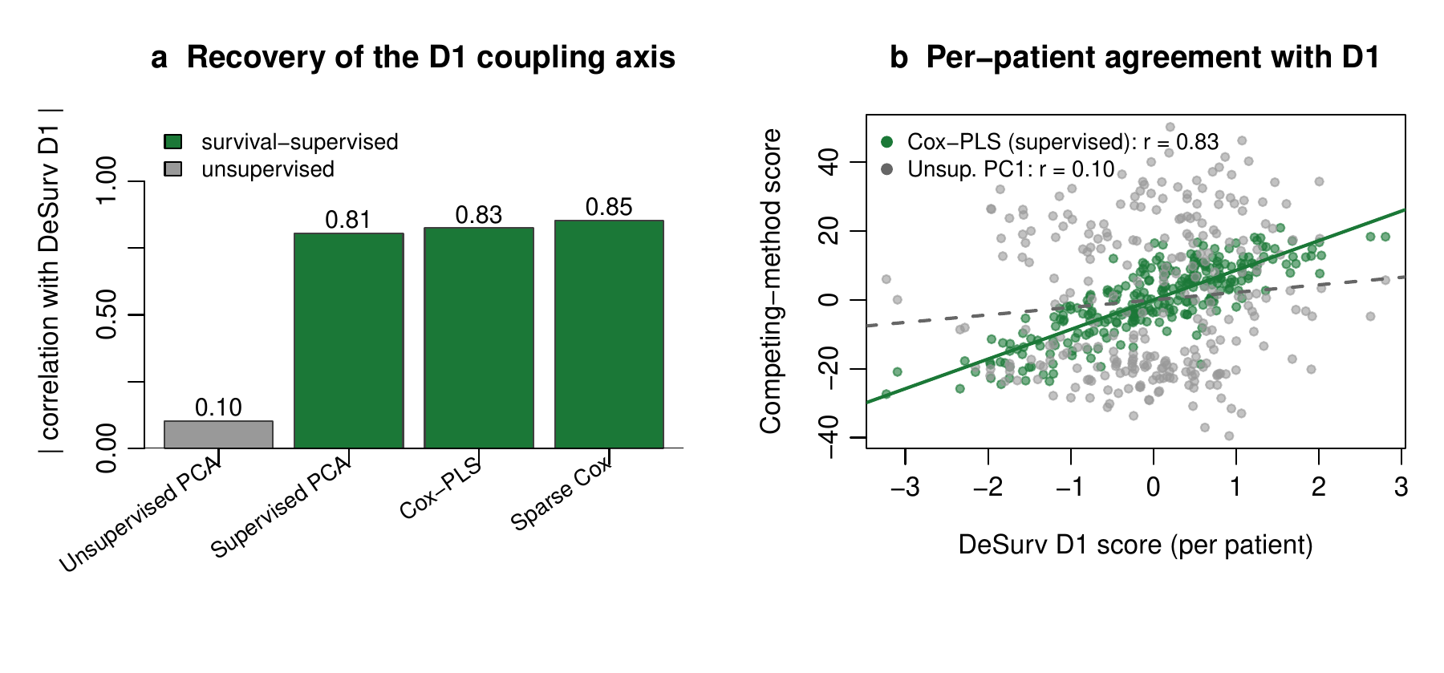
Correspondence of supervised scores and the first unsupervised principal component with D1 in the training cohort. (a) Absolute correlation (across training-cohort patients) of each method’s leading direction with the DeSurv D1 score, in the training cohort: supervised principal components, Cox partial least squares, and sparse Cox are each strongly correlated with D1 (green), whereas the leading unsupervised principal component is only weakly correlated (grey). (b) Sample-level agreement with D1 for Cox-PLS (supervised, green) versus the first unsupervised principal component (grey).

Robustness to tuned supervised comparators and compartment attribution
The preceding section establishes D1 as a survival-associated expression direction shared across supervised methods; here we ask what DeSurv adds beyond recovering that direction, using canonical, independently tuned comparators in place of the simple single-component versions above: supervised principal components (superpc; Bair–Tibshirani, with cross-validated screening threshold and component number) and lasso-penalized Cox regression (glmnet, mixing parameter 1, a single $λ_{min}$ model). Cox partial least squares was not included in this comparison because a validated multi-component implementation was not available. All methods used the same 1,970-gene universe selected from the training data by expression and variance, and each performed its own feature selection; for this comparison DeSurv’s program scores used per-program masks, each column zeroed outside its own top-$270$ gene set, rather than the union support used elsewhere in the manuscript, and the Cox weights combining the three program scores were re-estimated without penalty on the training scores, so that all three methods enter as training-fitted linear scores on an equal footing. Validation outcomes were never used: all scoring used the frozen, rank-transformed transfer with no validation refitting.
External discrimination was similar: the pooled frozen-transfer C-index was $0.61$ for the DeSurv linear predictor, $0.60$ for supervised PCA, and $0.60$ for lasso Cox. Consistent with the score-level recovery above, both tuned methods aligned with the D1 direction (correspondence between each supervised risk score and the DeSurv programs was quantified in the training cohort by absolute Pearson correlation; $\left|r\right|=0.71$ for lasso Cox and $0.46$ for supervised PCA) and with the DeSurv linear predictor ($\left|r\right|=0.86$ for lasso Cox and $0.65$ for supervised PCA), but were only weakly correlated with the activated-stroma/proCAF program D2 ($\left|r\right|=0.06$ for lasso Cox and $0.14$ for supervised PCA): a single supervised risk axis captures the dominant tumor-axis signal but not the separate stromal program.
The compartment attribution made this explicit. The genes emphasized by a supervised risk score need not coincide with D1’s positively weighted defining genes, because the high-risk end of D1 is characterized in part by loss of classical-tumor and restCAF-like expression. Empirically they were basal-like tumor markers: across 12 cross-validation seeds the genes selected by both methods were enriched (hypergeometric $P<0.01$) for the basal-like tumor program (in 12/12 seeds for lasso Cox and 12/12 for supervised PCA) and in no seed for the activated-stroma/proCAF, restraining-stroma, immune, or exocrine compartments. The supervised risk scores did nonetheless retain some stromal signal: each correlated modestly with an external activated-stroma/proCAF signature ($\left|r\right|=0.20$ for lasso Cox and $0.23$ for supervised PCA), but well below DeSurv’s D2 program ($\left|r\right|=0.55$), which tracks that signature directly.
The distinction is therefore representational: DeSurv preserves stromal context as an explicit program even when that program does not contribute independently to the fitted linear predictor. The independently tuned methods used different feature-selection procedures and retained different numbers of genes, and neither mechanism matches DeSurv’s. The penalized Cox comparator uses a pure lasso penalty (mixing parameter 1, distinct from DeSurv’s supervision parameter $α$), whereas supervised principal components applies no penalty at all, instead screening genes by a cross-validated feature-score threshold and extracting a cross-validated number of components; DeSurv’s internal Cox step uses an elastic net whose Bayesian-optimization-selected mixing parameter ($ξ=0.056$) sits close to ridge. Both comparators retain far fewer genes than DeSurv’s 810-gene support: across 12 resampling seeds, lasso Cox selected a median of 14 genes (range 9–33) and supervised principal components 39 (range 5–222), and both were tuned by their standard method-specific cross-validation rather than a budget matched to DeSurv. Absence of reference-program enrichment in their selected gene lists does not establish absence of stromal information in their risk scores.

Proper-scoring sensitivity of the external validation
The main-text external validation reports discrimination with Harrell’s C-index under a Cox proportional-hazards model. Harrell’s C ranks patients by a single time-invariant score, so when hazards are non-proportional, as the diagnostic below shows for this predictor, its value depends on the censoring distribution and need not reflect discrimination at any particular horizon^{28,29}, and it is not a proper scoring rule for predicted risks³⁰. We therefore additionally evaluated the DeSurv linear predictor, its direction frozen from training, with a proper score, the integrated Brier score (IBS), in each validation dataset, recalibrating only its scalar slope and baseline hazard within each dataset and integrating over that dataset’s follow-up to the 80th percentile of its event times.
Across the five validation platform datasets (PACA-AU array restricted to its array-only patients) the DeSurv predictor achieved an event-weighted integrated Brier score of 0.159 versus 0.168 for a Kaplan–Meier reference, an index of prediction accuracy (IPA $=1−IBS/{IBS}_{\text{null}}$) of 5.4% (per-dataset range 2.9–9.4%). Because each dataset’s IBS is integrated over its own event-time horizon, this pooled value is a descriptive event-weighted summary rather than a single common-horizon proper score, and the per-dataset IPA range is the more directly interpretable quantity.
Two caveats limit the interpretation of this analysis. First, the recalibration step estimates both the scalar slope and the baseline hazard from each validation dataset’s own outcomes, so unlike the C-index and hazard-ratio analyses, which use a fully frozen predictor, this sensitivity evaluates the transported score direction under local recalibration rather than a frozen absolute-risk model. Second, the scores are computed on the same data used to fit that recalibration, with no cross-validation or resampling, so the reported IBS and IPA are apparent in-sample values that are subject to optimism and do not estimate out-of-sample accuracy. Both caveats weaken the evidentiary value of the apparent improvement, which is already small. This modest proper-score improvement over the null is consistent with the moderate discrimination (C $=0.61$) and with DeSurv’s contribution being a separately resolved tumor- and stroma-associated decomposition rather than higher predictive accuracy.

Proportional-hazards diagnostic
Because the pooled hazard ratio assumes proportional hazards, we tested the scaled Schoenfeld residuals of the validation model, a Cox regression of overall survival on the standardized DeSurv linear predictor with a separate baseline hazard for each dataset (stratification), using the Grambsch–Therneau test. The proportional-hazards assumption was not supported for the standardized DeSurv linear predictor ($χ^{2}=14.7$, $df=1$, $P=1.3×{10}^{−4}$), with the association attenuating over follow-up: the estimated time-varying coefficient declines with follow-up (slope $−0.92$ on Kaplan–Meier-transformed time) from a positive value. The reported pooled hazard ratio is therefore a time-averaged summary of that association, not a constant multiplicative effect. The horizon-integrated proper-scoring (IBS/IPA) sensitivity above complements it by integrating prediction accuracy over each cohort’s event-time horizon rather than through a single hazard-ratio summary.

Between-cohort heterogeneity and C-index confidence intervals
The five validation platform datasets span four independent patient cohorts, because the PACA-AU array and RNA-seq series profile a partially overlapping set of the same ICGC patients. All analyses in this section are patient-level and de-duplicated by the rule used throughout the manuscript: a patient profiled on both PACA-AU platforms is represented once, by the RNA-seq record, leaving 69 PACA-AU patients (17 array-only and 52 RNA-seq) and 570 unique patients with 388 deaths in total.
The DeSurv linear predictor was standardized within cohort (centered and scaled to unit standard deviation separately in each cohort), the same within-group convention as the per-factor forest estimates in main-text Fig. [fig:val]a, there applied to the five platform datasets, and not the pooled-standard-deviation convention used for the headline pooled hazard ratio (Survival Analysis). Within-cohort standardization removes the scale degree of freedom (every cohort’s score then has mean zero and unit standard deviation by construction), so a cohort-by-score interaction tests only whether the slope per within-cohort standard deviation differs between cohorts, and not whether the score is more dispersed in one cohort than another. Both models are Cox regressions of overall survival with a separate baseline hazard for each cohort (stratification): the common-slope model has the standardized predictor as its single covariate, and the cohort-specific-slope model adds the predictor-by-cohort interaction. Comparing them by likelihood-ratio test gave $χ^{2}=1.47$ on 3 degrees of freedom ($P=0.69$); standardizing within platform rather than within cohort, which removes the small residual location difference between the two PACA-AU platforms, gives $χ^{2}=1.59$ on 3 degrees of freedom ($P=0.66$).
Cochran’s $Q$ over the four cohort-specific log hazard ratios and their standard errors was $1.47$ on 3 degrees of freedom ($P=0.69$), giving $I^{2}=0$% under $I^{2}=max\{0,\left(Q−df\right)/Q\}$. $Q$ and $I^{2}$ are descriptive summaries of dispersion among the four estimates and are reported as complements to the interaction test, not as a substitute for it. The likelihood-ratio test is the inferential statement, and with four cohorts both are low-powered against modest heterogeneity.
Confidence intervals for the C-index were obtained by a stratified nonparametric bootstrap on the same de-duplicated table, resampling patients with replacement within cohort so that no replicate mixes patients across cohorts or reinstates a de-duplicated PACA-AU record ($B=1,000$ replicates, seed 1, percentile intervals). Concordance was evaluated as Harrell’s C with higher scores treated as higher risk, the convention of the external-validation C-indices, and the heterogeneity script (Table [tab:scripts]) verifies that this reproduces the per-dataset C-indices of Supplementary Table [tab:tab-cindex-comparison] exactly. The combined value is the event-weighted mean of the cohort C-indices, the same convention as the proper-scoring and tuned-comparator analyses, and therefore never forms a concordance pair across cohorts. The combined C-index was $0.613$ (95% CI $0.579$–$0.646$); the per-cohort hazard ratios and C-indices are given in Table [tab:het-ci].

Variance partition of the D1 score
The main text reports the fraction of the D1 score’s variance explained by the binary PurIST and DeCAF classifications. D1 scores are first standardized within platform dataset (five levels, applied after PACA-AU de-duplication, so the array and RNA-seq platforms remain separate units), and an ordinary least-squares model is then fitted with platform dataset (five levels) as a fixed effect together with PurIST, DeCAF and their interaction. The quantity reported is the ordinary $R^{2}$ of that model, not the adjusted $R^{2}$; on $n=570$ with eight estimated parameters the adjusted value is about one percentage point lower. Because the scores are standardized within platform dataset before fitting, the dataset main effect absorbs essentially no variance, so the within-dataset normalization of the reported statistic is a formality rather than a correction. The interaction term contributes negligibly, so the additive and interaction models give the same figure to the reported precision. Prognostic increments over the classifiers are assessed separately, by a partial likelihood-ratio test and the change in concordance from adding D1 to a Cox model stratified by platform dataset (five strata) containing both classifiers.
D1 could also be a smoothed coding of the four joint PurIST-by-DeCAF subtype cells, so that its classical and restCAF-like arms would simply re-express one cell of a two-by-two. The main text reports the additive adjustment (D1 added to a Cox model stratified by platform dataset containing PurIST and DeCAF as main effects). As a sensitivity analysis we repeated that test with the PurIST-by-DeCAF interaction also in the base model; the statistics below are from this interaction model and differ slightly from the main-text additive ones for that reason. The interaction term itself is not prognostic (HR $1.42$, $P=0.28$), so there was no evidence that the joint classification improved prognostic fit over the additive one. Adding D1 does improve it: it gives a partial likelihood-ratio statistic of $10.44$ on 1 degree of freedom ($P=0.0012$), an adjusted hazard ratio per standard deviation of $0.82$ ($0.73$–$0.92$), and a concordance increase from $0.592$ to $0.621$. Re-coding the two classifiers as a single saturated four-level categorical variable is the same model reparameterized and returns the identical statistic ($χ^{2}=10.44$). D1’s prognostic information is therefore not captured by the saturated four-level joint classification.

Adjustment for clinical covariates and tumor purity
The association of the frozen DeSurv linear predictor with survival was estimated in cohort-specific Cox models before and after adjustment for the clinical covariates that cohort annotates and, where available, for tumor purity (Table [tab:clinical-adjustment]). Purity annotation is present in only a subset of cohorts and is derived by different estimators across them (TCGA-PAAD purity was estimated by ABSOLUTE; the PACA-AU and Moffitt purity fields were used as distributed with the cohort annotations, which do not identify the estimator), so it is used here solely as an adjustment covariate; wherever purity could be measured on a full cohort the adjusted hazard ratio was essentially unchanged from the unadjusted one, providing no evidence that the association was explained by measured tumor purity. Consistently, the D1 score itself correlated only weakly with purity in the two full-cohort datasets (Spearman $ρ=0.06$ in PACA-AU array and $−0.05$ in PACA-AU RNA-seq), the values reported in the main text.
Cohort | Covariates | Unadjusted | Clinical-adjusted | Purity-adjusted
PACA-AU array | stage, grade, age, sex | 1.44 (1.07–1.93), $0.016$ ($n$=63, 38 ev) | 1.58 (1.06–2.35), $0.025$ ($n$=62, 37 ev) | 1.45 (1.08–1.96), $0.014$ ($n$=63, 38 ev)
PACA-AU RNA-seq | stage, grade, age, sex | 1.66 (1.15–2.38), $0.006$ ($n$=52, 31 ev) | 1.56 (0.95–2.55), $0.077$ ($n$=51, 30 ev) | 1.65 (1.15–2.36), $0.006$ ($n$=52, 31 ev)
Puleo | sex, margin | 1.37 (1.18–1.59), $<0.001$ ($n$=288, 181 ev) | 1.33 (1.14–1.55), $<0.001$ ($n$=284, 177 ev) | —
Dijk | grade, age, sex, nodal | 1.32 (1.06–1.66), $0.015$ ($n$=90, 81 ev) | 1.18 (0.92–1.50), $0.189$ ($n$=85, 77 ev) | —
Moffitt | sex, margin | 1.20 (0.98–1.48), $0.076$ ($n$=123, 83 ev) | 1.20 (0.94–1.53), $0.154$ ($n$=98, 67 ev) | 0.87 (0.50–1.54), $0.639$ ($n$=29, 18 ev)
TCGA (train) | stage, grade, age, sex, nodal | 3.50 (2.63–4.66), $<0.001$ ($n$=144, 75 ev) | 3.32 (2.40–4.59), $<0.001$ ($n$=142, 74 ev) | 3.60 (2.68–4.84), $<0.001$ ($n$=143, 74 ev)
CPTAC (train) | stage, age, sex, nodal | 3.72 (2.73–5.08), $<0.001$ ($n$=129, 64 ev) | 3.59 (2.59–4.97), $<0.001$ ($n$=123, 61 ev) | —
Hazard ratios (per SD of the DeSurv linear predictor) for overall survival, before and after adjustment for standard clinical covariates and, where annotated, tumor purity, fitted separately in each cohort by complete-case analysis (per-cell $n$ and events shown). The Covariates column lists the clinical variables entered (stage, grade, age, sex, nodal status, or resection margin, as available). After clinical adjustment the DeSurv score remains independently prognostic in Puleo, PACA-AU array and both training cohorts, and is attenuated to non-significance in PACA-AU RNA-seq, Dijk and Moffitt, the three smallest complete-case sets. Where tumor-purity annotation was available, purity adjustment left the estimate essentially unchanged wherever it could be measured on the full cohort (PACA-AU array 1.44 versus 1.45, PACA-AU RNA-seq 1.66 versus 1.65, TCGA 3.50 versus 3.60; unadjusted versus purity-adjusted), providing no evidence that the association was explained by measured tumor purity. The smaller Dijk and Moffitt cohorts are individually underpowered, and their estimates are correspondingly unstable: Moffitt is non-significant both unadjusted and after adjustment, and its purity-adjusted model rests on only $n=29$ of its 123 patients. Training-cohort (TCGA, CPTAC) hazard ratios are in-sample.

Empirical optimization stability across random initializations
The idealized alternating scheme is not accompanied by a formal convergence guarantee for the fitted models. With $λ_{H}=0$, as in the reported analyses, strict convexity of the $H$-subproblem and uniqueness of its block minimizer are not guaranteed a priori, so convergence results that require unique block minimizers do not apply directly; in addition, the implemented algorithm combines column normalization, rescaling of the weighted reconstruction and Cox gradients by the norm-based factor $ζ$ subject to its stabilizer and cap, and a Coxnet approximation of the $β$ update. We therefore assessed optimization behavior empirically across $R=100$ independent random initializations of the selected PDAC model, with a stopping tolerance of ${10}^{−7}$ applied to the cosine change of $W$ and of $H$ between successive outer iterations, and a maximum of 4,000 iterations.
100 of the 100 runs terminated on the stopping criterion rather than the iteration cap, none failed numerically, and in every run the recorded outer-loop objective decreased monotonically; the median number of iterations was 38 (range 17–233). The recorded series is $L$ as defined in Model details, evaluated once per outer iteration after the $β$ update. It ends with the last outer iteration and does not include the post-loop $β$ refit, whose objective is stored separately (Update for $β$), so monotonicity here is a statement about the outer loop. The size of the decrease from a random start varies widely between initializations, but that quantity primarily reflects the starting objective value rather than agreement among the final solutions. Whether independent runs of the reported procedure recover the same gene programs is addressed in Stability of the recovered gene programs below.

Stability of the recovered gene programs
The previous section documents that the optimizer converges. It does not establish that the programs it converges to are the same ones each time, and that is the property the manuscript relies on when it applies a frozen decomposition across cohorts. We therefore measured stability at the level of the recovered programs rather than the objective, using the same $R=100$ cached initializations. No model was refitted for the restart analysis.
Individual restarts are highly dispersed. Comparing pairs of independent random restarts, and matching their columns one to one by absolute Spearman correlation of gene loadings, the median overlap between the top $270$ genes of matched programs was $0.13$ by Jaccard index, against a chance baseline of $0.074$ for two independent draws of that size from 1,970 genes. Matched gene-loading correlations were moderate (0.59–0.60 across the three programs). Over the same runs, training concordance was nearly constant (median $0.704$, standard deviation $0.010$). Near-identical predictive performance from bases that share little gene membership is consistent with a non-identifiable objective, and it is precisely why the reported model is not a single run.
The reported procedure is reproducible with respect to initialization. The reported basis is obtained by aggregating restarts into a consensus initialization and then fitting from it. To test whether that procedure returns the same programs, we partitioned the cached restarts into two disjoint halves, built a consensus initialization from each half independently, fitted from each at the production settings, and compared the results (8 random splits). Across the eight random splits, the paired consensus fits agreed closely with each other (gene-loading correlation 0.93–0.95, patient-score correlation 0.97–0.99), and each agreed still more closely with the reported basis (gene-loading correlation 0.97–0.99, top-$270$ Jaccard 0.73–0.88). Each half contained 50 of the same 100 cached starts and therefore shared restarts with the pool used to construct the reported basis. These comparisons assess sensitivity to restart-pool composition within the observed training data; they are not independent repetitions of the full procedure. Using fewer restarts does not establish that the agreement estimates are conservative.
The fitted basis also moved materially from the consensus initialization $W_{0}$: with programs corresponding by position (confirmed against the full correlation matrix), gene-loading correlations between $W_{0}$ and the final $W$ were 0.57–0.81 and top-$270$ Jaccard overlaps were 0.44–0.82. The consensus therefore supplies a reproducible initialization rather than fixing the final basis.
The optimizer alone is not identifiable. The consensus step is what makes the reported decomposition reproducible rather than one draw from a wide distribution, and reproducibility claims in this manuscript refer to that end-to-end procedure.
Stability under data perturbation is a separate and weaker property. The analyses above vary the initialization while holding the data fixed. Refitting on 25 repeated 80% subsamples of the training cohort, with each DeSurv refit a single run from one random initialization at the production hyperparameters rather than the 100-restart consensus procedure, and comparing the top-100 gene sets of the D1-matched factor across subsamples instead gives a mean pairwise Jaccard of $0.34$ for DeSurv, against $0.49$ for Cox partial least squares, $0.38$ for supervised principal components and $0.22$ for sparse Cox. DeSurv is mid-range. These figures come from the frozen-axis comparator analysis, which works on the full shared support of genes common to the trained basis and the analyzed expression matrix rather than on the truncated union, and whose frozen-transfer linear predictor refits unpenalized Cox coefficients on the three training scores (Survival Analysis). The 100-gene list is shorter than the 270-gene projection support so that the comparison is on a common footing with the single-vector comparators, whose gene rankings are not factor-specific. This comparison favors dense methods by construction, because a score that spreads weight across many genes has a more stable top-100 list than one built from a selective basis, as the sparse Cox value illustrates; it also disfavors DeSurv relative to the consensus procedure used for the reported model, because each refit here is a single run. Gene-level resampling stability addresses a complementary property distinct from reproducibility of the frozen end-to-end procedure.

Simulation design and data generation
Gene expression data were generated from a nonnegative factor model $X=WH$, where gene loadings $W$ comprised three gene classes: marker genes, background genes, and noise genes. Marker genes were simulated to load strongly on a single factor and weakly on others, background genes to load strongly across all factors, and noise genes to have uniformly low loadings. Specifically, marker gene primary loadings were drawn from $\text{Gamma}\left(\text{shape}=3,\text{rate}=0.8\right)$ and cross-loadings onto other factors from $\text{Gamma}\left(1,20\right)$; background gene loadings from $\text{Gamma}\left(2,1\right)$ across all factors; and noise gene loadings from $\text{Gamma}\left(1,20\right)$. Sample-level factor activities $H$ were drawn from $\text{Gamma}\left(2,2\right)$. Each dataset comprised $p=3,000$ genes, $n=200$ samples, and $k=3$ factors, with 150 marker genes per factor and 500 shared background genes. The three factors are exchangeable in this design: the prognostic factor is not generated with lower variance than the other two. The variance-dominant signal excluded from the survival-generating gene set is the shared background block, which loads on every factor, so the factor-specific marker genes that carry survival contribute less of the total expression variation than that block. Because the background genes load on the same latent activities as the markers, their expression remains correlated with the linear predictor; “background” here denotes exclusion from the survival-generating gene set, not statistical independence of outcome. The expression matrix actually analyzed was not the noise-free product $WH$: a per-gene baseline drawn as $N\left(3,1\right)$ was added to every row, independent Gaussian noise with standard deviation $0.01$ was added to every entry, and negative values were clipped to zero.
Cox regression coefficients were $β={\left(2,0,0\right)}^{⊤}$ in the prognostic and mixed scenarios and $β=0$ in the null scenario, which otherwise used the same baseline hazard parameter and censoring rate as the prognostic scenario. The mixed scenario differs from the prognostic scenario only in its survival gene set, 300 genes per column of the survival-generating weight matrix $W^{*}$, comprising the 150 markers of that factor and 150 randomly sampled background genes, which creates partial overlap between the prognostic signal and the variance-dominant background.
Survival times were generated from an exponential distribution, from the noise-free expression only. Let $X_{0}=WH$ denote that noise-free matrix and $W^{*}$ the survival-generating weight matrix, a masked copy of the column-normalized $W$ that retains, in each column, only the loadings of that factor’s survival-generating genes and is zero elsewhere: the 150 markers of that factor in the prognostic and null scenarios, and 150 markers plus 150 background genes in the mixed scenario. The raw generating scores were $Z_{\text{raw}}=X_{0}^{⊤}W^{*}∈R^{n×k}$, written here as the transpose of the main-text model convention $Z=W^{⊤}X$ so that rows index samples, and $Z_{\text{true}}$ denotes their column-wise standardization across all $n=200$ samples, applied before the 70/30 train/test split; the linear predictor was $η=Z_{\text{true}}β$, so with $β={\left(2,0,0\right)}^{⊤}$ only factor 1 contributes; event times were drawn as $T∼\text{Exponential}\left(λ_{0}e^{η}\right)$ with $λ_{0}=0.05$, and censoring times independently as $\text{Exponential}\left(0.02\right)$. Each scenario comprised 100 replicates, each with a held-out test split.
Recovery of the prognostic gene set was summarized by matched-factor precision, defined in the main-text Methods, and by global marker recall, defined below in Simulation results under null and mixed scenarios. The ground-truth target against which both are scored is scenario-specific. In the prognostic scenario the target comprised the 150 factor-specific marker genes driving survival ($β=\left(2,0,0\right)$); in the mixed scenario, marker-only and full survival-gene definitions of the target were evaluated separately.

Simulation results under null and mixed scenarios
To characterize the operating characteristics of DeSurv across different signal regimes, we evaluated performance under three simulation scenarios. In the prognostic scenario (main text Fig. [fig:sim]), the factor-specific survival signal contributed relatively little transcriptomic variation compared with the shared background signal excluded from the survival-generating gene set, and the specified survival-generating gene set comprised 150 factor-specific marker genes ($β_{1}=2$, $β_{2}=β_{3}=0$). In the null scenario, survival times were generated independently of gene expression, with generating coefficients $β_{1}=β_{2}=β_{3}=0$, so no prognostic structure existed. In the mixed scenario, 300 genes per column of the survival-generating weight matrix $W^{*}$ entered the survival gene set, each column carrying 150 factor-specific markers and 150 background genes with loadings shared across all factors, with survival weight placed on factor 1 only ($β_{1}=2$, $β_{2}=β_{3}=0$). All scenarios used $p=3,000$ genes, $n=200$ samples, $k=3$ true factors, the same baseline hazard parameter ($0.05$) and the same independent exponential censoring rate ($0.02$), and identical gamma distribution parameters for the gene loading matrix $W$ (Simulation design and data generation). In every scenario the generating scores are formed from the noise-free expression matrix $X_{0}=WH$ rather than from the analyzed matrix. The raw generating scores are $X_{0}^{⊤}W^{*}$, and their column-wise standardization across all $n=200$ samples, applied before the train/test split, gives the standardized scores from which the linear predictor is formed, so the generating $β$ is per standard deviation of the generating score and is not comparable to a coefficient on a raw projection. Performance was evaluated using the concordance index (C-index) on the held-out 30% test split of each replicate, precision of recovered prognostic gene sets, and the distribution of selected ranks across simulation replicates. In the prognostic scenario the shared background genes are excluded from the survival-generating gene set; their exclusion does not imply statistical independence from survival, because background and marker expression share latent factor activities.
In the prognostic scenario, median matched-factor precision was 0.50 for DeSurv versus 0.07 for unsupervised NMF, and global marker recall, the fraction of the survival-driving marker genes recovered anywhere in the union of all learned factors’ top-$n_{\text{top}}$ gene sets, was 0.26 versus 0.15. Recall is insensitive to factor matching because it searches the union of all learned factors rather than a single matched factor; like precision, it depends on each method’s selected $n_{\text{top}}$. It complements the matched-factor precision reported in main-text Fig. [fig:sim].
Under the null scenario (Fig. [fig:sim-null-mixed]a–b), DeSurv showed no advantage over unsupervised NMF ($α=0$): both methods yielded C-index values near 0.5, and selected ranks concentrated at low values (NMF favoring $k=2$), consistent with the absence of survival signal. Because the survival objective is uninformative under the null, the cross-validated concordance is essentially flat in $α$ and the Bayesian-optimized supervision strength is unidentified, dispersing across its admissible range rather than concentrating near zero (median $α=0.59$, IQR $0.19$–$0.82$; range $0$–$0.94$ across 100 replicates). The null-scenario specificity thus reflects the flat concordance surface itself, not the optimizer driving $α$ to zero.
Under the mixed scenario (Fig. [fig:sim-null-mixed]c–f), DeSurv’s advantage was concentrated in marker-gene recovery. Precision against the factor-specific marker genes alone (150 genes; Fig. [fig:sim-null-mixed]d left) substantially favored DeSurv, whereas precision against the full 300-gene survival set including background genes (Fig. [fig:sim-null-mixed]d right) was more modestly improved, indicating similar background-gene recovery between methods. The learned factor aligned with the true marker program also received a larger Cox coefficient ($\left|β\right|$) under DeSurv (Fig. [fig:sim-null-mixed]e), and C-index was modestly higher (Fig. [fig:sim-null-mixed]c). Across the three scenarios the pattern was graded: DeSurv’s advantage was greatest when variance and prognosis diverged (prognostic), attenuated in full-target precision and in discrimination when they partially overlapped (mixed, as background-gene dilution reduced the discrimination gain) while marker-only precision still favored DeSurv, and absent when no survival signal existed (null). These simulations indicate that DeSurv is most advantageous when prognostic structure is not aligned with the dominant sources of transcriptomic variation.
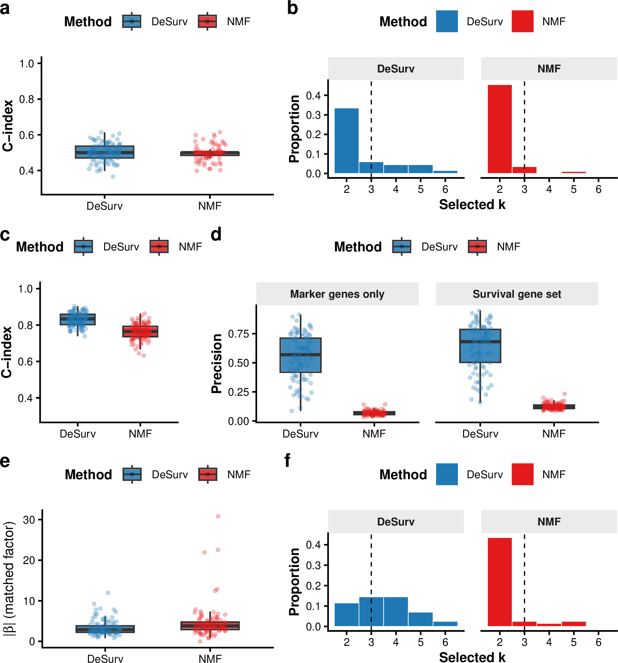
DeSurv performance under null and mixed simulation scenarios. (a,b) Null scenario ($β=0$): both methods yield C-index $≈0.5$ (a) and comparable rank distributions (b), so both methods show no out-of-sample prognostic discrimination under the null; precision is omitted as no true survival genes exist. (c–f) Mixed scenario: survival depends on factor-specific marker genes (50%) and shared background genes (50%). (c) C-index is modestly higher for DeSurv. (d) Precision by gene-set definition: marker-only precision (150 genes; left facet) substantially favors DeSurv; full 300-gene survival-set precision (right facet) shows a more modest improvement. (e) The matched factor receives a larger fitted Cox coefficient $\left|β\right|$ under DeSurv. (f) Selected-rank distributions. DeSurv (blue); NMF (red, $α=0$); both Bayesian-optimized.

Cross-validated C-index across factorization rank
To evaluate how the number of latent factors $k$ affects prognostic performance, as a sensitivity analysis we performed an exhaustive grid search over $k∈\{2,3,…,12\}$ and supervision strength $α∈\{0,0.05,…,0.95\}$ using 5-fold cross-validation on the TCGA+CPTAC training cohort. For each $k$, the best-performing $α$ was selected by maximizing the mean CV C-index. The unsupervised limit ($α=0$) was evaluated at the same $k$ values for comparison. Results are shown for two gene-selection settings: $n_{\text{top}}=270$ top genes per factor and $n_{\text{top}}=\text{ALL}$ (all genes retained), both at $λ=0.349$ and $ξ=0.056$. External validation C-index is shown descriptively; validation outcomes were not used to select $k$, $α$, $λ$, $ξ$, or $n_{\text{top}}$.
Fig. [fig:fig-cindex-by-k] shows the resulting C-index curves for both training (CV) and external validation (pooled across held-out cohorts), with shaded ribbons indicating $±1$ standard error. Rank was selected on the training cross-validated concordance. For DeSurv that curve is close to flat across the whole range examined, spanning about two standard errors from $k=2$ to $k=12$, with its nominal maximum at $k=9$ rather than at the selected rank. This fixed-$λ$, $ξ$, $n_{\text{top}}$ grid is a different exercise from the full Bayesian-optimization search over all tuned hyperparameters, whose highest observed mean C-index occurred at $k=7$. Applying the same one-standard-error rule to panel (a) of this sensitivity grid, at $n_{\text{top}}=270$, also selects $k=3$, from a grid best of $0.671$ (standard error $0.009$) at $k=9$ and the resulting threshold $0.662$. That threshold is the grid’s own, distinct from the Bayesian-optimization threshold of $0.644$, and what it corroborates is the selected rank rather than the exact final configuration, whose nearest neighbor in this grid clears only the Bayesian-optimization threshold (Bayesian Optimization). The selection depends on the gene-selection setting: under panel (b), with all genes retained, the same rule selects $k=2$. On the training cross-validated curve DeSurv had a higher point estimate than its unsupervised limit at every $k$ examined. The external-validation curve, shown only descriptively, does not show that ordering uniformly: the unsupervised limit is higher at $k=6$ and at $k=10$–$12$, and the supervised curve dips at $k=6$, where the single grid fit at its selected $α$ is the same fit whose factors correspond to almost no reference program (Reference-program coverage, edges and multiplicity). These rank-wise points are single fits, not consensus fits. At the selected rank the validation curve is consistent with the training-based choice, with DeSurv at $k=3$ attaining concordance comparable to the rank-optimized unsupervised control ($k=7$; Table [tab:tab-cindex-comparison]).
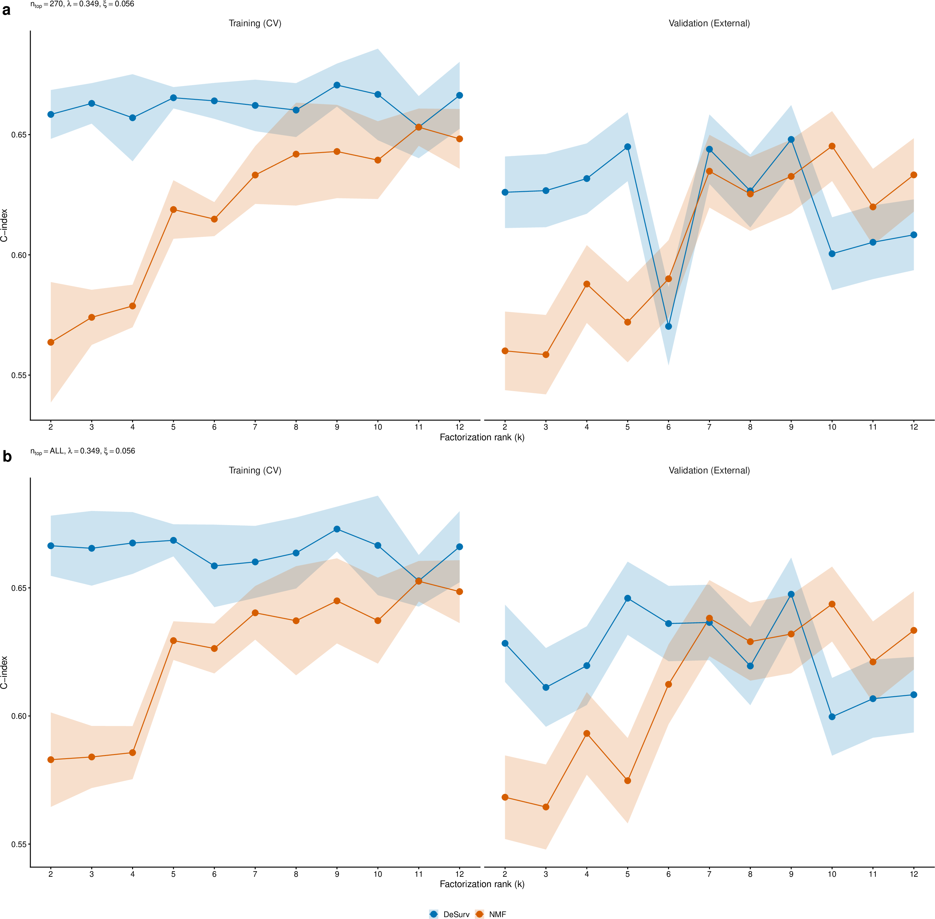
Training (CV) and external validation C-index as a function of factorization rank $k$ for DeSurv (blue) and its unsupervised limit (red, $α=0$). Shaded ribbons show $±1$ SE. For each $k$, the best $α$ was selected by maximizing the mean CV C-index. Validation C-index is pooled across all external cohorts. (a) Results using $n_{\text{top}}=270$ top genes per factor ($λ=0.349$, $ξ=0.056$). (b) Results retaining all genes ($n_{\text{top}}=\text{ALL}$; $λ=0.349$, $ξ=0.056$).

Standard NMF rank selection heuristics
Standard unsupervised rank selection criteria (reconstruction residuals, cophenetic correlation coefficient, and mean silhouette width) yielded inconsistent guidance for selecting the factorization rank $k$ in the PDAC training cohort (TCGA + CPTAC). Reconstruction residuals decreased smoothly without a visually distinct elbow (Fig. [fig:nmf-diagnostics]a); the Kneedle elbow rule (maximum deviation of the normalized curve from its chord) applied to this curve nonetheless returns $k=5$, which is the rank used for the elbow-selected standard NMF comparator in Table [tab:tab-cindex-comparison]. Cophenetic correlation fluctuated without a distinct transition point (Fig. [fig:nmf-diagnostics]b). Mean silhouette width favored very low ranks that conflicted with other criteria (Fig. [fig:nmf-diagnostics]c). These inconsistencies illustrate the ambiguity of rank selection under unsupervised criteria in this dataset; the main text selects rank on cross-validated prognostic performance.
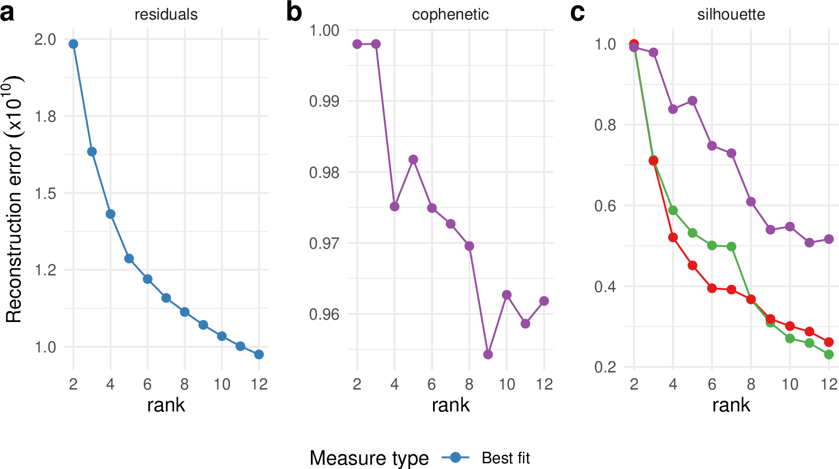
Standard unsupervised NMF rank selection heuristics for the PDAC training cohort (TCGA + CPTAC). (a) Reconstruction residuals as a function of factorization rank $k$. (b) Cophenetic correlation coefficient as a function of $k$. (c) Mean silhouette width of the basis, coefficient and consensus matrices as a function of $k$. These criteria yield inconsistent guidance, illustrating the ambiguity of rank selection under unsupervised criteria; the main text selects rank on cross-validated prognostic performance.

Factor structure of the rank-optimized unsupervised control ($k=7$)
Throughout the main text, both DeSurv and standard NMF were fit at the same rank ($k=3$), enabling a controlled comparison of the effect of survival supervision on factor structure. When the unsupervised limit of the same pipeline selects its own rank, the one-standard-error rule applied to the $α=0$ Bayesian-optimization results selects $k=7$ (the rank-optimized unsupervised control), whereas the same rule applied to the supervised DeSurv results selects $k=3$. We therefore examine the factor structure of this independently selected $k=7$ solution to characterize how the additional factors relate to established programs when supervision is absent (Fig. [fig:fig-nmf-k7-heatmap]).
At BO-selected $k=7$ under $α=0$ (Fig. [fig:fig-nmf-k7-heatmap]), the rank-optimized unsupervised control corresponds to a broader set of PDAC gene signatures than the matched-rank $k=3$ solution, with some programs represented by more than one factor; Supplementary Fig. [fig:fig-rpm] quantifies the accompanying changes in coverage and multiplicity.
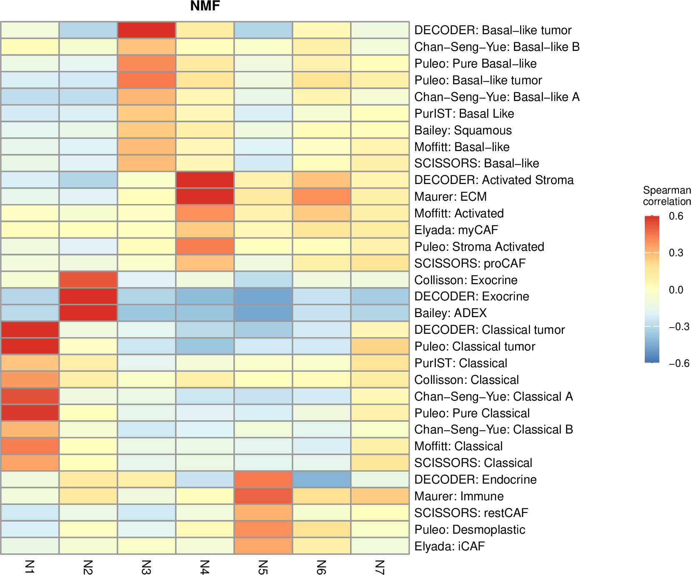
Gene-program correspondence for the rank-optimized unsupervised control ($k=7$, BO-selected rank at $α=0$), computed with the same Spearman-correlation analysis and reference programs as main-text Fig. 2a,b (top 50 genes per factor; reference programs with $ ho > 0.2$ for at least one factor are shown). Compared with the matched-rank $k=3$ solution, the $k=7$ solution shows broader correspondence to established PDAC programs, with some programs represented by more than one factor. Supplementary Fig. [fig:fig-rpm] quantifies the accompanying changes in coverage and multiplicity.

Reference-program coverage, edges and multiplicity
Fig. [fig:fig-nmf-k7-heatmap] (and main-text Fig. 2a,b) display factor-to-reference-program correspondence as a heatmap. We additionally summarize this same correspondence across factorization rank $k$ using three quantities computed from the same correlation matrix (top 50 genes per factor by factor-specificity score, Spearman correlation of factor loadings against binary reference-program membership, $ρ>0.2$ representation threshold; Supplementary Information, Section [sec:gene-program-correlation]), over the fixed 45-program reference universe. Coverage is the number of reference programs with at least one factor at $ρ>0.2$. Edges is the total number of (factor, reference-program) pairs at $ρ>0.2$. Reference-program multiplicity is edges divided by coverage, defined only when coverage $>0$, and reports edges per represented program. A low multiplicity is not by itself evidence that fewer programs are represented, so multiplicity is always reported alongside coverage rather than in place of it.
At each rank $k=2,…,12$, these quantities are computed for two single fits at fixed $λ$, $ξ$ and $n_{\text{top}}=270$ from the $k×α$ cross-validation grid: the unsupervised fit ($α=0$) and the fit at the $α$ maximizing mean cross-validated C-index, the same $α$-selection convention used for Supplementary Fig. [fig:fig-cindex-by-k]. These rank-wise points are single fits at fixed hyperparameters, not the 100-restart consensus fits used elsewhere in the manuscript. Three final-model anchors are overlaid: the consensus fits for DeSurv ($k=3$) and the rank-optimized unsupervised control ($k=7$, $α=0$), and the best-of-30-run NMF::nmf fit at matched rank ($k=3$).
At these anchors, DeSurv reaches coverage 16, edges 16, multiplicity 1.00; matched-rank standard NMF reaches coverage 15, edges 15, multiplicity 1.00; and the rank-optimized unsupervised control at $k=7$ reaches coverage 32, edges 36, multiplicity 1.125.
The supervised curve collapses at two ranks: at $k=6$ ($α=0.1$) and $k=8$ ($α=0.2$) the single grid fit reaches coverage 2 and 2 (edges 2 and 3), because the largest correlation between any of its factors and any reference program is only $0.21$ and $0.29$, barely above the $0.2$ representation threshold, whereas the unsupervised fits at the same ranks and the supervised fits at the neighboring ranks $k=5,7,9$ all reach at least $0.57$. These are single fits from one random start at fixed hyperparameters, and the $k=6$ fit is also the one whose external concordance dips in Supplementary Fig. [fig:fig-cindex-by-k]; these low-coverage endpoints are consistent with the single-start variability documented in Stability of the recovered gene programs; consensus fits at these ranks were not evaluated by this curve. Across the remaining ranks, coverage increases with rank considerably more than multiplicity does, indicating that the additional factors at higher rank extend correspondence to more reference programs rather than densely duplicating correspondence to the same ones. Through $k=7$ the dominant change is increased coverage with modest repeated representation. This is not a claim about predictive performance, which is addressed separately (Table [tab:hr-adjusted]; Supplementary Table [tab:tab-cindex-comparison]).
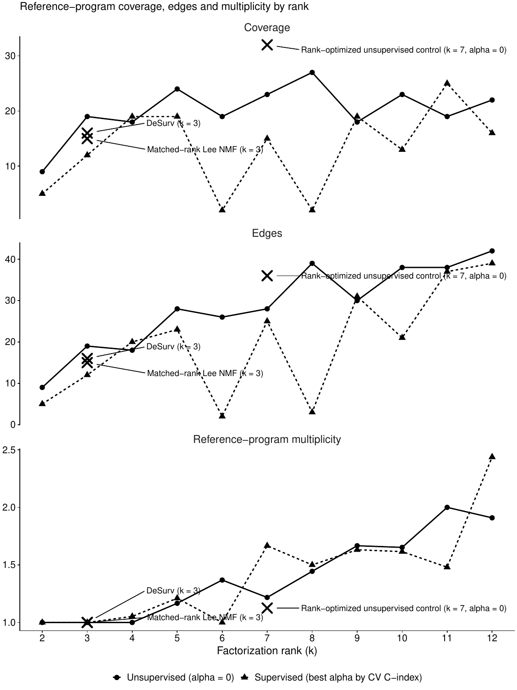
Reference-program coverage, edges and multiplicity by factorization rank $k$, for the unsupervised ($α=0$) and supervised (best $α$ by cross-validated C-index) curves, computed from the same factor-to-reference-program correspondence analysis as Fig. [fig:fig-nmf-k7-heatmap] and main-text Fig. 2a,b (top 50 genes per factor, $ ho > 0.2$ threshold, same reference-program universe). Rank-wise points are single fits at fixed $λ$, $ξ$ and $n_{\text{top}}$, not the 100-restart consensus fits used elsewhere; markers denote the three final-model anchors (the consensus fits for DeSurv $k=3$ and the rank-optimized unsupervised control $k=7$, and the best-of-30-run NMF::nmf fit at matched rank $k=3$).
Dataset | DeSurv ($k=3$) | standard NMF ($k=3$) | Matched-budget control ($k=3$, $α=0$) | standard NMF ($k=5$, elbow) | Rank-optimized control ($k=7$, $α=0$)
Dijk | 0.607 | 0.542 | 0.516 | 0.633 | 0.631
Moffitt | 0.562 | 0.521 | 0.516 | 0.552 | 0.578
PACA-AU array | 0.649 | 0.470 | 0.462 | 0.657 | 0.669
PACA-AU RNA-seq | 0.634 | 0.430 | 0.412 | 0.679 | 0.702
Puleo | 0.636 | 0.534 | 0.533 | 0.642 | 0.651
External validation C-index by method and validation dataset. DeSurv at the one-standard-error-selected rank ($k=3$) is compared with standard NMF at matched rank ($k=3$) and at elbow-selected rank ($k=5$), with the matched-budget unsupervised control ($k=3$, $α=0$) and with the rank-optimized unsupervised control ($k=7$, $α=0$). The unsupervised columns are not all produced by one implementation: the two standard NMF columns are NMF::nmf, whereas the two controls are the DeSurv optimizer run at $α=0$ with the same consensus-initialization procedure as the supervised model. The matched-budget column is the tuning-budget control: it holds rank, optimizer, consensus-initialization procedure and Bayesian-optimization budget fixed while re-optimizing the remaining hyperparameters with $α=0$. Its external discrimination is no better than that of NMF::nmf at the same rank, a comparison made across the two implementations described here. Higher values indicate better discrimination. Every method was scored on the union of its own factors’ top-$n_{\text{top}}$ gene supports at the supervised model’s $n_{\text{top}}=270$, the same construction as the pooled hazard ratios, main-text Table [tab:hr-adjusted] and Table [tab:het-ci]. Scoring the matched-budget control at its own tuned $n_{\text{top}}=299$ instead changes no per-dataset C-index by more than 0.007; the rank-optimized control was likewise scored at 270 rather than at its own tuned $n_{\text{top}}=187$.
Cohort | $n$ | Deaths | HR per within-cohort SD (95% CI) | C-index (95% CI)
Dijk | 90 | 81 | 1.32 (1.06–1.66) | 0.607 (0.531–0.679)
Moffitt | 123 | 83 | 1.20 (0.98–1.48) | 0.562 (0.478–0.639)
PACA-AU | 69 | 43 | 1.46 (1.09–1.96) | 0.630 (0.541–0.745)
Puleo | 288 | 181 | 1.37 (1.18–1.59) | 0.636 (0.594–0.678)
Combined | 570 | 388 | — | 0.613 (0.579–0.646)
Cohort-specific external-validation estimates for the frozen DeSurv linear predictor, on the de-duplicated patient-level table (570 unique patients, 388 deaths; PACA-AU represented once, RNA-seq retained). Hazard ratios are per standard deviation of the linear predictor computed within that cohort, the convention used for the interaction test, so they are not comparable to the pooled-standard-deviation hazard ratio in main-text Table [tab:hr-adjusted]. C-index confidence intervals are percentile intervals from 1000 stratified bootstrap replicates (seed 1) resampling within cohort; the combined C-index is the event-weighted mean of the four cohort values.

Stromal resolution: which reference programs are recovered from bulk
Bulk deconvolution has conventionally separated activated from normal stroma, whereas the finer cancer-associated fibroblast states, and the proCAF/restCAF classification derived from them, were established in single-cell data. We therefore asked which stromal reference programs each $k=3$ factorization actually resolves. Two views are reported because they do not agree, and the defensible claim depends on which question is asked.
In the top-gene view shown in main-text Fig. 2a,b, which asks whether signature genes are represented among the 50 genes that define each factor, the activated-stroma program is recovered comparably by all methods (7, 6 and 10 of 206 genes for DeSurv, standard NMF and the matched-budget control). The restraining-stroma programs behave differently: 2 of 25 restCAF genes and 2 of 35 iCAF genes appear among DeSurv’s defining genes, against 0 and 0 for standard NMF. The proCAF programs, by contrast, are recovered comparably by all methods (4 versus 3 of 25 genes).
In the full-gene view, which correlates loadings across all 1,970 analyzed genes with signature membership, no method separates restCAF from proCAF: every correspondence lies between $0.04$ and $0.10$, whereas the activated-stroma axis is recovered by all methods at $0.19$. This view is far more dilute for a 15–25 gene signature among 1,970 genes and correspondingly low powered, but it bounds what can be claimed. We therefore report the restraining-stroma difference as marker-gene presence among the defining genes of each factorization, and do not claim to have resolved the single-cell CAF states from bulk expression.
Note also that the SCISSORS iCAF and myCAF reference signatures are displayed as restCAF and proCAF in main-text Fig. 2, following the naming used by the DeCAF classification; the underlying gene sets are the single-cell-derived ones.

Matched-budget unsupervised control at the same rank
The matched-rank comparison in the main text uses Lee multiplicative NMF (NMF::nmf with nrun = 30, which returns the single run of the thirty with the lowest reconstruction residual), which receives neither DeSurv’s consensus initialization nor its hyperparameter tuning. That asymmetry leaves open whether the difference in factor structure reflects tuning effort rather than supervision. We therefore fit an unsupervised factorization control matched to DeSurv on rank, optimizer, search budget, gene filter, cross-validation folds, consensus procedure and stopping settings. With $α$ fixed at $0$ and the rank fixed at DeSurv’s selected $k=3$, the remaining hyperparameters were re-optimized within this otherwise identical pipeline, and the resulting model was fit by the same 100-restart consensus procedure used for DeSurv. This comparison isolates removal of survival supervision at the pipeline level rather than holding all non-supervision hyperparameters numerically fixed; the sensitivity analysis below holds DeSurv’s $λ$, $ξ$ and $n_{\text{top}}$ fixed and varies only $α$. Because both $α=0$ controls are fit by the DeSurv optimizer, they share its stopping settings (tolerance ${10}^{−7}$ on the cosine change of $W$ and of $H$, at most 4,000 outer iterations), whereas NMF::nmf stops on its own connectivity-based stationarity criterion (40 consecutive checks without a change in the connectivity matrix) under a $2,000$-iteration cap.
The control selected $λ=0.0025$, $ξ=0.0566$ and $n_{\text{top}}=299$; note that its gene support was selected near the upper bound of the search range ($300$), whereas the supervised model settled at $n_{\text{top}}=270$ well inside it. At $α=0$, $λ$ and $ξ$ govern the post hoc Cox fit rather than entering the factorization objective. These are tuning-selected values and not the values used for external scoring. Both $α=0$ controls were scored on the union of their own factors’ top-gene sets at the supervised model’s common $n_{\text{top}}=270$ rather than at their own tuned $299$ (this control) and $187$ (the rank-optimized $k=7$ control), so the primary factorization comparison used a common number of top genes per program when constructing each model’s scoring union; total union size can still differ with rank and overlap among programs. Scoring this control at its own tuned value instead changes no per-dataset C-index by more than 0.007 (Supplementary Table [tab:tab-cindex-comparison]).
The control does not recover D1. Its best-matching factor reaches Spearman $ρ=0.24$ against D1, slightly lower than the $ρ=0.36$ attained by NMF::nmf at the same rank, while still recovering D2 ($ρ=0.86$) and D3 ($ρ=0.75$). Its external discrimination is likewise no better than NMF::nmf at $k=3$ (Table [tab:tab-cindex-comparison]). A sensitivity analysis holding the supervised model’s own $λ$, $ξ$ and $n_{\text{top}}$ fixed and varying only $α$ gave the same conclusion. Matching the tuning budget therefore does not close the representational gap, supporting survival supervision rather than tuning effort alone as the source of the reorganization reported in the main text.
standard NMF at elbow-selected $k=5$ and the rank-optimized unsupervised control at $k=7$ both substantially improve over standard NMF at $k=3$ across all cohorts (Table [tab:tab-cindex-comparison]); additional unsupervised factors capture prognostically relevant variation missed at the matched rank. At $k=7$, the rank-optimized control exceeds DeSurv’s C-index in all five validation datasets, so unsupervised factorization given more factors discriminates at least as well as the supervised three-program model. The comparison also differs in representation size: the $k=7$ control represents a broader set of established programs across seven factors (Fig. [fig:fig-nmf-k7-heatmap]; Supplementary Fig. [fig:fig-rpm]) rather than concentrating the prognostic signal in three programs. Both the $k=7$ control and the DeSurv linear predictor retain significant prognostic value after adjustment for established classifiers (main-text Table [tab:hr-adjusted]); DeSurv does so with fewer factors. Both models selected their rank by the same one-standard-error rule applied to their own Bayesian-optimization results; seven is the smallest rank at which the $α=0$ search came within one standard error of its best configuration (which had rank 11), not a general minimum rank for unsupervised recovery of comparable prognostic information.

Supplementary Data: factor-specific gene lists
As Supplementary Data, Tables [tab:gene-list-270-D1]–[tab:gene-list-270-D3] list the top 270 genes for each of the three DeSurv factors, ranked by the factor specificity score $s_{ij}$ defined in Supplementary Information, Section [sec:gene-program-correlation]. The 270-gene cutoff corresponds to the Bayesian optimization–selected projection dimension ($n_{\text{top}}=270$); these are the genes used to compute sample-level factor scores for survival prediction.
Gene symbols in these tables are retained as distributed with the source expression matrices compiled for the training and validation cohorts (Section 6) and were not updated to current HGNC nomenclature; several therefore appear under previous symbols (for example SEPT11, WISP1, CYR61 and H1F0). Because the analysis set was selected for high mean expression as well as high variance, abundantly expressed ribosomal-protein and housekeeping genes are eligible for the factor supports, and some appear among the D2 and D3 defining genes (for example RPS26 and RPS28 in D2; RPS16, RPS21, RPL28 and GAPDH in D3); they enter the supports through the factor-specificity ranking and are not excluded post hoc. In the fitted model, each factor had at least $270$ genes with positive factor specificity (284, 401, 1,285 for D1, D2 and D3). Because this specificity can be positive for at most one factor, the three top-$270$ sets were disjoint, yielding an 810-gene projection support. Factor D1 is enriched for classical tumor and restCAF-like stromal genes, Factor D2 for proCAF-associated stromal genes, and Factor D3 for basal-like tumor genes.
Factor D1 (classical tumor + restCAF-like stroma)
1–45 | 46–90 | 91–135 | 136–180 | 181–225 | 226–270
DMBT1 | FGFR2 | GOLGA8A | PTPRN2 | RPL9 | PPP1R12B
IGFBP2 | COL9A2 | IL2RG | FCGBP | CD79A | PIP5K1B
S100A4 | COL22A1 | KIAA1211 | PLA2G2A | PROM1 | AHCYL2
KRT23 | IRF7 | SFRP1 | FABP4 | SCD | SST
LIF | SBNO2 | ADH1B | EPPK1 | TMC5 | CYP3A5
IFI6 | MGAT3 | MFSD2A | CPXM2 | CCL14 | SMAP2
PDLIM3 | SYNM | CLU | KIF1A | PLXNB1 | ZG16B
CLDN18 | APOD | CLMN | NGFR | TMEM119 | SERPINF1
MYO15B | SEMA6A | CHPF | NFKBIA | SORBS2 | CLDN3
SYT8 | TNXB | MTMR11 | SPOCK2 | C7 | NR1I2
TFF2 | PTGIS | TTR | ATP2C2 | SLC12A7 | JUND
TMPRSS2 | CCL18 | WFDC2 | NBEAL2 | QSOX1 | NCF2
CHGB | ZC3H12A | C2orf72 | CAPN9 | UNC5CL | CELSR1
CST1 | CELSR3 | CCND2 | PTGDS | LONRF2 | MUC17
B3GNT7 | EMB | ARHGAP4 | LSP1 | VSIG2 | INPP5D
F5 | KCNJ15 | PKDCC | LAMA5 | ADAMTSL2 | TM4SF5
TNRC18 | SORBS1 | SRPX | FASN | ARHGEF16 | HNF4A
IGF2 | PAQR8 | CCL21 | GFRA1 | PCOLCE | CFD
ARSD | SLC4A4 | CARD11 | PTPRH | CFC1B | HCLS1
ZDHHC7 | ACSS1 | CTRB2 | FMOD | SLC9A3 | SH3PXD2B
LENG8 | ST6GALNAC1 | GOLGA8B | FHL1 | ACACB | PCSK2
ATP9A | DES | IYD | PCDH20 | BCAS1 | HMGCS2
TMPRSS3 | PRUNE2 | CORO1A | CCR7 | RASD1 | FILIP1L
CES1 | PLCB4 | SAA2 | CHIT1 | LGALS4 | ETNK1
HOPX | CADPS | CDCA7 | PARM1 | MS4A1 | TNNI2
CNN1 | FMO5 | BOC | ITM2A | CAPN6 | TOX3
MIA | RAP1GAP2 | LTB | NAPSB | SCCPDH | FRZB
CRIP2 | GALNT12 | COMP | AGT | PTPRCAP | HABP2
NEURL1B | CCL2 | MANSC1 | FUT3 | VNN1 | GDA
CHGA | REG3A | SLC19A3 | SIPA1L2 | PI16 | NCOR2
ACTG2 | ZCCHC24 | STEAP2 | SPINK5 | SEMA7A | DNAH2
CXCL14 | LTF | FOXA1 | ACSL1 | IL10RA | DOK4
TPPP3 | EFHD2 | WNK2 | BTNL8 | GALNT3 | HOXB9
PIGR | ATP11A | SELL | CORO2A | GOLM1 | KIAA1324
CYP27A1 | GP2 | PLEKHA6 | LAD1 | TNFAIP2 | TRIM2
ADAM8 | HIPK2 | NFASC | TMEM63A | CD79B | FGFBP1
FGFR3 | SLC26A9 | EGR3 | GC | ENPP2 | IRX3
IGF1R | TACC2 | PLIN4 | C1orf21 | SQLE | TINAGL1
PLEKHB1 | TRAK1 | WDR72 | MIF | KLF4 | SFRP4
CPXM1 | SAA1 | AMY2A | FOXA2 | PDLIM7 | APLNR
ATP7B | CLDN23 | IL16 | CCL19 | FOSB | AGRN
SLC12A2 | FOXJ1 | TJP3 | GSTA1 | RHPN2 | SLC25A25
CCL20 | FRY | SLC9A2 | LLGL2 | SCG2 | PODN
AKNA | GATA6 | LMOD1 | ACP5 | EMILIN1 | ITIH2
COL16A1 | PLXNA2 | CPS1 | UGT2B15 | BACE2 | FLJ23867
Top 270 genes for DeSurv factor D1, classical tumor and restCAF-like stroma, ranked by factor specificity score $s_{ij}$. The 270-gene cutoff corresponds to the Bayesian optimization–selected projection dimension ($n_{\text{top}}$).
Factor D2 (proCAF-like stroma)
1–45 | 46–90 | 91–135 | 136–180 | 181–225 | 226–270
UHMK1 | RPS26 | SAMD9L | ATP8A1 | IRF6 | RASSF2
DDR2 | MYLK | DOCK2 | TGFBR1 | KLHL6 | ZNF83
INHBA | COL11A1 | IGF1 | SYNPO2 | C1QTNF3 | CYTIP
DYNC2H1 | NFIB | TACC1 | PDE4B | PCLO | SRPX2
ZDHHC20 | PTPN13 | CFH | SGCD | ITGA2 | LY75
ITPR2 | PDE3A | DMD | STK17B | LRIG3 | HLA-DOA
HMCN1 | TRIM22 | PCDH7 | NUAK1 | SSPN | STK38L
LAMA2 | DPYD | MALAT1 | FCGR3A | F2R | RSAD2
SLFN5 | COL14A1 | NOTCH2 | GPNMB | PDGFC | HBB
PLXNC1 | CNTN1 | CDK6 | VCAM1 | CD109 | HERC2P2
SVEP1 | NCKAP1L | FBN1 | ADAMTS9 | CLIC4 | AOX1
CYBB | PHLDB2 | SYNE2 | ITGB8 | SORL1 | PLIN2
SYNE1 | ITGA4 | RHOBTB3 | CR1 | AOAH | PFKFB2
SAMHD1 | MACC1 | CALCRL | SEPT11 | FMO2 | OGN
SKIL | SEMA5A | NRP1 | IFI44L | RDX | DOCK10
ADAMTS12 | MRC1 | LIFR | ELL2 | IL1RAP | RGS4
BICC1 | SLIT2 | STAB1 | GPR183 | GBP1 | AXL
ITGA1 | ZEB2 | FLRT2 | ZBTB16 | CXCR4 | FGD6
COL8A1 | ADAM10 | RNF144A | FRMD6 | WNK1 | CDC42BPA
PDGFRA | SAMD9 | BCAT1 | PDE5A | MFAP5 | SLC6A6
ABCA1 | MS4A7 | CILP | CSF1R | ALDH1A3 | RGS1
TCF4 | EFEMP1 | CCDC80 | PLEK | CD53 | KIAA1324L
CEP170 | BIRC3 | FAT4 | SLK | OMD | CPA3
CD163 | WISP1 | BNC2 | SLC7A2 | PLOD2 | CHL1
MAN1A1 | LAMA4 | LTBP1 | HEG1 | ITGAV | SLC7A11
MSR1 | FAM198B | COL12A1 | GREM1 | MACF1 | GFPT2
CCDC88A | PTPRC | IL1R1 | VGLL3 | NID2 | RAI14
F13A1 | FAP | SLA | GBP5 | NAMPT | LMAN1
RPS28 | ARRDC3 | MBOAT2 | SLC1A3 | ADAM28 | MECOM
RALGAPA2 | MYH10 | FNDC3B | FGF7 | GNE | FPR1
ZEB1 | FCGR2A | PRRX1 | ABCA8 | ENAH | EDEM3
FBXO32 | PARP14 | COL10A1 | ADAM12 | FAM129A | RASSF6
INPP4B | DSE | DDX60 | CYBRD1 | ECM2 | IQGAP2
CDH11 | EHF | DOCK9 | TFRC | VSIG4 | MIAT
PKHD1 | OSMR | SRGN | CTSK | MTAP | PRICKLE1
AKAP2 | ARID5B | FOXO1 | COLEC12 | INMT | CHST15
CYP1B1 | ASPN | MS4A6A | ALDH1L2 | SGMS2 | GEM
CCL5 | SLCO2B1 | ADAMTS2 | PGM2L1 | COL4A4 | CHRDL1
FGL2 | FPR3 | CPVL | FAM135A | CAPRIN2 | DSC2
MAP1B | DOCK8 | CD93 | DOCK11 | CENPF | RAB31
PLXDC2 | SLFN11 | DST | EPHA3 | DCLK1 | SLC38A1
LRRK2 | ZNF532 | CDK14 | PAPPA | EDNRA | CNN3
KIAA0754 | SPON1 | MSRB3 | EGFR | WNT5A | FLT1
EDIL3 | SEMA3C | RNF213 | RASA1 | GALNT5 | TMEM200A
ITGBL1 | FERMT2 | SEL1L | AHR | SLC38A2 | SLC2A3
Top 270 genes for DeSurv factor D2, proCAF-like stroma, ranked by factor specificity score $s_{ij}$.
Factor D3 (basal-like tumor)
1–45 | 46–90 | 91–135 | 136–180 | 181–225 | 226–270
HSPB1 | HLA-H | LAMB3 | MYL9 | IL1RN | SDC1
KRT7 | HSPA1A | FSCN1 | COL17A1 | TST | KLK11
MSLN | LGALS3 | TSPAN13 | EPS8L1 | RAPGEFL1 | PERP
RPSAP58 | FAM83H | TSPAN8 | CDH3 | C15orf48 | ARHGAP23
S100P | EPB41L1 | ALDH3B1 | RNASET2 | PFKP | HPGD
RPS16 | EFNA1 | ANPEP | TUBA1C | STARD10 | AKR1C3
IL32 | TKT | GSTP1 | RAP1GAP | FOXQ1 | CRABP2
SH3BGRL3 | SLC2A1 | KLK10 | H19 | REG4 | GRB7
IFITM2 | PLOD1 | B4GALT1 | LTBP3 | GJB1 | SERPINA4
RPS21 | IER3 | GAS6 | AQP3 | SLC29A1 | SLC39A4
SEMA4B | B3GNT3 | ABCC3 | MPZL2 | NOTCH3 | FA2H
APOL1 | PRSS3 | CLDN2 | ID1 | TRIM16 | RPL8
S100A16 | TOB1 | CEACAM6 | RARRES2 | TAP2 | MT1X
DNAJB1 | EGR1 | CREB3L1 | SLC25A6 | KRT19 | TCN1
MT2A | PLA2G16 | MST1R | RBP1 | CRP | AKAP1
TNFRSF21 | OCIAD2 | CEBPB | HSPA5 | SNHG5 | GJB3
RPL28 | LPCAT4 | TXN | PER1 | KRT18 | DUOXA2
FXYD3 | BST2 | NR4A1 | ADAP1 | CA12 | HLA-DRB5
SERPING1 | EPHA2 | AP1M2 | TMC4 | MYEOV | ARRDC2
HMGA1 | MUC5B | SYNPO | HSD17B2 | P4HB | OAS1
S100A14 | KCNN4 | ANO1 | PTP4A1 | VILL | ADRA2A
H1F0 | ITGA3 | SIK1 | PLAUR | HKDC1 | NQO1
KRT17 | TSTA3 | EFNB2 | ANXA10 | STEAP3 | LRG1
CSTB | IFI27 | CDKN1A | PYGB | PLEK2 | SERPINH1
ASS1 | MMP1 | S100A10 | CYP2S1 | CD68 | COL18A1
EFNB1 | SLPI | PKP3 | ALDOA | MAFF | CERCAM
MDK | CLTB | MCM7 | CDCP1 | CD9 | CA9
LY6E | SPINK1 | RARRES3 | IFITM3 | PLLP | CDHR2
CAMK2N1 | JUP | CEACAM1 | BAIAP2L1 | EPHB4 | ESRP1
MGLL | PPP1R15A | ALDH2 | MGST1 | KRT16 | CRYZ
PDZK1IP1 | TRIM29 | CES2 | TFF1 | ABLIM3 | TAGLN2
BCL2L1 | PPP1R1B | SLC6A8 | MUC4 | PTPRU | HNF1B
C19orf33 | ARPC1A | PPL | MMP28 | MUC6 | BMP4
SFN | GPRC5A | NDRG1 | CLDN1 | FDFT1 | MT1E
ITGB4 | RAB25 | AZGP1 | TM4SF1 | GAPDH | ANGPTL4
TSPAN1 | ZFP36L2 | S100A11 | TFF3 | EPS8L3 | CFB
SLC16A3 | CLDN7 | SEMA3B | UNC13D | CLDN10 | GDF15
C4A | DDIT4 | TNFRSF12A | SERINC2 | ITPKC | PADI1
KLF5 | FKBP4 | SOX9 | SPNS2 | LOXL2 | TMSB10
IER2 | LAPTM4B | PMEPA1 | AQP5 | AMIGO2 | B2M
ZFP36L1 | MUC13 | CYR61 | IGFBP4 | DUOX2 | CAV2
MAL2 | PSCA | EPCAM | SLC7A5 | CLDN4 | CTSH
SCNN1A | SDCBP2 | BHLHE40 | TESC | CAPG | PABPC1
MALL | PROM2 | CX3CL1 | IFITM1 | CEACAM5 | KRT8
BGN | LRRC8A | SMAD3 | KCNK5 | VWA1 | TAP1
Top 270 genes for DeSurv factor D3, basal-like tumor, ranked by factor specificity score $s_{ij}$.

Translational transportability into independent treated PDAC cohorts
The programs were learned in treatment-naive, non-metastatic PDAC, the setting in which the gene-program matrix $W$ and Cox coefficients $β$ were trained. As a translational test we projected the fixed programs, without retraining, into independently treated PDAC and asked whether they retained clinically relevant associations. We used two resources. The first is the O’Kane/COMPASS cohort of treated metastatic PDAC, laser-capture microdissected and therefore epithelial-enriched, which supports a transportability test of the tumor-associated $D_{1}$ direction under a model stratified by treatment arm (Fig. [fig:treated]a). The second is the borderline-resectable or locally advanced Linehan cohort, in which paired pre- and post-treatment biopsies allow a within-patient test of whether the projected $D_{2}$ score changes with therapy (Fig. [fig:treated]b).
Projection used the frozen union support without any retraining. Expression was rank transformed within sample over the genes each cohort shares with the trained gene-program namespace; support genes absent from a cohort were omitted from that cohort’s projection rather than imputed (805 of the support genes were measured in the COMPASS data), and the resulting program scores were standardized within each treated cohort before analysis. Because the omission rule drops rather than imputes missing support genes, a projected score is comparable within a treated cohort but not on the same absolute scale as the training-cohort score.
Each analysis is confined to a single cohort; no estimate is pooled across cohorts. Within O’Kane/COMPASS, arm-specific estimates are reported alongside a common $D_{1}$ slope from a Cox model stratified by treatment arm, which allows arm-specific baseline hazards. The elastic-net penalty shrank the trained survival coefficient for $D_{2}$ to exactly zero in the treatment-naive model (an estimated selection outcome, not an imposed constraint), so the paired analysis is reported as a change in program level and not as evidence that $D_{2}$ predicts survival.

Prognostic transportability of D1 in treated metastatic disease
To evaluate transportability in treated metastatic disease while retaining treatment-arm structure, we projected the frozen DeSurv programs into the O’Kane/COMPASS cohort and first estimated $D_{1}$ associations separately within each arm. Higher $D_{1}$ scores had protective point estimates in all three treatment arms: FOLFIRINOX (HR per SD $0.80$, 95% CI $0.61$–$1.03$), gemcitabine/nab-paclitaxel (HR $0.57$, 95% CI $0.37$–$0.86$) and the GA/experimental arm (HR $0.83$, 95% CI $0.58$–$1.20$; Fig. [fig:treated]a). An arm-stratified Cox model allowing treatment-specific baseline hazards yielded a common association of HR $0.75$, 95% CI $0.62$–$0.90$ ($P=0.003$; 173 patients, 123 deaths), with no evidence of heterogeneity across treatment arms (interaction $P=0.40$). Because these specimens were epithelial-enriched by laser-capture microdissection, this analysis specifically tests transportability of the tumor-associated $D_{1}$ direction rather than the stromal programs.

Treatment-associated change in D2
In the 29 Linehan patients with paired pre- and post-treatment biopsies, the projected $D_{2}$ score increased significantly from pre- to post-treatment (paired Wilcoxon $P=0.013$; mean $Δ=+0.34$ SD; Fig. [fig:treated]b), indicating a shift toward proCAF-associated bulk expression. This bulk analysis cannot distinguish a change in fibroblast state from altered tissue composition.

Caveats
These analyses are exploratory and do not establish treatment-predictive effects; treatment, stage and cohort are confounded, the treated cohorts are modestly sized, and no analysis plan was preregistered. The O’Kane/COMPASS analysis is prognostic within treated metastatic disease, whereas the Linehan analysis tests a paired change in program score. Each analysis is confined to a single cohort, and the O’Kane/COMPASS common slope is estimated within that cohort from a model with arm-specific baseline hazards; it is not a pooled estimate across cohorts. We did not test a survival association for $D_{2}$ in the paired Linehan cohort; this analysis concerns program-level change. The trained survival coefficient was zero, but that alone does not preclude a separate association in another setting. A stromal $D_{2}$ readout is not interpretable in O’Kane/COMPASS, whose specimens are laser-capture epithelium rather than bulk tissue. Its $D_{1}$ result chiefly supports transport of the tumor-associated component of the score. Robust treated-cohort validation, and any assessment of whether the programs predict differential treatment benefit, will require larger harmonized series with adequately powered treatment-by-program interaction analyses.

SI References
1. Lee, D. D. & Seung, H. S. Algorithms for non-negative matrix factorization. in Advances in neural information processing systems 13 (NIPS 2000) (eds. Leen, T. K., Dietterich, T. G. & Tresp, V.) 556–562 (MIT Press, 2001).
2. Pascual-Montano, A., Carazo, J. M., Kochi, K., Lehmann, D. & Pascual-Marqui, R. D. Nonsmooth nonnegative matrix factorization (nsNMF). IEEE Transactions on Pattern Analysis and Machine Intelligence 28, 403–415 (2006).
3. Simon, N., Friedman, J. H., Hastie, T. & Tibshirani, R. Regularization paths for Cox’s proportional hazards model via coordinate descent. Journal of Statistical Software 39, 1–13 (2011).
4. Donoho, D. & Stodden, V. When does non-negative matrix factorization give a correct decomposition into parts? in Advances in neural information processing systems 16 (NIPS 2003) (eds. Thrun, S., Saul, L. K. & Schölkopf, B.) 1141–1148 (MIT Press, 2004).
5. Laurberg, H., Christensen, M. G., Plumbley, M. D., Hansen, L. K. & Jensen, S. H. Theorems on positive data: On the uniqueness of NMF. Computational Intelligence and Neuroscience 2008, 764206 (2008).
6. Gillis, N. The why and how of nonnegative matrix factorization. in Regularization, optimization, kernels, and support vector machines (eds. Suykens, J. A. K., Signoretto, M. & Argyriou, A.) 257–291 (Chapman; Hall/CRC, 2014).
7. Brunet, J.-P., Tamayo, P., Golub, T. R. & Mesirov, J. P. Metagenes and molecular pattern discovery using matrix factorization. Proceedings of the National Academy of Sciences USA 101, 4164–4169 (2004).
8. Kim, J. & Park, H. Sparse Nonnegative Matrix Factorization for Clustering. https://faculty.cc.gatech.edu/~hpark/papers/GT-CSE-08-01.pdf (2008).
9. Gillis, N. & Glineur, F. Accelerated multiplicative updates and hierarchical ALS algorithms for nonnegative matrix factorization. Neural Computation 24, 1085–1105 (2012).
10. Huang, Z., Salama, P., Shao, W., Zhang, J. & Huang, K. Low-rank reorganization via proportional hazards non-negative matrix factorization unveils survival associated gene clusters. Preprint at https://arxiv.org/abs/2008.03776 (2020).
11. Le Goff, V. et al. SurvNMF: Non-negative matrix factorization supervised for survival data analysis. Preprint at https://hal.science/hal-04975434 (2025).
12. Blei, D. M. & McAuliffe, J. D. Supervised topic models. in Advances in neural information processing systems 20 (NIPS 2007) (eds. Platt, J. C., Koller, D., Singer, Y. & Roweis, S. T.) 121–128 (Curran Associates, Inc., 2007).
13. Raphael, B. J. et al. Integrated genomic characterization of pancreatic ductal adenocarcinoma. Cancer Cell 32, 185–203 (2017).
14. Cao, L. et al. Proteogenomic characterization of pancreatic ductal adenocarcinoma. Cell 184, 5031–5052 (2021).
15. Dijk, F. et al. Unsupervised class discovery in pancreatic ductal adenocarcinoma reveals cell-intrinsic mesenchymal features and high concordance between existing classification systems. Scientific Reports 10, 337 (2020).
16. Moffitt, R. A. et al. Virtual microdissection identifies distinct tumor- and stroma-specific subtypes of pancreatic ductal adenocarcinoma. Nature Genetics 47, 1168–1178 (2015).
17. Bailey, P. et al. Genomic analyses identify molecular subtypes of pancreatic cancer. Nature 531, 47–52 (2016).
18. Puleo, F. et al. Stratification of pancreatic ductal adenocarcinomas based on tumor and microenvironment features. Gastroenterology 155, 1999–2013 (2018).
19. Rashid, N. U. et al. Purity independent subtyping of tumors (PurIST), a clinically robust, single-sample classifier for tumor subtyping in pancreatic cancer. Clinical Cancer Research 26, 82–92 (2020).
20. Peng, X. L. et al. DeCAF defines clinical fibroblast subtypes and multidimensional tumor-stroma crosstalk shaping prognosis and immunotherapy response. Cell Reports Medicine 7, 102611 (2026).
21. Peng, X. L., Moffitt, R. A., Torphy, R. J., Volmar, K. E. & Yeh, J. J. De novo compartment deconvolution and weight estimation of tumor samples using DECODER. Nature Communications 10, 4729 (2019).
22. Collisson, E. A. et al. Subtypes of pancreatic ductal adenocarcinoma and their differing responses to therapy. Nature Medicine 17, 500–503 (2011).
23. Chan-Seng-Yue, M. et al. Transcription phenotypes of pancreatic cancer are driven by genomic events during tumor evolution. Nature Genetics 52, 231–240 (2020).
24. Maurer, C. et al. Experimental microdissection enables functional harmonisation of pancreatic cancer subtypes. Gut 68, 1034–1043 (2019).
25. Elyada, E. et al. Cross-species single-cell analysis of pancreatic ductal adenocarcinoma reveals antigen-presenting cancer-associated fibroblasts. Cancer Discovery 9, 1102–1123 (2019).
26. Leary, J. R. et al. Sub-cluster identification through semi-supervised optimization of rare-cell silhouettes (SCISSORS) in single-cell RNA-sequencing. Bioinformatics 39, btad449 (2023).
27. Shapley, L. S. A value for n-person games. in Contributions to the theory of games, volume II (eds. Kuhn, H. W. & Tucker, A. W.) 307–317 (Princeton University Press, 1953).
28. Uno, H., Cai, T., Pencina, M. J., D’Agostino, R. B. & Wei, L. J. On the C-statistics for evaluating overall adequacy of risk prediction procedures with censored survival data. Statistics in Medicine 30, 1105–1117 (2011).
29. Antolini, L., Boracchi, P. & Biganzoli, E. A time-dependent discrimination index for survival data. Statistics in Medicine 24, 3927–3944 (2005).
30. Blanche, P., Kattan, M. W. & Gerds, T. A. The c-index is not proper for the evaluation of $t$-year predicted risks. Biostatistics 20, 347–357 (2019).

