DeSurv identifies a replicable tumor–stroma prognostic architecture in pancreatic cancer through survival-supervised matrix factorization
Abstract
Pancreatic ductal adenocarcinoma (PDAC) outcomes reflect malignant and stromal biology, yet transcriptomic programs are typically discovered without patient outcomes. The programs dominating expression variation are therefore not necessarily the ones most relevant to survival. We developed DeSurv, a survival-supervised matrix factorization that incorporates outcome into gene-program estimation and fixes the gene weights for scoring new cohorts. In pooled TCGA and CPTAC cohorts, DeSurv recovered a three-program tumor–stroma architecture whose dominant survival-aligned direction (D1) linked classical tumor identity with restCAF-like stroma. Applied without refitting to five external datasets spanning four independent cohorts, the frozen representation remained prognostic (HR per SD, 1.42; 95% CI, 1.26–1.59), including after PurIST and DeCAF adjustment. Unsupervised factorization matched on program number and tuning budget did not recover D1, implicating survival supervision rather than model size or tuning effort. In simulations with known structure, DeSurv more accurately recovered prognostic genes when survival signal contributed little transcriptomic variation.
Pancreatic ductal adenocarcinoma (PDAC) is among the most lethal solid tumors¹. Bulk transcriptomic studies have identified clinically relevant malignant and stromal states in PDAC: basal-like and classical tumor programs^{2–4}, and tumor-promoting proCAF and tumor-restraining restCAF stromal programs⁵. Single-cell and spatial profiling have further shown that this heterogeneity extends across malignant, stromal, immune, and other microenvironmental compartments within individual tumors^{6–8}. It remains unclear whether a survival-aligned tumor–stroma direction provides prognostic information beyond existing subtype classifications. Such programs are typically discovered without outcome information and tested against survival only afterward^{2,9}.
Addressing this question requires large cohorts with survival-annotated transcriptomic data, which in PDAC are still derived primarily from bulk profiling¹⁰. Bulk profiles, however, mix signals from malignant and microenvironmental cells¹¹. Nonnegative matrix factorization (NMF) and related deconvolution methods separate these composite profiles into interpretable gene programs: weighted sets of co-varying genes that together form a representation of the tumor transcriptome^{3,12–14}. In PDAC, such methods have yielded molecular subtypes^{2,4,9}, virtual microdissection of basal-like and classical malignant programs³, and compartment-specific tumor–stroma deconvolution^{5,14}. The practical challenge is therefore not simply to resolve interpretable gene programs. It is to let survival shape the programs as they are learned, to retain a decomposed representation rather than only a risk score, and to test those same programs, unchanged, across independent studies.
Standard NMF learns gene programs by minimizing reconstruction error, the mismatch between the measured expression matrix and the approximation rebuilt from the programs. Such reconstruction-driven criteria favor patterns that capture prominent expression variation whether or not that variation is related to survival^{15,16}. This is particularly important in PDAC, where bulk tumors contain substantial stromal, exocrine, and other non-malignant signals that can dominate transcriptomic variation and obscure less prominent but prognostically relevant programs^{4,5,17,18}. Reconstruction alone also does not uniquely determine the recovered gene programs without additional constraints^{19–21}, which may contribute to cross-study variability among unsupervised PDAC subtype taxonomies²². Consequently, establishing which unsupervised programs are clinically relevant and transportable has required extensive multi-study refinement. In PDAC, the basal-like/classical dichotomy emerged through roughly a decade of iterative subtyping, virtual microdissection, independent cohorts, single-cell analyses and prospective clinical profiling^{2–4,8,10}, and comparable work on stromal CAF subtypes is under way⁵. Conversely, survival-supervised models such as penalized Cox regression and supervised principal components^{15,23} can identify outcome-associated expression patterns without resolving them into biologically interpretable tumor and microenvironmental programs. PDAC subtypes and their single-sample classifiers, however, are defined at the program level^{4,5}.
Here, we present DeSurv, a survival-supervised matrix factorization framework that integrates NMF with Cox regression, moving clinical relevance from a post hoc criterion to one that shapes gene programs during discovery. Because the factorization is sensitive to initialization, solutions from many independent restarts are aggregated to initialize a final fit. The resulting gene weights are then held fixed, or frozen, so the same learned programs can be tested in external cohorts without refitting the representation.
We evaluate DeSurv in PDAC by comparing the resulting representation with unsupervised factorization at matched and higher rank (the number of programs the factorization extracts) and with conventional survival-supervised models (Supplementary Table [tab:architecture]). These comparisons distinguish the contribution of survival supervision from effects of model complexity and tuning. We then test the frozen programs across independent cohorts, determine whether the dominant survival-aligned direction is shared by other supervised approaches, and ask whether it retains prognostic information beyond established PDAC classifiers. Simulations in which the true underlying (latent) programs are known characterize when survival supervision improves recovery of prognostic structure.

Results

DeSurv incorporates survival information into gene-program estimation
DeSurv learns gene programs by balancing reconstruction of the tumor transcriptome with association to patient survival, allowing outcome information to influence which programs are recovered rather than only selecting among programs after unsupervised factorization. After training, the gene weights are fixed so that the same learned programs can be scored and tested in new tumors without refitting the factorization (Fig. [fig:schema]a; Methods).
We trained DeSurv in pooled TCGA and CPTAC PDAC cohorts^{24,25} ($n=273$, 139 events). Hyperparameters were selected by Bayesian optimization^{26,27}, a sequential search algorithm that proposes each new setting from the results of previous ones to optimize a pre-specified objective, here cross-validated concordance (the C-index, the probability that the model ranks a pair of patients in the correct survival order; Methods). Concordance favored intermediate survival supervision over the unsupervised $α=0$ boundary but changed little across the ranks examined (Supplementary Figs. [fig:fig-si-bo-tuning] and [fig:fig-cindex-by-k]). We therefore applied the one-standard-error rule, which takes the most parsimonious model within one standard error of the best, selecting $k=3$; the remaining hyperparameters, including $α=0.334$, were retained from the best configuration (Fig. [fig:schema]b). In contrast, standard unsupervised NMF rank criteria based on reconstruction residuals, cophenetic correlation and silhouette width^{13,28} gave conflicting rank choices in the same data (Supplementary Fig. [fig:fig-nmf-diagnostics]). All model and hyperparameter selection was completed within the training cohorts before the programs were applied to external validation datasets.
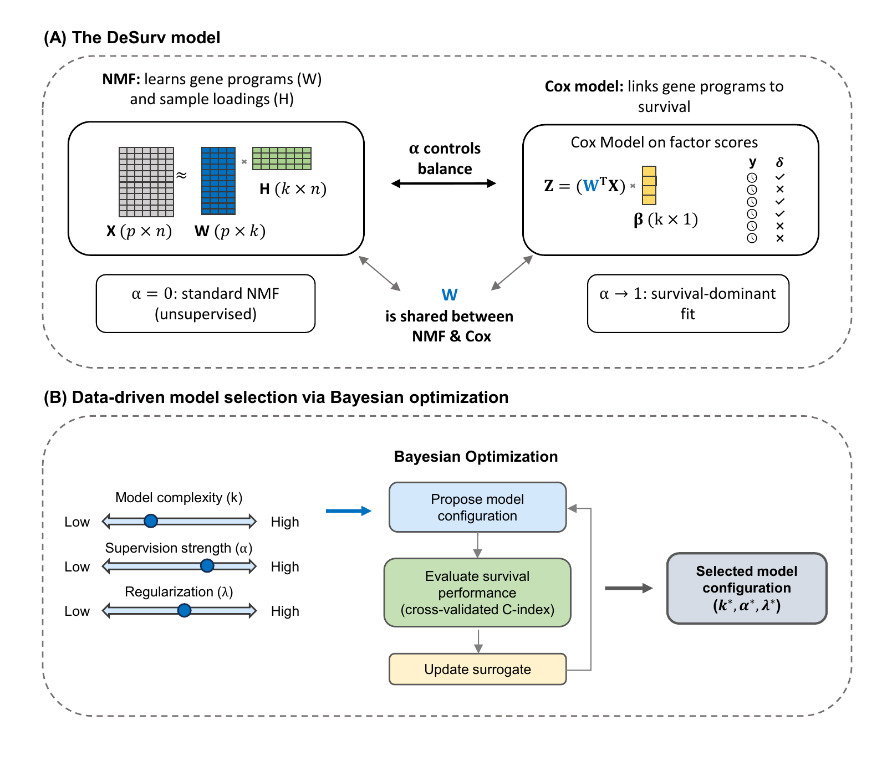
Overview of the DeSurv framework. (a) DeSurv jointly optimizes NMF reconstruction ($X≈WH$) and Cox proportional hazards likelihood. The gene program matrix $W$ is shared between objectives: factor scores $Z=W^{⊤}X$ serve as covariates in the Cox model with coefficients $β$. A supervision parameter $α∈[0,1)$ controls the balance between reconstruction fidelity ($α=0$, the unsupervised limit) and survival prediction ($α$ close to 1). (b) Hyperparameters (rank $k$, supervision strength $α$, regularization $λ$, $ξ$ and $n_{\text{top}}$) are searched by Bayesian optimization over cross-validated concordance; the rank is then chosen by a one-standard-error rule and the remaining hyperparameters are retained from the best configuration (Methods). Survival supervision acts on the gene-program matrix $W$ during discovery, rather than being applied only after an unsupervised factorization has been completed; following training-only model selection, the resulting gene weights are fixed for direct evaluation in external cohorts.

Survival supervision changes the recovered representation at matched complexity
To determine how survival supervision altered the biological representation, we compared DeSurv with standard Lee multiplicative NMF at the same rank ($k=3$), thereby holding model complexity constant. DeSurv resolved three distinct programs (D1–D3): D1, enriched for classical tumor and restCAF-like stromal signatures; D2, enriched for proCAF-like stroma; and D3, enriched for basal-like tumor programs (Fig. [fig:pdac]a). Together, these programs define a tumor–stroma architecture organized around the survival-aligned D1 direction. The classical component of D1 was independently supported in the COMPASS trial cohort, where D1 scores correlated with GATA6 RNA in situ hybridization (Spearman $ρ=0.68$, $P<0.001$, $n=33$; Fig. [fig:pdac]e).
Standard NMF produced a different representation at the same rank (Fig. [fig:pdac]b). Its malignant factor (N1) was enriched for both classical and basal-like tumor programs, its microenvironmental factor (N3) for multiple stromal and immune programs^{29,30}, and a third factor (N2) for exocrine-associated variation. DeSurv instead separated basal-like tumor (D3) and proCAF-like stroma (D2) while recovering the distinct classical/restCAF-like D1 program. Both methods recovered the activated-stroma and proCAF-like reference programs. They differed at the restraining end: among the displayed top-ranked genes, the restCAF and iCAF reference programs corresponded to a DeSurv program but to no standard NMF factor (Fig. [fig:pdac]a,b).
This difference reflected selective reorganization rather than wholesale loss of expression structure. D1 accounted for only $18.8$% of the full model’s reconstruction gain (Shapley shares³¹), the smallest share among the three programs. Yet omitting D1 lowered the Cox partial log-likelihood, the fit criterion of the Cox model, by $66.4$, compared with $1.0$ for D3 and $0.02$ for D2 (Fig. [fig:pdac]c). D3 showed the opposite pattern, accounting for $56$% of the reconstruction gain but little of the fitted survival contribution. Because D1 was estimated using these outcomes, these quantities show where the fitted model placed the survival signal rather than providing an independent test of that signal. In the unsupervised model, the factor contributing most to reconstruction ($42$%) lowered the partial log-likelihood by only $0.06$, and no unsupervised factor lowered it by more than $1.16$. Thus, the programs that best reconstruct the transcriptome need not be those most relevant to survival¹⁸.
The principal NMF tumor and microenvironmental factors corresponded closely to D3 ($ρ=0.84$) and D2 ($ρ=0.87$), whereas D1 correlated only weakly with every matched-rank NMF factor ($ρ≤0.36$; Spearman correlation of gene loadings over all analyzed genes; Fig. [fig:pdac]d). Consistently, D1 was poorly reconstructable from the full set of NMF factors ($R^{2}=0.09$; Supplementary Table [tab:projection-r2]). DeSurv nevertheless reconstructed the analysis matrix only modestly less completely than matched-rank NMF ($R^{2}$ 0.75 versus 0.81, a difference of 6.0 percentage points; Supplementary Table [tab:overall-r2]). Survival supervision therefore preserved most of the variance-dominant tumor and stromal structure while resolving a distinct survival-aligned program, at a measurable cost in reconstruction.
Tuning effort did not appear to explain this difference. We repeated the comparison with the matched-budget unsupervised control, an unsupervised model matched to DeSurv on rank, optimizer, tuning budget and consensus initialization. It again recovered D2 ($ρ=0.86$) and D3 ($ρ=0.75$) but similarly failed to recover D1 ($ρ≤0.24$).
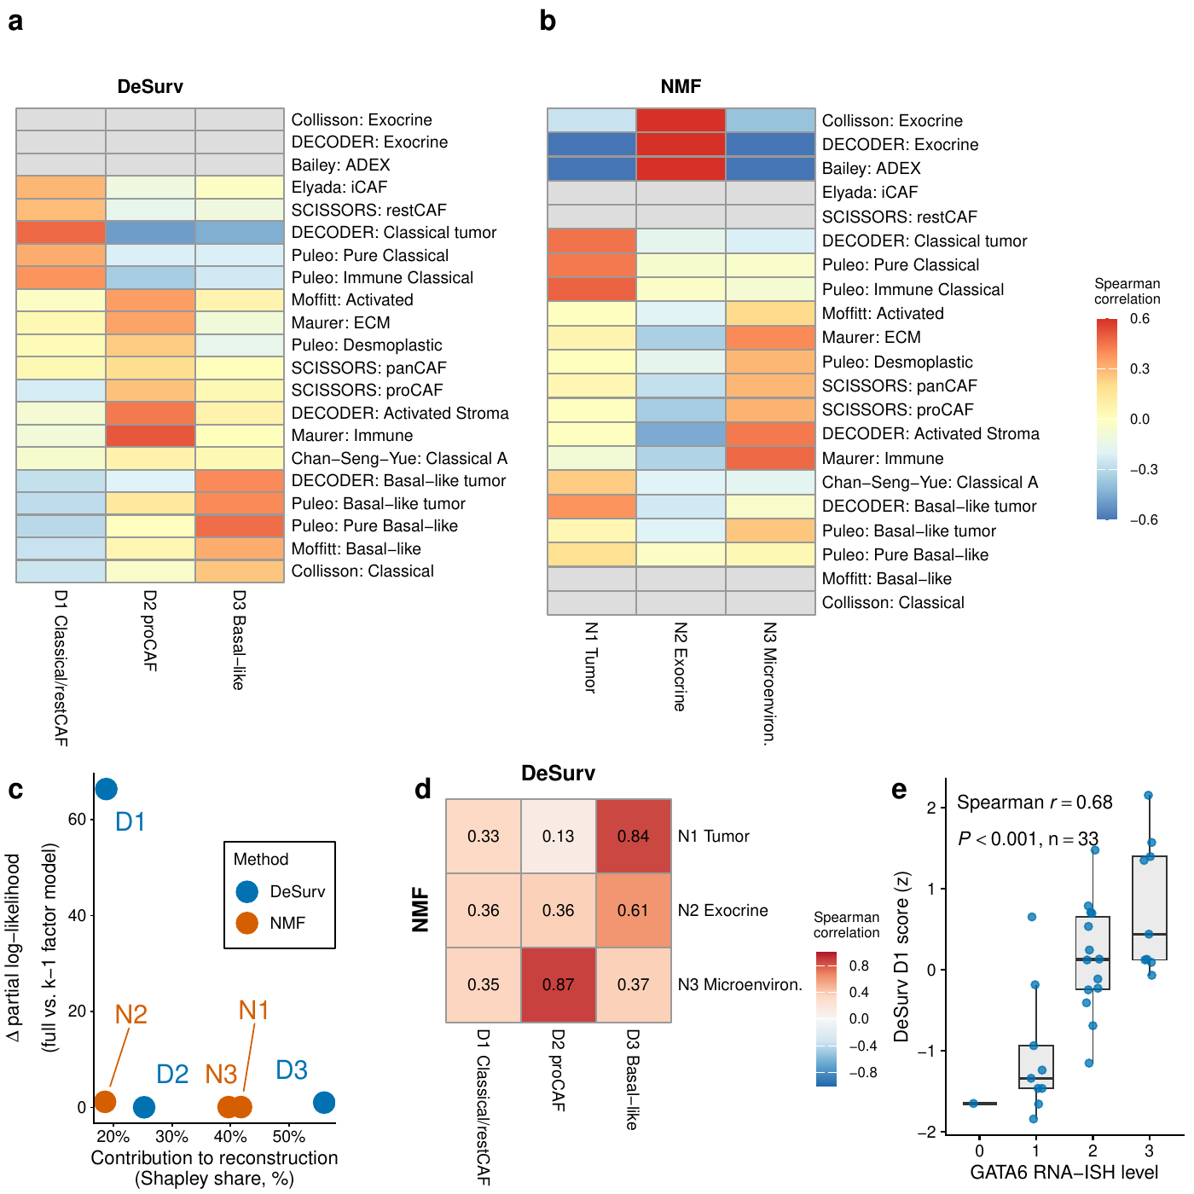
Survival supervision produces different factor structures in PDAC (TCGA + CPTAC training cohort, $n=273$ patients, 139 events). (a,b) Spearman correlations between factor gene rankings (top 50 genes per factor) and established PDAC gene programs for DeSurv (a) and standard NMF (b) at $k=3$. Both panels display the same rows, the union of reference programs correlating at Spearman $ρ>0.2$ with at least one factor of either method; grey cells denote programs with none of their genes in that method’s displayed gene space, where the correlation is not computable. The rows labeled SCISSORS: restCAF and SCISSORS: proCAF display the SCISSORS iCAF and myCAF gene sets under the naming used by the DeCAF classification (Supplementary Information). (c) Per-factor reconstruction contribution (normalized Shapley share, summing to 100%) versus survival contribution ($Δ$ Cox partial log-likelihood on factor removal). Because D1 was estimated using these survival outcomes, its increment describes where the model placed the survival signal rather than testing whether that signal is real. (d) Pairwise correspondence between NMF and DeSurv factors (Spearman correlation of W-matrix gene loadings over all genes). (e) DeSurv D1 score versus GATA6 RNA in situ hybridization level in the COMPASS cohort (Spearman correlation; $n=33$).

Frozen programs retain prognostic relevance across independent PDAC cohorts and transport to treated disease
We next projected the frozen programs into five external validation datasets from four independent, non-metastatic, treatment-naive PDAC cohorts (Dijk, Moffitt, PACA-AU [array and RNA-seq], and Puleo; Supplementary Table [tab:cohorts]). Each tumor was scored by projecting its expression onto the trained programs, restricted to their top-ranked genes ($Z={\tilde{W}}^{⊤}X_{\text{new}}$; Methods). Combined analyses represented each patient once, yielding $570$ unique patients and 388 deaths (Methods).
D1 had protective point estimates in all five validation datasets and was the only individual DeSurv program associated with survival in the combined cohort-stratified analysis (HR per SD $0.75$, 95% CI $0.68$–$0.83$, $P$ < 0.001). D3 had hazard ratios above 1 in four of the five datasets but was not associated with survival either individually or in the combined analysis ($1.09$, 95% CI $0.98$–$1.21$, $P=0.10$). D2 was near-null overall ($1.02$, 95% CI $0.92$–$1.12$, $P=0.76$) and showed greater variation across datasets (Fig. [fig:val]a). None of the three standard NMF factors at the same rank was associated with survival in the combined analysis (HRs 0.94–1.00; Fig. [fig:val]a, right).
The trained DeSurv linear predictor combines D1 and D3, with coefficients oriented so that higher values indicate higher risk; the elastic-net penalty set the D2 coefficient to exactly zero. It was associated with overall survival in the cohort-stratified analysis (pooled HR per SD 1.42, 95% CI $1.26$–$1.59$, $P=5.4×{10}^{−9}$; Table [tab:hr-adjusted]). Scaled Schoenfeld residuals indicated attenuation of this association over follow-up ($χ^{2}=14.7$, 1 df, $P=1.3×{10}^{−4}$; Supplementary Information, Proportional-hazards diagnostic), so the pooled hazard ratio should be interpreted as a time-averaged summary rather than a constant multiplicative effect. Leave-one-dataset-out estimates were similar (HRs 1.34–1.45; Fig. [fig:val]a).
Allowing cohort-specific slopes did not improve fit over a common slope (likelihood-ratio $χ^{2}=1.5$, 3 df, $P=0.69$; score standardized within cohort), and the four cohort estimates were descriptively homogeneous (Cochran $Q=1.5$, $I^{2}=0$%). Event-weighted discrimination across cohorts was moderate (C-index $0.61$, 95% CI $0.58$–$0.65$). In a sensitivity analysis with in-sample recalibration of the frozen score within each cohort (apparent rather than out-of-sample prediction error), the integrated Brier score was $0.159$ compared with $0.168$ for a Kaplan–Meier reference (index of prediction accuracy $5.4$%; Supplementary Information).
We next asked whether comparable prognostic information could be recovered without survival-supervised factorization. At DeSurv’s rank, the matched-budget unsupervised control was not associated with survival (Table [tab:hr-adjusted]). More generally, DeSurv reached near-maximal cross-validated concordance at the lowest ranks examined, with little change as additional factors were added, whereas the unsupervised limit ($α=0$) improved progressively with rank and approached DeSurv only at higher-rank solutions (Supplementary Fig. [fig:fig-cindex-by-k]).
The rank-optimized unsupervised control (the same pipeline at $α=0$ with rank selected by Bayesian optimization, $k=7$) also represented a broader set of established PDAC programs. Reference-program coverage increased from 16 for DeSurv at $k=3$ to 32 for the $k=7$ control, while multiplicity remained low (1.00 versus 1.125; Supplementary Figs. [fig:fig-nmf-k7-heatmap] and [fig:fig-rpm]). Higher rank therefore broadened biological representation rather than repeatedly mapping additional factors to the same programs. Survival supervision was not required to recover prognostic signal, but DeSurv represented comparable prognostic information with three rather than seven factors (Table [tab:hr-adjusted]; Supplementary Table [tab:tab-cindex-comparison]).
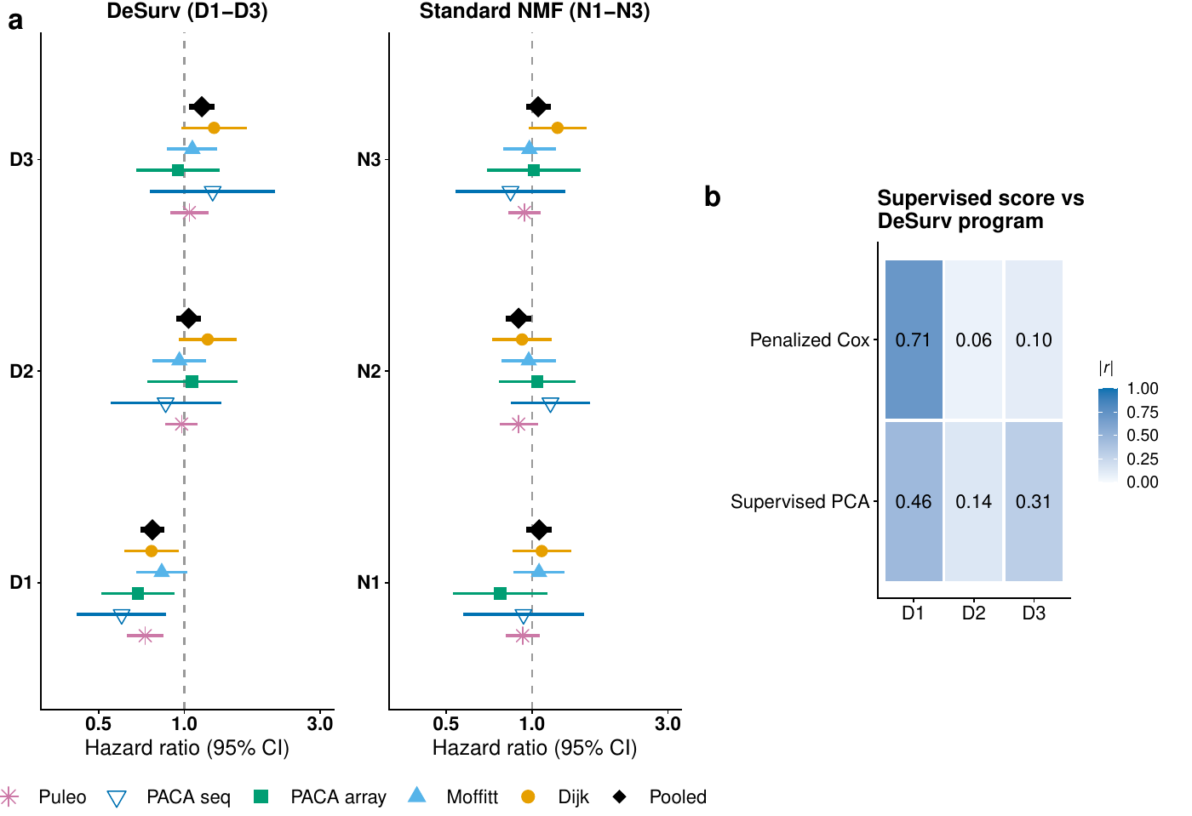
Survival-aligned programs generalize across independent PDAC patient cohorts (five external validation datasets: Dijk, Moffitt GEO array, PACA-AU array, PACA-AU RNA-seq and Puleo; combined $n=570$ unique patients, 388 deaths, with PACA-AU patients profiled on both platforms represented once via RNA-seq). (a) Forest plot of per-dataset univariate hazard ratios (95% CIs) for each DeSurv program (left) and standard NMF factor (right); the platform-specific PACA-AU array and RNA-seq estimates are shown separately, and the black diamonds denote the combined estimate over unique patients (per-factor cohort-stratified Cox on the de-duplicated patient-level data; PACA-AU array duplicates excluded). Puleo is the largest contributor, supplying $288$ of the $570$ unique patients (51%), which is why the combined estimate is also reported with each dataset omitted in turn; those leave-one-dataset-out estimates range from $1.34$ to $1.45$. (b) Correspondence ($|$Pearson $r|$) of tuned supervised risk scores (penalized Cox and supervised PCA) with the three DeSurv programs (D1–D3); supervised scores concentrate on D1 and are only weakly correlated with the D2 stromal program. No validation-cohort survival outcomes were used in training, scoring or hyperparameter selection.
Method | Unadjusted HR per SD (95% CI), $P$ | Adjusted HR per SD (95% CI), $P$
DeSurv ($k=3$) | 1.42 (1.26–1.59), $<0.001$ | 1.28 (1.11–1.47), $<0.001$
Matched-budget unsupervised control ($k=3$, $α=0$) | 1.04 (0.94–1.16), $0.428$ | 0.98 (0.88–1.09), $0.705$
Rank-optimized unsupervised control ($k=7$, $α=0$) | 1.44 (1.30–1.59), $<0.001$ | 1.40 (1.22–1.62), $<0.001$
Pooled external validation of DeSurv and unsupervised controls. Hazard ratios per SD of the linear predictor across five validation datasets spanning four independent cohorts (570 unique patients, 388 deaths). Adjusted models include PurIST and DeCAF and are stratified by dataset; all 570 patients had both classifier calls. The matched-budget control fixes rank at $k=3$, whereas the rank-optimized control uses its Bayesian-optimization-selected rank ($k=7$); both use the same unsupervised $α=0$ pipeline, consensus initialization and tuning budget as DeSurv (Supplementary Table [tab:tab-cindex-comparison]).
To test transport beyond untreated disease, we projected the frozen programs without retraining into two treated PDAC cohorts. In the O’Kane/COMPASS cohort of metastatic disease, D1 remained associated with overall survival in a Cox model stratified by treatment arm (HR per SD $0.75$, 95% CI $0.62$–$0.90$; Fig. [fig:treated]a). In the Linehan cohort, the projected proCAF-like D2 score increased from pre- to post-treatment biopsies (mean change +0.34 SD, paired Wilcoxon $P=0.013$; Fig. [fig:treated]b; Supplementary Information, Translational transportability).
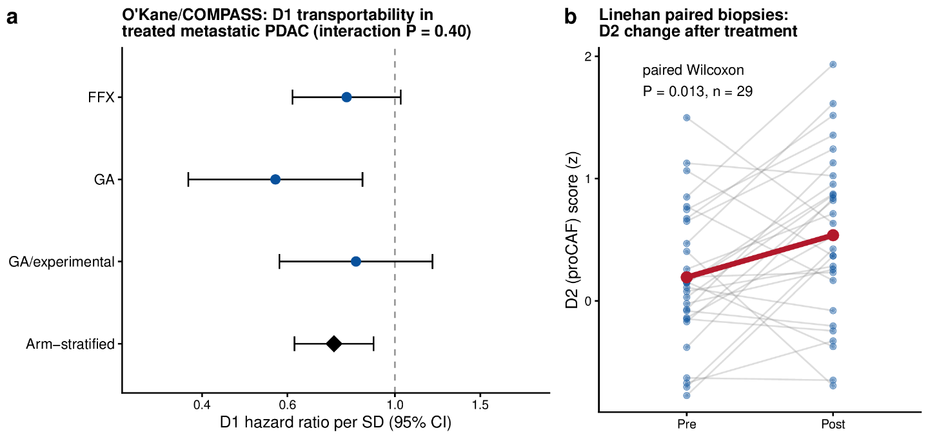
Transportability of the frozen DeSurv programs into independent treated PDAC cohorts. (a) Prognostic transportability of D1 in treated metastatic PDAC. Forest plot of hazard ratios per SD of the frozen D1 score within each O’Kane/COMPASS treatment arm (FOLFIRINOX, gemcitabine/nab-paclitaxel [GA], and GA/experimental); the diamond is the common association estimated across arms from a stratified Cox model with treatment-arm-specific baseline hazards, HR $0.75$ (95% CI $0.62$–$0.90$, $P=0.003$). D1 was protective in all three arms; the arm-by-score interaction was not significant (interaction $P=0.40$), though the individual arms are underpowered for detecting heterogeneity. Error bars denote 95% confidence intervals. (b) The proCAF program D2 before and after treatment in paired Linehan biopsies ($n=29$, paired Wilcoxon $P=0.013$); grey lines are individual patients, the red line the group mean ($+0.34$ SD). Because treatment, stage and cohort were not independently varied, these analyses support prognostic and biological transportability rather than treatment-predictive effects.

The D1 direction is shared across supervised methods and retains prognostic information beyond established PDAC classifiers
We first asked whether D1 simply recapitulated established PDAC subtype classifications. Across the pooled validation cohorts ($n=570$, 388 events), binary PurIST and DeCAF classifications together explained 34% of the variance in the continuous D1 score, and DeCAF alone explained 19%. D1 nevertheless remained associated with survival after simultaneous adjustment for both classifiers (HR per SD 0.82, 95% CI $0.73$–$0.93$, $P=0.0014$). Adding D1 to a stratified Cox model containing additive PurIST and DeCAF terms improved model fit (partial likelihood-ratio $χ^{2}=10.1$, 1 df, $P=0.0015$) and increased concordance from 0.592 to 0.622. These findings support overlap with established tumor-intrinsic and stromal classifications while showing that D1 retains prognostic information beyond those binary classifiers.
Because D1 spans tumor and stromal programs, we also asked whether it primarily reflected tumor purity. In the two datasets with purity estimates for all patients, D1 correlated only weakly with purity (Spearman $ρ=0.06$ and $−0.05$), and adjustment for purity left the linear predictor’s survival association essentially unchanged (HR per SD: PACA-AU array, 1.44 versus 1.45; RNA-seq, 1.66 versus 1.65; Supplementary Table [tab:clinical-adjustment]). These analyses do not establish the cellular identity of the restCAF-like component of D1, which cannot be resolved from bulk expression alone (Supplementary Information, Stromal resolution: which reference programs are recovered from bulk). In Puleo, the largest validation cohort, the DeSurv linear predictor also remained prognostic after adjustment for standard clinical covariates (HR per SD 1.33, 95% CI $1.14$–$1.55$; Supplementary Table [tab:clinical-adjustment]).
We next asked whether D1 was specific to the DeSurv optimizer. When fit as single-component models, three independent survival-supervised approaches (supervised principal components, Cox partial least squares and sparse Cox) produced patient scores strongly correlated with D1 in the training cohort (Pearson $\left|r\right|=0.81$, $0.83$ and $0.85$, respectively). The leading unsupervised principal component was only weakly correlated with D1 ($\left|r\right|=0.10$) and instead tracked the higher-variance D2/D3 structure (Supplementary Information, The D1 axis is not specific to DeSurv). D1 therefore represents a survival-associated expression direction recovered across supervised approaches rather than an idiosyncrasy of DeSurv.
We then asked what DeSurv adds beyond recovery of this shared prognostic direction. Independently tuned supervised principal components and penalized Cox achieved pooled external concordance comparable to DeSurv (C-index $0.60$ and $0.60$ versus $0.61$) and captured the dominant D1-associated direction. Their selected genes, however, were enriched for basal-like tumor programs but not proCAF, restCAF, immune or exocrine programs, and their risk scores correlated only weakly with the separately resolved proCAF-like D2 program (penalized Cox, $\left|r\right|=0.06$; supervised PCA, $\left|r\right|=0.14$; Fig. [fig:val]b; Supplementary Information). Discrimination was therefore comparable; DeSurv’s distinction is that it places the shared prognostic direction within a fixed set of separately measurable tumor and stromal programs that can be applied unchanged to new cohorts.

DeSurv recovers prognostic gene programs when survival signal is not variance-dominant
We used simulations with known latent structure to determine when survival supervision improves program recovery. In the primary scenario, the factor-specific genes driving survival contributed less transcriptomic variation than a shared outcome-neutral background signal ($p=3,000$ genes, $n=200$ samples, true $k=3$; Methods, Simulation studies); the three latent factors were otherwise exchangeable. DeSurv and its unsupervised limit ($α=0$) were tuned using the same cross-validation procedure, providing a controlled comparison of factorization with and without survival supervision.
Under this setting, DeSurv more accurately recovered the genes defining the true prognostic program, whereas unsupervised NMF was more strongly influenced by the variance-dominant background structure (Fig. [fig:sim]a,b). Across 100 replicates, median matched-factor precision for the true prognostic gene set was 0.50 for DeSurv versus 0.07 for unsupervised NMF (Methods). Median test-set C-index was $0.837$ versus $0.724$ ($Δ=0.113$, paired Wilcoxon $P<0.001$), and DeSurv recovered the true factorization rank ($k=3$) more frequently (Fig. [fig:sim]c).
This advantage depended on how strongly prognostic signal aligned with variance-dominant expression structure. It attenuated when the two partially overlapped and disappeared under the null, where neither method identified prognostic signal (Supplementary Fig. [fig:fig-sim-null-mixed]). In the mixed setting, the advantage was greatest for recovery of the factor-specific marker genes rather than the shared background genes that also carried survival signal, supporting a specific effect of supervision on identifying the genes that define the prognostic program.
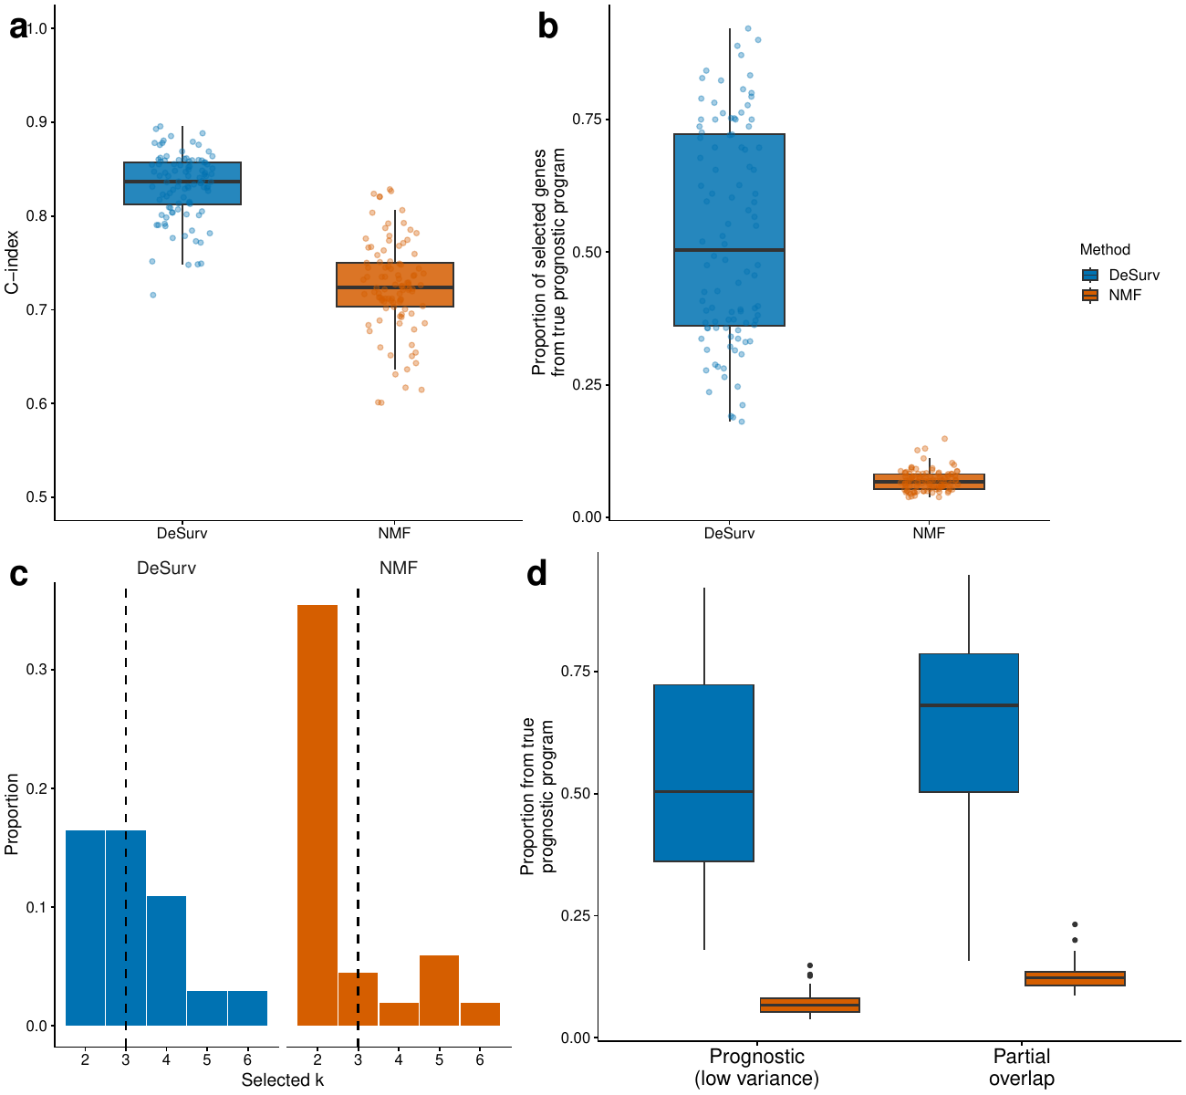
Survival supervision improves recovery of prognostic gene programs when survival signal is not variance-dominant. (a) Test-set concordance across 100 simulation replicates comparing DeSurv with unsupervised NMF ($α=0$; $p=3,000$ genes, $n=200$ samples, true $k=3$; paired Wilcoxon $P<0.001$). (b) Recovery of genes defining the true prognostic program, quantified as the proportion of selected genes in the best-matching learned program that belonged to the ground-truth prognostic gene set. In (a) and (b), boxes show median and interquartile range; whiskers extend to $1.5×$IQR; points are individual replicates. (c) Distribution of selected ranks across replicates for DeSurv versus unsupervised NMF. (d) The same matched-factor precision metric as in (b), computed for two signal regimes: a prognostic program whose genes carry low transcriptomic variance relative to the shared outcome-neutral background (separated from the dominant variance) versus one that partially overlaps the dominant variance. DeSurv recovers the prognostic program more accurately in both regimes, whereas the unsupervised solution is more strongly influenced by the dominant expression structure; the null scenario (no prognostic program) is shown in the Supplementary Information. The concordance gap in (a) is not an expected discrimination gain in real data, where the two approaches perform comparably (Table [tab:hr-adjusted]).

Discussion
DeSurv integrates survival into gene-program estimation while preserving a fixed basis that can be applied unchanged to new cohorts. In PDAC, this identified a dominant survival-aligned program, D1, characterized by coordinated cross-patient variation in classical tumor and restCAF-like stromal features, alongside separately resolved proCAF-like stromal and basal-like tumor programs. D1 was recovered without subtype labels, remained prognostic after adjustment for the established PurIST and DeCAF classifications, so it is not reducible to them, and was supported on its classical tumor side by GATA6 RNA in situ hybridization. The frozen programs then transferred without refitting across four independent external patient cohorts. DeSurv’s contribution is to place a reproducible prognostic direction within a decomposed tumor–stroma architecture whose components can be examined separately. The advance is in how clinically relevant programs are discovered, not in how well they predict.
The representational difference was evident at matched complexity and tuning effort. An unsupervised control given DeSurv’s rank, optimizer, tuning budget and consensus initialization did not recover D1. Higher-rank unsupervised factorization recovered comparable prognostic information across a broader seven-factor representation, while conventional supervised predictors recovered the dominant prognostic direction without separately resolving the stromal programs. These comparisons distinguish prognostic information from the representation in which that information is recovered. Survival supervision was not required to obtain a prognostic signal, but it altered which programs were identified and how that signal was decomposed.
This distinction also clarifies the role of the fixed gene-program basis. In conventional unsupervised discovery, clinical relevance is established only after programs have been learned, through factor selection, biological annotation and cross-study matching. In DeSurv, survival acts directly on the gene-program matrix $W$ while the reconstruction objective requires the learned programs to continue representing the observed transcriptome. Once learned, the gene weights are fixed, so external validation tests the same programs rather than a newly estimated representation. Empirically, supervision reorganized rather than replaced the reconstruction-driven structure. D2 and D3 corresponded closely to the major stromal and tumor factors recovered by NMF, whereas D1 was poorly reconstructable from the matched-rank NMF factors.
This differs from related supervised factorization approaches in where survival information enters the model. CoxNMF and SurvNMF^{32,33} place the survival term on the sample-side latent representation, so scoring a new cohort depends on obtaining sample-side loadings (Methods; Supplementary Table [tab:architecture]). DeSurv instead places supervision on the gene-program matrix and scores new tumors by projection onto a fixed basis. Deep latent-variable survival models^{34,35} similarly learn sample representations rather than a fixed gene-program basis. The distinction is therefore not simply whether survival supervision is used, but whether the supervised object itself can be transported unchanged.
Biologically, D1 is the dominant survival-aligned direction within the broader tumor–stroma architecture rather than the architecture itself. It captures coordinated cross-patient variation in classical tumor and restCAF-like stromal features. D2 and D3 provide separately measurable stromal and tumor context around that direction and do not necessarily represent independent components of the fitted risk score. This organization is consistent with broader evidence that malignant lineage state and stromal composition vary together in PDAC^{36–38}.
Rank selection remains an important source of uncertainty in factorization. Standard NMF criteria gave conflicting rank choices in the PDAC training data, and increasing rank progressively broadened correspondence to established PDAC programs, which may contribute to variability among unsupervised molecular taxonomies across studies^{2,3,9}. Survival supervision does not remove the non-uniqueness of matrix factorization, and individual DeSurv runs from different random starts recover appreciably different gene sets. Reproducibility of the reported decomposition instead comes from the consensus procedure, and independently seeded applications of the full procedure closely reproduced the final programs (Supplementary Information, Stability of the recovered gene programs). Survival supervision therefore provides an outcome-informed criterion for shaping the representation, while consensus initialization addresses instability across individual optimization runs.
The simulations show when that outcome information is most useful. In the primary setting, the factor-specific genes driving survival contributed less transcriptomic variation than a shared outcome-neutral background signal. Under those conditions, DeSurv more accurately recovered the genes defining the true prognostic program than unsupervised NMF. The advantage diminished when prognostic signal overlapped more strongly with variance-dominant structure and disappeared when no survival signal was present. These results support the interpretation of the real-data findings by showing under known truth that survival supervision can change program recovery when clinically relevant genes are not those contributing most strongly to transcriptomic variation. This matters beyond discrimination because the genes assigned to a program determine downstream biological interpretation, candidate signatures and potential biomarker development.
DeSurv is complementary to reference-based deconvolution methods such as CIBERSORTx³⁹ and BayesPrism⁴⁰. Those approaches estimate cellular composition using external cell-state references, whereas DeSurv learns survival-informed latent programs directly from bulk expression without assigning them a priori to cellular compartments.
Several limitations define the scope of the findings. DeSurv uses a proportional-hazards objective, while the external validation data showed attenuation of the prognostic association over follow-up (Results). Extensions could accommodate non-proportional hazards or nonlinear survival relationships. The framework itself is not PDAC-specific, but its representational advantage has so far been evaluated only in PDAC. Establishing generalizability will require multi-cancer benchmarking against unsupervised decompositions and strong penalized-regression baselines, which remain difficult to outperform consistently for out-of-sample prognosis⁴¹.
The treated-cohort analyses were exploratory. In O’Kane/COMPASS, D1 remained prognostic in an analysis stratified by treatment arm, but the individual arms were too small to establish treatment-specific associations. Whether these programs predict differential treatment benefit therefore remains unresolved and will require adequately powered, prespecified treatment-by-program interaction analyses. The increase in the projected D2 score after treatment in the Linehan cohort likewise indicates a shift toward proCAF-associated bulk expression but does not establish a treatment-induced change in fibroblast state.
The tumor–stroma architecture described here is a bulk-tissue phenomenon. It reflects cross-patient covariation in tumor- and stroma-associated transcriptional programs rather than cellular co-expression or spatial adjacency within individual tumors. Purity adjustment, DeCAF adjustment, cross-method recovery and the GATA6 analysis support D1 as a robust survival-associated bulk transcriptional program and independently support its classical tumor component, but they do not establish the cellular identity of its stromal component. Mapping these programs onto specific cellular states will require clinically annotated single-cell or spatial cohorts together with scoring methods suited to sparse and compartmentally mixed measurements.
These results separate prognostic representation from prognostic discrimination. In PDAC, incorporating survival during factorization recovered a three-program tumor–stroma architecture that transferred across independent cohorts while retaining biological components that could be interrogated separately. More generally, DeSurv provides a framework for asking not only whether transcriptomic data predict outcome, but which biological programs are recovered when outcome information helps shape their discovery.

Methods

Problem formulation and notation
Let $X∈R_{≥0}^{p×n}$ denote the nonnegative gene expression matrix. DeSurv approximates $X≈WH$, where $W∈R_{≥0}^{p×k}$ contains nonnegative gene programs and $H∈R_{≥0}^{k×n}$ contains sample loadings. Additionally, let $y∈R_{>0}^{n}$ denote patient survival times, $δ∈\{0,1\}^{n}$ the event indicators ($δ_{i}=1$ for an observed event, $δ_{i}=0$ for censoring), and $β∈R^{k}$ the Cox regression coefficients. Survival outcomes are modeled through a Cox proportional hazards model with factor scores $Z=W^{⊤}X∈R^{k×n}$: for sample $i$ with projected score $z_{i}=W^{⊤}x_{i}$, the hazard is $h\left(t∣x_{i}\right)=h_{0}\left(t\right)exp\left(z_{i}^{⊤}β\right)$, where $h_{0}$ is the baseline hazard. Defining factor scores by projection onto the learned gene programs ($Z=W^{⊤}X$) rather than by the inferred loadings $H$ lets the same gene weights score new cohorts without refitting, the property we exploit for external validation.

The DeSurv model
DeSurv integrates NMF with penalized Cox regression to identify gene programs associated with survival outcomes. The method operates in a survival-supervised framework: the reconstruction loss penalizes deviation from the observed expression data, while the survival term directs gene programs toward outcome-relevant structure. The parameter $α∈[0,1)$ controls the relative contribution of each objective.
The joint objective is
$$L\left(W,H,β\right)=\left(1−α\right) L_{NMF}\left(W,H\right)−α L_{Cox}\left(W,β\right),$$
where $L_{NMF}\left(W,H\right)$ is the NMF reconstruction error (with an optional $ℓ_{2}$ penalty on $H$, set to zero in all analyses reported here) and $L_{Cox}\left(W,β\right)$ is the elastic-net penalized partial log-likelihood. Both terms are normalized before weighting: the reconstruction error by $∥X∥_{F}^{2}$ and the partial log-likelihood by $n_{event}/2$. The $W$ update then balances the magnitudes of the two gradients before $α$ sets their relative contribution (Supplementary Information, Section 2). A key design choice is where survival supervision enters the factorization. Because factor scores are defined as $Z=W^{⊤}X$, the Cox partial likelihood $L_{Cox}$ is a direct function of $W$ and $β$, and the survival gradient acts explicitly on the gene program matrix $W$. The sample-level loadings $H$ enter only through the reconstruction term and receive no survival gradient, preserving their interpretation as mixture coefficients^{12,42}. This construction makes clinical outcome part of program estimation rather than a post hoc filter applied to an unsupervised decomposition.
When $α=0$, DeSurv reduces to its unsupervised limit. The Cox coefficients $β$ are then fit post hoc by penalized Coxnet on the projected scores $Z=W^{⊤}X$ and are used only for scoring and cross-validation; they do not affect the factorization. Note that the survival-tuned $n_{\text{top}}$ still enters the consensus initialization of the final $α=0$ model (Supplementary Information, Bayesian Optimization). The Cox component also supports optional adjustment for sample-level covariates (for example, stage or grade); the analyses reported here use factor scores alone.
Optimization alternates updates for $H$, $W$, and $β$ (Supplementary Information, Section 2), with backtracking used for proposed $W$ updates. The reconstruction term is minimized using multiplicative updates that preserve nonnegativity; the supervision term enters $W$’s gradient as a Cox partial-likelihood derivative; and $β$ is updated by Coxnet coordinate descent on the current factor scores $Z=W^{⊤}X$ with elastic-net penalty parameters $\left(λ,ξ\right)$.
Because the implemented algorithm combines normalization, gradient balancing and a Coxnet approximation, we assessed optimization behavior empirically rather than relying on a formal convergence guarantee. Across independent random initializations of the reported PDAC model, all 100 runs terminated on the stopping criterion and the fitted objective decreased monotonically to numerically stable solutions (Supplementary Information, Empirical optimization stability). Because objective convergence does not imply that the same programs are recovered each time, we separately assessed program-level stability. Individual restarts are dispersed, whereas independently seeded applications of the reported consensus procedure reproduce the decomposition closely (Supplementary Information, Stability of the recovered gene programs). Closed-form update equations are given in Supplementary Information, Sections 1–2, and Bayesian-optimization control parameters in the Bayesian Optimization section.

Hyperparameter selection and cross-validation
Hyperparameters $\left(k,α,λ,ξ,n_{\text{top}}\right)$ were selected by maximizing the cross-validated Harrell C-index using Bayesian optimization (BO)^{26,27}. The final rank $k$ was chosen by a one-standard-error rule: for each rank, the Bayesian-optimization configuration with the highest observed mean cross-validated C-index was retained, the threshold was set one fold-level standard error below the overall best configuration’s mean, and the smallest rank whose retained configuration met the threshold was selected; the remaining hyperparameters were those of the overall best configuration (Supplementary Information, Bayesian Optimization). All model selection was performed entirely within the training data using cross-validation; no validation cohort data were used during any stage of tuning, and out-of-sample generalization was assessed only on the external validation cohorts. Each fold was trained using multiple random initializations, and fold-level performance was defined as the average C-index across initializations; the consensus initialization described next was used only for the final model and is not reproduced within each fold.
The consensus initialization aggregates multiple DeSurv runs into a gene-gene co-occurrence matrix and constructs an initialization $W_{0}$ from the resulting clusters (Supplementary Information, Consensus initialization for the final model).
Before projection, the gene support was restricted to the union of each program’s BO-selected top genes, ranked by factor specificity (Supplementary Information, Section 8), giving the truncated matrix $\tilde{W}$ that was held fixed for all validation cohorts.
Two scoring conventions follow from this support and are used for different quantities. Factor-level scores retain all $k$ columns, $Z={\tilde{W}}^{⊤}X_{\text{new}}$, and are used for the per-factor and pooled survival analyses. Where a single risk score is required, as in cross-validated tuning, the columns are first collapsed to $θ=\tilde{W}β$ and $θ$ is scaled to unit $ℓ_{2}$ norm before projection; this normalization changes the resulting scalar risk score only by a positive multiplicative constant and therefore leaves concordance unchanged. The normalization applies to the collapsed score rather than to individual columns of $W$.
In PDAC, BO selected $n_{\text{top}}=270$ genes per factor. The ridge penalty on the loadings ($H$) was held fixed at $0$ in all analyses and was not tuned; factor scaling was instead controlled directly by column-normalization of $W$ during optimization.
Because the goal is prognostic factorization, DeSurv selects $k$ using the criterion that directly measures prognostic performance (cross-validated C-index) rather than the unsupervised diagnostics commonly used for NMF rank selection^{13,28}. In the PDAC training data, standard NMF diagnostics (reconstruction residuals, cophenetic correlation, mean silhouette width) yielded inconsistent guidance across candidate ranks, a known limitation of unsupervised rank-selection criteria that can disagree on the same dataset (Supplementary Fig. [fig:fig-nmf-diagnostics]). Cross-validated concordance varied little across candidate ranks, with no clear optimum anywhere between $k=2$ and $k=12$ and a total spread across that range of about two standard errors (Supplementary Fig. [fig:fig-cindex-by-k]). The one-standard-error rule applied to the rank-wise BO results accordingly selected the parsimonious $k=3$; the final model retained $α=0.334$ and the other non-rank hyperparameters from the overall best configuration. Biological support for the three-program solution comes from reference-program correspondence and the GATA6 comparison rather than from a sharp statistical optimum.
External validation cohorts were scored by projecting new datasets onto the learned programs via $Z={\tilde{W}}^{⊤}X_{\text{new}}$, and survival associations were evaluated using Harrell’s C-index and hazard ratios. Harrell’s C-index is rank-based and assesses discrimination only, not calibration or time-dependent prediction error, so we additionally report a proper score as a sensitivity check. This is the integrated Brier score and its index of prediction accuracy relative to a Kaplan–Meier reference (Supplementary Information, Proper-scoring sensitivity of the external validation).
Because the survival-supervised information lives in $W$ rather than $H$, scoring is a pure matrix projection requiring no retraining or validation survival information. Related supervised-NMF methods instead place the survival term on the sample side: CoxNMF maximizes a Cox partial likelihood whose covariates are the columns of $H$³², and SurvNMF jointly learns the factorization and a Cox model on the sample-side latent matrix, which its own transposed notation writes as $W$³³. Because the risk score under either formulation is a function of the sample loadings rather than of the gene-program basis, scoring an external cohort requires re-estimating those loadings; SurvNMF obtains them for held-out samples by a constrained least-squares fit (Supplementary Table [tab:architecture]). Validation survival outcomes were therefore used only for downstream performance evaluation, so reported external hazard ratios reflect purely out-of-sample generalization. Further training and validation details appear in Supplementary Information, Part I.
To characterize the biological identity of the learned factors, we quantified how strongly each factor’s gene loadings aligned with independently defined PDAC tumor and microenvironmental gene programs. For each factor, we correlated its gene loadings with binary membership indicators for each reference program (Spearman correlation computed over the union of the top 50 genes of all factors of that method, intersected with the reference-program gene universe; this differs from the factor-to-factor loading correlations, which use all analyzed genes), annotating Benjamini–Hochberg-adjusted $P$ values within each factor as descriptive marks, because the gene universe is itself selected by loading. The same analysis was applied to DeSurv and to standard NMF fit at the same rank. For display, reference programs whose Spearman correlation exceeded 0.2 with at least one factor of either method are shown, as the same row set in both panels of the main figure; the same threshold defines correspondence in the coverage analysis (Supplementary Information, Reference-program coverage, edges and multiplicity).
The matched-rank comparator shown in the figure is Lee multiplicative NMF (NMF::nmf), which does not receive DeSurv’s consensus initialization or hyperparameter tuning. We therefore also fit a matched-budget unsupervised control, which removes supervision and holds every other component of the DeSurv procedure fixed. Bayesian optimization was run with $α$ pinned to 0 and the rank pinned to DeSurv’s selected $k$, using the same optimizer, search budget, gene filter and cross-validation folds. The selected model was then fit by the same 100-restart consensus procedure. This control isolates the contribution of survival supervision. A further sensitivity analysis instead held DeSurv’s own $λ$, $ξ$ and $n_{\text{top}}$ fixed and varied only $α$. Both controls are reported in Supplementary Information, Matched-budget unsupervised control at the same rank.
To corroborate the classical component of D1 with an independent assay, we evaluated the association between projected D1 scores and GATA6 RNA in situ hybridization measurements in the COMPASS cohort among the 33 tumors with both measurements, using Spearman correlation. Because GATA6 is itself in the 810-gene projection support (805 of these genes were measured in the COMPASS expression data and contribute to the projected scores), part of this correlation could reflect the score being built from the assayed gene. We therefore repeated the comparison with GATA6 removed from the projection, and the correlation was essentially unchanged (Spearman $ρ=0.67$ versus $0.68$), indicating the association is not an artifact of self-correlation.

Supervised comparator analyses
To distinguish prognostic discrimination from biological representation, we independently fit supervised principal components (superpc; cross-validated screening threshold and component number) and lasso-penalized Cox regression (glmnet; $λ_{min}$) using the same 1,970-gene training universe as DeSurv. Each method performed feature selection and tuning using the training data only, after which the fitted model was frozen and applied to rank-transformed validation cohorts without refitting.
The two comparators select features by different mechanisms, and neither matches DeSurv’s. The penalized Cox comparator uses a pure lasso penalty (glmnet with mixing parameter 1, distinct from DeSurv’s supervision parameter $α$), whereas supervised principal components applies no penalty at all, instead screening genes by a cross-validated feature-score threshold and extracting a cross-validated number of components. DeSurv’s internal Cox step uses an elastic net whose Bayesian-optimization-selected mixing parameter ($ξ=0.056$) sits close to ridge. Both comparators retain far fewer genes than DeSurv’s 810-gene support (across resampling seeds, sparse Cox selected a median of 14 genes, range 9–33, and supervised principal components 39, range 5–222), and both were tuned by their standard method-specific cross-validation rather than a budget matched to DeSurv; the comparison therefore characterizes the representations each approach recovers rather than benchmarking tuned predictive performance.
No matched-budget control was run for these supervised comparators, as was done for the unsupervised arm. Correspondence between each supervised risk score and the DeSurv programs D1–D3 was quantified in the training cohort using absolute Pearson correlation. Additional analyses of selected-gene enrichment and compartment attribution are described in the Supplementary Information.

Simulation studies
Simulation studies were conducted to assess recovery of prognostic latent structure and survival prediction under controlled conditions in three scenarios: a prognostic scenario in which the factor-specific survival signal contributes little transcriptomic variation relative to the shared outcome-neutral background, a null scenario with no survival signal, and a mixed scenario where prognostic and variance-dominant signals partially overlap. Gene expression data were generated from a nonnegative factor model $X=WH$, where gene loadings $W$ comprised three gene classes: marker genes, background genes, and noise genes. Marker genes were simulated to load strongly on a single factor and weakly on others, background genes to load strongly across all factors, and noise genes to have uniformly low loadings. Specifically, marker gene primary loadings were drawn from $\text{Gamma}\left(\text{shape}=3,\text{rate}=0.8\right)$ and cross-loadings onto other factors from $\text{Gamma}\left(1,20\right)$; background gene loadings from $\text{Gamma}\left(2,1\right)$ across all factors; and noise gene loadings from $\text{Gamma}\left(1,20\right)$. Sample-level factor activities $H$ were drawn from $\text{Gamma}\left(2,2\right)$. Each dataset comprised $p=3,000$ genes, $n=200$ samples, and $k=3$ factors, with 150 marker genes per factor and 500 shared background genes. The three factors are exchangeable in this design: the prognostic factor is not generated with lower variance than the other two. The variance-dominant, outcome-neutral signal is the shared background block, which loads on every factor, so the factor-specific marker genes that carry survival contribute less of the total expression variation than that block. Cox regression coefficients were $β={\left(2,0,0\right)}^{⊤}$ in the prognostic and mixed scenarios and $β=0$ in the null scenario; the mixed scenario differs from the prognostic scenario only in its survival gene set, 300 genes comprising the 150 factor-1 markers and 150 randomly sampled background genes, which creates partial overlap between the prognostic signal and the variance-dominant outcome-neutral background.
Survival times were generated from an exponential distribution. True factor scores $Z_{\text{true}}=W_{\text{true}}^{⊤}X$, where $W_{\text{true}}$ retained marker gene loadings for their corresponding factors and was zero otherwise, were standardized column-wise; the linear predictor was $η=Z_{\text{true}}β$; event times were drawn as $T∼\text{Exponential}\left(λ_{0}e^{η}\right)$ with $λ_{0}=0.05$, and censoring times independently as $\text{Exponential}\left(0.02\right)$. Each scenario comprised 100 replicates, each with a held-out test split. Each dataset was analyzed using DeSurv and unsupervised NMF ($α=0$, the unsupervised limit of the same pipeline) followed by Cox regression on inferred factors, both tuned using cross-validated concordance index via Bayesian optimization. Performance was summarized across replicates using test-set concordance and matched-factor precision of prognostic-gene recovery.
Matched-factor precision was quantified separately for each survival-driving factor. We first matched each true program to the learned factor whose top-ranked genes had the highest precision against it. Precision was then the proportion of that learned factor’s top-$n_{\text{top}}$ genes belonging to the ground-truth prognostic gene set, with genes ranked by factor-specificity score and $n_{\text{top}}$ set to the Bayesian-optimization-selected signature size. Because the matching selects the factor by the precision that is then reported, matched-factor precision is optimistic by construction. We also report global marker recall, the fraction of the true survival-gene set recovered anywhere in the union of all learned factors’ top-$n_{\text{top}}$ gene sets; it is insensitive to factor matching, although, like precision, it depends on each method’s selected $n_{\text{top}}$ (Supplementary Information). In the primary scenario the target comprised the 150 factor-specific marker genes driving survival ($β=\left(2,0,0\right)$); in the mixed scenario, marker-only and full survival-gene definitions of the target were evaluated separately.

Real-world datasets
We analyzed publicly available and controlled-access RNA sequencing (RNA-seq) and microarray cohorts of PDAC with corresponding overall survival outcomes. Eligible samples were primary PDAC tumors with a measured bulk expression profile and valid overall-survival annotation, subject to cohort-specific quality-control and exclusion criteria detailed in Supplementary Information, Section 6; accrual and follow-up periods are as defined in each cohort’s original publication. Gene expression matrices were analyzed on a log scale: RNA-seq cohorts as log₂(TPM + 1); microarray cohorts in platform-normalized log-scale intensities. Within each training cohort, genes were ranked separately in descending order of mean expression and of variance, and the 3,000 genes with the smallest sum of the two ranks were retained, selecting genes that are both highly expressed and highly variable. The intersection across training cohorts yielded 1,970 genes used for all analyses. Validation datasets were restricted to this same gene set. Survival times and censoring indicators were taken from the associated clinical annotations. No missing-data imputation was performed: all analyses used complete cases, and analyses adjusted for the PurIST and DeCAF classifiers were restricted to samples with available classifier calls. Of the seven PDAC expression datasets we considered, two were used for training (TCGA and CPTAC) and five for external validation (Dijk, Moffitt, PACA-AU array, PACA-AU RNA-seq, and Puleo); because the two PACA-AU platforms profile one patient cohort, these five validation datasets span four independent patient cohorts. To harmonize differences in scale across cohorts, filtered gene expression data were within-sample rank transformed before model training (ranks are inherently nonnegative, preserving NMF compatibility). Within-sample ranking reduces platform- and library-size differences in expression scale that would otherwise dominate cross-cohort projection. More details about the datasets can be found in Supplementary Information, Section 6.
Per-cohort participant flow is summarized in Supplementary Table [tab:cohorts]. Of 321 pooled training-cohort samples (TCGA-PAAD, $n=181$; CPTAC-3, $n=140$), 48 were excluded for missing survival time, missing event indicator, missing tumor grade (an inclusion criterion of the curated training set, not a model input), or quality-control failure, yielding 273 analytic training samples (TCGA-PAAD 144, CPTAC-3 129; 139 events). Of 979 pooled validation-cohort samples, 363 were excluded for non-PDAC histology, non-tumor tissue, or missing survival annotation, yielding 616 analytic validation profiles across five platform datasets: Dijk ($n=90$, 81 events), Moffitt GEO array ($n=123$, 83), PACA-AU array ($n=63$, 38), PACA-AU RNA-seq ($n=52$, 31), and Puleo array ($n=288$, 181).
PACA-AU included partially overlapping array and RNA-seq datasets (46 shared patients). Platform-specific analyses retained each dataset separately; for analyses combining validation datasets, duplicate patient accessions were represented once, preferentially retaining the RNA-seq profile and excluding the corresponding array profile, consistent with the preprocessing rule used in the previously published DeCAF analysis⁵. This yielded a combined validation population of 570 unique patients (388 deaths) spanning four independent patient cohorts.

Ethics, sex and gender, and ancestry
Each dataset was collected under the ethical approvals and consent procedures of the original study. This secondary analysis used only de-identified, previously collected data and was not submitted for separate Institutional Review Board (IRB) review at the University of North Carolina at Chapel Hill. The patient cohorts analyzed in this study were curated by the original investigators or consortia (TCGA, CPTAC, ICGC, and the original Moffitt, Dijk, and Puleo studies) and our access was limited to the de-identified expression and survival data they provide. Sex was recorded in every cohort and was included as a covariate in the clinical-adjustment analyses (Supplementary Table [tab:clinical-adjustment]), where the prognostic association of the DeSurv linear predictor was unchanged. We did not conduct sex-stratified analyses, because the study was not powered for subgroup comparisons within individual cohorts, and we did not stratify by race or ethnicity because those annotations were not consistently available across cohorts. Whether the prognostic relevance of these gene programs differs by sex, race, or ethnicity remains an important question for adequately powered, more comprehensively annotated cohorts.

Treated-cohort analyses
Two independently treated PDAC cohorts were used only for projection of the frozen programs (Supplementary Information, Translational transportability). In the O’Kane/COMPASS cohort of treated metastatic PDAC ($n=173$ patients, 123 deaths; laser-capture microdissected, epithelial-enriched expression), the association of the projected D1 score with survival was reported both as arm-specific estimates and as a common slope from a Cox model stratified by treatment arm, which allows arm-specific baseline hazards, with a treatment-by-D1 interaction test reported descriptively; no estimate is pooled across cohorts. In the Linehan cohort of borderline-resectable or locally advanced disease, 29 patients with paired pre- and post-treatment biopsies were compared on the projected D2 score by a paired Wilcoxon signed-rank test; this analysis concerns program level, not survival. Both analyses were exploratory and not preregistered.

Use of large language models
During preparation of this manuscript, the authors used large language models (Claude, Anthropic; ChatGPT, OpenAI) for language editing, for assistance with code used to generate and format the display items, for verification of the written algorithm description against the released code, and for critical review of the manuscript’s presentation and evidentiary framing. All model output was directed, reviewed, and verified by the authors, who take full responsibility for the work. The models were not used to design the study or to develop the DeSurv methodology, and they do not meet the criteria for authorship.

Data Availability
The training and validation datasets used in this study are publicly available or accessible through controlled-access repositories. Training data were obtained from the Genomic Data Commons: TCGA-PAAD⁴³ and CPTAC-3⁴⁴. Validation cohorts were obtained from ArrayExpress (Dijk, E-MTAB-6830⁴⁵; Puleo, E-MTAB-6134⁴⁶), the Gene Expression Omnibus (GEO; Moffitt, GSE71729⁴⁷), and the International Cancer Genome Consortium (ICGC): the PACA-AU array cohort is publicly available from the Gene Expression Omnibus (GSE36924), and the PACA-AU RNA-seq cohort from the European Genome–phenome Archive (EGA) study EGAS00001000154 under controlled access⁴⁸. Expression data and molecular classifications (PurIST, DeCAF) for the validation cohorts were originally compiled for the DeCAF study⁵; cohort details and sample sizes after quality control are summarized in Supplementary Information, Section 6. The Linehan FOLFIRINOX$±$CCR2-inhibitor series, used for the paired pre- and post-treatment comparison (Fig. [fig:treated]b), and the O’Kane/COMPASS treated metastatic PDAC cohort used both for the D1 prognostic-transportability survival analysis (Fig. [fig:treated]a) and, in the subset of 33 tumors with matched staining, for the GATA6 RNA in situ hybridization comparison (main-text Fig. [fig:pdac]e), are restricted-access clinical-trial datasets that are not publicly deposited; raw data are available from the respective study investigators under a data-use agreement, subject to the governing trial consents and institutional approvals. To preserve reproducibility without redistributing restricted data, the derived per-cohort summary statistics reported in the main text and Supplementary Information are provided in the reproducibility repository (file results/treated\_cohort\_stats.rds), so that every treated-cohort value can be inspected and verified. Code used to generate the COMPASS D1–GATA6 comparison (main-text Fig. [fig:pdac]e) is also provided in the reproducibility repository; reproduction of the patient-level analysis requires authorized access to the COMPASS data.

Code Availability
All analyses were performed in R (version 4.6.0; R Core Team) using DeSurv (v1.0.1; this work), NMF (v0.28)⁴², glmnet (v5.0)²³, survival (v3.8.6), ggplot2 (v4.0.3) and cowplot (v1.2.0); Bayesian optimization for hyperparameter selection was implemented within DeSurv. The DeSurv R package is available at https://github.com/rashidlab/DeSurv (archived at Zenodo, DOI 10.5281/zenodo.20150929). Reproducibility code, processed data, and the exact session-info file are available at https://github.com/rashidlab/DeSurv-paper (archived at Zenodo, DOI 10.5281/zenodo.20150946); this includes code/11\_treated\_cohort\_analysis.R, which generates the treated-cohort summary statistics above.

Acknowledgements
This work was supported by the National Cancer Institute grants U01 CA274298, P50 CA257911, T32 CA106209, and R01 CA288145, and by the Department of Defense Peer Reviewed Cancer Research Program (HT9425241103100121). We thank the patients and research teams who contributed samples and clinical data to the public cohorts used here (TCGA, CPTAC, Dijk, Moffitt, Puleo, PACA-AU).

Author Contributions
Conceptualization: A.M.Y., N.U.R. Methodology: A.M.Y., A.Y., D.L., N.U.R. Software: A.M.Y. Formal analysis: A.M.Y. Investigation: A.M.Y. Data curation: A.M.Y., X.L.P. Visualization: A.M.Y. Writing – original draft: A.M.Y., N.U.R. Writing – review and editing: A.M.Y., A.Y., X.L.P., J.J.Y., D.L., N.U.R. Resources (PDAC domain expertise and biological interpretation): X.L.P., J.J.Y. Supervision: N.U.R. Funding acquisition: A.M.Y., N.U.R. All authors reviewed and approved the final manuscript.

Competing Interests
N.U.R. and J.J.Y. are named as inventors on US patents US20220127676A1 and US20250066856A1, which relate to pancreatic cancer subtype classification. The PurIST and DeCAF classifiers were used only as published, independently derived comparators: their subtype calls were obtained with the released classifiers and enter only as fixed covariates in the adjustment analyses, not as components of DeSurv. The other authors declare no competing interests.

References
1. Siegel, R. L., Kratzer, T. B., Wagle, N. S., Sung, H. & Jemal, A. Cancer statistics, 2026. CA: A Cancer Journal for Clinicians 76, e70043 (2026).
2. Collisson, E. A. et al. Subtypes of pancreatic ductal adenocarcinoma and their differing responses to therapy. Nature Medicine 17, 500–503 (2011).
3. Moffitt, R. A. et al. Virtual microdissection identifies distinct tumor- and stroma-specific subtypes of pancreatic ductal adenocarcinoma. Nature Genetics 47, 1168–1178 (2015).
4. Rashid, N. U. et al. Purity independent subtyping of tumors (PurIST), a clinically robust, single-sample classifier for tumor subtyping in pancreatic cancer. Clinical Cancer Research 26, 82–92 (2020).
5. Peng, X. L. et al. DeCAF defines clinical fibroblast subtypes and multidimensional tumor-stroma crosstalk shaping prognosis and immunotherapy response. Cell Reports Medicine 7, 102611 (2026).
6. Moncada, R. et al. Integrating microarray-based spatial transcriptomics and single-cell RNA-seq reveals tissue architecture in pancreatic ductal adenocarcinomas. Nature Biotechnology 38, 333–342 (2020).
7. Hwang, W. L. et al. Single-nucleus and spatial transcriptome profiling of pancreatic cancer identifies multicellular dynamics associated with neoadjuvant treatment. Nature Genetics 54, 1178–1191 (2022).
8. Werba, G. et al. Single-cell RNA sequencing reveals the effects of chemotherapy on human pancreatic adenocarcinoma and its tumor microenvironment. Nature Communications 14, 797 (2023).
9. Bailey, P. et al. Genomic analyses identify molecular subtypes of pancreatic cancer. Nature 531, 47–52 (2016).
10. Aung, K. L. et al. Genomics-driven precision medicine for advanced pancreatic cancer: Early results from the COMPASS trial. Clinical Cancer Research 24, 1344–1354 (2018).
11. Nguyen, H., Nguyen, H., Tran, D., Draghici, S. & Nguyen, T. Fourteen years of cellular deconvolution: Methodology, applications, technical evaluation and outstanding challenges. Nucleic Acids Research 52, 4761–4783 (2024).
12. Lee, D. D. & Seung, H. S. Learning the parts of objects by non-negative matrix factorization. Nature 401, 788–791 (1999).
13. Brunet, J.-P., Tamayo, P., Golub, T. R. & Mesirov, J. P. Metagenes and molecular pattern discovery using matrix factorization. Proceedings of the National Academy of Sciences USA 101, 4164–4169 (2004).
14. Peng, X. L., Moffitt, R. A., Torphy, R. J., Volmar, K. E. & Yeh, J. J. De novo compartment deconvolution and weight estimation of tumor samples using DECODER. Nature Communications 10, 4729 (2019).
15. Bair, E. & Tibshirani, R. Semi-supervised methods to predict patient survival from gene expression data. PLoS Biology 2, e108 (2004).
16. Cook, R. D. Fisher lecture: Dimension reduction in regression. Statistical Science 22, 1–26 (2007).
17. Torre-Healy, L. A. et al. Open-source curation of a pancreatic ductal adenocarcinoma gene expression analysis platform (pdacR) supports a two-subtype model of clinical relevance. Communications Biology 6, 163 (2023).
18. Aran, D., Sirota, M. & Butte, A. J. Systematic pan-cancer analysis of tumour purity. Nature Communications 6, 9971 (2015).
19. Donoho, D. & Stodden, V. When does non-negative matrix factorization give a correct decomposition into parts? in Advances in neural information processing systems 16 (NIPS 2003) (eds. Thrun, S., Saul, L. K. & Schölkopf, B.) 1141–1148 (MIT Press, 2004).
20. Laurberg, H., Christensen, M. G., Plumbley, M. D., Hansen, L. K. & Jensen, S. H. Theorems on positive data: On the uniqueness of NMF. Computational Intelligence and Neuroscience 2008, 764206 (2008).
21. Gillis, N. The why and how of nonnegative matrix factorization. in Regularization, optimization, kernels, and support vector machines (eds. Suykens, J. A. K., Signoretto, M. & Argyriou, A.) 257–291 (Chapman; Hall/CRC, 2014).
22. Lautizi, M., Baumbach, J., Weichert, W., Steiger, K. & List, M. A systematic assessment of pancreatic cancer molecular subtype classification across cohorts. NAR Cancer 4, zcac030 (2022).
23. Simon, N., Friedman, J. H., Hastie, T. & Tibshirani, R. Regularization paths for Cox’s proportional hazards model via coordinate descent. Journal of Statistical Software 39, 1–13 (2011).
24. Raphael, B. J. et al. Integrated genomic characterization of pancreatic ductal adenocarcinoma. Cancer Cell 32, 185–203 (2017).
25. Cao, L. et al. Proteogenomic characterization of pancreatic ductal adenocarcinoma. Cell 184, 5031–5052 (2021).
26. Snoek, J., Larochelle, H. & Adams, R. P. Practical Bayesian optimization of machine learning algorithms. in Advances in neural information processing systems 25 (NeurIPS 2012) (2012).
27. Shahriari, B., Swersky, K., Wang, Z., Adams, R. P. & Freitas, N. de. Taking the human out of the loop: A review of Bayesian optimization. Proceedings of the IEEE 104, 148–175 (2016).
28. Frigyesi, A. & Höglund, M. Non-negative matrix factorization for the analysis of complex gene expression data: Identification of clinically relevant tumor subtypes. Cancer Informatics 6, 275–292 (2008).
29. Leary, J. R. et al. Sub-cluster identification through semi-supervised optimization of rare-cell silhouettes (SCISSORS) in single-cell RNA-sequencing. Bioinformatics 39, btad449 (2023).
30. Maurer, C. et al. Experimental microdissection enables functional harmonisation of pancreatic cancer subtypes. Gut 68, 1034–1043 (2019).
31. Shapley, L. S. A value for n-person games. in Contributions to the theory of games, volume II (eds. Kuhn, H. W. & Tucker, A. W.) 307–317 (Princeton University Press, 1953).
32. Huang, Z., Salama, P., Shao, W., Zhang, J. & Huang, K. Low-rank reorganization via proportional hazards non-negative matrix factorization unveils survival associated gene clusters. Preprint at https://arxiv.org/abs/2008.03776 (2020).
33. Le Goff, V. et al. SurvNMF: Non-negative matrix factorization supervised for survival data analysis. Preprint at https://hal.science/hal-04975434 (2025).
34. Zaccaria, G. M. et al. SurvIAE: Survival prediction with interpretable autoencoders from diffuse large B-cell lymphoma gene expression data. Computer Methods and Programs in Biomedicine 244, 107966 (2024).
35. Meng, X. et al. A novel attention-mechanism based Cox survival model by exploiting pan-cancer empirical genomic information. Cells 11, 1421 (2022).
36. Ogawa, Y. et al. Three distinct stroma types in human pancreatic cancer identified by image analysis of fibroblast subpopulations and collagen. Clinical Cancer Research 27, 107–119 (2021).
37. Neuzillet, C. et al. Periostin- and podoplanin-positive cancer-associated fibroblast subtypes cooperate to shape the inflamed tumor microenvironment in aggressive pancreatic adenocarcinoma. The Journal of Pathology 258, 408–425 (2022).
38. Lee, J. J. et al. Tumor-intrinsic and cancer-associated fibroblast subtypes independently predict outcomes in pancreatic cancer. Annals of Surgery 280, 659–666 (2024).
39. Newman, A. M. et al. Determining cell type abundance and expression from bulk tissues with digital cytometry. Nature Biotechnology 37, 773–782 (2019).
40. Chu, T., Wang, Z., Pe’er, D. & Danko, C. G. Cell type and gene expression deconvolution with BayesPrism enables Bayesian integrative analysis across bulk and single-cell RNA sequencing in oncology. Nature Cancer 3, 505–517 (2022).
41. Smith, A. M. et al. Standard machine learning approaches outperform deep representation learning on phenotype prediction from transcriptomics data. BMC Bioinformatics 21, 119 (2020).
42. Gaujoux, R. & Seoighe, C. A flexible R package for nonnegative matrix factorization. BMC Bioinformatics 11, 367 (2010).
43. The Cancer Genome Atlas Research Network. Data from ‘integrated genomic characterization of pancreatic ductal adenocarcinoma’ (TCGA-PAAD). (2017).
44. National Cancer Institute Clinical Proteomic Tumor Analysis Consortium. Data from CPTAC-3 pancreatic ductal adenocarcinoma cohort. (2019).
45. Dijk, F. et al. Data from ‘unsupervised class discovery in pancreatic ductal adenocarcinoma’. (2020).
46. Puleo, F. et al. Data from ‘stratification of pancreatic ductal adenocarcinomas based on tumor and microenvironment features’. (2018).
47. Moffitt, R. A. et al. Data from ‘virtual microdissection identifies distinct tumor- and stroma-specific subtypes of pancreatic ductal adenocarcinoma’. (2015).
48. Australian Pancreatic Cancer Genome Initiative & International Cancer Genome Consortium. Pancreatic cancer (PACA-AU) cohort: Array and RNA-sequencing data. (2016).

