DeSurv identifies a prognostic tumor–stroma architecture in pancreatic cancer through survival-supervised matrix factorization
Abstract
Pancreatic ductal adenocarcinoma (PDAC) outcomes reflect malignant, stromal, and microenvironmental heterogeneity. However, unsupervised gene-program discovery typically captures dominant axes of transcriptomic variation that are not necessarily prognostic. We developed DeSurv, a survival-supervised matrix factorization that incorporates outcomes into gene-program discovery and applies the learned programs to new cohorts without refitting. In pooled TCGA and CPTAC cohorts, DeSurv recovered a three-program tumor–stroma architecture whose survival-aligned program (D1) combined classical-tumor and restCAF-like stromal features. Applied without refitting to five datasets spanning four independent cohorts, the risk score remained prognostic (HR per pooled SD 1.42, 95% CI 1.26–1.59) before and after PurIST and DeCAF adjustment. A matched-rank, matched-budget unsupervised control did not recover D1, whereas a rank-optimized seven-factor control carried comparable prognostic information. In simulations with known structure, DeSurv recovered prognostic genes more accurately when survival signal contributed little expression variation.
Pancreatic ductal adenocarcinoma (PDAC) is among the most lethal solid tumors¹, and its clinical heterogeneity reflects variation in both malignant cells and the surrounding microenvironment. Bulk transcriptomic studies have identified clinically relevant malignant and stromal states in PDAC, including basal-like and classical tumor programs^{2–4} and, from single-cell-informed analyses, tumor-promoting proCAF and tumor-restraining restCAF stromal programs⁵. Single-cell and spatial profiling have further shown that this heterogeneity extends across malignant, stromal, immune, and other microenvironmental compartments within individual tumors^{6–8}. Most transcriptomic programs in PDAC have been defined from expression patterns and only subsequently related to outcome^{2,9}. It remains unclear whether using survival information during discovery can characterize programs that add prognostic information beyond established classifications. Such programs could support prognostic assay development and trial stratification, while highlighting genes and biological processes for downstream validation and clinical application.
Addressing this question often requires large cohorts with survival-annotated transcriptomic data, which in PDAC are still derived primarily from bulk profiling¹⁰. Bulk profiles, however, mix signals from malignant and microenvironmental cells¹¹. Nonnegative matrix factorization (NMF) and related deconvolution methods represent these composite profiles as combinations of gene programs, defined by weighted sets of co-varying genes that together form a representation of the tumor transcriptome, alongside sample-specific program usage indicating how strongly each program contributes to each tumor. In PDAC, these approaches have supported molecular subtype discovery and subsequent single-sample classification^{2,4,9}, virtual microdissection of tumor- and stroma-specific expression³, and compartment-specific tumor–stroma characterization^{5,12}. Incorporating survival into program discovery could instead resolve prognostic signal into distinct gene programs, helping identify the biological processes associated with outcome and whether those same programs recur across independent cohorts.
Standard NMF learns gene-program weights and sample-specific program usage by minimizing reconstruction error, the mismatch between the measured expression matrix and the expression reconstructed from the product of those program weights and usages. Such reconstruction-driven criteria favor patterns that capture prominent expression variation regardless of their relevance to patient survival^{13,14}. This is particularly important in PDAC, where bulk tumors contain substantial stromal, exocrine, and other non-malignant signals that can dominate transcriptomic variation and obscure less prominent but prognostically relevant programs^{4,5,15,16}.
Because NMF decompositions are not unique, different solutions can reconstruct the same expression data comparably well while defining the underlying gene programs differently^{17–19}. This ambiguity may contribute to the variation among proposed unsupervised PDAC subtype taxonomies²⁰. The basal-like/classical dichotomy itself emerged through roughly a decade of iterative subtyping, virtual microdissection, independent cohorts, single-cell analyses and prospective clinical profiling^{2–4,8,10}, and comparable refinement of stromal CAF subtypes is ongoing⁵. Existing survival-supervised models such as penalized Cox regression and supervised principal components generally identify outcome-associated genes or linear combinations of genes rather than decomposing expression into interpretable gene programs^{13,21}. This distinction is particularly relevant in PDAC, where malignant and stromal gene programs underlie established molecular subtypes^{4,5}.
Here, we present DeSurv, a survival-supervised matrix factorization framework that integrates NMF with Cox regression, allowing survival information to influence gene-program discovery while retaining a decomposed representation of the transcriptome. Because the factorization is sensitive to initialization, solutions from many independent restarts are aggregated to initialize a final fit. The resulting gene weights are then held fixed, or frozen, so that the same learned programs can be evaluated in external cohorts without refitting the representation.
We evaluate DeSurv in PDAC by comparing the resulting representation with unsupervised NMF at matched and higher rank, where rank is the number of programs the factorization extracts, and with conventional supervised survival models such as penalized Cox regression and supervised principal components (Supplementary Table [tab:architecture]). We then evaluate the clinical relevance of the learned programs in independent cohorts and ask whether they retain prognostic information beyond established PDAC classifiers. Simulations in which the true underlying (latent) programs are known characterize the conditions under which incorporating survival into factorization improves recovery of prognostic structure.

Results

DeSurv directly incorporates survival information into gene program discovery
DeSurv jointly factorizes the tumor transcriptome into gene programs and sample-specific program usage while incorporating association with patient survival into the learning objective. A supervision parameter $α$ controls the influence of survival, with $α=0$ reducing the model to a purely reconstruction-driven factorization, while the rank $k$ sets the number of programs extracted (Fig. [fig:schema]a; Methods). During fitting, DeSurv estimates gene-program weights, sample-specific program usage, and Cox coefficients. After training, the gene-program weights are fixed, allowing the same learned programs to be evaluated in new cohorts without refitting the representation.
We trained DeSurv in pooled TCGA and CPTAC PDAC cohorts^{22,23} ($n=273$, 139 events). Hyperparameters were selected by Bayesian optimization^{24,25}, a sequential search algorithm that proposes each new setting based on the results of previous ones to optimize a prespecified objective, here cross-validated concordance (the C-index, the probability that the model ranks a pair of patients in the correct survival order; Methods). Concordance favored intermediate survival supervision over the unsupervised $α=0$ boundary but changed little across ranks (Supplementary Figs. [fig:fig-si-bo-tuning] and [fig:fig-cindex-by-k]). We therefore applied the one-standard-error rule, selecting the most parsimonious model within one standard error of the best and yielding $k=3$. The remaining hyperparameters, including $α=0.334$, were retained from the best observed configuration, which had rank $k=7$ (Fig. [fig:schema]b; Methods; Supplementary Information, Bayesian Optimization). In contrast, standard unsupervised rank criteria (reconstruction residuals, cophenetic correlation and silhouette width^{26,27}) gave conflicting rank choices in the same data (Supplementary Fig. [fig:fig-nmf-diagnostics]), echoing the cross-study instability of unsupervised PDAC subtype taxonomies²⁰. All model and hyperparameter selection was completed within the training cohorts.
The final fit was initialized from a consensus of 100 random restarts (Methods). Individual restarts reached similar training concordance (median C-index 0.70, range 0.68–0.73) yet dispersed gene sets (median pairwise Jaccard of top-ranked genes 0.13 against 0.07 by chance), so the consensus step, not any single restart, defines the reported programs. Consensus fits from each half of 8 split-half partitions of that restart pool agreed closely with the reported basis (median gene-loading correlations 0.97–0.99, median top-ranked-gene Jaccard 0.73–0.88; Supplementary Information, Stability of the recovered gene programs). These partitions assess sensitivity to restart-pool composition within the same training data; they do not independently repeat the full discovery procedure.
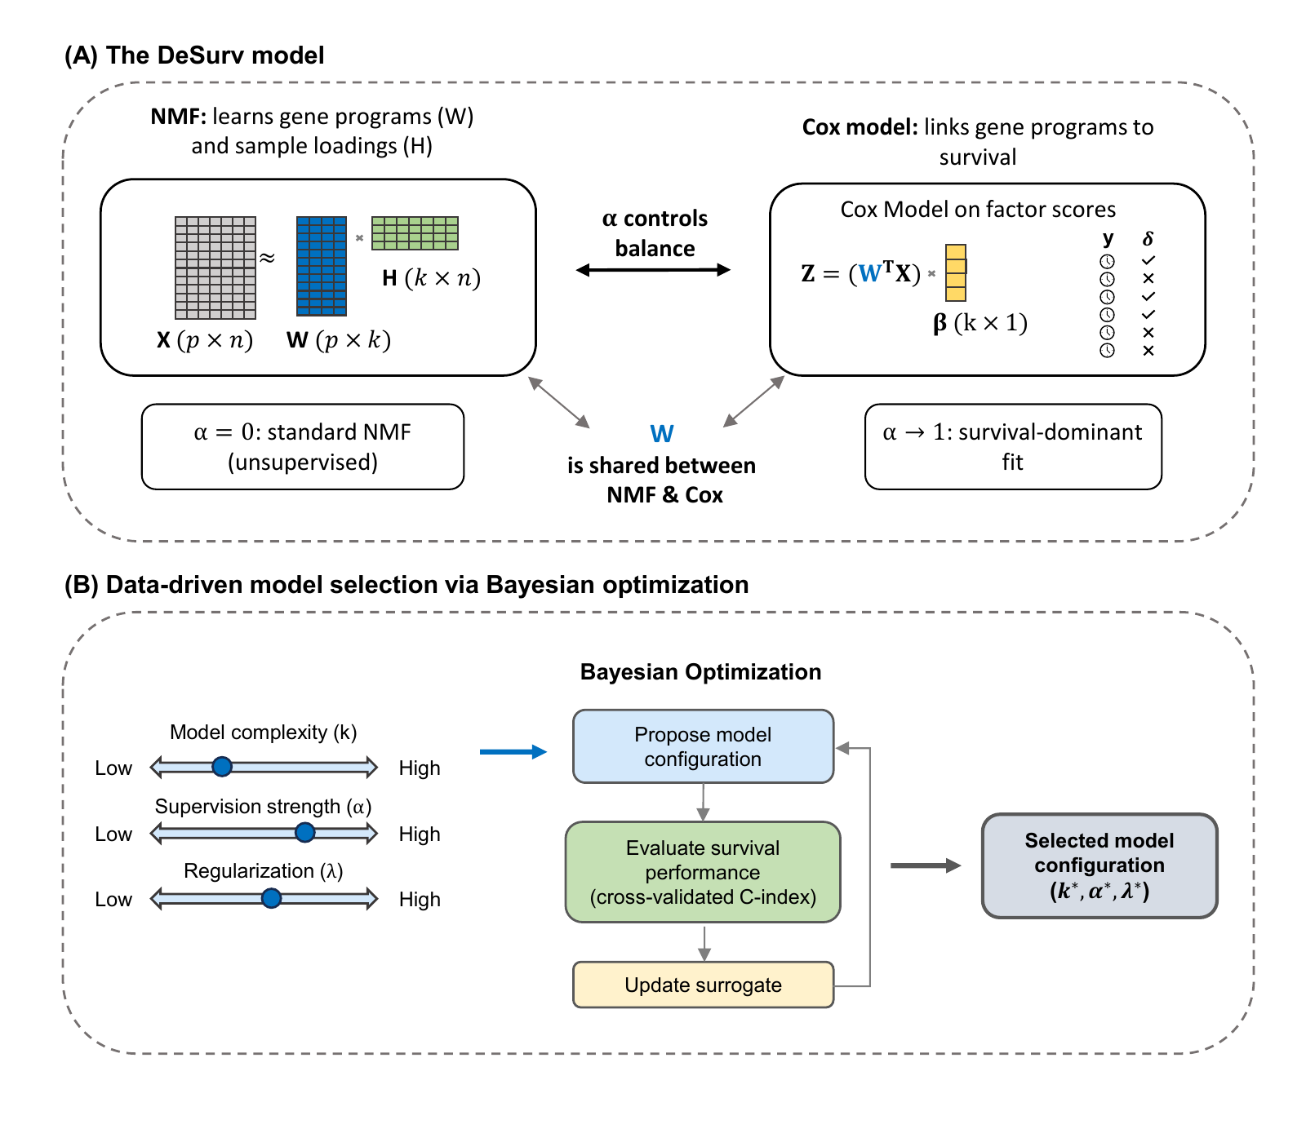
Overview of the DeSurv framework. (a) DeSurv jointly optimizes NMF reconstruction and Cox proportional hazards likelihood. The gene-program matrix $W$ enters both objectives: $X≈WH$ defines the reconstruction, while projected scores $Z=W^{⊤}X$ serve as covariates in the Cox model with coefficients $β$. A supervision parameter $α∈[0,1)$ controls the balance between reconstruction fidelity ($α=0$, the unsupervised limit) and survival prediction ($α$ close to 1). (b) Hyperparameters (rank $k$, supervision strength $α$, regularization $λ$, $ξ$ and $n_{\text{top}}$) are searched by Bayesian optimization over cross-validated concordance; the rank is then chosen by a one-standard-error rule and the remaining hyperparameters are retained from the best observed configuration (Methods). Survival supervision therefore acts on the gene-program matrix $W$ during discovery rather than being applied only after an unsupervised factorization. Following model selection in the training data, the resulting gene weights are fixed for evaluation in external cohorts.

Survival supervision changes which gene programs are recovered
To compare the recovered gene programs at the same rank, we fitted DeSurv and standard Lee multiplicative NMF with $k=3$. DeSurv resolved three distinct programs (D1–D3): D1, enriched for classical tumor and restCAF-like stromal signatures; D2, enriched for proCAF-like stroma; and D3, enriched for basal-like tumor programs (Fig. [fig:pdac]a). In the COMPASS trial cohort, D1 scores correlated with GATA6 RNA in situ hybridization, independently supporting the classical tumor component of D1 (Spearman $ρ=0.68$, $P<0.001$, $n=33$; Fig. [fig:pdac]e).
Standard NMF, the unsupervised comparator, recovered a different set of programs (Fig. [fig:pdac]b). Its malignant factor (N1) was enriched for both classical and basal-like tumor programs, its microenvironmental factor (N3) for multiple stromal and immune programs^{28,29}, and a third factor (N2) for exocrine-associated variation. Both methods recovered activated-stroma and proCAF-like reference programs but differed at the tumor-restraining end: among the displayed top-ranked genes, the restCAF and iCAF reference programs corresponded to a DeSurv factor but to no standard NMF factor (Fig. [fig:pdac]a,b). These are bulk gene-program correspondences, not identifications of CAF cell states (Supplementary Information, Stromal resolution: which reference programs are recovered from bulk).
This difference reflected selective reorganization rather than wholesale loss of expression structure. D1 accounted for only $18.8$% of the full model’s reconstruction gain (Shapley shares³⁰), the smallest share among the three factors. However, in post-fit unpenalized Cox models of the three training-cohort scores, omitting D1 and refitting on the remaining scores lowered the maximized Cox partial log-likelihood, the fit criterion of the Cox model, by $66.4$, compared with $1.0$ for D3 and $0.02$ for D2 (Fig. [fig:pdac]c). D3 showed the opposite pattern, accounting for $56$% of the reconstruction gain but little of this conditional survival contribution. In the matched-rank standard NMF model, the factor contributing most to reconstruction ($42$%) lowered the partial log-likelihood by only $0.06$, and no unsupervised factor lowered it by more than $1.16$. These conditional, nonadditive increments describe associations in the training data used for discovery and do not independently validate prognostic relevance. Thus, the programs that best reconstruct the transcriptome need not be those that are most relevant to survival¹⁶.
The principal NMF tumor and microenvironmental factors corresponded closely to D3 ($ρ=0.84$) and D2 ($ρ=0.87$), whereas D1 correlated only weakly with every matched-rank NMF factor ($ρ≤0.36$; gene-loading Spearman correlation over all analyzed genes; Fig. [fig:pdac]d). Consistently, D1’s gene weights were poorly reconstructed from the three NMF factors together ($R^{2}=0.09$; Supplementary Table [tab:projection-r2]). DeSurv reconstructed the analysis matrix less completely than matched-rank NMF ($R^{2}$ 0.75 versus 0.81, a difference of 6.0 percentage points; Supplementary Table [tab:overall-r2]). Thus, survival supervision preserved most of the variance-dominant tumor and stromal structure while resolving D1 as a distinct program not captured by matched-rank NMF.
Differences in optimization procedure or computational effort did not appear to explain this result. We repeated the comparison with a matched-budget unsupervised control that used DeSurv’s optimizer, gene filter, cross-validation folds, Bayesian-optimization budget and consensus initialization, with rank fixed at three, $α$ fixed at zero and the remaining hyperparameters re-optimized (Methods). Survival therefore played no part in the factorization objective, although it still guided tuning, including the gene support used in consensus initialization. The control again recovered D2 ($ρ=0.86$) and D3 ($ρ=0.75$) but similarly failed to recover D1 ($ρ≤0.24$).
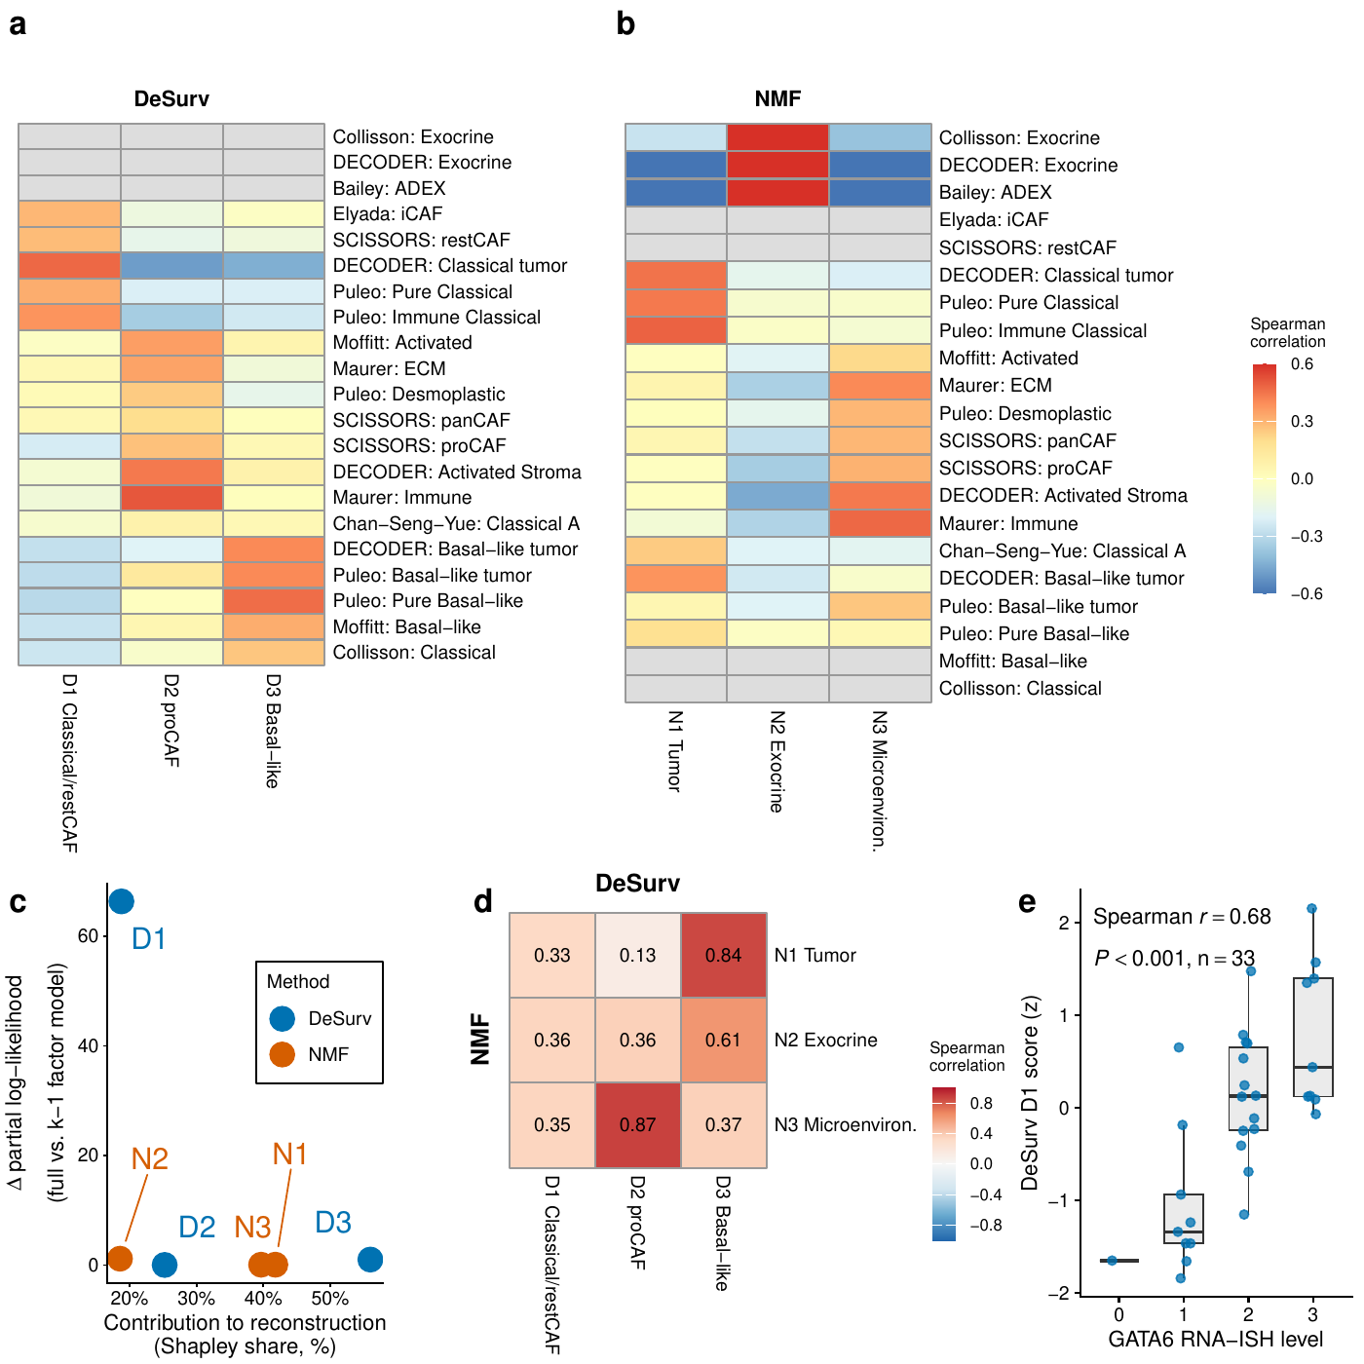
Survival supervision produces different factor structures in PDAC (TCGA + CPTAC training cohort, $n=273$ patients, 139 events). (a,b) Spearman correlations between factor gene rankings (top 50 genes per factor) and established PDAC gene programs for DeSurv (a) and standard NMF (b) at $k=3$. Both panels display the same rows, defined as the union of reference programs with Spearman $ρ>0.2$ for at least one factor from either method. Grey cells denote programs with no genes represented in that method’s displayed gene space, for which the correlation is not computable. Rows labeled SCISSORS: restCAF and SCISSORS: proCAF display the SCISSORS iCAF and myCAF gene sets under the naming used by the DeCAF classification (Supplementary Information). These are correspondences between bulk gene programs and reference signatures, not direct identifications of CAF cell states. (c) Per-factor reconstruction contribution (normalized Shapley share, summing to 100%) versus survival contribution, defined as the decrease in maximized unpenalized Cox partial log-likelihood when one factor is omitted and the model is refitted using the remaining training-cohort scores computed over all analyzed genes. These increments are conditional and nonadditive; because D1 was estimated using these survival outcomes, its increment locates survival signal within the fitted model but does not independently validate its prognostic relevance. (d) Pairwise correspondence between NMF and DeSurv factors (Spearman correlation of gene loadings in $W$ over all analyzed genes). (e) DeSurv D1 score versus GATA6 RNA in situ hybridization level in the COMPASS cohort (Spearman correlation; $n=33$).

Frozen DeSurv programs retain prognostic information across independent PDAC cohorts
We next scored five external validation datasets from four independent, non-metastatic, treatment-naive PDAC cohorts (Dijk, Moffitt, PACA-AU [array and RNA-seq], and Puleo; Supplementary Table [tab:cohorts]) by projecting each tumor’s expression onto the frozen programs over the union of their top-ranked genes (810 genes; $Z={\tilde{W}}^{⊤}X_{\text{new}}$; Methods). Combined analyses represented each patient once, retaining the RNA-sequencing measurement for PACA-AU patients profiled on both platforms, and included $570$ unique patients and 388 deaths (Methods).
D1 had protective point estimates in all five validation datasets and was the only individual DeSurv program with a statistically significant combined association in the dataset-stratified analysis (HR per within-dataset SD $0.75$, 95% CI $0.68$–$0.83$, $P$ < 0.001). D3 had hazard ratios above 1 in four of the five datasets ($1.09$, 95% CI $0.98$–$1.21$, $P=0.10$), while D2 was near null overall ($1.02$, 95% CI $0.92$–$1.12$, $P=0.76$) and varied more across datasets (Fig. [fig:val]a). None of the three standard NMF factors at the same rank showed a significant combined association (HRs 0.94–1.00; Fig. [fig:val]a, right); these are individual factor associations from a standard NMF fit, not the combined risk score of the matched-budget control in Table [tab:hr-adjusted].
The trained DeSurv linear predictor combines D1 and D3, with coefficients oriented so that higher values indicate higher risk; the elastic-net penalty set the D2 coefficient to exactly zero. It was associated with overall survival in the dataset-stratified analysis (HR per pooled SD 1.42, 95% CI $1.26$–$1.59$, $P=5.4×{10}^{−9}$; Table [tab:hr-adjusted]). Puleo contributed 288 of the 570 unique patients, so leave-one-dataset-out analyses assessed whether the pooled estimate depended strongly on that cohort; the estimates were similar with each dataset omitted in turn (HRs 1.34–1.45; Supplementary Table [tab:loco]). Scaled Schoenfeld residuals indicated attenuation over follow-up ($χ^{2}=14.7$, 1 df, $P=1.3×{10}^{−4}$; Supplementary Information, Proportional-hazards diagnostic), so it should be read as a time-averaged summary rather than a constant multiplicative effect.
Allowing cohort-specific slopes did not significantly improve fit over a common slope (likelihood-ratio $χ^{2}=1.5$, 3 df, $P=0.69$; score standardized within each of the four cohorts), and the cohort estimates were descriptively homogeneous (Cochran $Q=1.5$, $I^{2}=0$%). Discrimination across cohorts was moderate (event-weighted C-index $0.61$, 95% CI $0.58$–$0.65$). In a sensitivity analysis recalibrating the frozen score in sample within each validation dataset (apparent rather than out-of-sample error), the integrated Brier score, an event-weighted summary over dataset-specific follow-up horizons, was $0.159$ compared with $0.168$ for a Kaplan–Meier reference (index of prediction accuracy $5.4$%; Supplementary Information).
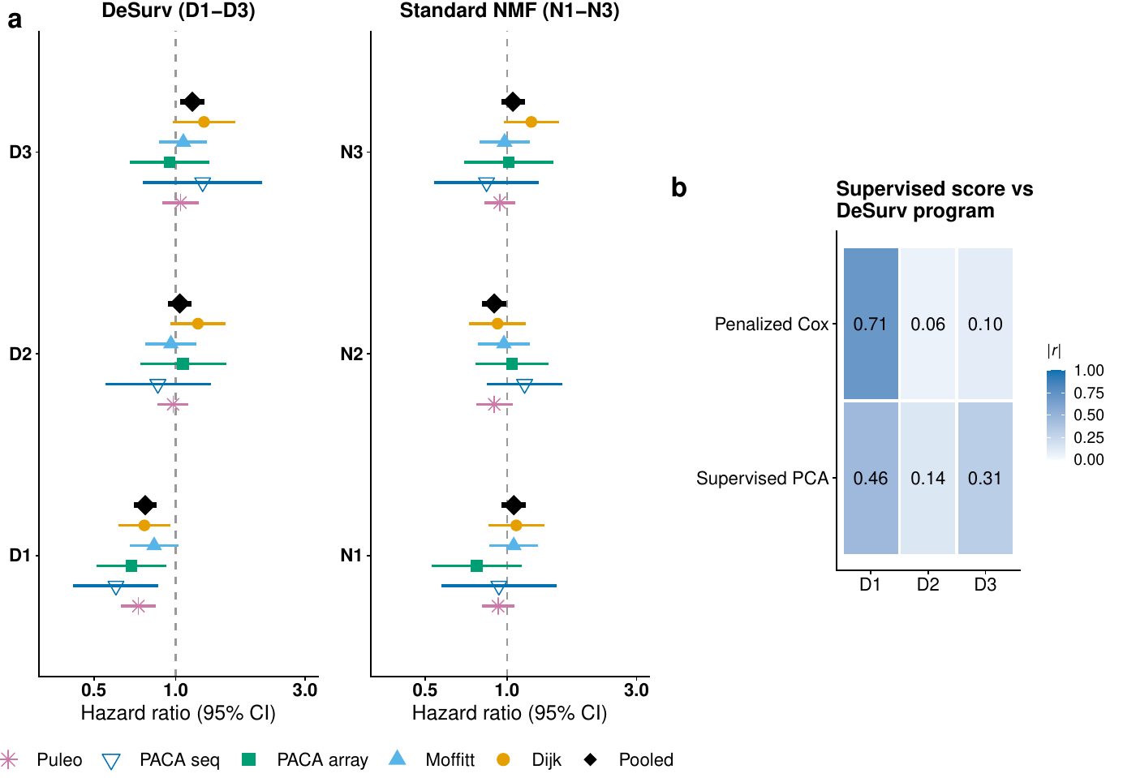
Survival-aligned programs generalize across independent PDAC patient cohorts (five external validation datasets: Dijk, Moffitt GEO array, PACA-AU array, PACA-AU RNA-seq and Puleo; combined $n=570$ unique patients, 388 deaths, with PACA-AU patients profiled on both platforms represented once via RNA-seq). (a) Forest plot of per-dataset univariate hazard ratios (95% CIs) for each DeSurv program (left) and standard NMF factor (right). Platform-specific PACA-AU array and RNA-seq estimates are shown separately, and black diamonds denote combined estimates over unique patients (per-factor dataset-stratified Cox models on the de-duplicated patient-level data, with each program standardized within dataset and scored on the union top-gene support; PACA-AU array duplicates excluded). (b) Correspondence ($|$Pearson $r|$) of tuned supervised risk scores (penalized Cox and supervised PCA) with the three DeSurv programs (D1–D3) in the training data. Supervised scores correlated most strongly with D1 and only weakly with the D2 stromal program. These score correspondences do not establish recovery of identical gene programs. No validation-cohort survival outcomes were used in training, scoring or hyperparameter selection; they enter only the association estimates shown and the separately described recalibration analysis (Methods; Supplementary Information, Proper-scoring sensitivity of the external validation).
Method | Unadjusted HR per pooled SD (95% CI), $P$ | Adjusted HR per pooled SD (95% CI), $P$
DeSurv ($k=3$) | 1.42 (1.26–1.59), $<0.001$ | 1.28 (1.11–1.47), $<0.001$
Matched-budget unsupervised control ($k=3$, $α=0$) | 1.04 (0.94–1.16), $0.428$ | 0.98 (0.88–1.09), $0.705$
Rank-optimized unsupervised control ($k=7$, $α=0$) | 1.44 (1.30–1.59), $<0.001$ | 1.40 (1.22–1.62), $<0.001$
Pooled external validation of DeSurv and unsupervised controls. Hazard ratios per pooled SD of the linear predictor across five validation datasets spanning four independent cohorts (570 unique patients, 388 deaths). Adjusted models include PurIST and DeCAF and are stratified by dataset; all 570 patients had both classifier calls. The matched-budget control fixes rank at $k=3$, whereas the rank-optimized control uses the rank selected by the same one-standard-error rule applied to its own Bayesian-optimization results ($k=7$); both use the same fitting pipeline, consensus procedure and outcome-based tuning budget as DeSurv, with $α$ fixed at zero (Supplementary Table [tab:tab-cindex-comparison]). These are point estimates for the selected models, not tests of superiority and not a comparison of minimum ranks.

D1 retains prognostic information beyond established PDAC classifications
Across the pooled validation cohorts ($n=570$, 388 events), binary PurIST and DeCAF classifications together explained 34% of the within-dataset variance in the continuous D1 score, and DeCAF alone explained 19%. D1 nevertheless remained associated with survival after adjustment for both classifiers (HR per within-dataset SD 0.82, 95% CI $0.73$–$0.93$, $P=0.0014$). Adding D1 to a dataset-stratified Cox model with additive PurIST and DeCAF terms improved fit (partial likelihood-ratio $χ^{2}=10.1$, 1 df, $P=0.0015$) and increased concordance from 0.592 to 0.622. D1 therefore overlaps substantially with these classifications without being reducible to them.
Because D1 spans tumor and stromal programs, we also asked whether it primarily reflected tumor purity. In the two datasets with purity estimates for all patients, D1 correlated only weakly with purity (Spearman $ρ=0.06$ and $−0.05$). In these same datasets, adjustment for purity left the DeSurv linear predictor’s survival association essentially unchanged (HR per SD: PACA-AU array, 1.44 versus 1.45; RNA-seq, 1.66 versus 1.65; Supplementary Table [tab:clinical-adjustment]). In Puleo, the largest validation cohort, the DeSurv linear predictor also remained prognostic after adjustment for sex and resection-margin status (HR per SD 1.33, 95% CI $1.14$–$1.55$; Supplementary Table [tab:clinical-adjustment]). Together, within the PACA-AU datasets, the weak correlations between D1 and purity and the stability of the linear predictor after purity adjustment argue against measured tumor purity as the main explanation for these findings, although they do not establish the cellular identity of D1’s restCAF-like component (Supplementary Information, Stromal resolution: which reference programs are recovered from bulk).

Exploratory transport to treated disease
We also projected the frozen programs, without retraining, into two treated PDAC cohorts. In the O’Kane/COMPASS cohort of metastatic disease ($n=173$, 123 deaths), D1 remained associated with overall survival in a Cox model stratified by treatment arm (HR per SD $0.75$, 95% CI $0.62$–$0.90$; Fig. [fig:treated]a); these laser-capture microdissected profiles are epithelial-enriched, primarily reflecting the tumor component of D1. In the Linehan cohort, the projected proCAF-like D2 score increased from pre- to post-treatment biopsies (mean change +0.34 SD, paired Wilcoxon $P=0.013$; Fig. [fig:treated]b; Supplementary Information, Translational transportability into independent treated PDAC cohorts), a shift that may reflect cell composition, cellular state or both. Because treatment, stage and cohort were not independently varied, these analyses are exploratory and do not establish differential treatment benefit.
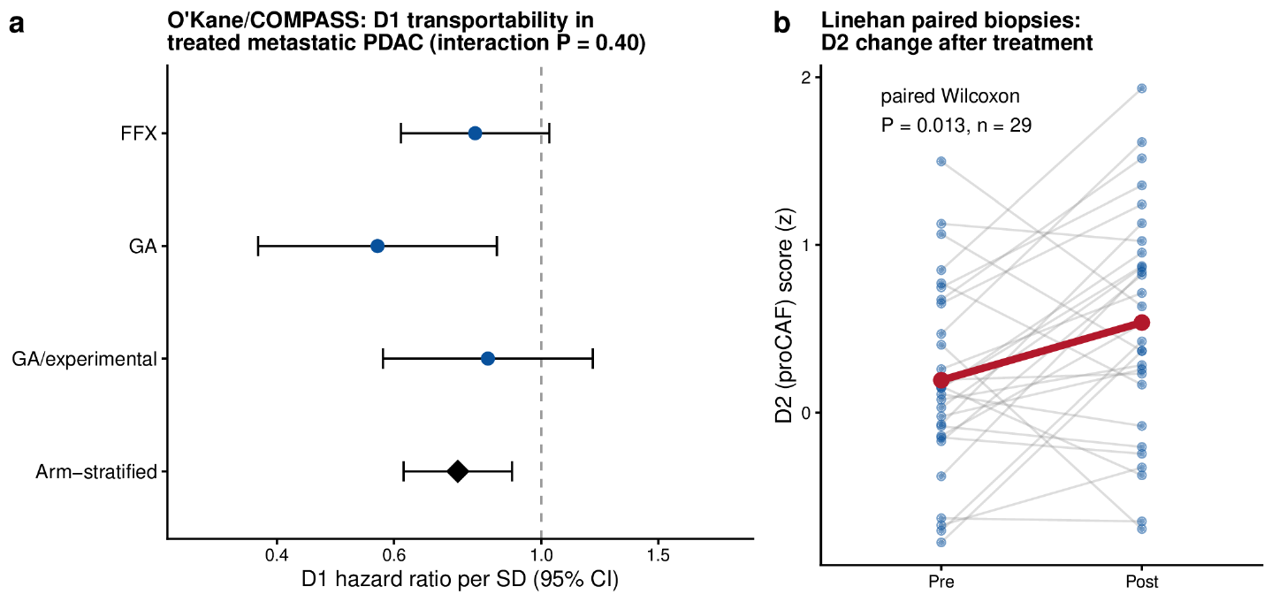
Transportability of the frozen DeSurv programs into independent treated PDAC cohorts. (a) D1 in treated metastatic PDAC from the O’Kane/COMPASS cohort. Points and 95% confidence intervals show hazard ratios per SD of the frozen D1 score within the FOLFIRINOX (FFX), gemcitabine/nab-paclitaxel (GA), and GA/experimental treatment arms; the diamond shows the common association from a Cox model stratified by treatment arm (HR $0.75$, 95% CI $0.62$–$0.90$, $P=0.003$). D1 had protective point estimates in all three arms, with no evidence of an arm-by-score interaction ($P=0.40$), although individual arms were underpowered for detecting heterogeneity. Scores were derived from laser-capture microdissected, epithelial-enriched profiles. (b) Projected proCAF-like D2 scores before and after treatment in paired Linehan biopsies ($n=29$). Grey lines connect biopsies from the same patient; the red line shows the group mean, which increased by $0.34$ SD after treatment (paired Wilcoxon $P=0.013$). Because treatment, stage and cohort were not independently varied, these analyses support transportability rather than treatment-predictive effects.

Method comparisons distinguish survival prediction from gene program recovery
At DeSurv’s rank, the matched-budget unsupervised control did not show a statistically significant survival association (Table [tab:hr-adjusted]). More generally, DeSurv reached near-maximal cross-validated concordance at the lowest ranks examined, with little change as additional factors were added, whereas the unsupervised limit ($α=0$) improved progressively with rank and approached DeSurv only at higher-rank solutions (Supplementary Fig. [fig:fig-cindex-by-k]).
The rank-optimized unsupervised control, whose rank the same one-standard-error rule set at $k=7$, carried comparable external prognostic information (Table [tab:hr-adjusted]; Supplementary Table [tab:tab-cindex-comparison]). Reference-program coverage increased from 16 for DeSurv at $k=3$ to 32 for the $k=7$ control, while multiplicity remained low (1.00 versus 1.125; Supplementary Figs. [fig:fig-nmf-k7-heatmap] and [fig:fig-rpm]). Seven is where the one-standard-error rule landed for the unsupervised search, not a general minimum rank for comparable prognostic information. Survival supervision was not required to obtain a prognostic signal, but it altered which programs were identified and how that signal was decomposed.
To test whether D1 was specific to the DeSurv optimizer, we applied three other survival-supervised approaches to the training datasets (one supervised component each for supervised principal components and Cox partial least squares, one penalized fit for sparse Cox; Methods). All three produced patient scores strongly correlated with D1 (Pearson $\left|r\right|=0.81$, $0.83$ and $0.85$, respectively), whereas the leading unsupervised principal component was only weakly correlated with D1 ($\left|r\right|=0.10$) and instead tracked the higher-variance D2/D3 structure (Supplementary Information, The D1 axis is not specific to DeSurv). This indicates a shared survival-associated signal in the patient scores, not that the three methods recover the same gene programs.
Independently tuned supervised principal components and lasso-penalized Cox regression had pooled external C-indices of $0.60$ and $0.60$, versus $0.61$ for DeSurv. For this comparison, DeSurv used per-program gene supports and unpenalized Cox coefficients re-estimated on the training scores, rather than the union-support predictor used for primary external validation. The selected genes of the supervised predictors, however, were enriched for basal-like tumor programs in every cross-validation seed and for none of the stromal, immune or exocrine programs examined, and their risk scores correlated only weakly with the separately resolved proCAF-like D2 program (lasso Cox, $\left|r\right|=0.06$; supervised PCA, $\left|r\right|=0.14$; Fig. [fig:val]b). They nevertheless carried some stromal information, correlating with an external activated-stroma and proCAF signature at $\left|r\right|=0.20$ and $0.23$, against $0.55$ for D2 (Supplementary Information). Thus, the methods differed less in prognostic discrimination than in how that information was represented: conventional supervised predictors combined contributions from underlying expression programs within a single score, whereas DeSurv retained D1–D3 as separately scored programs with explicit survival coefficients. This decomposition allows the tumor and stromal programs contributing to prognosis to be interrogated separately and retains program-specific ranked gene sets.

Survival supervision improves program recovery when prognostic signal contributes little expression variation
In simulations with known latent structure, expression profiles were generated for $p=3,000$ genes and $n=200$ samples from $k=3$ true programs, each with its own marker genes and all drawn from the same loading and activity distributions (Supplementary Information, Simulation design and data generation). In the primary scenario, survival depended on the marker genes of one program only, and those genes contributed less transcriptomic variation than a shared background signal excluded from the survival-generating gene set. DeSurv and its unsupervised limit ($α=0$) were tuned by the same cross-validation procedure.
In this setting, DeSurv more accurately recovered the genes defining the true prognostic program, whereas unsupervised NMF was more strongly influenced by the dominant background structure. Across 100 simulated datasets, median matched-factor precision (the proportion of the best-matching learned program’s selected genes belonging to the true prognostic gene set) was 0.50 for DeSurv versus 0.07 for unsupervised NMF (Fig. [fig:sim]b). Global marker recall (the proportion of the true survival-driving marker genes appearing in the union of all learned programs’ top-ranked gene sets) was 0.26 versus 0.15 (Supplementary Information). Median test-set C-index was $0.837$ versus $0.724$ ($Δ=0.113$, paired Wilcoxon $P<0.001$; Fig. [fig:sim]a), and DeSurv selected the true rank ($k=3$) more frequently (Fig. [fig:sim]c).
Performance depended on how prognostic signal aligned with expression structure. In the mixed setting, the benefit of supervision was concentrated in recovery of program-specific marker genes and was smaller for shared background genes included in the survival-generating set (Fig. [fig:sim]d; Supplementary Fig. [fig:fig-sim-null-mixed]), consistent with supervision preferentially improving recovery of genes that define the prognostic program. Under the null, test-set concordance was near chance for both methods. The selected supervision strength dispersed across its admissible range rather than concentrating at zero (median $α=0.59$, interquartile range $0.19$–$0.82$ across 100 simulated datasets), consistent with weak discrimination among supervision strengths when survival contained no signal.
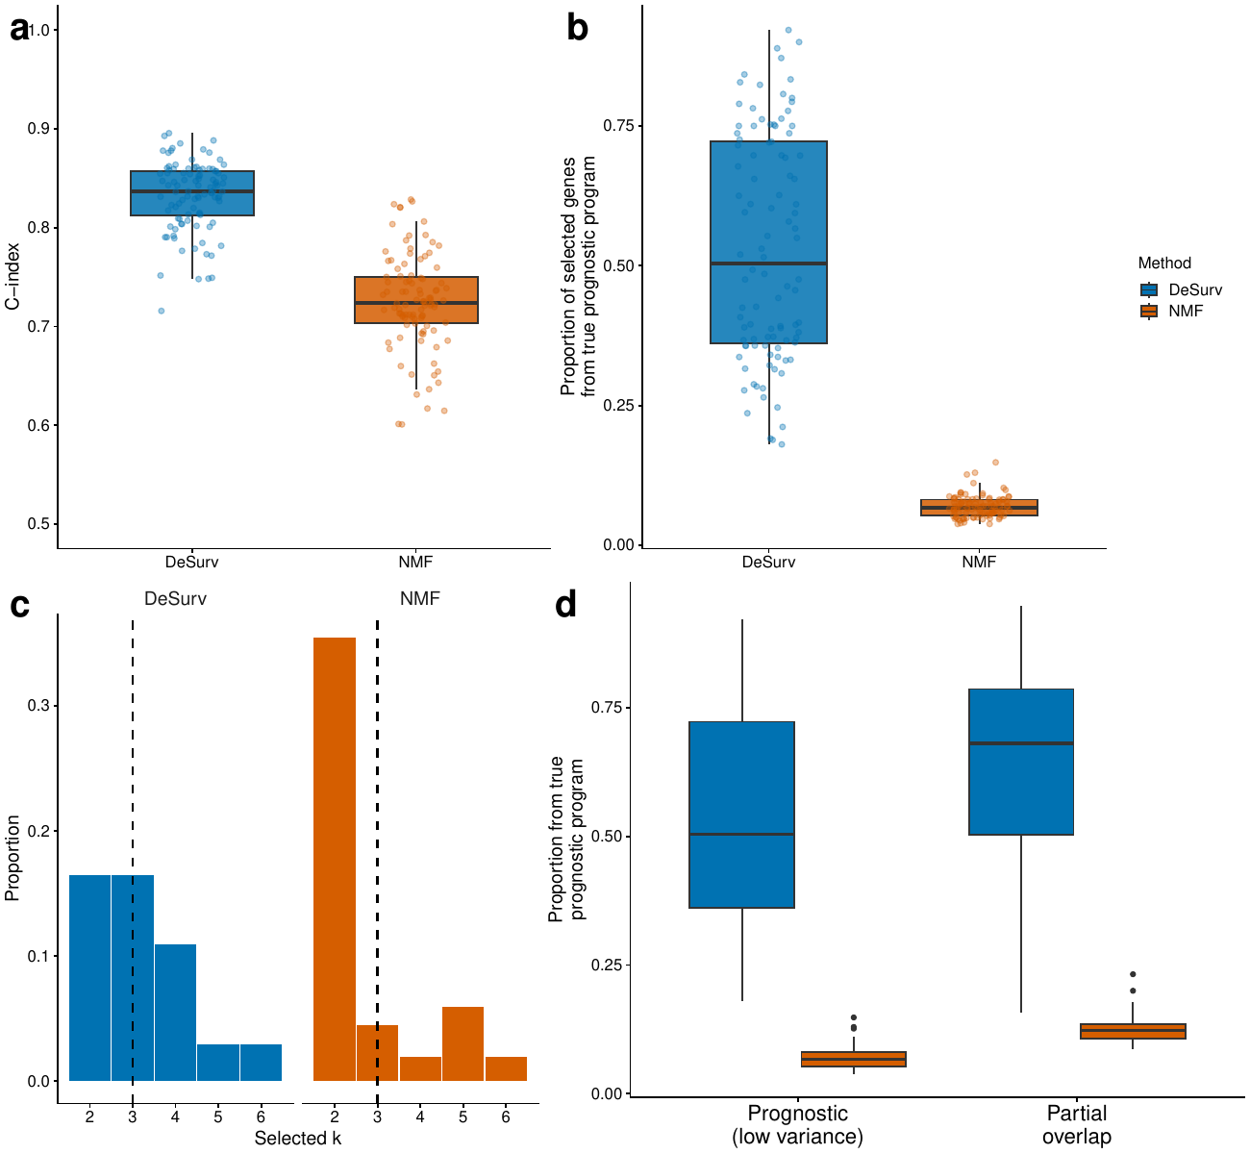
Survival supervision improves recovery of prognostic gene programs when prognostic signal contributes relatively little expression variation. (a) Test-set concordance across 100 simulated datasets comparing DeSurv with unsupervised NMF ($α=0$; $p=3,000$ genes, $n=200$ samples, true $k=3$); median C-indices were 0.837 versus 0.724 (paired Wilcoxon $P<0.001$). (b) Recovery of genes defining the true prognostic program, quantified as the proportion of selected genes in the best-matching learned program that belonged to the ground-truth prognostic gene set; medians were 0.50 versus 0.07. The best-matching program is selected using the known simulated gene set, so this metric evaluates recovery with access to ground truth. Global marker recall, which requires no factor matching, is reported in the Supplementary Information. In (a) and (b), boxes show medians and interquartile ranges, whiskers extend to $1.5×$IQR, and points represent individual simulated datasets. (c) Distribution of ranks selected across simulated datasets for DeSurv and unsupervised NMF; dashed lines indicate the true rank ($k=3$). (d) The same matched-factor precision metric as in (b) under two signal regimes: a prognostic program whose genes contribute relatively little transcriptomic variation and are separated from the dominant shared background, and a setting in which the survival-generating gene set partially overlaps that dominant background structure. DeSurv recovered the prognostic program more accurately in both regimes, with a larger separation when the prognostic program was distinct from the dominant expression structure. The null scenario, with no prognostic signal, is shown in the Supplementary Information. The concordance difference in (a) should not be interpreted as an expected gain in discrimination in real data, where a rank-optimized unsupervised control carried comparable prognostic information (Table [tab:hr-adjusted]).

Discussion
DeSurv allows patient survival to shape gene-program discovery, yielding a tumor–stroma architecture that connects prognostic information with interpretable malignant and stromal programs. In PDAC, the architecture comprised a dominant survival-aligned program, D1, characterized by coordinated cross-patient variation in classical tumor and restCAF-like stromal features, alongside separately resolved proCAF-like stromal and basal-like tumor programs. D1 remained prognostic after adjustment for the established PurIST and DeCAF classifications. The frozen programs then transferred without refitting across four independent external patient cohorts.
An unsupervised control at $α=0$, matched to DeSurv on rank and tuning budget, did not recover D1, so the difference in the recovered programs did not appear to reflect rank or tuning effort. A rank-optimized unsupervised control recovered comparable prognostic information across a broader seven-factor representation, and conventional supervised predictors achieved similar discrimination while combining contributions from underlying expression programs within single scores. These comparisons separate prognostic information from the representation in which that information is recovered. DeSurv instead retains the contributing sources as separately scored programs rather than combining them only within a composite prognostic predictor.
This distinction clarifies the role of the frozen gene-program basis. In DeSurv, survival acts directly on the gene-program matrix $W$ while the reconstruction objective requires the learned programs to continue representing the observed transcriptome. Once learned, the gene weights are held fixed, so external validation tests the same programs rather than a newly estimated representation. In CoxNMF and SurvNMF, the survival term depends on sample-side latent representations^{31,32}. In DeSurv, it depends directly on projections through the gene-program matrix, and new samples are scored using fixed gene weights without an additional sample-loading estimation step (Supplementary Table [tab:architecture]). Deep latent-variable survival models^{33,34} likewise learn sample representations rather than a fixed gene-program basis, and reference-based deconvolution methods such as CIBERSORTx³⁵ and BayesPrism³⁶ estimate the abundance of predefined cell types rather than outcome-aligned programs, so DeSurv is complementary to them.
Program-level outputs are the practical product of this architecture, because the genes defining each program determine how it can be interpreted and what can be tested next. Previous PDAC studies illustrate how interpretable malignant and stromal programs can support biological characterization and the development of single-sample classifiers^{3–5,12}. DeSurv extends this line of work by allowing patient outcomes to influence the gene weights themselves while retaining separately measurable programs: for example, D2 remains available as proCAF-like stromal context although the fitted risk score combines D1 and D3. In settings without established molecular annotations, the ranked genes defining each recovered program could instead provide the starting point for biological annotation, subtype development and reduced biomarker assays. These outputs do not yet establish clinical utility or a treatment-selection rule.
Rank choice and initialization can affect the recovered gene programs. Increasing rank progressively broadened correspondence to established PDAC programs. The three-factor DeSurv solution and the seven-factor unsupervised control were selected by the same one-standard-error rule. Survival supervision provides an outcome-informed criterion for shaping the representation, but it does not remove the non-uniqueness of matrix factorization, and individual DeSurv runs from different random starts recover appreciably different gene sets. Split-half consensus fits agreed closely with the reported basis (Supplementary Information, Stability of the recovered gene programs), supporting stability to restart-pool composition within the training data but not establishing reproducibility under independent repetition or patient resampling.
The simulations identify conditions under which survival information improves program recovery. They provide a controlled example in which survival supervision prioritizes prognostically relevant programs that contribute relatively little expression variation and are therefore less readily recovered by reconstruction-driven factorization.
Three statistical qualifications limit interpretation of the prognostic findings. DeSurv uses a proportional-hazards objective, while the external validation data showed attenuation of the prognostic association over follow-up (Schoenfeld test, Results), so the reported hazard ratios are time-averaged summaries and extensions could accommodate non-proportional hazards or nonlinear survival relationships. The integrated Brier analysis recalibrated the score’s scalar slope and baseline hazard within each validation dataset, so it describes apparent prediction error rather than out-of-sample prediction error (Supplementary Information, Proper-scoring sensitivity of the external validation). The pooled training objective was fitted without a cohort term; within-cohort analyses argued against simple encoding of training-cohort membership, although cohort influence on the learned representation remains possible (Supplementary Information, Cohort handling in the training objective).
In treated cohorts the frozen scores remained informative in exploratory analyses, but arm-level sample sizes limited assessment of variation in the association across treatments. Whether these programs predict differential treatment benefit therefore remains unresolved and will require adequately powered, prespecified treatment-by-program interaction analyses in studies designed to support treatment comparisons.
The tumor–stroma architecture described here is a bulk-tissue phenomenon. It reflects cross-patient covariation in tumor- and stroma-associated transcriptional programs rather than cellular co-expression or spatial adjacency within individual tumors. This organization is consistent with broader evidence that malignant lineage state and stromal composition vary together in PDAC^{37–39}. Adjustment for PurIST and DeCAF supports D1’s prognostic association beyond those classifiers, purity adjustment in the PACA-AU datasets leaves the risk score’s association essentially unchanged, and other supervised methods capture related survival-associated signal. GATA6 RNA in situ hybridization independently supports D1’s classical tumor component; these analyses do not establish the cellular identity of its stromal component. Single-cell or spatial profiling could clarify the cellular sources of these programs; linking those sources to prognosis would additionally require outcome-annotated cohorts and scoring methods appropriate for the measurement platform.
The question DeSurv addresses extends beyond PDAC. In any tumor type, the programs that dominate expression variation may differ from those most relevant to survival, so outcome information could help prioritize programs that reconstruction alone underweights. Testing generalizability will require multi-cancer evaluation of prognostic performance, program recovery and stability, with attention to cohort composition and event counts. Comparators should include unsupervised decompositions and strong penalized-regression baselines, which remain difficult to outperform consistently for out-of-sample prognosis⁴⁰. PDAC is the empirical demonstration presented here rather than evidence of pan-cancer validation.
In PDAC, incorporating survival during factorization recovered a three-program tumor–stroma architecture that transferred across independent cohorts while retaining biological components that could be interrogated separately. More generally, DeSurv provides a framework for asking not only whether transcriptomic data predict outcome, but which biological programs are recovered when outcome information helps shape their discovery.

Methods

Problem formulation and notation
Let $X∈R_{≥0}^{p×n}$ denote the nonnegative gene expression matrix. DeSurv approximates $X≈WH$, where $W∈R_{≥0}^{p×k}$ contains nonnegative gene programs and $H∈R_{≥0}^{k×n}$ contains sample loadings. Additionally, let $y∈R_{>0}^{n}$ denote patient survival times, $δ∈\{0,1\}^{n}$ the event indicators ($δ_{i}=1$ for an observed event, $δ_{i}=0$ for censoring), and $β∈R^{k}$ the Cox regression coefficients. Survival outcomes are modeled through a Cox proportional hazards model with projected scores $Z=W^{⊤}X∈R^{k×n}$: for sample $i$ with projected score $z_{i}=W^{⊤}x_{i}$, the hazard is $h\left(t∣x_{i}\right)=h_{0}\left(t\right)exp\left(z_{i}^{⊤}β\right)$, where $h_{0}$ is the baseline hazard. Defining projected scores by projection onto the learned gene programs ($Z=W^{⊤}X$) rather than by the inferred loadings $H$ lets the same gene weights score new cohorts without refitting, the property we exploit for external validation. We use factor for a mathematical component and program for its biological interpretation, including for comparator methods. “Unsupervised” describes a factorization objective without a survival term; outcome-based tuning is stated separately.

The DeSurv model
DeSurv integrates NMF with penalized Cox regression to identify gene programs associated with survival outcomes. The method operates in a survival-supervised framework: the reconstruction loss penalizes deviation from the observed expression data, while the survival term directs gene programs toward outcome-relevant structure. Five quantities are tuned. The rank $k$ is the number of programs; $α∈[0,1)$ controls the relative contribution of the two objectives; $λ$ and $ξ$ are the strength and elastic-net mixing of the Cox penalty; and $n_{\text{top}}$ determines each program’s top-gene set, whose union defines the scoring support. A sixth, the optional ridge penalty $λ_{H}$ on the loadings, was held at zero throughout.
The joint objective is
$$L\left(W,H,β\right)=\left(1−α\right) L_{NMF}\left(W,H\right)−α L_{Cox}\left(W,β\right),$$
with components
$$\begin{matrix}L_{NMF}\left(W,H\right) & =\frac{1}{2∥X∥_{F}^{2}}∥X−WH∥_{F}^{2}+\frac{λ_{H}}{2nk}∥H∥_{F}^{2}, \\ L_{Cox}\left(W,β\right) & =\frac{2}{n_{event}} ℓ\left(W,β\right)−λ\left(ξ∥b∥_{1}+{1−ξ}/2∥b∥_{2}^{2}\right),\end{matrix}$$
where $∥⋅∥_{F}$ is the Frobenius norm, $ℓ\left(W,β\right)$ is the Cox log-partial likelihood, the fit criterion of the Cox model, and $n_{event}$ is the number of observed deaths. The elastic-net penalty acts on the standardized-score coefficients $b=D_{Z}β$. Here $D_{Z}=diag\left(sd\left(Z_{1⋅}\right),…,sd\left(Z_{k⋅}\right)\right)$ contains the standard deviations across samples of the factor-score rows at the current $W$. The inverse map $β=D_{Z}^{−1}b$ is applied only on the retained, nondegenerate score rows; a row whose score standard deviation falls below the numerical floor given in Supplementary Information, Optimization Algorithm, is dropped and its coefficient set to zero. This is the objective the implementation evaluates and records. The constants $1/\left(2∥X∥_{F}^{2}\right)$, $λ_{H}/\left(2nk\right)$ and $2/n_{event}$ normalize the component losses before $α$ sets their relative contribution (Supplementary Information, Model details).
A key design choice is where survival supervision enters the factorization. Because projected scores are defined as $Z=W^{⊤}X$, the Cox partial likelihood $L_{Cox}$ is a direct function of $W$ and $β$, and the survival gradient acts explicitly on the gene program matrix $W$. The sample-level loadings $H$ enter only through the reconstruction term and receive no survival gradient, preserving their interpretation as mixture coefficients^{41,42}; the entries of $H$ are sample loadings on the learned programs, not estimated cell-type fractions. This construction makes clinical outcome part of program estimation rather than a post hoc filter applied to an unsupervised decomposition.
When $α=0$, DeSurv reduces to its unsupervised limit. The Cox coefficients $β$ are then fit post hoc by penalized Coxnet on the projected scores $Z=W^{⊤}X$ and are used only for scoring and cross-validation; they do not affect the factorization. At $α=0$, $λ$ and $ξ$ therefore govern the post hoc Cox fit rather than entering the factorization objective. Note that the survival-tuned $n_{\text{top}}$ still enters the consensus initialization of the final $α=0$ model (Supplementary Information, Bayesian Optimization). The Cox component also supports optional adjustment for sample-level covariates (for example, stage or grade); the analyses reported here use projected scores alone.

Optimization
Optimization alternates updates for $H$, $W$, and $β$. The reconstruction term is minimized using multiplicative updates that preserve nonnegativity, and the supervision term enters the proposal for $W$ as a Cox log-partial-likelihood derivative. That proposal does not differentiate the $W$-dependent penalty on the standardized-score coefficients and is therefore not the gradient of the full objective, so every candidate $W$ is first normalized to unit-Euclidean-norm columns, with $H$ and $β$ rescaled by the same constants so that $WH$, the linear predictor and $b=D_{Z}β$ are all preserved, and is then evaluated under the full objective by a backtracking line search (Supplementary Information, Optimization Algorithm and Normalization of W).
$β$ is then updated by Coxnet-style cyclic coordinate descent on the current centered and standardized projected scores, and is refit on the converged $W$ once the outer loop terminates. The coordinate sweeps approximate rather than exactly minimize the conditional objective, and their proposal is accepted only under a safeguard that prevents it from increasing the evaluated objective, so the $β$ block is non-increasing in that objective without establishing convergence to a conditional or joint optimum. The closed-form update, the stopping tolerances and the iteration cap are given in Supplementary Information, Update for $β$ and Bayesian Optimization.
Because the implemented algorithm combines normalization, gradient rescaling and a Coxnet approximation, we assessed optimization behavior empirically rather than relying on a formal convergence guarantee. Across 100 independent random initializations of the reported PDAC model, every run terminated on the stopping criterion rather than the iteration cap, none failed numerically, and the recorded outer-loop objective decreased monotonically (Supplementary Information, Empirical optimization stability across random initializations). Monotone decrease together with the stopping rule on the cosine change of $W$ and $H$ (Supplementary Information, Optimization Algorithm) is what these runs establish, and they are checks on the optimizer rather than on which programs it recovers.

Hyperparameter selection and cross-validation
Hyperparameters $\left(k,α,λ,ξ,n_{\text{top}}\right)$ were explored by Bayesian optimization (BO) maximizing the cross-validated Harrell C-index^{24,25}, and the reported configuration was then fixed by applying a one-standard-error rule on rank to the resulting search history, as specified below. The objective was the mean 5-fold cross-validated C-index, with folds constructed separately within each training cohort and stratified by event status under a fixed seed (123). Each configuration was evaluated from 30 random initializations at the cross-validation stopping tolerance ${10}^{−5}$, and its C-index averaged over initializations and folds. The search used an initial design of 50 evaluations followed by 100 Gaussian-process-guided evaluations; search bounds, acquisition settings and parameter transformations are given in Supplementary Information, Bayesian Optimization. The final rank $k$ was chosen by a one-standard-error rule: for each rank, the Bayesian-optimization configuration with the highest observed mean cross-validated C-index was retained, the threshold was set one fold-level standard error below the best observed configuration’s mean, and the smallest rank whose retained configuration met the threshold was selected (Supplementary Information, Bayesian Optimization). The best observed configuration had mean cross-validated C-index 0.655 (fold-level SE 0.011) at $k=7$, giving a threshold of 0.644, and the best configuration observed at $k=3$ reached 0.646 and was therefore eligible. The remaining hyperparameters were inherited from the overall best observed configuration, which had rank $k=7$, so the resulting final $k=3$ combination was not itself among the configurations evaluated during Bayesian optimization. We therefore evaluated this exact combination afterward using the identical cross-validation protocol. Re-evaluated together under the current software build, the final configuration achieved a mean cross-validated C-index of 0.642 (fold-level SE 0.007), compared with 0.655 (0.011) for the overall best configuration and 0.647 (0.009) for the best $k=3$ configuration. The recomputed one-standard-error threshold was 0.644, placing the final configuration 0.002 below that threshold (Supplementary Table [tab:final-config-cv]). All model selection was performed entirely within the training data using cross-validation; no validation cohort data were used during any stage of tuning, and out-of-sample generalization was assessed only on the external validation cohorts. The consensus initialization described next was used only for the final model and is not reproduced within each fold.
Because this rule combined $k=3$ with the non-rank hyperparameters of the best observed configuration, a configuration not itself evaluated in the search, we ran a sensitivity check on rank selection: an exhaustive grid over ranks and supervision strengths at the selected non-rank hyperparameters, to which the same one-standard-error rule again selects $k=3$ (Supplementary Information, Bayesian Optimization and Cross-validated C-index across factorization rank).
Because the goal is prognostic factorization, DeSurv selects $k$ using the criterion that directly measures prognostic performance (cross-validated C-index) rather than the unsupervised diagnostics commonly used for NMF rank selection^{26,27}, which gave inconsistent guidance across candidate ranks in these training data (Supplementary Information, Standard NMF rank selection heuristics). On the sensitivity grid, cross-validated concordance varied little across candidate ranks, with no clear optimum anywhere between $k=2$ and $k=12$ and a total spread across that range of 2.0 standard errors (Supplementary Fig. [fig:fig-cindex-by-k]). The one-standard-error rule applied to the rank-wise BO results accordingly selected the parsimonious $k=3$; the final model retained $α=0.334$, $λ=0.349$, $ξ=0.056$ and $n_{\text{top}}=270$ from the best observed configuration. Reference-program correspondence and the GATA6 comparison support biological interpretation of the selected programs; they do not establish a uniquely correct rank.

Consensus initialization and program stability
At the selected hyperparameters the final model was fit once from a consensus initialization built from 100 fits from independent random initializations, aggregated as a gene-by-gene co-occurrence matrix and therefore invariant to factor-label permutation (Supplementary Information, Consensus initialization for the final model).
We assessed program stability by partitioning the cached restart pool into disjoint halves and constructing a consensus initialization and final fit from each half. Across 8 random splits, median agreement with the reported basis was 0.97–0.99 for gene-loading correlations and 0.73–0.88 for top-ranked-gene Jaccard overlap across the three programs. These comparisons assess sensitivity to restart-pool composition within the training data, rather than independent repetition of the full procedure (Supplementary Information, Stability of the recovered gene programs). That section also reports stability under patient subsampling, a separate and weaker property.

Frozen gene-program and risk scoring
Scoring uses a truncated copy of the fitted basis. Within each program the genes were ranked by factor specificity (Supplementary Information, Gene Program Correlation Analysis) and the top $n_{\text{top}}=270$ retained; the gene support for scoring is the union of the $k$ programs’ top sets, giving the truncated matrix $\tilde{W}$ that was held fixed for every validation and treated cohort. All columns retain their weights on the same union of gene rows, and truncated columns are not renormalized. This union construction defines the primary external-validation scores, including the headline, leave-one-dataset-out and classifier-adjusted risk-score analyses, and it is the construction that cross-validation evaluated when selecting $n_{\text{top}}$. Genes outside the union still shape the factorization but do not enter the linear predictor. Other analyses use explicitly identified scoring constructions, namely full-support scores for the training-data contribution analysis and for the frozen-axis comparator analysis, and per-program masks for the tuned supervised-comparator analysis and for the Supplementary Information analyses that identify them. Both supervised-comparator constructions, the one on the full shared support and the one on per-program masks, also refit unpenalized Cox coefficients on the training scores. Treated-cohort preprocessing and missing-gene handling are described separately below.
Factor-level scores retain all $k$ columns of the truncated basis, $Z={\tilde{W}}^{⊤}X_{\text{new}}$, and the risk score is $η=Z^{⊤}β$. Where a single risk score is required, as in cross-validated tuning, the columns are first collapsed to $θ=\tilde{W}β$ and $θ$ is scaled to unit $ℓ_{2}$ norm before projection, which changes the resulting scalar risk score only by a positive multiplicative constant. The normalization applies to the collapsed score rather than to individual columns of $W$. Here, projection denotes multiplication by the fixed truncated gene-weight matrix, ${\tilde{W}}^{⊤}X_{\text{new}}$; because truncation does not renormalize the columns, these scores are not orthogonal geometric projections. During model fitting, $β$ was estimated from the full-support scores $W^{⊤}X$ over all analyzed genes. For external scoring, the fitted $β$ was carried forward unchanged and applied to scores computed on the union support $\tilde{W}$; $β$ was not refit after truncation. The elastic-net penalty set the D2 coefficient to exactly zero, so the frozen risk score is a weighted combination of D1 and D3.

Unsupervised and supervised comparators
The matched-rank comparator shown in the figure is Lee multiplicative NMF (NMF::nmf with nrun = 30, which returns the single run of the thirty with the lowest reconstruction residual, followed by a post hoc Cox fit on its projected scores), which does not receive DeSurv’s consensus initialization or hyperparameter tuning. We therefore also fit a matched-budget unsupervised control, an unsupervised factorization control with outcome-based hyperparameter tuning. At $α=0$ survival does not enter the factorization objective, but cross-validated survival performance still tunes the remaining hyperparameters and $n_{\text{top}}$. Bayesian optimization was run with $α$ pinned to 0 and the rank pinned to DeSurv’s selected $k$, matched to the supervised search on optimizer, search budget, gene filter, cross-validation folds, consensus procedure and stopping settings. The selected model was then fit by the same 100-restart consensus procedure. This control isolates removal of survival supervision at the pipeline level, with the remaining hyperparameters re-optimized rather than held numerically fixed. A second, rank-optimized control let Bayesian optimization choose the rank at $α=0$ as well, and the same one-standard-error rule applied to those results selected $k=7$ (Supplementary Information, Factor structure of the rank-optimized unsupervised control). A further sensitivity analysis instead held DeSurv’s own $λ$, $ξ$ and $n_{\text{top}}$ fixed and varied only $α$. All three controls are reported in Supplementary Information, Matched-budget unsupervised control at the same rank.
Both unsupervised controls were scored externally at the supervised model’s $n_{\text{top}}=270$ rather than at their own tuning-selected values, a choice to which the per-dataset C-indices are insensitive (Supplementary Information, Matched-budget unsupervised control at the same rank).
To distinguish prognostic discrimination from biological representation, we independently fit supervised principal components (superpc; cross-validated screening threshold and component number) and lasso-penalized Cox regression (glmnet; $λ_{min}$) using the same 1,970-gene training universe as DeSurv. Each method performed feature selection and tuning using the training data only, after which the fitted model was frozen and applied to rank-transformed validation cohorts without refitting.
The two comparators, lasso-penalized Cox regression and supervised principal components, select features by different mechanisms, neither matching DeSurv’s elastic net, and both retain far fewer genes than DeSurv’s 810-gene support (Supplementary Information, Robustness to tuned supervised comparators and compartment attribution). Because tuning budgets were not matched, the comparison characterizes the representations each approach recovers rather than benchmarking tuned predictive performance. A separate exploratory comparison used restricted supervised principal components, Cox partial least squares and a single sparse Cox fit (Supplementary Information, The D1 axis is not specific to DeSurv).
No matched-budget control was run for these supervised comparators, as was done for the unsupervised arm. Score correspondence with the DeSurv programs, selected-gene enrichment and compartment attribution are reported in Supplementary Information, Robustness to tuned supervised comparators and compartment attribution.

Biological correspondence and factor contributions
To characterize the biological identity of the learned factors, we quantified how strongly each factor’s gene loadings aligned with independently defined PDAC tumor and microenvironmental gene programs. For each factor, we correlated its gene loadings with binary membership indicators for each reference program (Spearman correlation computed over the union of the top 50 genes of all factors of that method, intersected with the reference-program gene universe; this differs from the factor-to-factor loading correlations, which use all analyzed genes), annotating Benjamini–Hochberg-adjusted $P$ values within each factor as descriptive marks, because the gene universe is itself selected by loading. The same analysis was applied to DeSurv and to standard NMF fit at the same rank. For display, reference programs whose Spearman correlation exceeded 0.2 with at least one factor of either method are shown, as the same row set in both panels of the main figure; the same threshold defines correspondence in the coverage analysis (Supplementary Information, Reference-program coverage, edges and multiplicity).
Two per-factor contribution measures are reported alongside this correspondence: reconstruction shares, computed as exact Shapley values over the fixed rank-one factor contributions without refitting the factorization, and survival contributions, computed as the loss in maximized unpenalized Cox partial log-likelihood when one factor is omitted. Reconstruction gain and the separately reported centered $R^{2}$ describe different aspects of reconstruction and should not be interpreted as interchangeable measures, and because the programs were estimated from the same training outcomes both measures are descriptive rather than independent tests of prognosis (Supplementary Information, Reconstruction and Survival Contribution per Factor).
To corroborate the classical component of D1 with an independent assay, we evaluated the association between projected D1 scores and GATA6 RNA in situ hybridization measurements in the COMPASS cohort among the 33 tumors with both measurements, using Spearman correlation. Because GATA6 is itself in the 810-gene projection support (805 of these genes were measured in the COMPASS expression data and contribute to the projected scores), part of this correlation could reflect the score being built from the assayed gene. We therefore repeated the comparison with GATA6 removed from the projection, and the correlation was essentially unchanged (Spearman $ρ=0.67$ versus $0.68$), indicating the association is not an artifact of self-correlation.

External validation and survival analysis
External validation cohorts were scored by projecting new datasets onto the learned programs via $Z={\tilde{W}}^{⊤}X_{\text{new}}$, and survival associations were evaluated using Harrell’s C-index and hazard ratios. Analyses combining validation datasets represented each patient once and used Cox models stratified by dataset, so that each dataset carries its own baseline hazard. PurIST and DeCAF calls entered only as fixed adjustment covariates and were never inputs to the factorization or to tuning. For a fixed fitted predictor and scoring support, the manuscript uses the following reporting scalings. Primary risk-score hazard ratios, comprising the headline estimate, the covariate-adjusted estimates and the leave-one-dataset-out estimates, are expressed per standard deviation of the linear predictor over the pooled de-duplicated validation set. The per-factor forest estimates and the D1 classifier-adjustment analysis instead standardize each score within validation dataset, whereas the between-cohort slope analysis standardizes within patient cohort, so hazard ratios under these scalings are not interchangeable. Within a given cohort or dataset, centering and positive rescaling of a fixed score leave its C-index unchanged. Discrimination was summarized as the event-weighted mean of the four cohort C-indices, so no concordance pair spans two cohorts, with percentile confidence intervals from 1,000 bootstrap resamples of patients drawn within cohort (seed 1); resampling preserves cohort membership. Cohort-specific slopes were compared with a common slope by likelihood-ratio test, and proportional hazards were assessed from scaled Schoenfeld residuals. Because the association attenuated over follow-up, the pooled hazard ratio is a time-averaged summary.
Harrell’s C-index is rank-based and assesses discrimination only, not calibration or time-dependent prediction error, so we additionally report a proper score as a sensitivity check: the integrated Brier score and its index of prediction accuracy relative to a Kaplan–Meier reference, computed under within-dataset recalibration. These are apparent, in-sample recalibrated values rather than out-of-sample prediction error (Supplementary Information, Proper-scoring sensitivity of the external validation).
Because the survival-supervised information lives in $W$ rather than $H$, DeSurv scores new samples by multiplication with the fixed gene-weight matrix, ${\tilde{W}}^{⊤}X_{\text{new}}$, without using their survival outcomes. Related supervised-NMF methods instead place the survival term on the sample side, so that the risk score is a function of the sample loadings and a new sample needs loadings of its own (Supplementary Information, Supervision on $W$ versus $H$; Supplementary Table [tab:architecture]). External survival outcomes were used to estimate associations and evaluate performance, including the separately described recalibration analysis, rather than to learn or tune the primary programs or risk score. Further training and validation details appear in Supplementary Information, Cross-validation procedure and Survival Analysis.

Simulation studies
Simulation studies were conducted to assess recovery of prognostic latent structure and survival prediction under controlled conditions in three scenarios: a prognostic scenario in which the factor-specific survival signal contributes little transcriptomic variation relative to the shared background that is excluded from the survival-generating gene set, a null scenario with no survival signal, and a mixed scenario where prognostic and variance-dominant signals partially overlap. Expression matrices were generated from a nonnegative factor model $X=WH$ with marker, background and noise gene classes, and survival times from an exponential model applied to the noise-free expression through a masked survival-generating weight matrix; the generating distributions, dimensions, scenario coefficients and masking construction are given in Supplementary Information, Simulation design and data generation.
DeSurv incorporated survival during factorization, whereas its unsupervised limit used a post hoc Cox model on projected scores; both pipelines were tuned by Bayesian optimization using cross-validated concordance. Performance was summarized across replicates, each with a held-out test split, using test-set concordance and matched-factor precision of prognostic-gene recovery.
Matched-factor precision was quantified separately for each survival-driving factor. We first matched each true program to the learned factor whose top-ranked genes had the highest precision against it. Precision was then the proportion of that learned factor’s top-$n_{\text{top}}$ genes belonging to the ground-truth prognostic gene set, with genes ranked by factor-specificity score and $n_{\text{top}}$ set to the Bayesian-optimization-selected signature size. Because the matching selects the factor by the precision that is then reported, matched-factor precision is optimistic by construction. Global marker recall and the per-scenario definitions of the target gene set are reported in Supplementary Information, Simulation design and data generation and Simulation results under null and mixed scenarios.

PDAC datasets and preprocessing
We analyzed publicly available and controlled-access RNA sequencing (RNA-seq) and microarray cohorts of PDAC with corresponding overall survival outcomes. Eligible samples were primary PDAC tumors with a measured bulk expression profile and valid overall-survival annotation, subject to cohort-specific quality-control and exclusion criteria detailed in Supplementary Information, PDAC Datasets; accrual and follow-up periods are as defined in each cohort’s original publication. Of the seven PDAC expression datasets we considered, two were used for training (TCGA and CPTAC) and five for external validation (Dijk, Moffitt, PACA-AU array, PACA-AU RNA-seq, and Puleo); because the two PACA-AU platforms profile one patient cohort, these five validation datasets span four independent patient cohorts. Expression matrices were analyzed on a log scale and filtered within each training cohort by a combined mean-and-variance rank rule, whose intersection across training cohorts yielded the 1,970 genes used for all analyses; validation datasets were restricted to this same gene set. Filtered expression was then within-sample rank transformed before model training, which reduces platform- and library-size differences in expression scale that would otherwise dominate cross-cohort projection (ranks are inherently nonnegative, preserving NMF compatibility). No missing-data imputation was performed: all analyses used complete cases, and analyses adjusted for the PurIST and DeCAF classifiers were restricted to samples with available classifier calls. The training Cox objective was fit to the pooled TCGA and CPTAC samples without a cohort term, with cross-validation folds constructed within cohort and stratified by event status; both training cohorts are RNA-seq and had similar event rates (52% in TCGA-PAAD and 50% in CPTAC; Supplementary Table [tab:cohorts]). All validation analyses stratify by dataset, and a descriptive check against cohort-driven association is given in Supplementary Information, Cohort handling in the training objective.
Per-cohort participant flow is summarized in Supplementary Table [tab:cohorts]. Of 321 pooled training-cohort samples (TCGA-PAAD, $n=181$; CPTAC-3, $n=140$), 48 were excluded for missing survival time, missing event indicator, missing tumor grade (an inclusion criterion of the curated training set, not a model input), or quality-control failure, yielding 273 analytic training samples (TCGA-PAAD 144, CPTAC-3 129; 139 events). Of 979 pooled validation-cohort samples, 363 were excluded for non-PDAC histology, non-tumor tissue, or missing survival annotation, yielding 616 analytic validation profiles across five platform datasets: Dijk ($n=90$, 81 events), Moffitt GEO array ($n=123$, 83), PACA-AU array ($n=63$, 38), PACA-AU RNA-seq ($n=52$, 31), and Puleo array ($n=288$, 181).
PACA-AU included partially overlapping array and RNA-seq datasets (46 shared patients). Platform-specific analyses retained each dataset separately; for analyses combining validation datasets, duplicate patient accessions were represented once, preferentially retaining the RNA-seq profile and excluding the corresponding array profile, consistent with the preprocessing rule used in the previously published DeCAF analysis⁵. This yielded a combined validation population of 570 unique patients (388 deaths) spanning four independent patient cohorts.

Ethics, sex and gender, and ancestry
Each dataset was collected under the ethical approvals and consent procedures of the original study. This secondary analysis used only de-identified, previously collected data and was not submitted for separate Institutional Review Board (IRB) review at the University of North Carolina at Chapel Hill. The patient cohorts analyzed in this study were curated by the original investigators or consortia (TCGA, CPTAC, ICGC, and the original Moffitt, Dijk, and Puleo studies) and our access was limited to the de-identified expression and survival data they provide. Sex was recorded in every cohort and was included as a covariate in the clinical-adjustment analyses (Supplementary Table [tab:clinical-adjustment]); cohort-specific estimates and complete-case sample sizes are reported there. We did not conduct sex-stratified analyses, because the study was not powered for subgroup comparisons within individual cohorts, and we did not stratify by race or ethnicity because those annotations were not consistently available across cohorts. Whether the prognostic relevance of these gene programs differs by sex, race, or ethnicity remains an important question for adequately powered, more comprehensively annotated cohorts.

Treated-cohort analyses
Two independently treated PDAC cohorts were used only for projection of the frozen programs, without any retraining. In the O’Kane/COMPASS cohort of treated metastatic PDAC ($n=173$ patients, 123 deaths; laser-capture microdissected, epithelial-enriched expression), the association of the projected D1 score with survival was reported both as arm-specific estimates and as a common slope from a Cox model stratified by treatment arm, which allows arm-specific baseline hazards, with a treatment-by-D1 interaction test reported descriptively; no estimate is pooled across cohorts. In the Linehan cohort of borderline-resectable or locally advanced disease, 29 patients with paired pre- and post-treatment biopsies were compared on the projected D2 score by a paired Wilcoxon signed-rank test; this analysis concerns program level, not survival. Projection mechanics, including missing-gene handling and within-cohort standardization, are described in Supplementary Information, Translational transportability into independent treated PDAC cohorts. Both analyses were exploratory and not preregistered.

Use of large language models
During preparation of this manuscript, the authors used large language models (Claude, Anthropic; ChatGPT, OpenAI) for language editing, for assistance with code used to generate and format the display items, for verification of the written algorithm description against the released code, and for critical review of the manuscript’s presentation and evidentiary framing. All model output was directed, reviewed, and verified by the authors, who take full responsibility for the work. The models were not used to design the study or to develop the DeSurv methodology, and they do not meet the criteria for authorship.

Data Availability
The training and validation datasets used in this study are publicly available or accessible through controlled-access repositories. Training data were obtained from the Genomic Data Commons: TCGA-PAAD⁴³ and CPTAC-3⁴⁴. Validation cohorts were obtained from ArrayExpress (Dijk, E-MTAB-6830⁴⁵; Puleo, E-MTAB-6134⁴⁶), the Gene Expression Omnibus (GEO; Moffitt, GSE71729⁴⁷), and the International Cancer Genome Consortium (ICGC): the PACA-AU array cohort is publicly available from the Gene Expression Omnibus (GSE36924), and the PACA-AU RNA-seq cohort from the European Genome–phenome Archive (EGA) study EGAS00001000154 under controlled access⁴⁸. Expression data and molecular classifications (PurIST, DeCAF) for the validation cohorts were originally compiled for the DeCAF study⁵; cohort details and sample sizes after quality control are summarized in Supplementary Information, Section 6. The Linehan FOLFIRINOX$±$CCR2-inhibitor series, used for the paired pre- and post-treatment comparison (Fig. [fig:treated]b), and the O’Kane/COMPASS treated metastatic PDAC cohort used both for the D1 prognostic-transportability survival analysis (Fig. [fig:treated]a) and, in the subset of 33 tumors with matched staining, for the GATA6 RNA in situ hybridization comparison (main-text Fig. [fig:pdac]e), are restricted-access clinical-trial datasets that are not publicly deposited; raw data are available from the respective study investigators under a data-use agreement, subject to the governing trial consents and institutional approvals. To preserve reproducibility without redistributing restricted data, the derived per-cohort summary statistics reported in the main text and Supplementary Information are provided in the reproducibility repository (file results/treated\_cohort\_stats.rds), so that every treated-cohort value can be inspected and verified. Code used to generate the COMPASS D1–GATA6 comparison (main-text Fig. [fig:pdac]e) is also provided in the reproducibility repository; reproduction of the patient-level analysis requires authorized access to the COMPASS data.

Code Availability
All analyses were performed in R (version 4.6.0; R Core Team) using DeSurv (v1.0.1; this work), NMF (v0.28)⁴², glmnet (v5.0)²¹, survival (v3.8.6), ggplot2 (v4.0.3) and cowplot (v1.2.0); Bayesian optimization for hyperparameter selection was implemented within DeSurv. The DeSurv R package is available at https://github.com/rashidlab/DeSurv (archived at Zenodo, DOI 10.5281/zenodo.20150929). Reproducibility code, processed data, and the exact session-info file are available at https://github.com/rashidlab/DeSurv-paper (archived at Zenodo, DOI 10.5281/zenodo.20150946); this includes code/11\_treated\_cohort\_analysis.R, which generates the treated-cohort summary statistics above.

Acknowledgements
This work was supported by the National Cancer Institute grants U01 CA274298, P50 CA257911, T32 CA106209, and R01 CA288145, and by the Department of Defense Peer Reviewed Cancer Research Program (HT9425241103100121). We thank the patients and research teams who contributed samples and clinical data to the public cohorts used here (TCGA, CPTAC, Dijk, Moffitt, Puleo, PACA-AU).

Author Contributions
Conceptualization: A.M.Y., N.U.R. Methodology: A.M.Y., A.Y., D.L., N.U.R. Software: A.M.Y. Formal analysis: A.M.Y. Investigation: A.M.Y. Data curation: A.M.Y., X.L.P. Visualization: A.M.Y. Writing – original draft: A.M.Y., N.U.R. Writing – review and editing: A.M.Y., A.Y., X.L.P., J.J.Y., D.L., N.U.R. Resources (PDAC domain expertise and biological interpretation): X.L.P., J.J.Y. Supervision: N.U.R. Funding acquisition: A.M.Y., N.U.R. All authors reviewed and approved the final manuscript.

Competing Interests
N.U.R. and J.J.Y. are named as inventors on US patents US20220127676A1 and US20250066856A1, which relate to pancreatic cancer subtype classification. The PurIST and DeCAF classifiers were used only as published, independently derived comparators: their subtype calls were obtained with the released classifiers and enter only as fixed covariates in the adjustment analyses, not as components of DeSurv. The other authors declare no competing interests.

References
1. Siegel, R. L., Kratzer, T. B., Wagle, N. S., Sung, H. & Jemal, A. Cancer statistics, 2026. CA: A Cancer Journal for Clinicians 76, e70043 (2026).
2. Collisson, E. A. et al. Subtypes of pancreatic ductal adenocarcinoma and their differing responses to therapy. Nature Medicine 17, 500–503 (2011).
3. Moffitt, R. A. et al. Virtual microdissection identifies distinct tumor- and stroma-specific subtypes of pancreatic ductal adenocarcinoma. Nature Genetics 47, 1168–1178 (2015).
4. Rashid, N. U. et al. Purity independent subtyping of tumors (PurIST), a clinically robust, single-sample classifier for tumor subtyping in pancreatic cancer. Clinical Cancer Research 26, 82–92 (2020).
5. Peng, X. L. et al. DeCAF defines clinical fibroblast subtypes and multidimensional tumor-stroma crosstalk shaping prognosis and immunotherapy response. Cell Reports Medicine 7, 102611 (2026).
6. Moncada, R. et al. Integrating microarray-based spatial transcriptomics and single-cell RNA-seq reveals tissue architecture in pancreatic ductal adenocarcinomas. Nature Biotechnology 38, 333–342 (2020).
7. Hwang, W. L. et al. Single-nucleus and spatial transcriptome profiling of pancreatic cancer identifies multicellular dynamics associated with neoadjuvant treatment. Nature Genetics 54, 1178–1191 (2022).
8. Werba, G. et al. Single-cell RNA sequencing reveals the effects of chemotherapy on human pancreatic adenocarcinoma and its tumor microenvironment. Nature Communications 14, 797 (2023).
9. Bailey, P. et al. Genomic analyses identify molecular subtypes of pancreatic cancer. Nature 531, 47–52 (2016).
10. Aung, K. L. et al. Genomics-driven precision medicine for advanced pancreatic cancer: Early results from the COMPASS trial. Clinical Cancer Research 24, 1344–1354 (2018).
11. Nguyen, H., Nguyen, H., Tran, D., Draghici, S. & Nguyen, T. Fourteen years of cellular deconvolution: Methodology, applications, technical evaluation and outstanding challenges. Nucleic Acids Research 52, 4761–4783 (2024).
12. Peng, X. L., Moffitt, R. A., Torphy, R. J., Volmar, K. E. & Yeh, J. J. De novo compartment deconvolution and weight estimation of tumor samples using DECODER. Nature Communications 10, 4729 (2019).
13. Bair, E. & Tibshirani, R. Semi-supervised methods to predict patient survival from gene expression data. PLoS Biology 2, e108 (2004).
14. Cook, R. D. Fisher lecture: Dimension reduction in regression. Statistical Science 22, 1–26 (2007).
15. Torre-Healy, L. A. et al. Open-source curation of a pancreatic ductal adenocarcinoma gene expression analysis platform (pdacR) supports a two-subtype model of clinical relevance. Communications Biology 6, 163 (2023).
16. Aran, D., Sirota, M. & Butte, A. J. Systematic pan-cancer analysis of tumour purity. Nature Communications 6, 9971 (2015).
17. Donoho, D. & Stodden, V. When does non-negative matrix factorization give a correct decomposition into parts? in Advances in neural information processing systems 16 (NIPS 2003) (eds. Thrun, S., Saul, L. K. & Schölkopf, B.) 1141–1148 (MIT Press, 2004).
18. Laurberg, H., Christensen, M. G., Plumbley, M. D., Hansen, L. K. & Jensen, S. H. Theorems on positive data: On the uniqueness of NMF. Computational Intelligence and Neuroscience 2008, 764206 (2008).
19. Gillis, N. The why and how of nonnegative matrix factorization. in Regularization, optimization, kernels, and support vector machines (eds. Suykens, J. A. K., Signoretto, M. & Argyriou, A.) 257–291 (Chapman; Hall/CRC, 2014).
20. Lautizi, M., Baumbach, J., Weichert, W., Steiger, K. & List, M. A systematic assessment of pancreatic cancer molecular subtype classification across cohorts. NAR Cancer 4, zcac030 (2022).
21. Simon, N., Friedman, J. H., Hastie, T. & Tibshirani, R. Regularization paths for Cox’s proportional hazards model via coordinate descent. Journal of Statistical Software 39, 1–13 (2011).
22. Raphael, B. J. et al. Integrated genomic characterization of pancreatic ductal adenocarcinoma. Cancer Cell 32, 185–203 (2017).
23. Cao, L. et al. Proteogenomic characterization of pancreatic ductal adenocarcinoma. Cell 184, 5031–5052 (2021).
24. Snoek, J., Larochelle, H. & Adams, R. P. Practical Bayesian optimization of machine learning algorithms. in Advances in neural information processing systems 25 (NeurIPS 2012) (2012).
25. Shahriari, B., Swersky, K., Wang, Z., Adams, R. P. & Freitas, N. de. Taking the human out of the loop: A review of Bayesian optimization. Proceedings of the IEEE 104, 148–175 (2016).
26. Brunet, J.-P., Tamayo, P., Golub, T. R. & Mesirov, J. P. Metagenes and molecular pattern discovery using matrix factorization. Proceedings of the National Academy of Sciences USA 101, 4164–4169 (2004).
27. Frigyesi, A. & Höglund, M. Non-negative matrix factorization for the analysis of complex gene expression data: Identification of clinically relevant tumor subtypes. Cancer Informatics 6, 275–292 (2008).
28. Leary, J. R. et al. Sub-cluster identification through semi-supervised optimization of rare-cell silhouettes (SCISSORS) in single-cell RNA-sequencing. Bioinformatics 39, btad449 (2023).
29. Maurer, C. et al. Experimental microdissection enables functional harmonisation of pancreatic cancer subtypes. Gut 68, 1034–1043 (2019).
30. Shapley, L. S. A value for n-person games. in Contributions to the theory of games, volume II (eds. Kuhn, H. W. & Tucker, A. W.) 307–317 (Princeton University Press, 1953).
31. Huang, Z., Salama, P., Shao, W., Zhang, J. & Huang, K. Low-rank reorganization via proportional hazards non-negative matrix factorization unveils survival associated gene clusters. Preprint at https://arxiv.org/abs/2008.03776 (2020).
32. Le Goff, V. et al. SurvNMF: Non-negative matrix factorization supervised for survival data analysis. Preprint at https://hal.science/hal-04975434 (2025).
33. Zaccaria, G. M. et al. SurvIAE: Survival prediction with interpretable autoencoders from diffuse large B-cell lymphoma gene expression data. Computer Methods and Programs in Biomedicine 244, 107966 (2024).
34. Meng, X. et al. A novel attention-mechanism based Cox survival model by exploiting pan-cancer empirical genomic information. Cells 11, 1421 (2022).
35. Newman, A. M. et al. Determining cell type abundance and expression from bulk tissues with digital cytometry. Nature Biotechnology 37, 773–782 (2019).
36. Chu, T., Wang, Z., Pe’er, D. & Danko, C. G. Cell type and gene expression deconvolution with BayesPrism enables Bayesian integrative analysis across bulk and single-cell RNA sequencing in oncology. Nature Cancer 3, 505–517 (2022).
37. Ogawa, Y. et al. Three distinct stroma types in human pancreatic cancer identified by image analysis of fibroblast subpopulations and collagen. Clinical Cancer Research 27, 107–119 (2021).
38. Neuzillet, C. et al. Periostin- and podoplanin-positive cancer-associated fibroblast subtypes cooperate to shape the inflamed tumor microenvironment in aggressive pancreatic adenocarcinoma. The Journal of Pathology 258, 408–425 (2022).
39. Lee, J. J. et al. Tumor-intrinsic and cancer-associated fibroblast subtypes independently predict outcomes in pancreatic cancer. Annals of Surgery 280, 659–666 (2024).
40. Smith, A. M. et al. Standard machine learning approaches outperform deep representation learning on phenotype prediction from transcriptomics data. BMC Bioinformatics 21, 119 (2020).
41. Lee, D. D. & Seung, H. S. Learning the parts of objects by non-negative matrix factorization. Nature 401, 788–791 (1999).
42. Gaujoux, R. & Seoighe, C. A flexible R package for nonnegative matrix factorization. BMC Bioinformatics 11, 367 (2010).
43. The Cancer Genome Atlas Research Network. Data from ‘integrated genomic characterization of pancreatic ductal adenocarcinoma’ (TCGA-PAAD). (2017).
44. National Cancer Institute Clinical Proteomic Tumor Analysis Consortium. Data from CPTAC-3 pancreatic ductal adenocarcinoma cohort. (2019).
45. Dijk, F. et al. Data from ‘unsupervised class discovery in pancreatic ductal adenocarcinoma’. (2020).
46. Puleo, F. et al. Data from ‘stratification of pancreatic ductal adenocarcinomas based on tumor and microenvironment features’. (2018).
47. Moffitt, R. A. et al. Data from ‘virtual microdissection identifies distinct tumor- and stroma-specific subtypes of pancreatic ductal adenocarcinoma’. (2015).
48. Australian Pancreatic Cancer Genome Initiative & International Cancer Genome Consortium. Pancreatic cancer (PACA-AU) cohort: Array and RNA-sequencing data. (2016).

