Rashid Lasker

Kate Kostelnik

ENWR 2520

1/1/1990

P vs. NP Musings

Bogus Proof:

Prove: P = NP

We will assume that P = NP is a valid mathematical expression:

P = NP

Let N = 1:

P = 1P

By the identity property of multiplication, any number multiplied by 1 is equal to itself. Therefore:

P = P

Thus, P = NP.

XKCD:

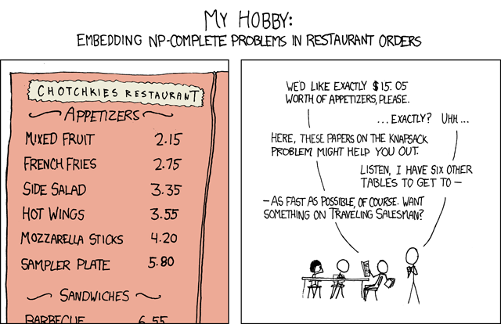

This comic references two common problems that are in NP: the knapsack problem and the traveling salesman problem. The joke is that its sounds easy, but is actually really hard and will take the waiter a LOT of time.

<https://xkcd.com/287/>

Inspiration:

<https://www.youtube.com/watch?v=YX40hbAHx3s>

Outline:

1. Title:
   1. An Introduction to P vs. NP
   2. P vs. NP for Dummies
   3. P vs. NP for Non-mathematicians
   4. P vs. NP for Normal People
2. Introduction to P = NP:
   1. Joke proof, show how that’s not actually the problem
   2. Quickly explain P vs. NP
3. History:
   1. John Nash
   2. Origin of the problem
      1. Computer Scientists in the 70s
   3. Millennium Problems
4. What it is (analogy):
   1. Mountain analogy?
      1. The peak is when you find the solution.
      2. Problems in P mean that you start pretty close to the summit
      3. Problems in NP mean that you’re at the base of the mountain
      4. Your distance is how much time it’ll take to solve the problem
      5. In either case, its easy to check if you’ve solved the problem (am I at the summit?)
      6. If P = NP, then there is some magical shortcut (helicopter?) to the summit.
5. What it is (technical):
   1. Definitions:
   2. P
      1. Easy to do, easy to check.
   3. NP
      1. Hard to do, easy to check.
   4. NP-complete
   5. NP-hard
   6. Euler Diagram:
   7. 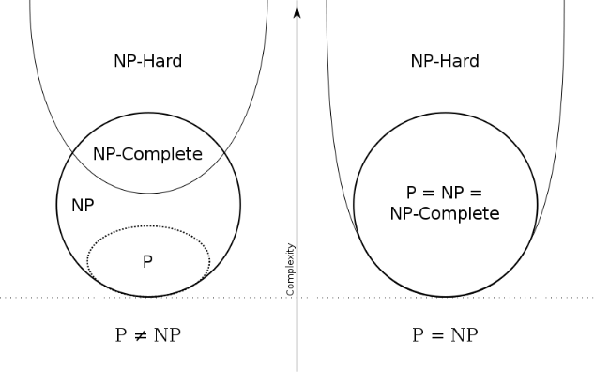
6. Relevance:
   1. Protein folding
   2. Sudoku
   3. [Joke about how these two things are just as hard, but totally different in importance]
      1. Sudoku is more important
7. Future:
   1. How either answer would change the world.
   2. P ≠ NP
      1. This is the normal assumption, not much would really change
   3. P = NP
      1. Finding a solution will be the same difficulty as checking a solution
      2. From video: Listening to a symphony is the same as being Mozart.

Other things to do:

1. Ask Professor Evans if he knows any analogies
2. “Does being able to quickly recognize correct answers mean there’s also a quick way to find them?”
3. “If P = NP, then the world would be a profoundly different place than we usually assume it to be. There would be no special value in "creative leaps," no fundamental gap between solving a problem and recognizing the solution once it's found.” – Scott Aaronson, MIT
4. The main argument in favor of P ≠ NP is the total lack of fundamental progress in the area of exhaustive search. This is, in my opinion, a very weak argument. The space of algorithms is very large and we are only at the beginning of its exploration. [...] The resolution of Fermat's Last Theorem also shows that very simple questions may be settled only by very deep theories. — Moshe Y. Vardi, Rice University