Swagger Test Results

JSON 1 - Main Endpoint Example
{
"holdings": [
{ "ticker": "SPY", "weight": 60 },
{ "ticker": "AGG", "weight": 30 },
{ "ticker": "GLD", "weight": 10 }
],
"strategy": "minimize_volatility"
}
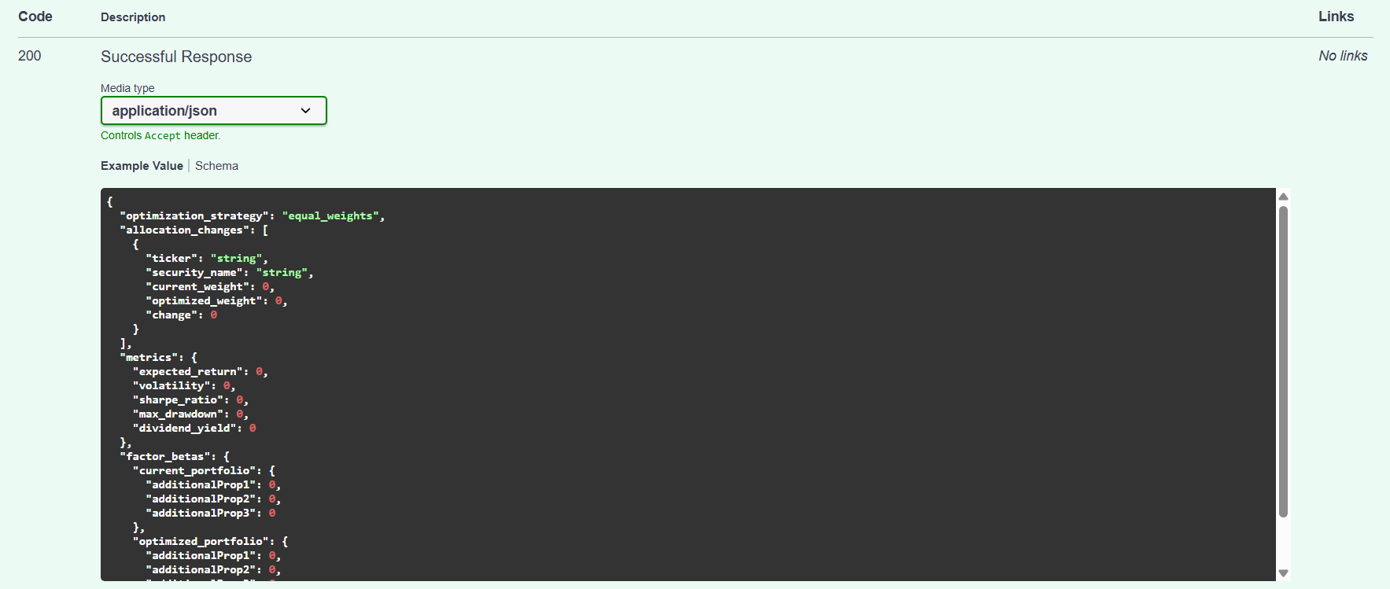

JSON 2 - Constraints Example
{
"constraints": {
"min_weight": 5,
"max_weight": 40,
"min_dividend_yield": 0.025,
"min_cagr": null,
"max_drawdown": null,
"volatility_min": null,
"volatility_max": null
}
}
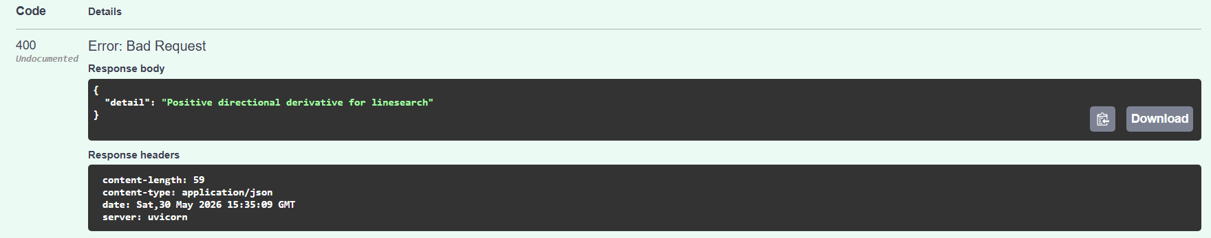

JSON 3 - Factor Exposure Example
{
"holdings": [
{ "ticker": "IEFA", "weight": 20 },
{ "ticker": "GLD", "weight": 20 },
{ "ticker": "AGG", "weight": 20 },
{ "ticker": "VEA", "weight": 20 },
{ "ticker": "SPY", "weight": 20 }
],
"strategy": "optimize_factor_exposure",
"factor_target": "momentum"
}
