**ETL Screenshots-SSIS Sale Reporting**

**Control Flow-Staging and Loading Date Dimension into Destination Table**

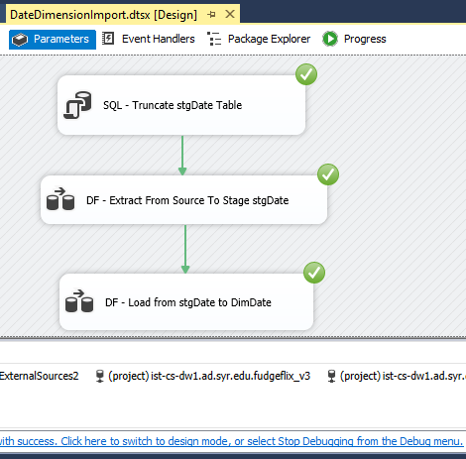

Data Flow-Importing data from ExternalSources2

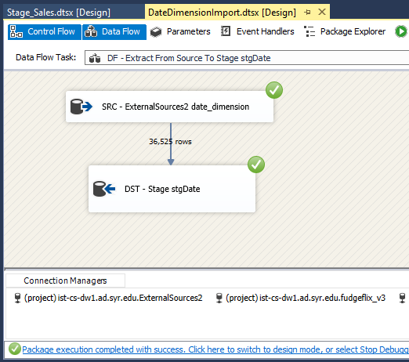

Dataflow from ExternalSourcesv2 to Stage Date

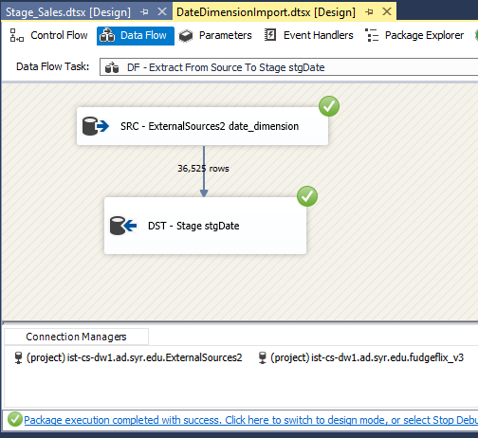

Data Flow-From StageDate to Dimension Date Table

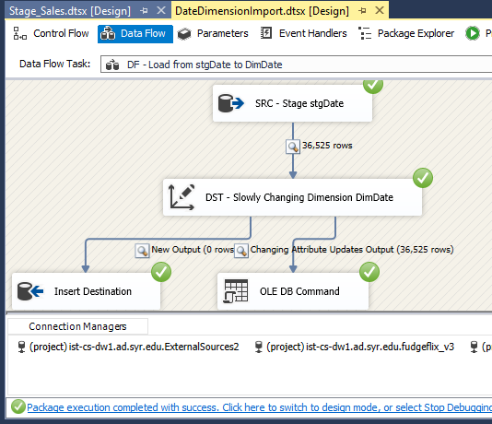

**Control Flow of Stage Fudgemart Sales**

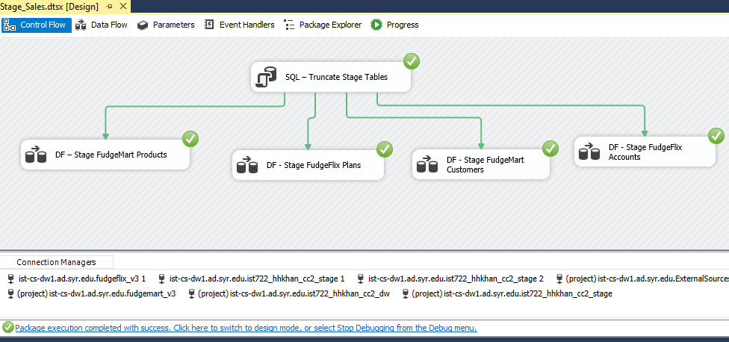

Data Flow-Importing data from fudegflix account source into stage

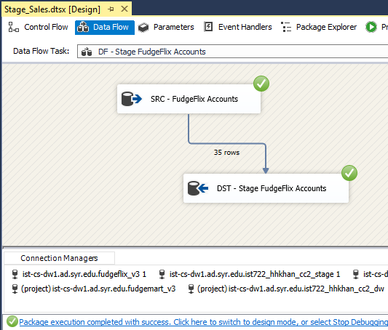

Data Flow-Importing data from fudgemart product source into stage

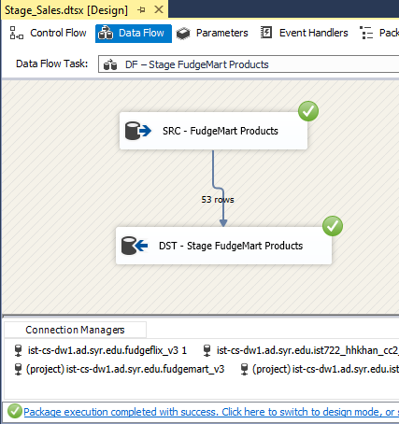

Data Flow-Importing data from fudgeflix plans source into stage

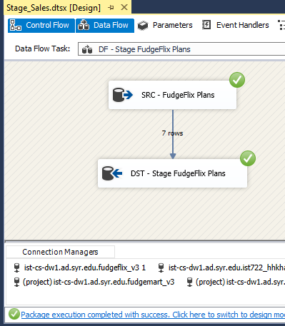

Data Flow-Importing data from fudgemart product Customer into stage

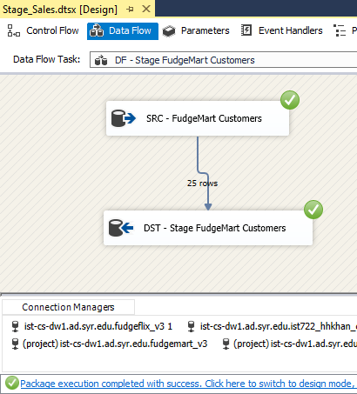

Control Flow of Stage Sales

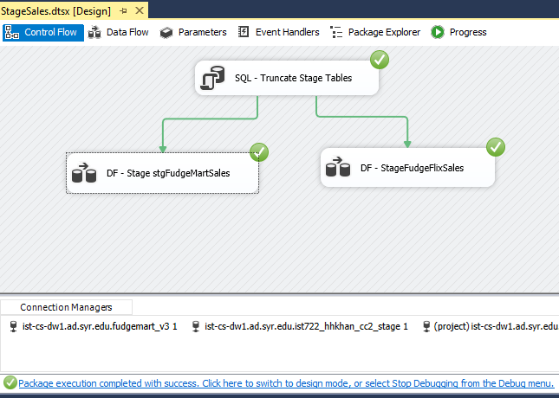

Data Flow from source Orders to FudgeMart-Stage Sales

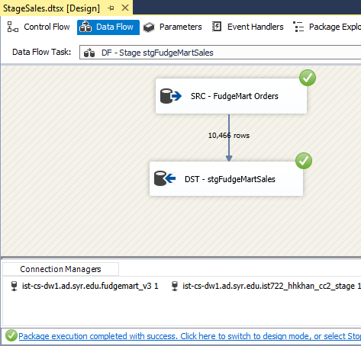

Data Flow from source Account-Billing to FudgeFlix-Stage Sales

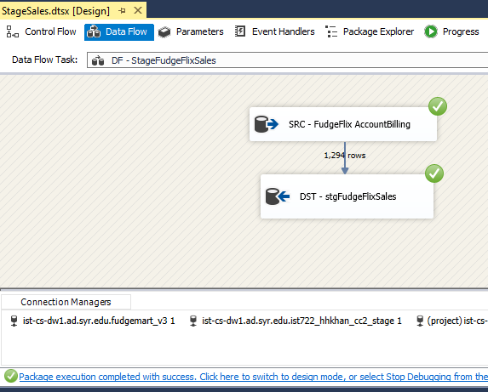

**Data Flow of Loading FudgeFlix Account**

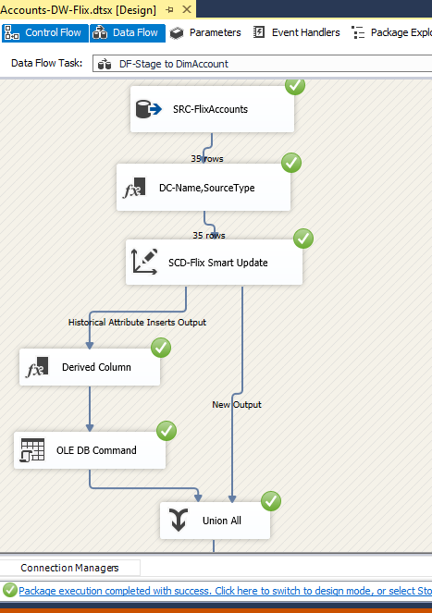

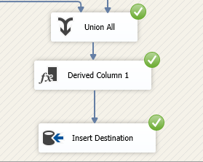

**Data Flow of Loading Fudgemart Customers**

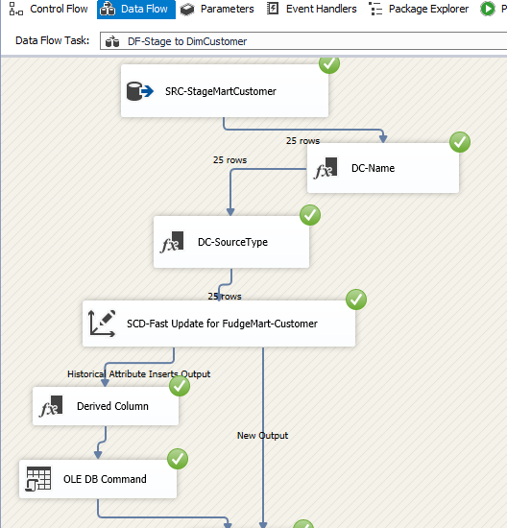

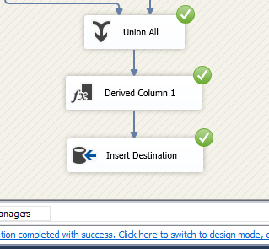

**Data Flow of Loading Fudgemart Products**

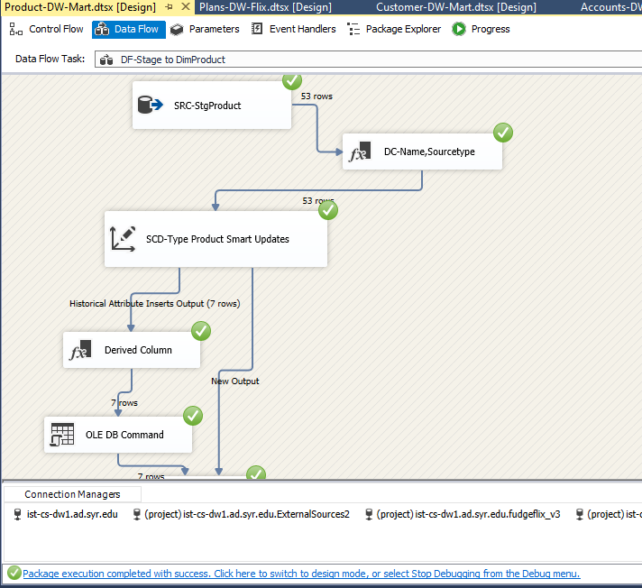

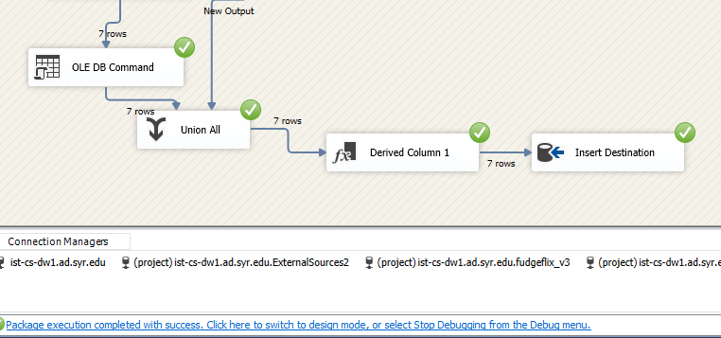

**Data Flow of Loading FudgeFlix Plans**

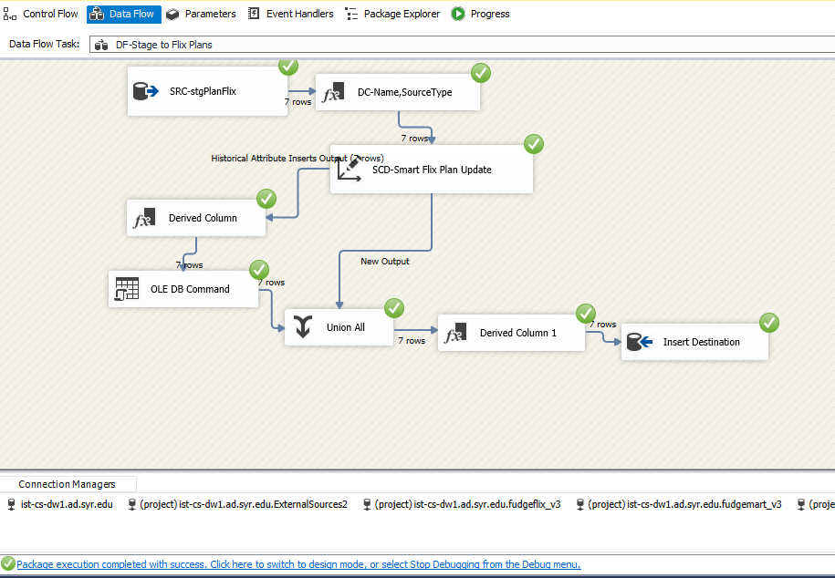

**Data flow of Loading Stage to Fact Sales-Mart**

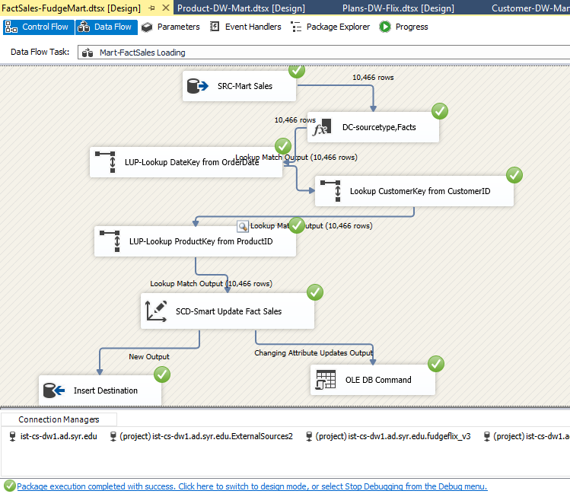

**Data flow of Loading Stage to FudgeFlix-Sales**

