IST722: Unit 02 Class Exercise

**This is an individual assignment.**

**Before you begin, please make sure you’ve read and understand 1) our class honor code, 2) course policies on late work and 3) participation policies as posted on the syllabus. “I didn’t know” is not an excuse.**

**You should cite your sources in a standard format like MPA or APA and include a list of works cited.**

|  |  |
| --- | --- |
| Your Name: | Rashika Singh |
| Your Email: | Rsingh37@syr.edu |

# Instructions

Answer each of the following questions as concisely as possible. More is not necessarily better. Please justify your answer by citing your sources from the assigned readings from our textbooks, our class lectures, or online if directed to do so. Be sure to cite in text and include a list of works cited. Place your answer below each question. When you’re finished, print out this document and bring it to class as part of your participation grade.

# Questions

[1] What is the difference between Systems Architecture and Technical Architecture. Can you provide one example of each?

Technical Architecture (Data Flow Architecture) is also known as Logical Architecture shows how the data stores are arranged in the data warehouse and how data moves from one data store to another. It is not a software architecture or physical network but shows how data moves. The arrow demonstrates the movement of data from one data store to another. Example of Technical Architecture is the flow of information from an ERP system by an ETL process to a data warehouse in an organization.

DW

ETL

ERP

Logical Architecture

System Architecture is the physical configuration of systems, networks and servers for the technical architecture. It shows the technology and network to support the technical architecture. It is an infrastructure of hardware and software to facilitate the technical architecture based on the organizational needs. Example of systems architecture is the configuration of servers and networks in an organization storing customer’s information

Physical Architecture



DW SQL Server 2012



PeopleSoft  
ERP Oracle 12c

[2] What are the 4 types of data stores found in technical architectures?

Data stores are represented as cylinders and not necessary to be database management systems however, they usually are. They can be Big data such as Hadoop HDFS, file systems, web services, mainframes anywhere where there is information available and the data is at rest. There are four types of data stores:

1. User facing- available to end users which can be accessed directly by users.
2. Internal- used by the warehouse which is not open and cannot be accessed by users.
3. Hybrid- combination of user facing and internal.
4. External not a part of the warehouse.

Example of data stores:

*User-Facing* **DDS**

*Internal* **NDS**

*External***OLTP**

*Internal***Stage**

*Hybrid***ODS**

8

[3] List and explain the 5 technical architectures discussed throughout the coursework.

The five technical architectures:

1. Independent data marts-

It is the least complex architecture with source system and one or more DDS system which is a separate entity. It can be done independently however; it is difficult to mature the data warehouse as not much integration can be done between data marts. It is departmentalized and lacks enterprise focus and data is sources independently for each data mart.

1. Centralized-

It is similar to independent data mart except all the data marts are consolidated in a single data store. They are consolidated in a single DDS however; they still lack integration among dimensions and there are copies of dimension for each data mart. It is better than independent architecture but still not the ideal technical architecture.

1. Enterprise bus architecture

All the dimensions from DDS store are reused across the data marts so that there is a single dimension for master data. It is ideal but difficult to achieve as enterprise focus is required to build data mart. This is also the Kimball technical architecture.

Enterprise Bus with ODS- It is variation to the enterprise bus includes an ODS for reporting current data.

1. Hub and spoke-

Data lies in the NDS which is single version of the truth which is sent to DDS as and when needed. Dimensional models in data marts are distributed and sourced from the NDS. The data is normalized but has reduced complexity of conformed dimensions. It is Inmon technical architecture. Data stored in NDS can be used for other purposes as well rather than only dimensional data stores. An ODS can be added to consolidate data at particular time from NDS.

1. Federated-

It is complex architecture which is used when there are several data warehouses which are used for mergers and acquisitions. It can be done with ETL and EII. ETL unifies different sources into a single federated data warehouse. It can be used to integrate existing data marts, warehouses and applications into a single data warehouse.

Federated with EII-

EII is enterprise application integration where Federation is achieved by consolidating data without duplication. It is more complex, and outputs are aggregated on the fly.

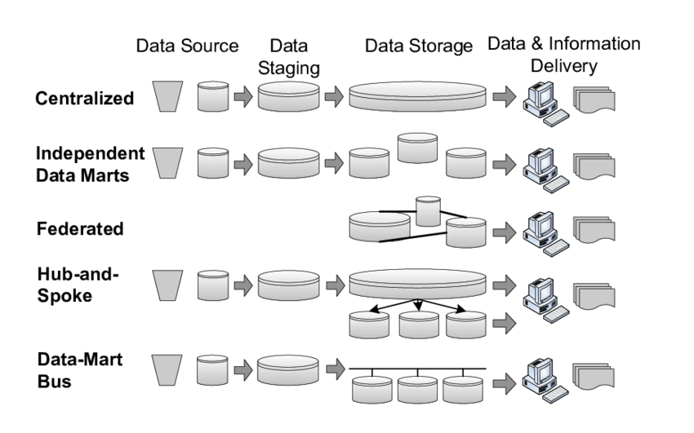

[4] Is the Corporate Information Factory a technical architecture? Explain.

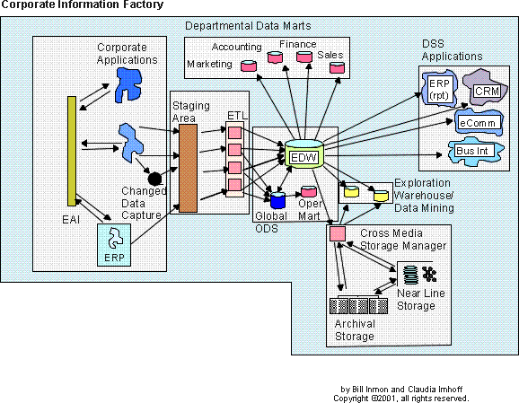

Yes, the Corporate Information Factory is the Hub and Spoke technical architecture. It has an enterprise data warehouse at the center as the hub and the departmental data marts are the data marts which are the spokes. The diagram shows the flow of data from one data store to another. The rectangular components shows the external worlds, decisions with the boxes represent the processes of the technical architecture with the cylinders as the data stores.

WORKS CITED:

Szwed, Piotr (2015, May) Basic Five data warehouse architectures identifiled. Retrieved from <https://www.researchgate.net/figure/Basic-five-data-warehouse-architectures-identified_fig2_277476655>

Professor Fudge Videos