**SYRACUSE UNIVERSITY**



Rashika Singh

Syracuse University

School of Information Studies

IST 659-Project Design Repo

1. **Project Summary**

The project is on designing a centralized database for Syracuse University Students for Community Safety (SCS) which handles the security of the residential halls. The RSA is responsible to monitor public halls by checking student ID cards and ensuring that an unauthorized person cannot enter residential halls. It keeps a track of visitors who enter the residential halls by recording their details.

There are students who work in RSA employed by the SCS for shifts. However, there are certain times when a student wants to drop a particular shift, in this case, they have to come to the SCS office and inform them in advance. A book is maintained in which every week, the shifts which are put for substitution are entered. Another student who wishes to take up the shift can visit the SCS office and pick up shifts. However, this entire process is done manually and consumes time, also, in times where a person might be ill or is unable to visit the office faces problems. In order to solve this problem, an automated system for maintaining shifts can be adopted which will be efficient for the entire process.

There is a vast amount of data which is difficult to maintain as the records include numerous students, shift of halls and time schedule. Students maintain a schedule of their shifts that they have to maintain and thus there is need for a structured format to maintain the records. The information fields include employee details, their type, schedule and payroll. This will help to reduce the time required for the manual storage and make the system easier to use.

As mentioned, a centralized solution for maintaining a database for all the employees, locations and shifts will be beneficial. Another person who wants to pick up a shift can access this system and pick up a shift as per his requirement. It will also be useful for the SCS who can keep a track of the employees. The proposed solution will be called subitup and will include functions for dropping shifts along with specifying the reason for the same. It will also have option to pick up the shift for another employee. It does not include a function for registering for the RSA and giving the exam online as physical verification of the employee is essential. The proposed solution is a centralized repository containing information about all the employees, their shifts, halls, payroll, managers.

The report has design modules which specifies the summary report, entity tables, relational data model, business rules and data questions which are necessary for the development of any module. It includes entity relationship diagram (ERD) including all the entities, attributes and relation between the participating entities and the major issues. It also answers all the major data questions and the business rules

1. **Entity and Attribute Table:**

|  |  |
| --- | --- |
| **Objects** | **Description** |
|  |  |
| 1. Account | Specifies whether employee or manager |
| 1. User_ID | Primary key for identification of user |
| 1. UName | Name of user |
| 1. Utype | Type of the user |
| 1. Ucontact | Contact of the user |
| 1. Uaddress | Address of the user |
|  |  |
| 1. Residential Halls | Specifies the hall in the university |
| 1. Hall_ID | Primary key for the hall |
| 1. HallName | Name of the hall |
| 1. HLocation | Location of the hall |
| 1. STime | Time of the Shift |
|  |  |
| 1. Employee |  |
| 1. Emp_ID | Primary key for employee |
| 1. User_ID | Foreign key for identifying employee |
| 1. Emp_contact | Contact of the employee |
| 1. Emp_address | Employee address |
|  |  |
| 1. Employee Schedule | Schedule of the employee |
| 1. Es_ID | Surrogate key for employee schedule |
| 1. Emp_ID | Foreign key identifies employee |
| 1. S_ID | Foreign key identifies shift |
|  |  |
| 1. Manager | The manager who supervises the shifts |
| 1. M_ID | Primary key for identifying managers |
| 1. User_ID | Foreign key specifies user |
| 1. M_name | Name of the employer |
| 1. M_contact | Contact of the manager |
|  |  |
| 1. Shift | The shift of the employees |
| 1. S_ID | Primary key for shift |
| 1. SLocation | Location of shift |
| 1. STime | Time of the shift |
| 1. SDate | Date of the shift |
|  |  |
| 1. EmpHall | The hall where employees work |
| 1. Eh_ID | Surrogate key for employee hall |
| 1. Emp_ID | Foreign key specifies employee |
| 1. Hall_ID | Foreign key specifies hall |
|  |  |
| 1. Picked Shift | The shifts which are picked |
| 1. Pick_ID | Primary key for picked shift |
| 1. Es_ID | Surrogate key specifies Employee schedule |
|  |  |
| 1. Dropped Shift | The shifts which are dropped |
| 1. Drop_ID | Primary key for dropped shift |
| 1. Es_ID | Surrogate key specifies Employee schedule |
| 1. Approved | Specifies if approved or not by manager |
|  |  |

1. **Relational Data Model:**

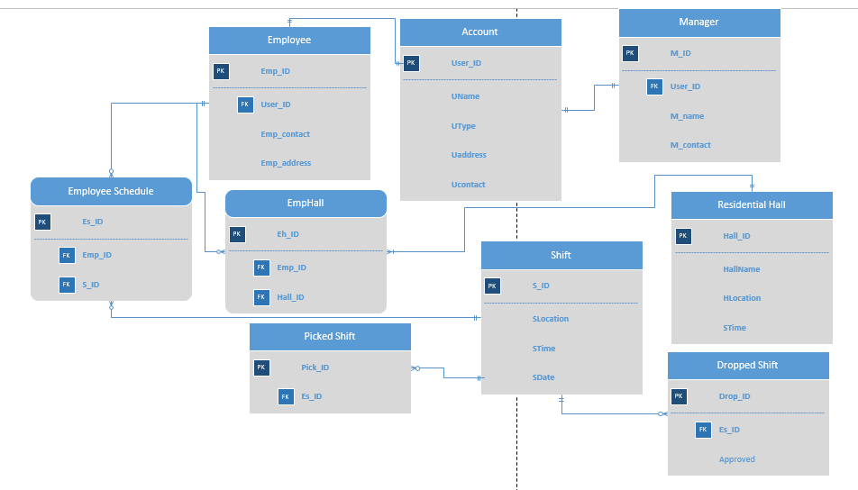

1. **Business Rules:**
2. An employee needs to pick one-night shift.
3. Every user must be a student, employee or manager.
4. Once a shift has been dropped, the same student cannot pick it.
5. A student cannot be free of the shift till someone else picks it.
6. It is allowed to drop a shift till a week prior to the shift day.
7. A student is allowed to work a maximum of 20 hours per week.
8. Whatever maybe the job of the student, the hours worked for a student is maintained in a single database.
9. It is allowed to have a sick call prior to four hours of the shift.
10. An employee is not allowed to have a no-show without informing the managers in any situation.
11. **Major data questions:**
12. How many employees are working at a particular hall?
13. What are the shift timings for a particular employee?
14. How many employees are working at a hall at a particular time?
15. What are the number of hours a particular employee is working?
16. Is the reason for dropping a shift valid?
17. Has the student arrived for his shift?
18. Is the student receiving the pay for the number of hours he is working?
19. Has the person who picked up the shift arrived for the shift?