Customer Churn Prediction
Project Report
Company: ShopEase Retail Pvt. Ltd.
Notebook: Customer_Churn_Prediction.ipynb
Date: October 2026

1. Project summary
ShopEase Retail wanted to know which customers are likely to stop buying (churn). We took the company's old purchase data, cleaned it, studied it with simple tables and charts, and built machine learning models to predict churn.
Data received: 2,535 rows (2,500 customers after removing duplicates)
Customers who left: 750 out of 2,500 (30%)
Best model: Logistic Regression
Accuracy: 85.2% (the model was right for about 85 out of 100 new customers)
Main warning signs of churn: a long gap since the last purchase, many complaints, a low satisfaction score, Basic membership and Cash on Delivery payment

2. Tools used
Tool | What we used it for
Python | The programming language for the whole project
Jupyter Notebook | To write and run the code step by step, with notes in between
pandas | To read the Excel file, clean the data, make tables and find group averages
numpy | For simple number work, like turning Yes/No into 1/0
matplotlib | To draw the charts
scikit-learn (sklearn) | To split the data, train the models and find the accuracy score
openpyxl | Lets pandas read Excel files (works in the background)

How to run the project
- Install Python, then install the libraries with this command: pip install pandas numpy matplotlib scikit-learn openpyxl notebook
- Keep Customer_Purchase_History.xlsx and Customer_Churn_Prediction.ipynb in the same folder.
- Open the notebook in Jupyter and click Run All. Every step will run from top to bottom.

3. Step 1: Loading the data and first look
What we did
- Read the Excel file with pd.read_excel().
- Looked at the first 5 rows with head(), the size with shape, and the column types with info().
What we found
The file has 2,535 rows and 14 columns. In info(), some columns showed fewer filled values than the number of rows. This told us that some cells were empty.
Why we did it
Before changing anything, we must know what the data looks like. Otherwise we can make mistakes in the later steps.

4. Step 2: Data cleaning

4.1 Removing duplicate rows
We counted duplicate rows with duplicated().sum() and found 35. We removed them with drop_duplicates(). The data went from 2,535 rows to 2,500 rows.
Why: If the same customer is counted two times, all our counts and percentages become wrong, and the model gives extra importance to that customer.

4.2 Fixing messy text
The City column had 24 different spellings for just 6 cities, like "delhi", "DELHI" and " Delhi ". The Membership_Type column had 6 spellings for 3 types. We fixed both columns with two simple pandas functions:
- str.strip() removes extra spaces at the start and end
- str.title() makes the first letter capital and the rest small
After this, City had exactly 6 values and Membership_Type had exactly 3 values.
Why: The computer treats "Delhi" and "delhi" as two different cities. Our city-wise counts would be wrong, and the model would learn from wrong groups.

4.3 Filling missing values
We counted empty cells with isna().sum(). Five columns had empty cells. As the guidelines asked, we filled them using only mean, median or mode:
- Mean = the average value
- Median = the middle value when all values are put in order
- Mode = the value that appears the most
Column | Empty cells | Method | Value filled | Why this method
Age | 100 | Mean | 36 years | Ages are spread evenly, so the average is a fair guess. Rounded to a whole number.
Total_Spend | 125 | Median | ₹14,140 | A few very big spenders pull the average up to ₹17,588. The middle value is fairer for a normal customer.
City | 75 | Mode | Delhi | Text cannot be averaged, so we use the most common city.
Payment_Method | 75 | Mode | UPI | Text cannot be averaged, so we use the most common method.
Satisfaction_Score | 100 | Mode | 4 | A rating is a whole number from 1 to 5. An average like 3.7 is not a real rating.

After this step, every column had 0 empty cells. The clean data has 2,500 rows and 14 columns.
Why we filled the cells instead of deleting the rows: 444 customers (about 18% of the data) had at least one empty cell. Deleting them would throw away a lot of useful information. Filling with mean, median or mode keeps all the customers and is easy to explain.

5. Step 3: Exploring the data (EDA)
Techniques used
- describe() to see a quick summary (average, smallest and largest value) of every number column
- value_counts() to count how many customers stayed and how many left
- A helper column Churn_Flag (1 = left, 0 = stayed), made with np.where(), so that the average of this column gives the churn percentage
- groupby().mean() to find the churn percentage in each group, for example in each membership type
- Simple bar charts to show the results
Why we did EDA
EDA shows us which things are linked to churn before we build any model. These findings are useful for the business even without a model, and they help us check that the model's results make sense.
What we found
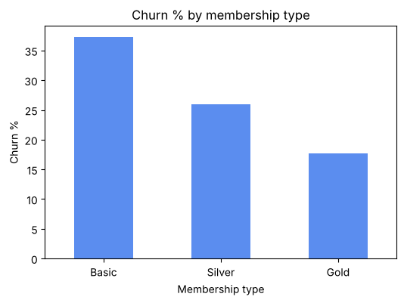
Figure 1: Churn % by membership type
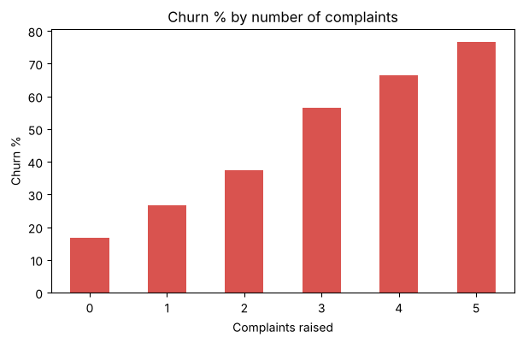
Figure 2: Churn % by number of complaints
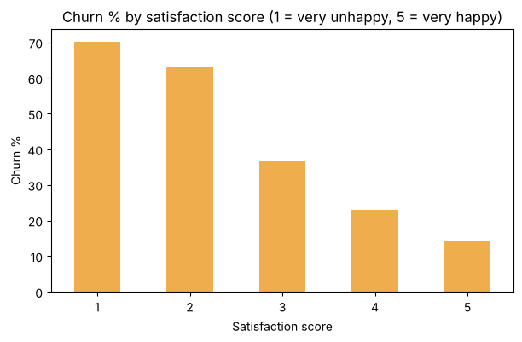
Figure 3: Churn % by satisfaction score
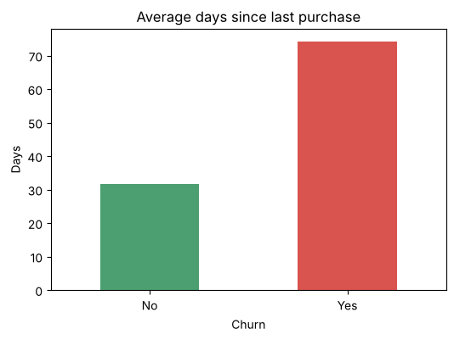
Figure 4: Average days since last purchase, for customers who stayed and who left
- 30% of customers left (750 out of 2,500).
- Membership matters. Basic members leave the most (37.3%). Gold members leave the least (17.7%).
- Complaints are a strong warning sign. Customers with no complaints left 16.8% of the time. Customers with 5 complaints left 76.7% of the time.
- Unhappy customers leave. Customers who gave a score of 1 left 70.2% of the time. Customers who gave 5 left only 14.2% of the time.
- A long gap since the last purchase is a danger sign. Customers who left had not bought anything for 74 days on average. Customers who stayed had bought something in the last 32 days on average.
- Newer customers leave more. Customers who left had been with the company for about 30 months on average. Customers who stayed had been with it for about 39 months, and they also placed more orders.
- Cash on Delivery customers leave more (36.9%) than Wallet users (25.2%).
- City does not matter much. Churn is between 27% and 32% in every city.

6. Step 4: Preparing the data for machine learning
A machine learning model understands only numbers, and it needs a clear answer column. So we did these four things:
What we did | Why we did it
Removed Customer_ID | It is only a name tag. It does not tell anything about how the customer behaves.
Used Churn_Flag (1 or 0) as the answer column and removed the text Churn column | The model needs the answer as a number.
Used pd.get_dummies() on Gender, City, Membership_Type and Payment_Method | It turns each text column into 0/1 columns. For example, a Gold member gets 1 in the "Membership_Type_Gold" column and 0 in the Basic and Silver columns. After this we had 23 input columns.
Split the data with train_test_split(): 80% for training (2,000 customers) and 20% for testing (500 customers), with random_state = 42 | The model learns from the training data. Then we test it on customers it has never seen, like a fair exam. random_state = 42 gives the same split every time we run the notebook.

7. Step 5: Training and checking the models
We trained 3 basic models from scikit-learn on the same training data and tested them on the same test data. We tried more than one model because no single model is the best for every dataset. Comparing a few simple models is a fair way to choose.
Accuracy score = out of all test customers, how many the model predicted correctly. For example, 0.85 means the model was right for 85 out of 100 customers.
Model | How it works (in simple words) | Accuracy
Logistic Regression | Looks at all the columns together and gives a Yes/No answer | 85.2%
Random Forest | Builds many decision trees and takes the majority vote | 83.8%
Decision Tree | Asks a chain of yes/no questions, like a flowchart | 73.0%
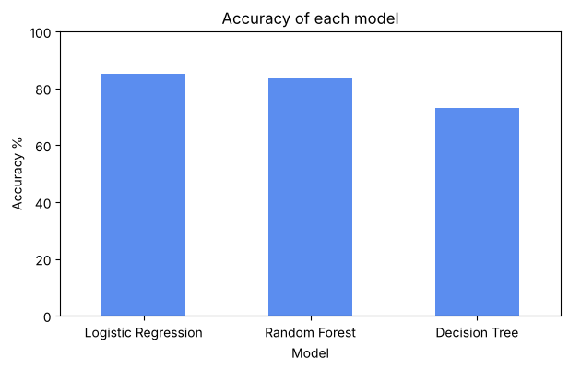
Figure 5: Accuracy of each model
Is 85.2% good?
If we simply said "No, this customer will not leave" for every customer, we would be right 70.4% of the time, because most customers stay. Our best model is right 85.2% of the time. So the model has clearly learned real patterns from the data.
Why is the Decision Tree the weakest?
A single tree learns the training data too closely, almost like memorising the answers. So it makes more mistakes on new customers. Random Forest fixes this partly, because many trees vote together.
One small setting
For Logistic Regression we set max_iter = 5000. This gives the model enough tries to finish learning. Without it, Python shows a warning that the model stopped before it finished.

8. Step 6: Checking and using the model
Sample check: We looked at 10 test customers and compared what really happened with what the model said. The model was right for 8 out of 10. The 2 mistakes were customers who left, but the model said they would stay.
New customer: We gave the model the details of one new customer: a Basic member from Pune with 5 months of tenure, 4 orders, 120 days since the last purchase, 3 complaints, a satisfaction score of 2, and Cash on Delivery payment. The model said this customer is likely to leave. This matches the warning signs we found in EDA.
To predict for a new customer, we used pd.get_dummies() in the same way and reindex() to put the columns in the same order as the training data.

9. Final result and suggestions for the company
Logistic Regression is the final model, with an accuracy of 85.2%. The company can use it in these ways:
- Monthly churn list: Every month, run the model on all current customers. Give the list of customers who are likely to leave to the customer care team.
- Solve complaints fast: Complaints are one of the strongest warning signs. Customers with 2 or more complaints should get a call from the team.
- Win back quiet customers: Send an offer to customers who have not bought anything for about two months.
- Grow membership: Basic members leave the most. A trial of Silver membership may help to keep them.
- Move Cash on Delivery users to UPI or wallets: A small cashback for online payment may build a stronger habit with the company.

10. Limitations
- The model is right for about 85 out of 100 customers, so some predictions will be wrong. It should help the team decide, not replace the team.
- The data covers only 12 months. Customer habits change, so the model should be trained again with new data every few months.
- Missing values were filled with mean, median or mode. These are good guesses, but they are still guesses.
- EDA shows which things happen together. It does not prove that one thing causes the other.

11. Files in this folder
File | What it contains
Problem_Statement.docx | What the company wants, why it needs the project, and information about the dataset
Customer_Purchase_History.xlsx | The company's old customer data (raw, before cleaning)
Customer_Churn_Prediction.ipynb | The full code: cleaning, EDA, models and predictions
Project_Report.docx | This report

