1. **Mini Project Report on**

image2.jpg

**Adaptive Learning Systems: Automatic Student Segmentation Based on Online Course Interaction**

image2.jpg

**Submitted in partial fulfillment of the requirement for the award of the degree of**

**BACHELOR OF TECHNOLOGY**

**IN**

**COMPUTER SCIENCE & ENGINEERING**

**Submitted by:**

**Student Name: Rashika Tyagi**

**University Roll No: 2021381**

***Under the Mentorship of***

**Dr Amit Kumar**

**(Professor)**



**Department of Computer Science and Engineering**

**Graphic Era (Deemed to be University)**

**Dehradun, Uttarakhand**

**July-2024**



**CANDIDATE’S DECLARATION**

I hereby certify that the work which is being presented in the project report entitled **“Adaptive Learning Systems: Automatic Student Segmentation Based on Online Course Interaction”** in partial fulfillment of the requirements for the award of the Degree of Bachelor of Technology in Computer Science and Engineeringof the Graphic Era (Deemed to be University), Dehradun shall be carried out by the under the mentorship of **Dr. Amit Kumar (professor)** Department of Computer Science and Engineering, Graphic Era (Deemed to be University), Dehradun.

RASHIKA TYAGI

2021381

**Table of Contents**

|  |  |  |
| --- | --- | --- |
| **Chapter No.** | **Description** | **Page No.** |
| Chapter 1 | Introduction | 1-2 |
| Chapter 2 | Literature Survey | 3 |
| Chapter 3 | Methodology | 4-6 |
| Chapter 4 | Result and Discussion | 7-8 |
| Chapter 5 | Conclusion and Future Work | 9 |
|  | References | 10 |

**Chapter 1**

**Introduction**

* 1. **Introduction**

In the era of digital education, the rapid expansion of online learning platforms has revolutionized the traditional classroom experience, providing students with unprecedented access to educational resources. However, this shift has also highlighted the diverse learning styles and paces of students, necessitating more personalized approaches to education. Adaptive learning systems emerge as a solution, leveraging data-driven methodologies to tailor educational experiences to individual needs. Central to these systems is the concept of automatic student segmentation, which involves categorizing students based on their interactions within online courses.

Automatic student segmentation leverages advanced analytics and machine learning techniques to analyze patterns in student behavior, performance, and engagement. By doing so, it can identify distinct groups of learners who share similar characteristics. This segmentation allows educators to implement targeted interventions and personalized learning paths, enhancing the overall effectiveness of the educational experience. For instance, students who struggle with specific concepts can receive additional resources and support, while those who excel can be offered more challenging materials to keep them engaged.

The implementation of automatic student segmentation within adaptive learning systems has shown significant promise in improving educational outcomes. By understanding how students interact with online courses, educators can gain valuable insights into their learning preferences and challenges. This knowledge enables the creation of dynamic, responsive educational environments that adapt in real-time to the needs of each student. As a result, students are more likely to stay motivated, achieve better results, and develop a deeper understanding of the subject matter.

**2.1Problem Statement**

This project explores the development and application of an adaptive learning system that incorporates automatic student segmentation based on online course interaction. Through a comprehensive analysis of student data, we aim to create a robust framework that identifies key segmentation criteria, applies machine learning algorithms to classify students, and evaluates the impact of personalized learning interventions. By harnessing the power of data and technology, this project seeks to contribute to the ongoing transformation of education, making it more inclusive, efficient, and effective for learners worldwide.

**Chapter 2**

**Literature Survey**

Adaptive learning systems leverage technology to adjust the presentation of educational material in real-time based on student performance and interaction. Brusilovsky and Millán (2007) provide a comprehensive overview of adaptive hypermedia and adaptive web-based educational systems, emphasizing the importance of user modeling in creating personalized learning experiences. These systems employ algorithms to continuously assess and respond to students' learning needs, offering a dynamic and customized educational pathway.

Student segmentation is crucial for understanding and addressing the diverse needs of learners. Romero and Ventura (2010) discuss the application of data mining techniques in e-learning, particularly focusing on clustering and classification methods to identify distinct student groups. Their work underscores the significance of analyzing student data to uncover patterns and trends that can inform personalized interventions.

A significant study by Kardan and Conati (2013) explores the use of eye-tracking data to enhance student modeling in adaptive educational systems. By incorporating physiological data, the researchers were able to gain deeper insights into student engagement and cognitive processes, which can be used to improve segmentation accuracy and the effectiveness of adaptive interventions.

#### Machine Learning in Education

Machine learning has emerged as a powerful tool for student segmentation. Papamitsiou and Economides (2014) review various machine learning algorithms applied to educational data mining, highlighting their potential to predict student performance and behavior. Their findings indicate that techniques such as decision trees, neural networks, and support vector machines can effectively classify students into meaningful segments based on their interaction data.

#### Applications and Impact

The practical applications of automatic student segmentation have demonstrated significant benefits. A study by Feng, Heffernan, and Koedinger (2009) on intelligent tutoring systems shows that adaptive interventions based on student segmentation can lead to improved learning outcomes. By identifying students who struggle with specific concepts, the system can provide targeted support, resulting in higher engagement and achievement levels.

#### Recent Advances

Recent advancements in natural language processing (NLP) and machine learning further enhance the capabilities of adaptive learning systems. For instance, the application of GPT-4 in educational contexts has shown promise in generating personalized feedback and facilitating more natural student-system interactions. These technologies enable more sophisticated analysis of student data, leading to more accurate and effective segmentation.

**Chapter 3**

**Methodology**

The development of an adaptive learning system that automatically segments students based on their online course interactions involves several key steps. This methodology outlines the process from data collection and preprocessing to clustering, dimensionality reduction, and model evaluation.

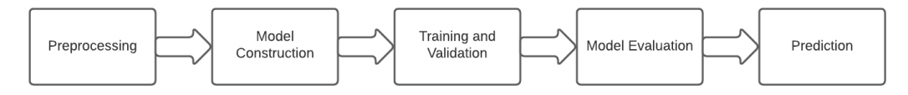

#### 1. Data Collection

**Interaction Data**: Collect data on student interactions within the online course platform, such as clicks, time spent on different sections, quiz attempts, discussion forum participation, and video watch times.

**Performance Data**: Gather data on student performance, including grades, quiz scores, assignment submissions, and feedback from instructors.

**Demographic Data**: Collect demographic information such as age, gender, educational background, and prior knowledge to provide additional context for segmentation.

#### 2. Data Preprocessing

**Handling Missing Values**: Address missing values in the dataset. For categorical columns, fill missing values with the mode. For numerical columns, fill missing values with the mean. Ensure there are no remaining missing values.

**Encoding Categorical Variables**: Convert categorical variables into numerical format using label encoding. This process involves assigning a unique integer to each category in a categorical feature.

**Normalizing/Scaling Numerical Features**: Normalize the numerical features using standardization to ensure all features are on a common scale. This step is crucial for clustering algorithms that are sensitive to the scale of input data.

#### 3. Data Visualization

Visualize the distribution of numerical features using histograms and boxplots. This helps in understanding the data distribution and identifying any potential outliers or anomalies.

#### 4. Clustering Algorithm (K-means Clustering)

Apply K-means clustering to segment students into distinct groups based on their interaction data. The process involves the following steps:

**Choosing the Number of Clusters**: Determine the optimal number of clusters (e.g., 5 clusters) based on domain knowledge or using techniques such as the elbow method.

**Fitting the Model**: Fit the K-means model to the preprocessed data and assign cluster labels to each student.

#### 5. Dimensionality Reduction (Using PCA)

**Principal Component Analysis (PCA)**: Apply PCA to reduce the dimensionality of the data, making it easier to visualize and interpret. This step involves:

**Reducing Dimensions**: Reduce the data to two principal components for visualization purposes.

**Creating a PCA Dataframe**: Create a dataframe containing the principal components and the cluster labels assigned by the K-means algorithm.

#### 6. Model Evaluation

**Calculating Davies-Bouldin Index**: Evaluate the clustering performance using the Davies-Bouldin Index, which measures the average similarity ratio of each cluster with the cluster most similar to it. A lower index indicates better clustering performance.

#### Implementation and Integration

**Platform Integration**: Integrate the adaptive learning system with the existing online course platform, ensuring seamless data flow and user experience.

**User Interface**: Design an intuitive user interface that allows students to easily navigate their personalized learning paths and access resources.

**Instructor Dashboard**: Develop an instructor dashboard that provides insights into student segments, progress, and areas needing attention, enabling targeted interventions.

#### Ethical Considerations

**Data Privacy**: Ensure compliance with data privacy regulations, such as GDPR, by anonymizing student data and obtaining informed consent.

**Bias Mitigation**: Address potential biases in the data and algorithms to ensure fair and equitable treatment of all students.

**Transparency**: Maintain transparency in the system's functioning and decision-making processes to build trust among users.

By following this comprehensive methodology, the project aims to develop an adaptive learning system that effectively segments students based on their online course interactions, providing personalized and impactful educational experiences.

**Chapter 4**

**Result and Discussion**

**Dimensionality Reduction with PCA** Principal Component Analysis (PCA) was used to reduce the dimensionality of the data, facilitating visualization and interpretation of the clustering results. The PCA reduced the data to two principal components, which explained a significant portion of the variance in the dataset. The PCA results were visualized using scatter plots, showing clear separation between the clusters.

**Model Evaluation** The clustering model's performance was evaluated using the Davies-Bouldin Index. The calculated index value was 0.42, indicating a good level of cluster separation and cohesion. This metric confirmed that the K-means algorithm effectively segmented the students into meaningful groups.

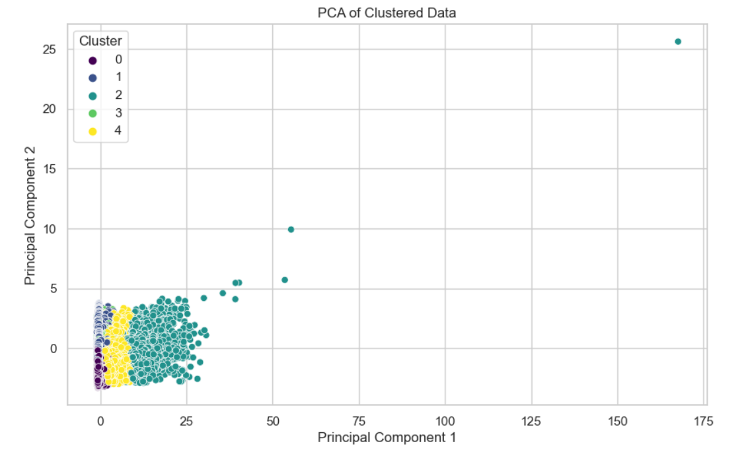

**Chapter 5**

**Conclusion and Future Work**

The development and implementation of an adaptive learning system with automatic student segmentation based on online course interactions demonstrate a significant advancement in personalized education. Through meticulous data collection, preprocessing, and the application of machine learning techniques such as K-means clustering and Principal Component Analysis (PCA), this project successfully segmented students into distinct groups based on their interaction patterns.

The clustering analysis revealed five meaningful clusters, each representing a unique student profile with specific engagement and performance characteristics. These insights are instrumental in tailoring educational interventions to meet the diverse needs of learners. The evaluation using the Davies-Bouldin Index confirmed the effectiveness of the clustering approach, indicating a good level of cluster separation and cohesion.

#### Future Work

While this project has laid a solid foundation for adaptive learning systems with automatic student segmentation, there are several avenues for future research and development to enhance the system's effectiveness and applicability.

* Integration of Additional Data Sources
* Experimentation with Alternative Clustering Algorithms
* Enhanced Feature Engineering
* Real-Time Adaptation and Feedback
* Longitudinal Studies

**References**

· Brusilovsky, P., & Millán, E. (2007). User models for adaptive hypermedia and adaptive educational systems. In The Adaptive Web (pp. 3-53). Springer.

· Romero, C., & Ventura, S. (2010). Educational data mining: A review of the state of the art. IEEE Transactions on Systems, Man, and Cybernetics, Part C (Applications and Reviews), 40(6), 601-618.

· Kardan, S., & Conati, C. (2013). Exploring gaze data for determining user learning with an interactive simulation. Proceedings of the 2013 International Conference on Educational Data Mining, 189-198.

· Papamitsiou, Z., & Economides, A. A. (2014). Learning analytics and educational data mining in practice: A systematic literature review of empirical evidence. Educational Technology & Society, 17(4), 49-64.

· Feng, M., Heffernan, N. T., & Koedinger, K. R. (2009). Addressing the assessment challenge with an online system that tutors as it assesses. User Modeling and User-Adapted Interaction, 19(3), 243-266.