Case Project 2

# Silly Introduction

A large part of support is tracking issues. These are done through Application/services such as JIRA. You all now work for me. I am your evil overlord. MUAHAHAHAHAHA. Oh wait what’s that? I still have to adhere to all local legal regulations but beyond that, you all deserve resect as humans and not just numbers that make me money? Cool! NOW (please) GET TO WORK AND (with respect) MAKE ME MONEY (succeed as a team and feel fulfilled and needed)

# Actual Work

## Part 1 /10

1. Select **ONE** ticket from the Case Project 2 – Part 1 queue in [JIRA](http://encs-comp-dc.northeurope.cloudapp.azure.com:8080/) and ASSIGN IT to yourself. **/2**
2. Once assigned to yourself, change the Ticket status as you deem fit. There is no wrong answer here so long as you do at least one transition. **/3**
3. Answer the math question in the comments, keeping in mind if you are answering it internally, or sharing with customer/client**. /3**
4. Close/complete the ticket. **/2**

## Part 2 /10

You should have been **assigned** a nonsense ticket that might as well be from the typical user as it is intended to make NO SENSE.

1. Please respond to the ticket asking for clarification in a professional, “real world” way as you would expect. **/8**
2. Please set the status to “Waiting for Customer” and leave it there. You’re done! **/2**

**IF YOU WEREN’T ASSIGNED A TICKET for PART 2:**

If you are **able** to login, but do not see a ticket assigned to you under **Issues > My Open Issues** (see Figure 1 in Appendix) then take one from the following QUEUE in JIRA (appendix figure 2):



# Submission Guideline

**PLEASE PASTE LINKS TO YOUR JIRA TICKETS BELOW THIS LINE. THERE SHOULD BE TWO ONLY:**ex: <http://encs-comp-dc.northeurope.cloudapp.azure.com:8080/browse/ENCS06-12345> (not real.. yet)

# Appendix

Figure 1

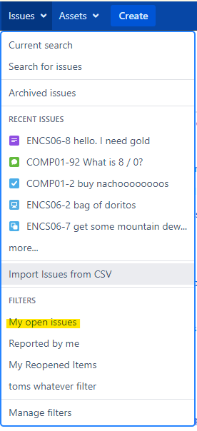

Figure 2:

