Unit First- Introduction and Basic Concepts

Structure of DBMS:
- DBMS (Database Management System) acts as an interface between the user and the database. The user requests the DBMS to perform various operations such as insert, delete, update and retrieval on the database.
- The components of DBMS perform these requested operations on the database and provide necessary data to the users.
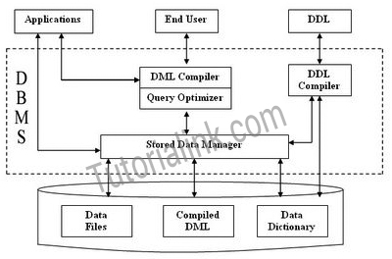
1. Query Processor: It interprets the requests (queries) received from end user via an application program into instructions. It also executes the user request which is received from the DML compiler.
Query Processor contains the following components –
- DML Compiler: It processes the DML statements into low level instruction (machine language), so that they can be executed.
- DDL Interpreter: It processes the DDL statements into a set of table containing meta data (data about data).
- Embedded DML Pre-compiler: It processes DML statements embedded in an application program into procedural calls.
- Query Optimizer: It executes the instruction generated by DML Compiler.
2. Storage Manager: Storage Manager is a program that provides an interface between the data stored in the database and the queries received. It is also known as Database Control System. It maintains the consistency and integrity of the database by applying the constraints and executing the DCL statements. It is responsible for updating, storing, deleting, and retrieving data in the database.
It contains the following components –
- Authorization Manager: It ensures role-based access control, i.e,. checks whether the particular person is privileged to perform the requested operation or not.
- Integrity Manager: It checks the integrity constraints when the database is modified.
- Transaction Manager: It controls concurrent access by performing the operations in a scheduled way that it receives the transaction. Thus, it ensures that the database remains in the consistent state before and after the execution of a transaction.
- File Manager: It manages the file space and the data structure used to represent information in the database.
- Buffer Manager: It is responsible for cache memory and the transfer of data between the secondary storage and main memory.
3. Disk Storage: It contains the following components –
- Data Files: It stores the data.
- Data Dictionary: It contains the information about the structure of any database object. It is the repository of information that governs the metadata.
- Indices: It provides faster retrieval of data item.

Users or DBMS
1. Online Users – These are the users who can communicate with DB directly using any online terminal or indirectly through Application Interface.
- These users having very limited access and very average knowledge and skill of DB handling.
- E.g. A user visiting irctc.co.in web site to access Railway Database for booking online tickets.
2. Naïve Users - These are also called as end users or unsophisticated users.
- These users interacts with DB using previously created or installed application. These users may know about the presence of DB system.
- E.g. a user operating ATM to perform bank transaction on his/her account.
3. Application Programmer – These are the professional programmers who are responsible for developing application program or user interface utilized by the naive and online users.
- These programmers write the application programs in general purpose languages like VB, java, COBOL, Assembly language, etc.
- These programmers may also use available tools to develop programs as per RAD(Rapid Application Development).
- Today many high-end programming tools available which creates applications and also web applications.
4. Sophisticated User – This user interacts with DB without using any application program.
- To complete any task, this user write queries to be compiled and executed by DBMS.

- Advantages Of DBMS:
1. Simplicity – as database is based on hierarchical structure, it’s design is simple.
2. Data Security –It is the first model which offers data security with the help of DBMS.
3. Data Sharing – As the database is stored in common place hence data can be shared between multiple users.
4. Data Integrity – Because of parent child relationship, there will be first a parent segment and then child.
5. Data Independence – It separates / isolates program and complex storage. If there are changes in data no change in application program with less maintenance.
6. Efficiency – It is very efficient if DB contains large numbers of records with 1:m (one-t0-many) relationships
Disadvantages
- Implementation Complexity – Hierarchical DB is conceptually simple and easy to deign but complex to implement.
- It needs good knowledge of physical data storage characteristics.
- Also if there is change in DB structure, it also needs changes in application programs
2. Inflexibility –Hierarchical DB is not flexible i.e not easy to change. If changes are made, it creates more complexed DB model. If any segment deleted, it may cause error in whole DB str.
3. Database Management Problems – If any change is made in DB, it also needs changes in its application program hence the maintenance becomes very difficult.
4. No Structural Independence – If there is change in DB then the functions in DBMS to access data also to be changed

What is RDBMS (Relational Database Management System)
RDBMS stands for Relational Database Management System.
All modern database management systems like SQL, MS SQL Server, IBM DB2, ORACLE, My-SQL, and Microsoft Access are based on RDBMS.
It is called Relational Database Management System (RDBMS) because it is based on the relational model introduced by E.F. Codd.

How it works
Data is represented in terms of tuples (rows) in RDBMS.
A relational database is the most commonly used database. It contains several tables, and each table has its primary key.
Due to a collection of an organized set of tables, data can be accessed easily in RDBMS.

Brief History of RDBMS
From 1970 to 1972, E.F. Codd published a paper to propose using a relational database model.
RDBMS is originally based on E.F. Codd's relational model invention.
Following are the various terminologies of RDBMS:
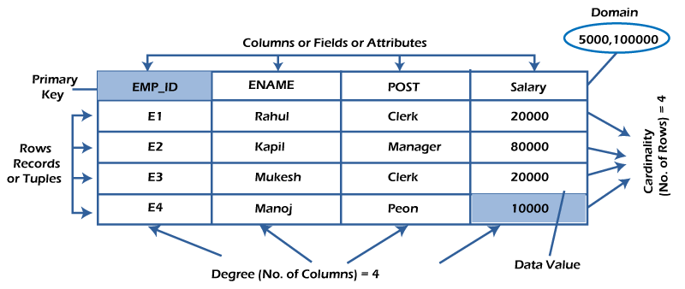

What is table/Relation?
Everything in a relational database is stored in the form of relations. The RDBMS database uses tables to store data. A table is a collection of related data entries and contains rows and columns to store data. Each table represents some real-world objects such as person, place, or event about which information is collected. The organized collection of data into a relational table is known as the logical view of the database.
Properties of a Relation:
- Each relation has a unique name by which it is identified in the database.
- Relation does not contain duplicate tuples.
- The tuples of a relation have no specific order.
- All attributes in a relation are atomic, i.e., each cell of a relation contains exactly one value.
A table is the simplest example of data stored in RDBMS.
Let's see the example of the student table.
ID | Name | AGE | COURSE
1 | Ajeet | 24 | B.Tech
2 | aryan | 20 | C.A
3 | Mahesh | 21 | BCA
4 | Ratan | 22 | MCA
5 | Vimal | 26 | BSC

What is a row or record?
A row of a table is also called a record or tuple. It contains the specific information of each entry in the table. It is a horizontal entity in the table. For example, The above table contains 5 records.
Properties of a row:
- No two tuples are identical to each other in all their entries.
- All tuples of the relation have the same format and the same number of entries.
- The order of the tuple is irrelevant. They are identified by their content, not by their position.
Let's see one record/row in the table.
ID | Name | AGE | COURSE
1 | Ajeet | 24 | B.Tech

What is a column/attribute?
A column is a vertical entity in the table which contains all information associated with a specific field in a table. For example, "name" is a column in the above table which contains all information about a student's name.
Properties of an Attribute:
- Every attribute of a relation must have a name.
- Null values are permitted for the attributes.

Database Schema
A database schema is a structure that represents the logical storage of the data in a database. It represents the organization of data and provides information about the relationships between the tables in a given database. In this topic, we will understand more about database schema and its types. Before understanding database schema, lets first understand what a Database is.

What is Database?
A database is a place to store information. It can store the simplest data, such as a list of people as well as the most complex data. The database stores the information in a well-structured format.

What is Database Schema?
- A database schema is the logical representation of a database, which shows how the data is stored logically in the entire database. It contains list of attributes and instruction that informs the database engine that how the data is organized and how the elements are related to each other.
- A database schema contains schema objects that may include tables, fields, packages, views, relationships, primary key, foreign key,
- In actual, the data is physically stored in files that may be in unstructured form, but to retrieve it and use it, we need to put it in a structured form. To do this, a database schema is used. It provides knowledge about how the data is organized in a database and how it is associated with other data.
- The schema does not physically contain the data itself; instead, it gives information about the shape of data and how it can be related to other tables or models.
- A database schema object includes the following:
  - Consistent formatting for all data entries.
  - Database objects and unique keys for all data entries.
  - Tables with multiple columns, and each column contains its name and datatype.
