Unit IV:- Sorting and Grouping Data and Joining tables & subqueries in Oracle
What is Sorting:-
The SQL ORDER BY clause is used to sort the data in ascending or descending order, based on one or more columns. Some databases sort the query results in an ascending order by default.

ORDER BY
The ORDER BY command is used to sort the result set in ascending or descending order.
The ORDER BY command sorts the result set in ascending order by default. To sort the records in descending order, use the DESC keyword.
The following SQL statement selects all the columns from the "Customers" table, sorted by the "CustomerName" column:

Syntax
The basic syntax of the ORDER BY clause which would be used to sort the result in an ascending or descending order is as follows −
SELECT column-list
FROM table_name
[WHERE condition]
[ORDER BY column1, column2, .. columnN] [ASC | DESC];

Example
SELECT * FROM Customers
ORDER BY CustomerName;
Consider the CUSTOMERS table having the following records −
+----+----------+-----+-----------+----------+
| ID | NAME | AGE | ADDRESS | SALARY |
+----+----------+-----+-----------+----------+
| 1 | Ramesh | 32 | Ahmedabad | 2000.00 |
| 2 | Khilan | 25 | Delhi | 1500.00 |
| 3 | kaushik | 23 | Kota | 2000.00 |
| 4 | Chaitali | 25 | Mumbai | 6500.00 |
| 5 | Hardik | 27 | Bhopal | 8500.00 |
| 6 | Komal | 22 | MP | 4500.00 |
| 7 | Muffy | 24 | Indore | 10000.00 |

SQL> SELECT * FROM CUSTOMERS
ORDER BY NAME, SALARY;

This would produce the following result −
+----+----------+-----+-----------+----------+
| ID | NAME | AGE | ADDRESS | SALARY |
+----+----------+-----+-----------+----------+
| 4 | Chaitali | 25 | Mumbai | 6500.00 |
| 5 | Hardik | 27 | Bhopal | 8500.00 |
| 3 | kaushik | 23 | Kota | 2000.00 |
| 2 | Khilan | 25 | Delhi | 1500.00 |
| 6 | Komal | 22 | MP | 4500.00 |
| 7 | Muffy | 24 | Indore | 10000.00 |
| 1 | Ramesh | 32 | Ahmedabad | 2000.00 |
+----+----------+-----+-----------+----------+

ORDER BY Descending order
The following code block has an example, which would sort the result in a descending order by NAME.
SQL> SELECT * FROM CUSTOMERS
ORDER BY NAME DESC;
This would produce the following result −
+----+----------+-----+-----------+----------+
| ID | NAME | AGE | ADDRESS | SALARY |
+----+----------+-----+-----------+----------+
| 1 | Ramesh | 32 | Ahmedabad | 2000.00 |
| 7 | Muffy | 24 | Indore | 10000.00 |
| 6 | Komal | 22 | MP | 4500.00 |
| 2 | Khilan | 25 | Delhi | 1500.00 |
| 3 | kaushik | 23 | Kota | 2000.00 |
| 5 | Hardik | 27 | Bhopal | 8500.00 |
| 4 | Chaitali | 25 | Mumbai | 6500.00 |
+----+----------+-----+-----------+----------+
Group By:-
The GROUP BY clause is used in SQL queries to organize data that have the same attribute values. Usually, we use it with the SELECT statement. It is always to remember that we have to place the GROUP BY clause after the WHERE clause. Additionally, it is paced before the ORDER BY clause.
We can often use this clause in collaboration with aggregate functions like SUM, AVG, MIN, MAX, and COUNT to produce summary reports from the database. It's important to remember that the attribute in this clause must appear in the SELECT clause, not under an aggregate function. If we do so, the query would be incorrect. As a result, the GROUP BY clause is always used in conjunction with the SELECT clause. The query for the GROUP BY clause is grouped query, and it returns a single row for each grouped object.
The following is the syntax to use GROUP BY clause in a SQL statement:
SELECT column_name, function(column_name)
FROM table_name
WHERE condition
GROUP BY column_name;
Let us understand how the GROUP BY clause works with the help of an example. Here we will demonstrate it with the same table.
The GROUP BY statement groups rows that have the same values into summary rows, like "find the number of customers in each country".
The GROUP BY statement is often used with aggregate functions (COUNT(), MAX(), MIN(), SUM(), AVG()) to group the result-set by one or more columns.
1)SELECT COUNT(CustomerID), Country
FROM Customers
GROUP BY Country;

2)SELECT COUNT(CustomerID), Country
FROM Customers
GROUP BY Country
ORDER BY COUNT(CustomerID) DESC;

HAVING Clause in SQL
The HAVING clause places the condition in the groups defined by the GROUP BY clause in the SELECT statement.
This SQL clause is implemented after the 'GROUP BY' clause in the 'SELECT' statement.
This clause is used in SQL because we cannot use the WHERE clause with the SQL aggregate functions. Both WHERE and HAVING clauses are used for filtering the records in SQL queries.

Syntax of HAVING clause in SQL
- SELECT column_Name1, column_Name2, ....., column_NameN aggregate_function_name(column_Name) FROM table_name GROUP BY column_Name1 HAVING condition;

Examples of HAVING clause in SQL
In this article, we have taken the following four different examples which will help you how to use the HAVING clause with different SQL aggregate functions:
Example 1: Let's take the following Employee table, which helps you to analyze the HAVING clause with SUM aggregate function:
Emp_Id | Emp_Name | Emp_Salary | Emp_City
201 | Abhay | 2000 | Goa
202 | Ankit | 4000 | Delhi
203 | Bheem | 8000 | Jaipur
204 Ram | 2000 | Goa
205 | Sumit | 5000 | Delhi
If you want to add the salary of employees for each city, you have to write the following query:
- SELECT SUM(Emp_Salary), Emp_City FROM Employee GROUP BY Emp_City;
The output of the above query shows the following output:
SUM(Emp_Salary) | Emp_City
4000 | Goa
9000 | Delhi
8000 | Jaipur

SELECT SUM(Emp_Salary), Emp_City FROM Employee GROUP BY Emp_City HAVING SUM(Emp_Salary)>5000;
The output of the above SQL query shows the following table in the output:
SUM(Emp_Salary) | Emp_City
9000 | Delhi
8000 | Jaipur

What is JOIN:- If you want to access more than one table through a select statement.
If you want to combine two or more table then SQL JOIN statement is used .it combines rows of that tables in one table and one can retrieve the information by a SELECT statement. The joining of two or more tables is based on common field between them.
SQL INNER JOIN also known as simple join is the most common type of join.

SQL JOIN
As the name shows, JOIN means to combine something. In case of SQL, JOIN means "to combine two or more tables".
The SQL JOIN clause takes records from two or more tables in a database and combines it together.
ANSI standard SQL defines five types of JOIN :
- Inner join,
- Left join,
- Right join,
- Full join, and
- Cross join.

- EQUI Join
- NON-EQUI Join
Example –
Let’s Consider the two tables given below.
Table name — Student
In this table, you have I’d, name, class and city are the fields.
Select * from Student;
id | name | class | city
3 | Hina | 3 | Delhi
4 | Megha | 2 | Delhi
6 | Gouri | 2 | Delhi
Table name — Record
In this table, you have I’d, class and city are the fields.
Select * from Record;
id | class | city
9 | 3 | Delhi
10 | 2 | Delhi
12 | 2 | Delhi
1. EQUI JOIN :
EQUI JOIN creates a JOIN for equality or matching column(s) values of the relative tables. EQUI JOIN also create JOIN by using JOIN with ON and then providing the names of the columns with their relative tables to check equality using equal sign (=).
Syntax :
SELECT column_list
FROM table1, table2....
WHERE table1.column_name =
table2.column_name;
Example –
SELECT student.name, student.id, record.class, record.city
FROM student, record
WHERE student.city = record.city;
Or
Syntax :
SELECT column_list
FROM table1
JOIN table2
[ON (join_condition)]
Example –
SELECT student.name, student.id, record.class, record.city
FROM student
JOIN record
ON student.city = record.city;
Output :
name | id | class | city
Hina | 3 | 3 | Delhi
Megha | 4 | 3 | Delhi
Gouri | 6 | 3 | Delhi
Hina | 3 | 2 | Delhi
Megha | 4 | 2 | Delhi
Gouri | 6 | 2 | Delhi
Hina | 3 | 2 | Delhi
Megha | 4 | 2 | Delhi
Gouri | 6 | 2 | Delhi
2. NON EQUI JOIN :
NON EQUI JOIN performs a JOIN using comparison operator other than equal(=) sign like >, <, >=, <= with conditions.
Syntax:
SELECT *
FROM table_name1, table_name2
WHERE table_name1.column [> | < | >= | <= ] table_name2.column;

Example –
SELECT student.name, record.id, record.city
FROM student, record
WHERE Student.id < Record.id ;
Output :
name | id | city
Hina | 9 | Delhi
Megha | 9 | Delhi
Gouri | 9 | Delhi
Hina | 10 | Delhi
Megha | 10 | Delhi
Gouri | 10 | Delhi
Hina | 12 | Delhi
Megha | 12 | Delhi
Gouri | 12 | Delhi

SQL Natural Join

Natural join is an SQL join operation that creates a join on the base of the common columns in the tables. To perform natural join there must be one common attribute(Column) between two tables. Natural join will retrieve from multiple relations. It works in three steps.
In this article, we will discuss the overview of SQL Natural Join and then mainly focus to implement queries with the help of examples.
Syntax :
We will perform the natural join query by using the following syntax.
SELECT *
FROM TABLE1
NATURAL JOIN TABLE2;

Features of Natural Join
Here, we will discuss the features of natural join.
- It will perform the Cartesian product.
- It finds consistent tuples and deletes inconsistent tuples.
- Then it deletes the duplicate attributes.

Steps to implement SQL Natural Join
Here, we will discuss the steps to implement SQL Natural Join as follows.
Step 1:Creating Database
Query:
create database geeks;
Step 2: Using the Database. To use this database as follows.
Query:
use geeks;
Step 3: Reference Tables Into The Database .These are our tables in the geek’s database as follows.
Query:
Table-1: Department
Create Table department
(
DEPT_NAME Varchar(20),
MANAGER_NAME Varchar(255)
);
Table-2: Employee
Create Table employee
(
EMP_ID int,
EMP_NAME Varchar(20),
DEPT_NAME Varchar(255)
);
Step 4: Inserting values. Add value to the tables as follows.
Query:
INSERT INTO department(DEPT_NAME,MANAGER_NAME) VALUES ( "IT", "ROHAN");
INSERT INTO department(DEPT_NAME,MANAGER_NAME) VALUES ( "SALES", "RAHUL");
INSERT INTO department(DEPT_NAME,MANAGER_NAME) VALUES ( "HR", "TANMAY");
INSERT INTO department(DEPT_NAME,MANAGER_NAME) VALUES ( "FINANCE", "ASHISH");
INSERT INTO department(DEPT_NAME,MANAGER_NAME) VALUES ("MARKETING", "SAMAY");
Now, insert data in the employee table.
Query:
INSERT INTO employee(EMP_ID, EMP_NAME, DEPT_NAME) VALUES (1, "SUMIT", "HR");
INSERT INTO employee(EMP_ID, EMP_NAME, DEPT_NAME) VALUES (2, "JOEL", "IT");
INSERT INTO employee(EMP_ID, EMP_NAME, DEPT_NAME) VALUES (3, "BISWA", "MARKETING");
INSERT INTO employee(EMP_ID, EMP_NAME, DEPT_NAME) VALUES (4, "VAIBHAV", "IT");
INSERT INTO employee(EMP_ID, EMP_NAME, DEPT_NAME) VALUES (5, "SAGAR", "SALES");
Step 5: Verifying Inserted Data.This is our data inside the table as follows.
Query:
SELECT * FROM employee;
Output :
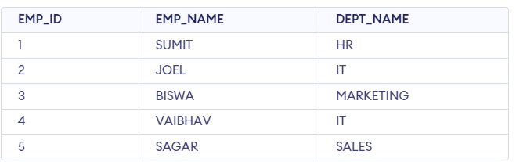

Query:
SELECT * FROM department;
Output :
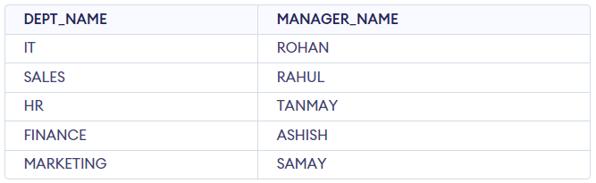

Step 6: Query to Implement SQL Natural Join.
SELECT *
FROM employee
NATURAL JOIN department;
Output :
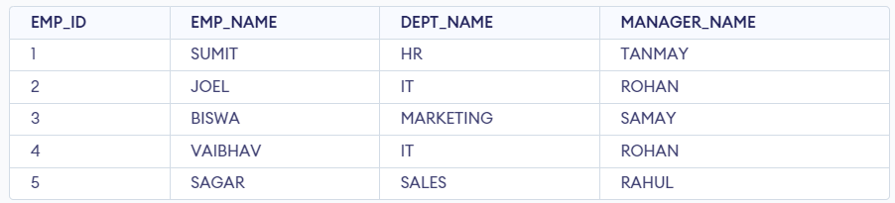
ANSI standard SQL defines five types of JOIN :
- Inner join,
- Left join,
- Right join,
- Full join, and
- Cross join.

1)Inner join
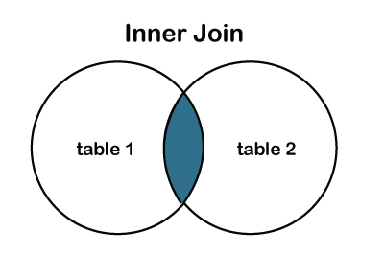
The INNER JOIN keyword selects records that have matching values in both tables.

INNER JOIN Syntax
SELECT column_name(s)
FROM table1
INNER JOIN table2
ON table1.column_name = table2.column_name;

Example:-
SQL> Select *from Mgm_staff;
ID | Staff_name | Staff_add
12 | Rasika Sharma | Bombey
13 | Mansi Varma | Pune
14 | Aryan Shinde | Nanded
33 | Rajesh Khanna | Delhi

SQL> Select *from Payment_mgm;

ID | Pstaff_Name | Pstaff_add
33 | Rajesh Khanna | Delhi
600 | Rani Mukhrjee | Bombey
490 | Sahil KApur | Pune

SQL>select id,staff_name,staff_add from mgm_staff INNER JOIN payment_mgm on mgm_staff.ID=payment_mgm.ID
OUT PUT:-
Staffid | Staff_name | Staff_add
33 | Rajesh Khanna | Delhi

SQL LEFT JOIN Keyword

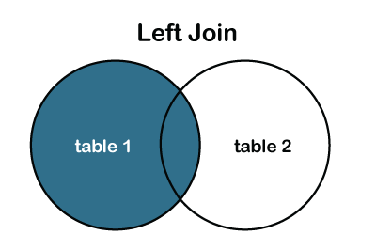
The LEFT JOIN keyword returns all records from the left table (table1), and the matching records from the right table (table2). The result is 0 records from the right side, if there is no match.
SQL>select staffId,staff_name,staff_add from mgm_staff Left JOIN ON mgm_staff.staffID=payment_mgm.ID;
OUTPUT:-
StaffID | Staff_Name | Staff_add
33 | Rajesh khanna | Delhi
12 | Rasika Sharma | Bombey
13 | Mansi Varma | Pune
14 | Aryan Shinde | Nanded

SQL RIGHT JOIN Keyword

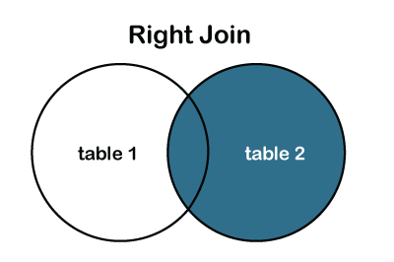
The RIGHT JOIN keyword returns all records from the right table (table2), and the matching records from the left table (table1). The result is 0 records from the left side, if there is no match.

RIGHT JOIN Syntax
SELECT column_name(s)
FROM table1
RIGHT JOIN table2
ON table1.column_name = table2.column_name;
SQL>select staffId,staff_name,staff_add from mgm_staff RIGHT JOIN ON mgm_staff.staffID=payment_mgm.ID;
OUT PUT:-
Staffid | Staff_name | Staff_add
33 | Rajesh Khanna | Delhi

FULL OUTER JOIN

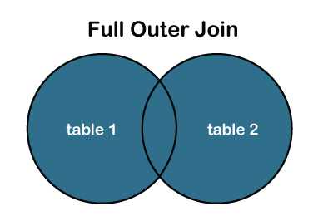
The FULL OUTER JOIN command returns all rows when there is a match in either left table or right table.
The following SQL statement selects all customers, and all orders:
SELECT Customers.CustomerName, Orders.OrderID
FROM Customers
FULL OUTER JOIN Orders ON Customers.CustomerID=Orders.CustomerID
ORDER BY Customers.CustomerName;

Note: The FULL OUTER JOIN keyword returns all the rows from the left table (Customers), and all the rows from the right table (Orders). If there are rows in "Customers" that do not have matches in "Orders", or if there are rows in "Orders" that do not have matches in "Customers", those rows will be listed as well.

SQL CROSS JOIN Keyword
The CROSS JOIN keyword returns all records from both tables (table1 and table2).

CROSS JOIN Syntax
SELECT column_name(s)
FROM table1
CROSS JOIN table2;

Example
SELECT Customers.CustomerName, Orders.OrderID
FROM Customers
CROSS JOIN Orders;
Note: The CROSS JOIN keyword returns all matching records from both tables whether the other table matches or not. So, if there are rows in "Customers" that do not have matches in "Orders", or if there are rows in "Orders" that do not have matches in "Customers", those rows will be listed as well.
If you add a WHERE clause (if table1 and table2 has a relationship), the CROSS JOIN will produce the same result as the INNER JOIN clause:

Example
SELECT Customers.CustomerName, Orders.OrderID
FROM Customers
CROSS JOIN Orders
WHERE Customers.CustomerID=Orders.CustomerID;

SQL Self Join
A self join is a regular join, but the table is joined with itself.

Self Join Syntax
SELECT column_name(s)
FROM table1 T1, table1 T2
WHERE condition;

Demo Database
In this tutorial we will use the well-known Northwind sample database.
Below is a selection from the "Customers" table:
CustomerID | CustomerName | ContactName | Address | City | PostalCode | Country
1 | Alfreds Futterkiste | Maria Anders | Obere Str. 57 | Berlin | 12209 | Germany
2 | Ana Trujillo Emparedados y helados | Ana Trujillo | Avda. de la Constitución 2222 | México D.F. | 05021 | Mexico
3 | Antonio Moreno Taquería | Antonio Moreno | Mataderos 2312 | México D.F. | 05023 | Mexico
The following SQL statement matches customers that are from the same city:

Example
SELECT A.CustomerName AS CustomerName1, B.CustomerName AS CustomerName2, A.City
FROM Customers A, Customers B
WHERE A.CustomerID <> B.CustomerID
AND A.City = B.City
ORDER BY A.City;

SQL Subquery
The Subquery or Inner query is an SQL query placed inside another SQL query. It is embedded in the HAVING or WHERE clause of the SQL statements.
Following are the important rules which must be followed by the SQL Subquery:
1. The SQL subqueries can be used with the following statements along with the SQL expression operators:
- SELECT statement,
- UPDATE statement,
- INSERT statement, and
- DELETE statement.
- The subqueries in SQL are always enclosed in the parenthesis and placed on the right side of the SQL operators.
3. We cannot use the ORDER BY clause in the subquery. But, we can use the GROUP BY clause, which performs the same function as the ORDER BY clause.
4. If the subquery returns more than one record, we have to use the multiple value operators before the Subquery.
5. We can use the BETWEEN operator within the subquery but not with the subquery.

Subquery with SELECT statement
In SQL, inner queries or nested queries are used most frequently with the SELECT statement. The syntax of Subquery with the SELECT statement is described in the following block:
SELECT Column_Name1, Column_Name2, ...., Column_NameN
FROM Table_Name WHERE Column_Name Comparison_Operator
( SELECT Column_Name1, Column_Name2, ...., Column_NameN
FROM Table_Name WHERE condition;
Examples of Subquery with the SELECT Statement
Example 1: This example uses the Greater than comparison operator with the Subquery.
Let's take the following table named Student_Details, which contains Student_RollNo., Stu_Name, Stu_Marks, and Stu_City column.
Student_RollNo. | Stu_Name | Stu_Marks | Stu_City
1001 | Akhil | 85 | Agra
1002 | Balram | 78 | Delhi
1003 | Bheem | 87 | Gurgaon
1004 | Chetan | 95 | Noida
1005 | Diksha | 99 | Agra
1006 | Raman | 90 | Ghaziabad
1007 | Sheetal | 68 | Delhi
The following SQL query returns the record of those students whose marks are greater than the average of total marks:
- SELECT * FROM Student_Details WHERE Stu_Marks> ( SELECT AVG(Stu_Marks ) FROM Student_Details);
- Output:
Student_RollNo. | Stu_Name | Stu_Marks | Stu_City
1003 | Bheem | 87 | Gurgaon
1004 | Chetan | 95 | Noida
1005 | Diksha | 99 | Agra
1006 | Raman | 90 | Ghaziabad
Example 2: This example uses the IN operator with the subquery.
Let's take the following two tables named Faculty_Details and Department tables. The Faculty_Details table contains ID, Name, Dept_ID, and address of faculties. And, the Department table contains the Dept_ID, Faculty_ID, and Dept_Name.
Faculty_ID | Name | Dept_ID | Address
101 | Bheem | 1 | Gurgaon
102 | Chetan | 2 | Noida
103 | Diksha | NULL | Agra
104 | Raman | 4 | Ghaziabad
105 | Yatin | 3 | Noida
106 | Anuj | NULL | Agra
107 | Rakes | 5 | Gurgaon

Dept_ID | Faculty_ID | Dept_Name
1 | 101 | BCA
2 | 102 | B.Tech
3 | 105 | BBA
4 | 104 | MBA
5 | 107 | MCA
SELECT * FROM Department WHERE Faculty_ID IN (
SELECT Faculty_ID FROM Faculty WHERE City = 'Noida' OR City = 'Gurgaon' ) ;
Output:
Dept_ID | Faculty_ID | Dept_Name
1 | 101 | BCA
2 | 102 | B.Tech
3 | 105 | BBA
5 | 107 | MCA

Subquery with the INSERT statement
We can also use the subqueries and nested queries with the INSERT statement in Structured Query Language. We can insert the results of the subquery into the table of the outer query. The syntax of Subquery with the INSERT statement is described in the following block:
- INSERT INTO Table_Name SELECT * FROM Table_Name WHERE Column_Name Operator (Subquery);

Examples of Subquery with the INSERT Statement
Example1: This example inserts the record of one table into another table using subquery with WHERE clause.
Let's take Old_Employee and New_Employee tables. The Old_Employee and New_Employee table contain the same number of columns. But, both the tables contain different records.
Emp_ID | Emp_Name | Emp_Salary | Address
1001 | Akhil | 50000 | Agra
1002 | Balram | 25000 | Delhi
1003 | Bheem | 45000 | Gurgaon
1004 | Chetan | 60000 | Noida
1005 | Diksha | 30000 | Agra
1006 | Raman | 50000 | Ghaziabad
1007 | Sheetal | 35000 | Delhi
Table: Old_Employee
Emp_ID | Emp_Name | Emp_Salary | Address
1008 | Sumit | 50000 | Agra
1009 | Akash | 55000 | Delhi
1010 | Devansh | 65000 | Gurgaon
Table: New_Employee
The New_Employee contains the details of new employees. If you want to move the details of those employees whose salary is greater than 40000 from the Old_Employee table to the New_Employee table. Then for this issue, you have to type the following query in SQL:
- INSERT INTO New_Employee SELECT * FROM Old_Employee WHERE Emp_Salary > 40000;
Now, you can check the details of the updated New_Employee table by using the following SELECT query:
- SELECT * FROM New_Employee;
Output:
Emp_ID | Emp_Name | Emp_Salary | Address
1008 | Sumit | 50000 | Agra
1009 | Akash | 55000 | Delhi
1010 | Devansh | 65000 | Gurgaon
1001 | Akhil | 50000 | Agra
1003 | Bheem | 45000 | Gurgaon
1004 | Chetan | 60000 | Noida
1006 | Raman | 50000 | Ghaziabad

Subquery with the UPDATE statement
The subqueries and nested queries can be used with the UPDATE statement in Structured Query Language for updating the columns of the existing table. We can easily update one or more columns using a subquery with the UPDATE statement.
Syntax of Subquery with the UPDATE statement
- UPDATE Table_Name SET Column_Name = New_value WHERE Value OPERATOR (SELECT COLUMN_NAME FROM TABLE_NAME WHERE Condition) ;
Example of Subquery with the UPDATE statement
This example updates the record of one table using the IN operator with Subquery in the UPDATE statement.
Let's take an Employee_Details and Department table.
The data of the Employee_Details table is shown in the following table:
Emp_ID | Emp_Name | Emp_Salary | Dept_ID
1001 | Akhil | 50000 | 404
1002 | Balram | 25000 | 403
1003 | Bheem | 45000 | 405
1004 | Chetan | 60000 | 402
1005 | Ram | 65000 | 407
1006 | Shyam | 55500 | NULL
1007 | Shobhit | 60000 | NULL
Table: Employee_Details
The data of Department table is shown in the below table:
Dept_ID | Dept_Name | Emp_ID | Dept_Grade
401 | Administration | 1008 | B
402 | HR | 1004 | A
403 | Testing | 1002 | A
404 | Coding | 1001 | B
405 | Sales | 1003 | A
406 | Marketing | NULL | C
407 | Accounting | 1005 | A
The following updates the salary of those employees whose Department Grade is A:
- UPDATE Employee_Details SET Emp_SalaryEmp_Salary = Emp_Salary + 5000 WHERE Emp_ID IN ( SELECT Emp_ID FROM Department WHERE Dept_Grade = 'A' ) ;
- SELECT * FROM Employee_Details ;
Output:
Emp_ID | Emp_Name | Emp_Salary | Dept_ID
1001 | Akhil | 50000 | 404
1002 | Balram | 30000 | 403
1003 | Bheem | 50000 | 405
1004 | Chetan | 65000 | 402
1005 | Ram | 70000 | 407
1006 | Shyam | 55500 | NULL
1007 | Shobhit | 60000 | NULL

Subquery with the DELETE statement
We can easily delete one or more records from the SQL table using Subquery with the DELETE statement in Structured Query Language.
Syntax of Subquery with DELETE statement
- DELETE FROM Table_Name WHERE Value OPERATOR (SELECT COLUMN_NAME FROM TABLE_NAME WHERE Condition) ;
- Example of Subquery with DELETE statement
- This example deletes the records from the table using the IN operator with Subquery in the DELETE statement.
- Let's take an Employee_Details and Department table.
- The data of the Employee_Details table is shown in the following table:
Emp_ID | Emp_Name | Emp_Salary | Dept_ID
1001 | Akhil | 50000 | 404
1002 | Balram | 25000 | 403
1003 | Bheem | 45000 | 405
1004 | Chetan | 60000 | 402
1005 | Ram | 65000 | 407
1006 | Shyam | 55500 | NULL
1007 | Shobhit | 60000 | NULL
1008 | Ankit | 48000 | 401
Table: Employee_Details
The data of Department table is shown in the below table:
Dept_ID | Dept_Name | Emp_ID | Dept_Grade
401 | Administration | 1008 | C
402 | HR | 1004 | A
403 | Testing | 1002 | C
404 | Coding | 1001 | B
405 | Sales | 1003 | A
406 | Marketing | NULL | C
407 | Accounting | 1005 | C
The following query deletes the record of those employees from the Employee_Details whose Department Grade is C:
- DELETE FROM Employee_Details WHERE Emp_ID IN ( SELECT Emp_ID FROM Department WHERE Dept_Grade = 'C' ) ;
he following query will show the updated data of the Employee_Details table in the output:
- SELECT * FROM Employee_Details ;
Output:
Emp_ID | Emp_Name | Emp_Salary | Dept_ID
1001 | Akhil | 50000 | 404
1003 | Bheem | 45000 | 405
1004 | Chetan | 60000 | 402
1006 | Shyam | 55500 | NULL
1007 | Shobhit | 60000 | NULL
Table: Employee_Details

Joining Three or More Tables in SQL
Joining multiple tables in SQL is some tricky task. It can be more difficult if you need to join more than two tables in single SQL query, we will analyze how to retrieve data from multiple tables using INNER JOINs. In this section, we have used two approaches to join three or more tables in SQL.

Example:
We are creating three tables, as follows:
- student
- marks
- details

Table 1: student
- create table student(s_id int primary key, s_name varchar(17));
- insert into student values(1, 'Jack');
- insert into student values(2, 'Rithvik');
- insert into student values(3, 'Jaspreet');
- insert into student values(4, 'Praveen');
- insert into student values(5, 'Bisa');
- insert into student values(6, 'Suraj');
STUDENT TABLE
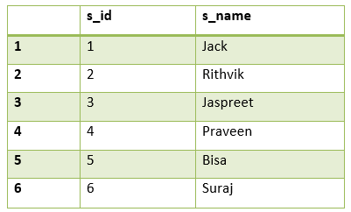
In the above table s_id is the primary key.

Table 2: marks
- create table marks(school_id int primary key, s_id int, score int, status varchar(20));
- insert into marks values(1004, 1, 23, 'fail');
- insert into marks values(1008, 6, 95, 'pass');
- insert into marks values(1012, 2, 97, 'pass');
- insert into marks values(1016, 7, 67, 'pass');
- insert into marks values(1020, 3, 100, 'pass');
- insert into marks values(1025, 8, 73, 'pass');
- insert into marks values(1030, 4, 88, 'pass');
- insert into marks values(1035, 9, 13, 'fail');
- insert into marks values(1040, 5, 16, 'fail');
- insert into marks values(1050, 10, 53, 'pass');
MARKS TABLE
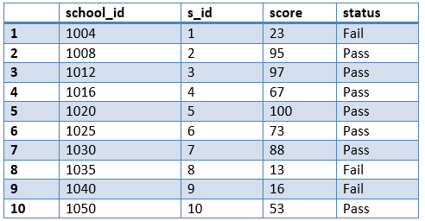
In the above table, school_id is primary key and s_id is the foreign key.

Table 3: details
create table details(address_city varchar(20), email_ID varchar(20), school_id int, accomplishments varchar(50));

insert into details values('Bangalore', 'jsingh@jtp.com',
1020, 'ACM ICPC selected');
insert into details values('Hyderabad', 'praveen@jtp.com',
1030, 'Geek of the month');
insert into details values('Delhi', 'rithvik@jtp.com',
1012, 'IOI finalist');
insert into details values('Chennai', 'om@jtp.com',
1111, 'Geek of the year');
insert into details values('Banglore', ' suraj@jtp.com',
1008, 'IMO finalist');
insert into details values('Mumbai', 'sasukeh@jtp.com',
2211, 'Made a robot');
insert into details values('Ahmedabad', 'itachi@jtp.com',
1172, 'Code Jam finalist');
insert into details values('Jaipur', 'kumar@jtp.com',
1972, 'KVPY finalist');
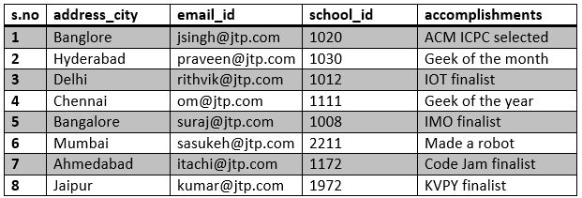
In the above table, school_id is the foreign key.
There are two approaches to join three or more tables in SQL:

1. Using JOINS in SQL:
The same logic is applied here which is used to join two tables i.e., the minimum number of join statements to join n tables are (n-1).
select s_name, score, status, address_city, email_id,
accomplishments from student s inner join mark m on
s.s_id = m.s_id inner join details d on
- d.school_id = m.school_id;
- Output:
- 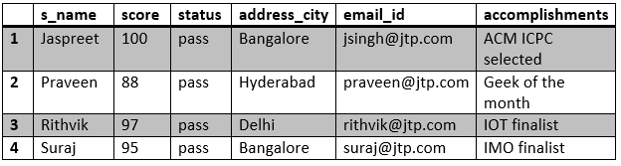

2. Using the Parent-child Relationship:
In the parent-child relationship, we use where clause to join two or more tables. Create column X as a primary key in one table and a foreign key in another table
Look at the tables which are created:
s_id is the primary key in the student table and foreign key in the marks table. (student (parent) - marks(child)).
school_id is the primary key in the marks table and foreign key in the student table. (marks(parent) - details(child)).
Query:
select s_name, score, status, address_city,
email_id, accomplishments from student s,
marks m, details d where s.s_id = m.s_id and
m.school_id = d.school_id;
Output:
