**21BEC1534**

**RASHI PAHUJA**

**Experiment - 7**

**Homomorphic Filtering Technique**

**Aim:** To implement and observe the effect of homomorphic filtering technique on images with different levels of brightness using MATLAB.

**Software Required:** MATLAB

**Code:**

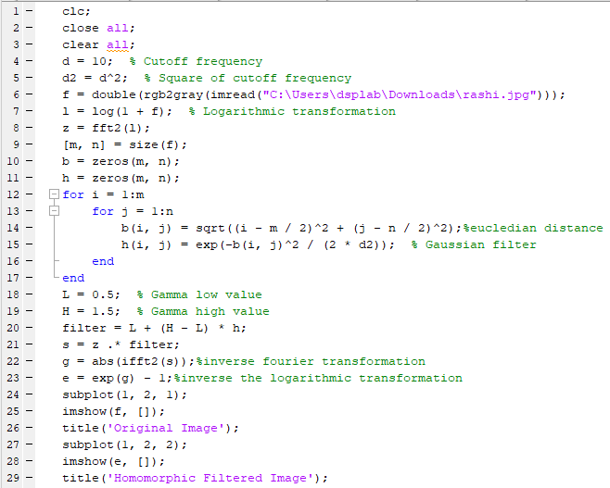

**Figure:**

Applying Homomorphic filtering technique on:

1. Original Image

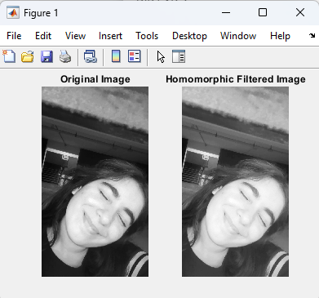

1. Increased brightness by 50

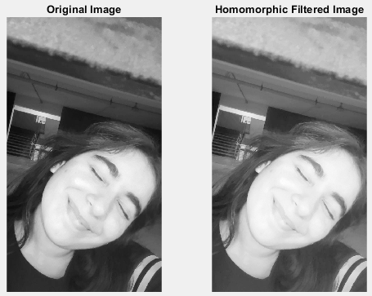

1. Increased brightness by 100

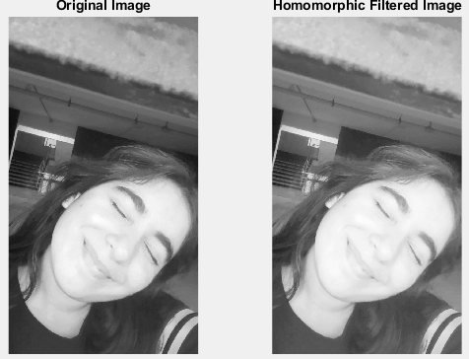

1. Decreased brightness by 50

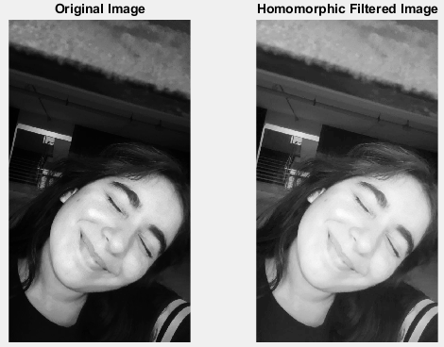

1. Decreased brightness by 100

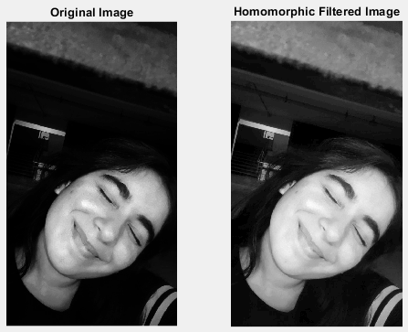

1. Various images with different lighting

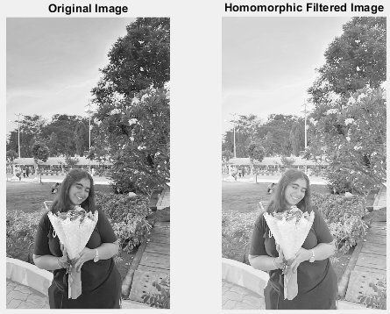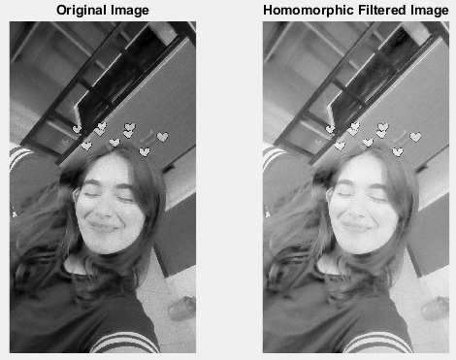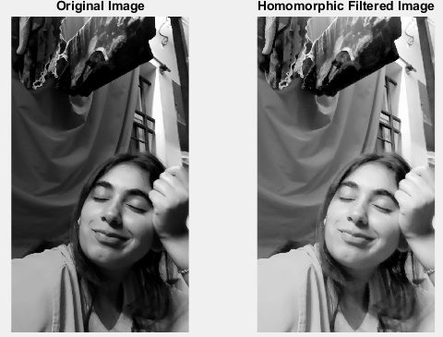

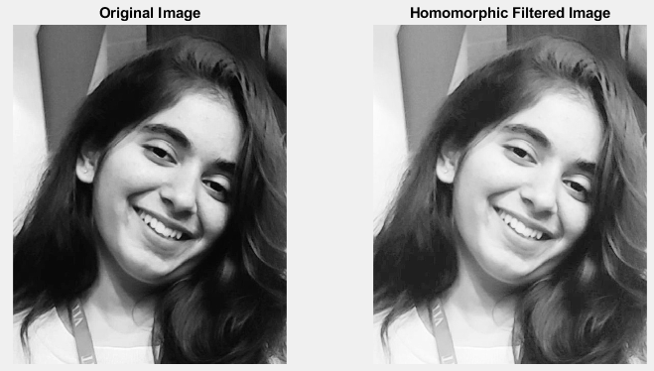

**Result:** Successfully implememted Homomorphic Filtering Techniques on on images with different levels of brightness and observed that the Homomorphic filtering effectively enhances image clarity and contrast, demonstrating significant improvement across various brightness levels, allowing for better feature visibility and reduced lighting inconsistencies.