**21BEC1534**

**RASHI PAHUJA**

**Experiment - 8**

**Aim:** To analyze the effects of color image smoothing using a mean filter and sharpening using a Laplacian filter, evaluate the quality of the processed images using PSNR and SSIM metrics, and compare the results when applying smoothing followed by sharpening and vice versa using MATLAB.

**Software Required:** MATLAB

**Code:**

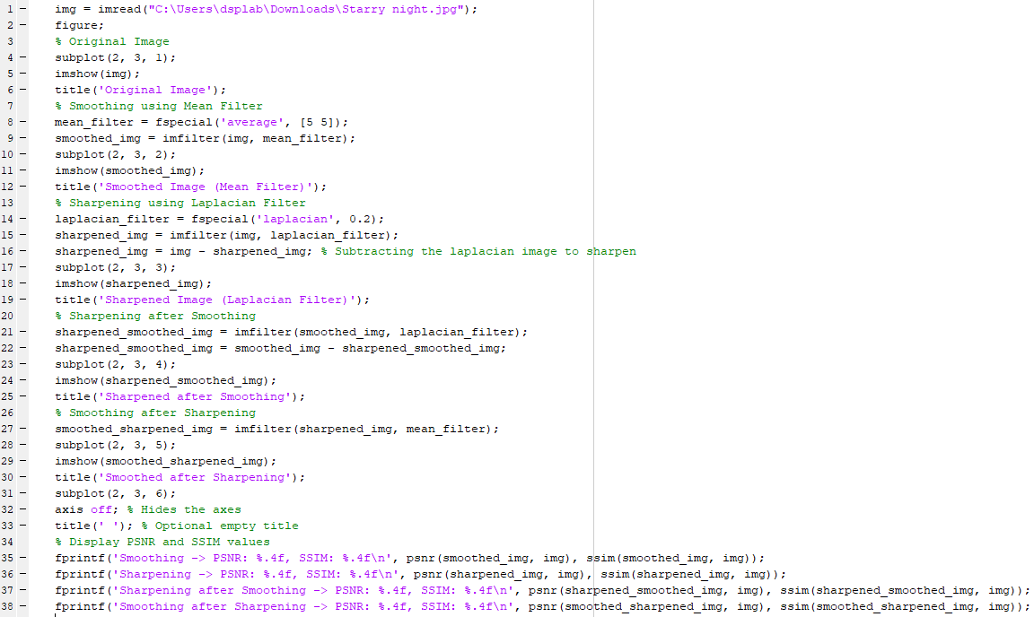

**Command Window:**

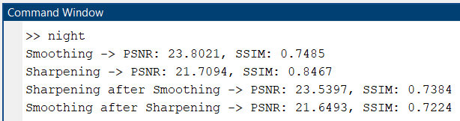

**Figure:**

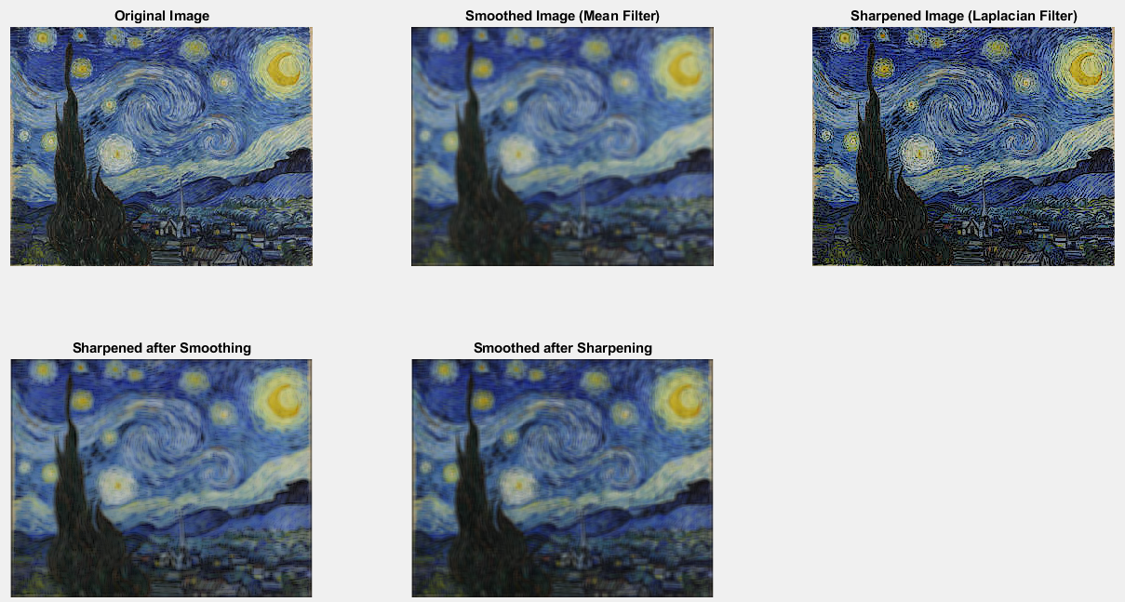

**Result:** Successfully implememted the given filters on ‘Starry Night’ image and observed that higher PSNR and SSIM values indicate better image quality. Sharpening after smoothing balances noise reduction and detail enhancement, while smoothing after sharpening lowers image sharpness and reduces PSNR and SSIM values.