**Tableau 2 Project**

1. DATA:

Initially, I connected the provided data to a new Tableau Workbook where I used the Data Source tab to look into the fields and values present in the data. I was able to understand the data relates to a company’s sales and profits for the year 2022-23 in the United States in a variety of different items in the Appliances, Beds and Sofas departments. I was able to create a goal of finding the area of most potential improvements in terms of profits. This was the target that guided my visualizations for the project. The only unexpected part of the data was its size being comparatively short since I have worked on bigger data in other projects this semester. This created a limited space to work with.

1. WORKBOOK SHEETS:

**Worksheet 1: Sales by Department**

This worksheet shows the sales made by the different departments of the company during the year 2022-23 in different regions. It helped me locate the lower sales in the South region for all the departments of the company for the given time period. Due to the nature of the data, I began by looking at the sales and wanted more details, which led me to add more filters to this data. This data is the first step towards analyzing the sales/ profit for the different departments. This data was best presented in the stacked bars visualization format due to the way it is able to show sales for each region as well.

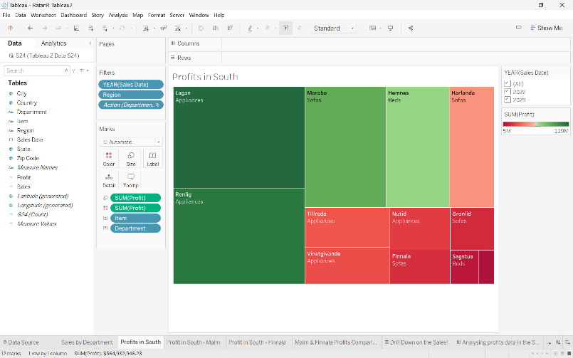**Worksheet 2: Profits in the South**

After looking at the previous worksheet, I created this one to focus on the profits being made in the Southern region. The worksheet shows these profits by item and also displays the departments for each item. This worksheet is a very significant part of this project because of the way it starts to narrow down on a certain part of the data for us to analyze. This data is best displayed in this manner as you’re able to see the items that contribute to the largest part of the region’s profit and those that don’t.

**Worksheet 3: Profits in South - Malm**

This worksheet displays the profits made by the different states in the Southern region, filtered by item. Here, we are only displaying the profits for the “Malm” item since that was identified as one of the items with the least profits in the South. From this worksheet, we understand that part of the reason behind that is the number of states that are not selling this item. We will be able to analyze this further when we look at the story. Please note that this visualization was created as a map to display the locations better and make the data easier to understand.

**Worksheet 4: Profits in South - Finnala**

This worksheet also displays the profits made by the different states in the Southern region, filtered by item. However, here we are only displaying the profits for the “Finnala” item since that was identified as one of the items with the least profits in the South. From this worksheet, we see that there is a large variation in the profits made by these Southern states. We will be able to analyze this further when we look at the story. Please note that this visualization was created as a map to display the locations better and make the data easier to understand.

**Worksheet 4: Profits in South - Finnala**

The Malm and Finnala Profits Comparison worksheet shows us the progress of the profits made by the different region over the given time period. This was an interesting visualization because A screenshot of a computer
it puts the data we understood in the previous worksheets into perspective as we compare the profits for the two items in other regions as well. The data is presented using a line graph perfectly as it gives us an overview of the changes in these profits across the regions without having to perform calculations or compare numerical values. In the story, we will learn about our observations from this sheet.

1. A screenshot of a computer

   Description automatically generatedWORKBOOK DASHBOARD

In this interactive dashboard, we are able to see the sales of the regions in specific departments. Here, the sales by departments worksheet and the profits worksheet have been combined to create a dashboard where the sales by departments sheet is being used as a filter to look at the items that are making the most profits. As you click on the region in the department you want to see, the visualization changes to display the items with the highest profits. This dashboard helps us find the low profit-making items in the different regions and departments. This will play an important role in our story.

1. THE STORY

The story begins with looking at an interactive dashboard first where we are able to look at how the sales in the South are the lowest amongst all the regions. As we narrow down on the Southern region across the departments, we notice Malm and Finnala as items that are among those with least amount of sales. The next slide shows us the PROFITS in the South to compare the sales data we saw in the last slide. Here, we see that the information is consistent, and we decide to look into the profits for Malm and Finnala in the South region. The next pane shows us the profits being made by the the Malm item in the states of the South region. We understand that all states in the South are not selling this item, justifying the lower profits. However, we do see that scope of improvement that we were looking for as we notice the large variation in the profits being made across the states. Next, we look at the same data but for the Finnala item. This item is being sold in all the states, but the profits are still vastly varying across states. Take note of the profits in Kentucky, Tennessee, South Carolina and, Mississippi. Now when we compare this to the profits being made by Alabama and Florida, we see the large gap in the numbers. Finally, we look at the next pane that shows us the same data but for all the regions and along with trend that it follows across the time period. This puts all of the information we just understood into perspective. We see that Finnala’s profits in the South are lower, but growing, as compared to Central region that sees that the profits are stagnant. For Malm, we see that both the Central and South regions see a stagnant level of profits in this time duration. Therefore, we make the conclusion that the primary area of improvement is sales and profits of Malm in the South, specifically Kentucky. Next, the company needs to work on Finnala in the South in the before mentioned states. Finally, we note that the Central region may need to work on its profits in Malm and analyze the cause of the stagnancy.

1. CONCLUSIONS:

Part A: I recommend the company to begin with a region-wide comparison of the sales strategies used by the states for the Malm and Finnala items. This will help them understand what are the strategies that are working for Florida and such states as compared to the states that are unable to match profits. Next, the regions should look into the possibility of expanding the sales of Malm in the other states that are not selling the item right now, depending on the item’s potential to sell in the other areas. Finally, the regions should come together to discuss strategies as there is a huge variation visible in the profits made by East and West region as compared to the Central and South regions. These conclusions were made as we went deeper into our analysis as demonstrated in the story.

Part B: The project was very interesting as it helped me learn several Tableau skills like connecting Excel data to Tableau, creating worksheets, dashboards, and stories. I also learned to use the filters, colors, different types of visualizations, tooltip, labels, details, etc. I was able to understand what fields each visualization needs in what manners, and how to use the visualization for specific types of data. The main obstacle for me was to be able to understand what to display and how, and the manner in which it needs to be done. Fortunately, I was aware of how and where to use most skills due to the Tableau 1 project.