Name: Roll No. Section
- Find the output of the Matlab code
b = [2 0 0 1 0];
a = [1 0 1];
[p,r,k] = residue(b,a)

k =
r =
p =

- Find the A,B C and D matrices of the following network’s state equations R₁= R₄ = 2 Ω. R₂ =1Ω L =1 H C =1 F . The output are the voltages across R_{1,} R₂ and the current through C
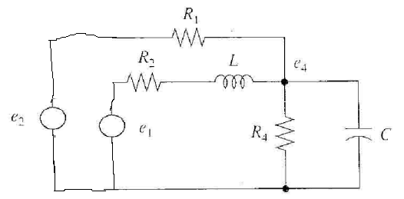
D =
C =
B =
A =

