Weekly Student Progress Performa
Team Id | CS26084 | Week no / Date | Week 4  10 August 2026
Project Title | SentinelCore: A Network Detection and Incident Response Platform
Members Present | Om Rashiya (24cs084), Yash Patel (24cs082)

Section | Details to be filled by the team
Planned Tasks  (from last week) | Create the repository and establish a reproducible full-stack development environment.
Tasks Completed This Week | Initialized SentinelCore, created backend/frontend/helper structures, added Docker Compose services, Nginx routing, PostgreSQL and Redis, environment configuration, and application health endpoints. Established the initial React shell and FastAPI service.
Commits Made  (count + 3 sample messages, e.g. 'Added Login Module') | Total: 2 commits.  6a9c10c — “Initial commit”  96396ba — “initial project setup”
Issues Created / Closed (numbers or IDs) | Created: Coordinating service startup and database readiness.  Closed: Added health checks, dependency ordering, and a single Compose workflow for the entire stack.
Milestone Status  (% complete, on-track / delayed) | ~26% complete — on track. The full skeleton could be built and launched consistently.
Blockers / Challenges Faced | Container networking and host-port conflicts required separating internal service names from loopback-only host mappings.
Plan for Next Week | Complete container health, implement authentication/RBAC, seed an administrator, and add immutable auditing.

Research & Technical Study
Reviewed Docker Compose health semantics, reverse-proxy routing, secret injection, and reproducible environment configuration. PostgreSQL is exposed only on loopback for tools, while application traffic stays on the private Compose network.
Weekly Evidence — Week 4
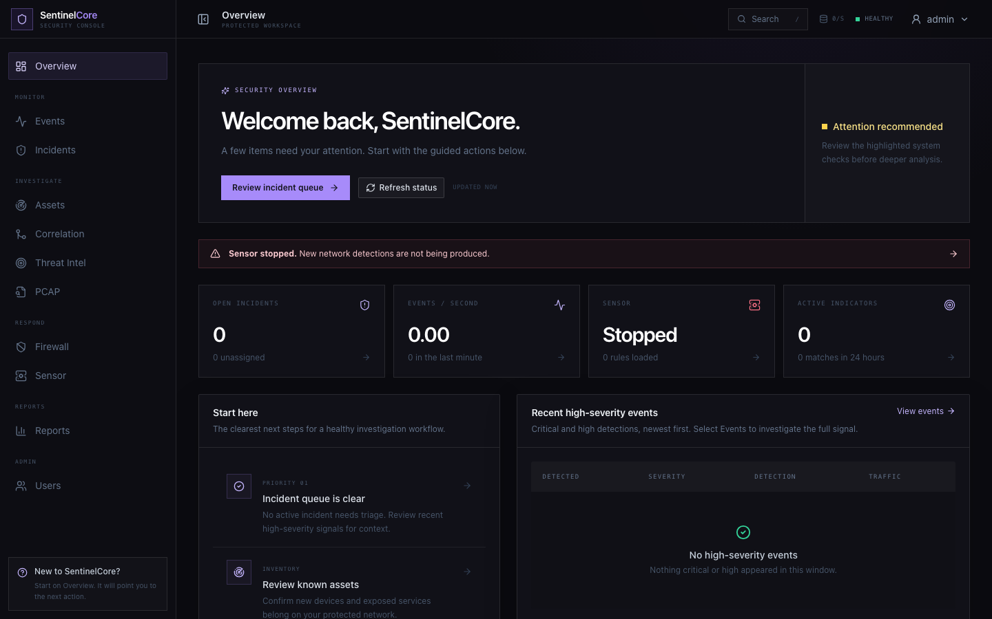
Live evidence: authenticated overview dashboard reached through the complete Docker/Nginx/API/frontend stack.
GitHub Repository: https://github.com/rashiyaom/SentinelCore
Assessed By (Faculty) | Marks Awarded  (5 marks) | Faculty Remarks

