Weekly Student Progress Performa
Team Id | CS26084 | Week no / Date | Week 5  17 August 2026
Project Title | SentinelCore: A Network Detection and Incident Response Platform
Members Present | Om Rashiya (24cs084), Yash Patel (24cs082)

Section | Details to be filled by the team
Planned Tasks  (from last week) | Stabilize the Docker stack and implement secure authentication, role-based access, session refresh, and audit logging.
Tasks Completed This Week | Completed the container stack health flow, added Argon2 password hashing, JWT access tokens with HttpOnly refresh cookies, login throttling, seeded admin support, protected React routes, role-aware navigation, and audit-log services.
Commits Made  (count + 3 sample messages, e.g. 'Added Login Module') | Total: 1 milestone commit.  9fc44f2 — “M0: Docker stack complete, health endpoint working”  Authentication work continued in the later consolidated M1–M5 commit.
Issues Created / Closed (numbers or IDs) | Created: Access tokens must not persist in localStorage; repeated login attempts require throttling.  Closed: Kept access tokens in memory, used rotating refresh cookies, and added server-side throttling and role checks.
Milestone Status  (% complete, on-track / delayed) | ~36% complete — on track. Secure access control and the deployment foundation were functional.
Blockers / Challenges Faced | Maintaining a session without exposing durable tokens to JavaScript storage. The refresh endpoint and in-memory access token model resolved this.
Plan for Next Week | Implement asset discovery, scan parsing, device inventory, and the privileged helper protocol.

Research & Technical Study
Studied OWASP authentication guidance, Argon2 password hashing, short-lived bearer tokens, refresh-token cookies, RBAC enforcement, and tamper-evident audit design. Authorization is checked again in the backend even when navigation is hidden in the UI.
Weekly Evidence — Week 5
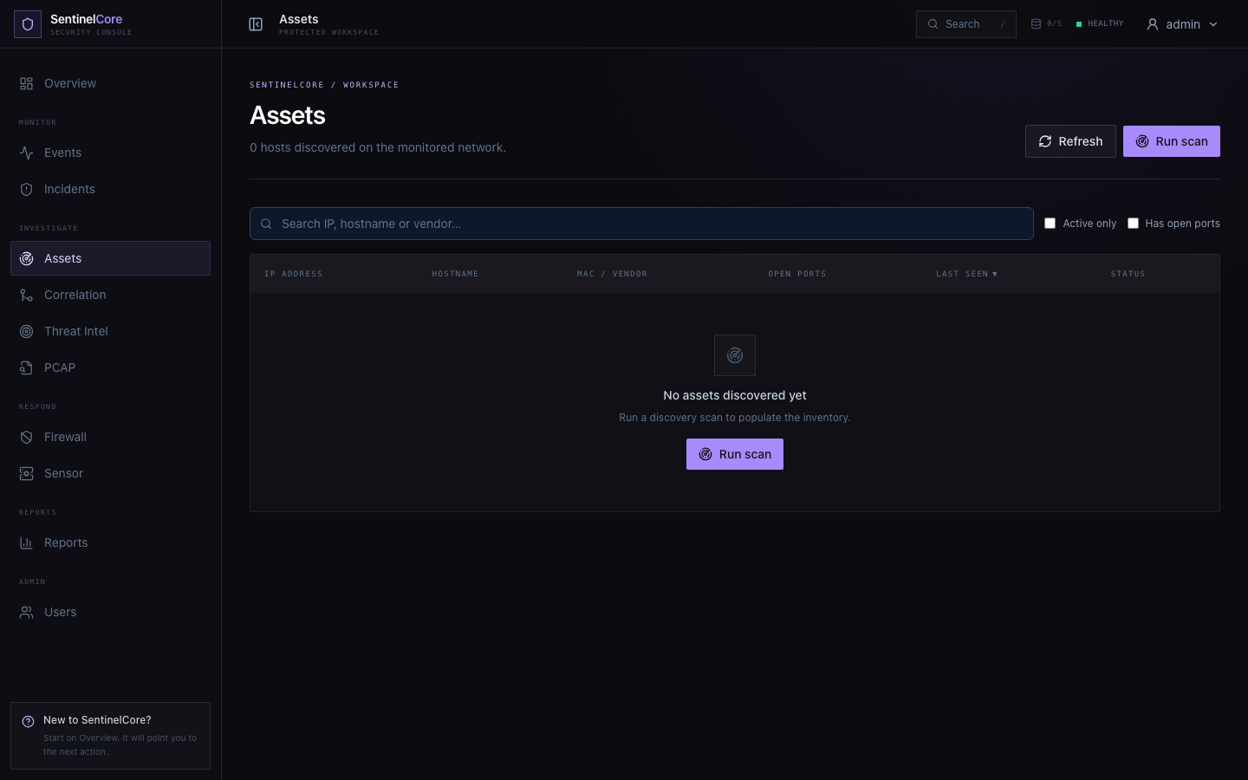
Live evidence: role-protected asset inventory and network discovery workspace.
GitHub Repository: https://github.com/rashiyaom/SentinelCore
Assessed By (Faculty) | Marks Awarded  (5 marks) | Faculty Remarks

