Weekly Student Progress Performa
Team Id | CS26084 | Week no / Date | Week 1 20 July 2026
Project Title | SentinelCore: A Network Detection and Incident Response Platform
Members Present | Om Rashiya (24cs084), Yash Patel (24cs082)
Mentor | Akshita Kadam
Page 1 of 5 — Weekly Progress Summary: Problem Definition and Product Direction
Section | Details to be filled by the team
Planned Tasks (from last week) | Define the SGP problem statement, identify target users, study existing home-network security tools, and establish the project scope.
Tasks Completed This Week | Finalized SentinelCore as a self-hosted network detection and incident-response platform. Defined the primary workflow: discover devices, collect network alerts, correlate suspicious activity, investigate incidents, contain threats, and generate evidence reports.
Commits Made | Total: 0 commits (research and planning week). Repository work had not started; requirements and module boundaries were documented before implementation.
Issues Created / Closed | Created: Need a security platform understandable to non-specialist home/small-network users. Closed: Agreed on a modular, local-first platform rather than a cloud-only monitoring service.
Milestone Status | ~5% complete — on track. Problem definition, audience, objectives, and success criteria approved by the team.
Blockers / Challenges Faced | The initial scope was too broad. We reduced it to a staged pipeline with clearly separated discovery, detection, investigation, response, and reporting capabilities.
Plan for Next Week | Prepare the threat model, compare IDS technologies, and select the backend, database, queue, and frontend stack.

SENTINELCORE • WEEK 1 • 20 July 2026
Research and Technical Study
Section | Details to be filled by the team
Research Objective | Define the SGP problem statement, identify target users, study existing home-network security tools, and establish the project scope.
Study Conducted | Compared Suricata, Snort, and Zeek for visibility, rule support, and structured event output. Suricata was selected because EVE JSON integrates cleanly with an application pipeline while retaining mature signature-based detection. The incident-response lifecycle was used to shape the product flow.
Decision Applied | The selected approach was carried into the SentinelCore workflow and implementation described for this week. The table below records the alternatives, project requirement, and the decision that was actually used.
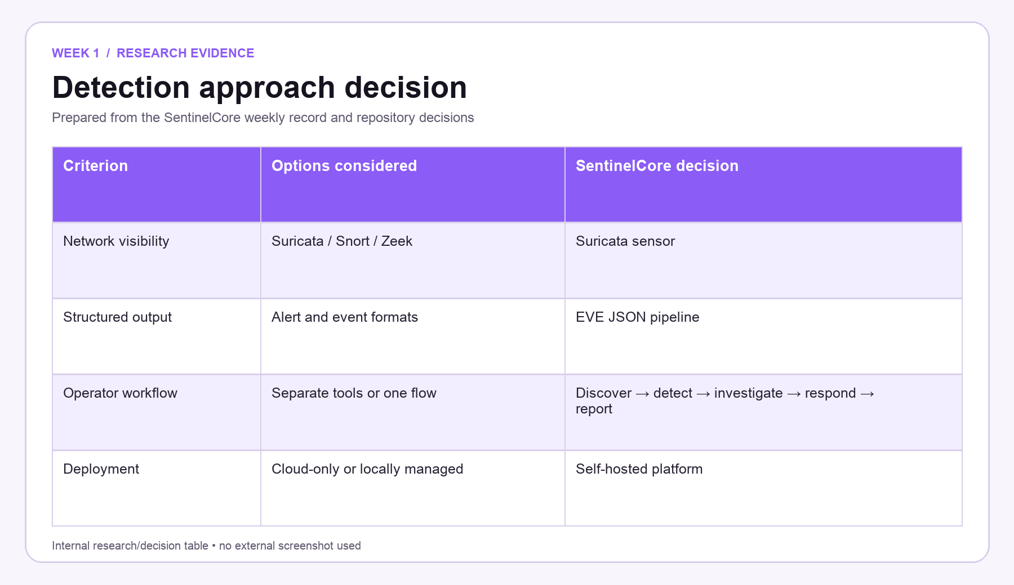
Figure W1.1 — Week-specific research/decision table prepared only from the SentinelCore weekly record.

SENTINELCORE • WEEK 1 • 20 July 2026
Implementation Record and Website Evidence
Section | Details to be filled by the team
Work Completed | Finalized SentinelCore as a self-hosted network detection and incident-response platform. Defined the primary workflow: discover devices, collect network alerts, correlate suspicious activity, investigate incidents, contain threats, and generate evidence reports.
What the Website Shows | The evidence screen presents the SentinelCore/SecureHome identity and the visual theme later carried into the public and authenticated website.
Problem statement | Home and small-network users need one understandable place to see devices, detections, investigations, response actions, and evidence. The project was therefore framed as a complete operational workflow rather than a collection of disconnected security tools.
Intended workflow | The agreed sequence was asset discovery → network detection → event search → correlation → incident investigation → guarded containment → reporting. This sequence later became the product navigation and the module order used throughout the repository.
Week Mapping | This project-owned SentinelCore screen is assigned specifically to Week 1. Its labels, actions, status areas, and navigation correspond to the work recorded for this milestone.
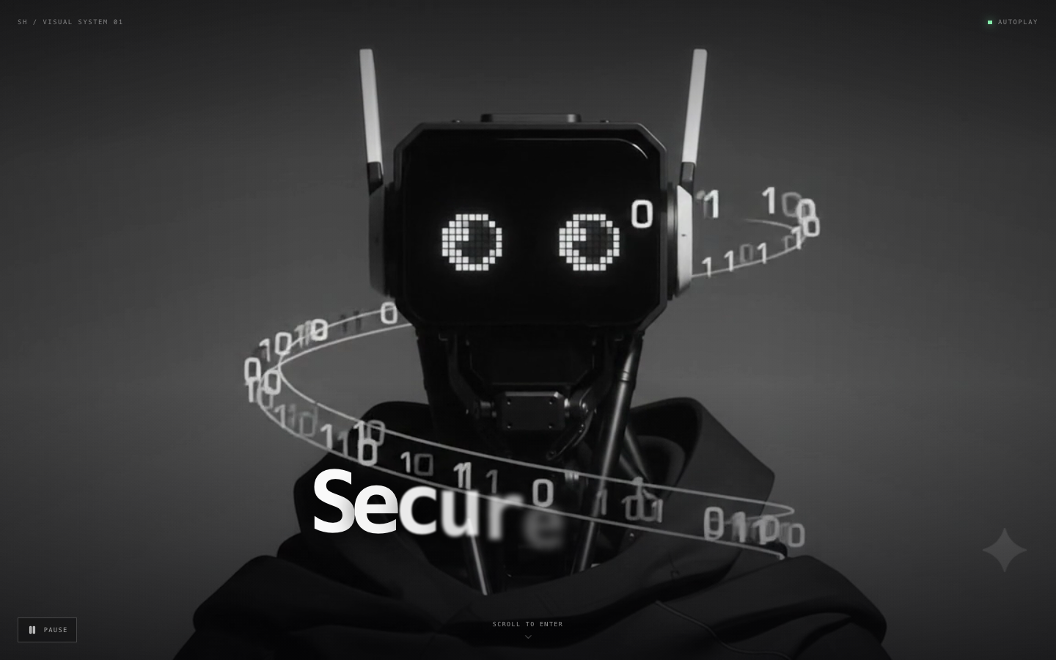
Figure W1.2 — Original 1440 × 900 SentinelCore website evidence for Week 1; shown once without repeated zooms.

SENTINELCORE • WEEK 1 • 20 July 2026
Repository and Architecture Evidence
Section | Details to be filled by the team
Artifact | SentinelCore workflow traceability
Repository Traceability | README.md — What it is and module workflow; frontend/public/media/securehome-intro.mp4; frontend/src/pages/LandingPage.jsx
Verification | Scope and workflow were checked against the final repository module list so the week records only capabilities that SentinelCore actually contains.
Product boundary | The platform would be locally deployable and explainable. Detection findings would remain traceable to a Suricata signature or a readable correlation rule; response and reporting would follow only after evidence was visible to an operator.
User-facing direction | The product introduction had to describe network defence in plain language. The identity and introductory visual shown in the evidence capture established the name SentinelCore and the SecureHome presentation used by the website.
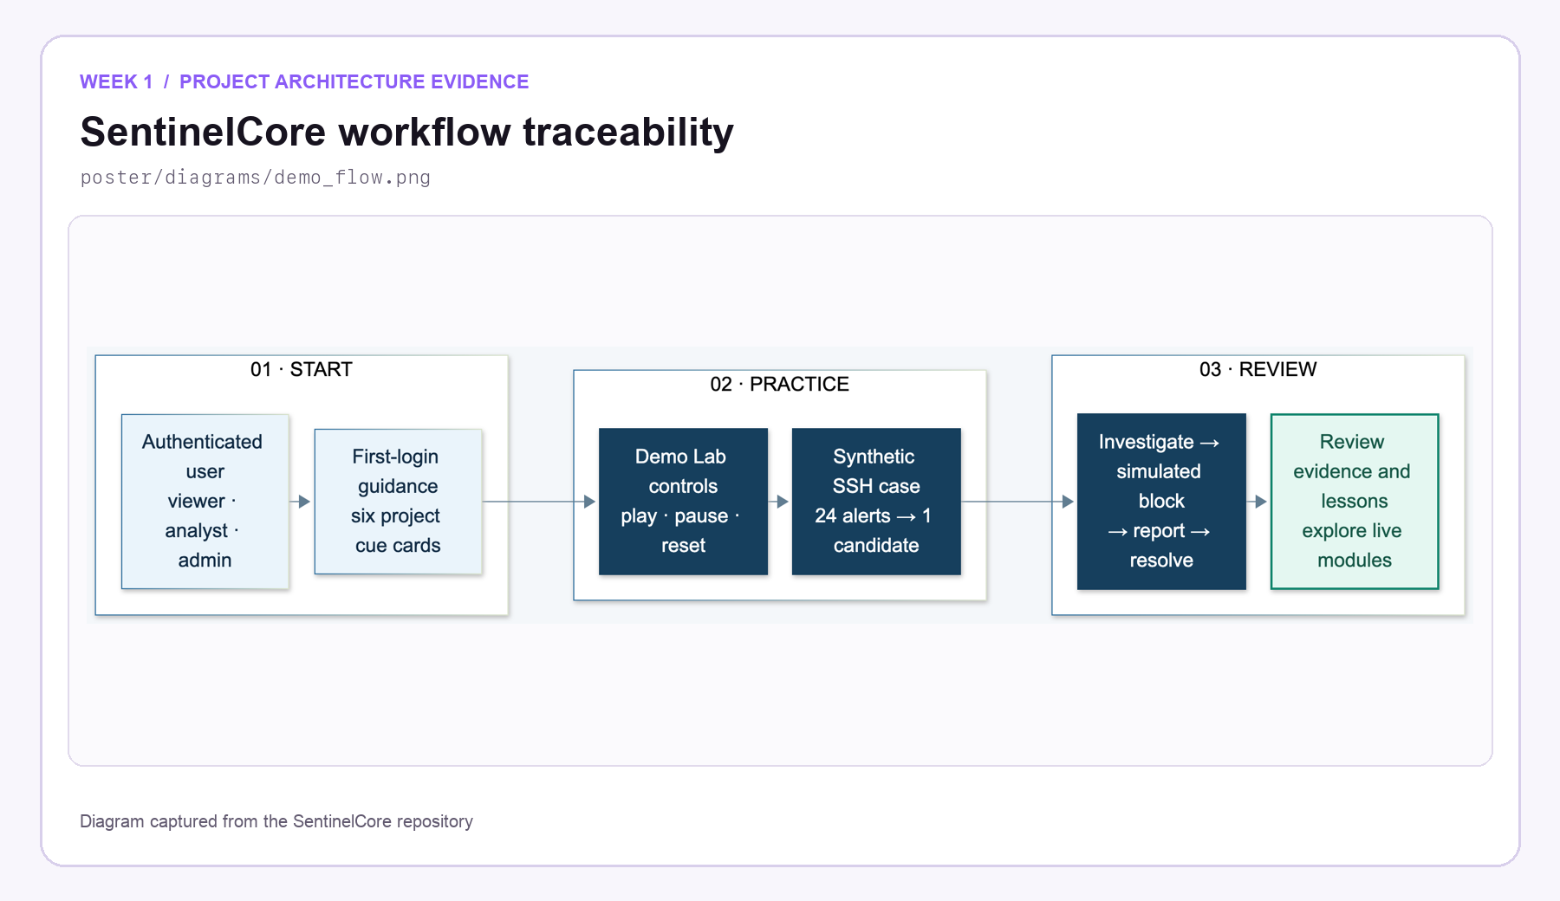
Figure W1.3 — Distinct internal project artifact used to verify the Week 1 implementation record.

SENTINELCORE • WEEK 1 • 20 July 2026
Weekly Closure and Faculty Assessment
Section | Details to be filled by the team
Detailed Work Completed | Finalized SentinelCore as a self-hosted network detection and incident-response platform. Defined the primary workflow: discover devices, collect network alerts, correlate suspicious activity, investigate incidents, contain threats, and generate evidence reports.
Implementation Areas | Problem statement; Intended workflow; Product boundary; User-facing direction
Verification Note | Scope and workflow were checked against the final repository module list so the week records only capabilities that SentinelCore actually contains.
Challenges / Resolution | The initial scope was too broad. We reduced it to a staged pipeline with clearly separated discovery, detection, investigation, response, and reporting capabilities.
Plan for Next Week | Prepare the threat model, compare IDS technologies, and select the backend, database, queue, and frontend stack.
GitHub Repository | https://github.com/rashiyaom/SentinelCore
Faculty Assessment
Assessed By (Faculty) | Marks Awarded (5 marks) | Faculty Remarks

