Weekly Student Progress Performa
Team Id | CS26084 | Week no / Date | Week 4 10 August 2026
Project Title | SentinelCore: A Network Detection and Incident Response Platform
Members Present | Om Rashiya (24cs084), Yash Patel (24cs082)
Mentor | Akshita Kadam
Page 1 of 5 — Weekly Progress Summary: Repository and Full-Stack Foundation
Section | Details to be filled by the team
Planned Tasks (from last week) | Create the repository and establish a reproducible full-stack development environment.
Tasks Completed This Week | Initialized SentinelCore, created backend/frontend/helper structures, added Docker Compose services, Nginx routing, PostgreSQL and Redis, environment configuration, and application health endpoints. Established the initial React shell and FastAPI service.
Commits Made | Total: 2 commits. 6a9c10c — “Initial commit”; 96396ba — “initial project setup”.
Issues Created / Closed | Created: Coordinating service startup and database readiness. Closed: Added health checks, dependency ordering, and a single Compose workflow for the entire stack.
Milestone Status | ~26% complete — on track. The full skeleton could be built and launched consistently.
Blockers / Challenges Faced | Container networking and host-port conflicts required separating internal service names from loopback-only host mappings.
Plan for Next Week | Complete container health, implement authentication/RBAC, seed an administrator, and add immutable auditing.

SENTINELCORE • WEEK 4 • 10 August 2026
Research and Technical Study
Section | Details to be filled by the team
Research Objective | Create the repository and establish a reproducible full-stack development environment.
Study Conducted | Reviewed Docker Compose health semantics, reverse-proxy routing, secret injection, and reproducible environment configuration. PostgreSQL is exposed only on loopback for tools, while application traffic stays on the private Compose network.
Decision Applied | The selected approach was carried into the SentinelCore workflow and implementation described for this week. The table below records the alternatives, project requirement, and the decision that was actually used.
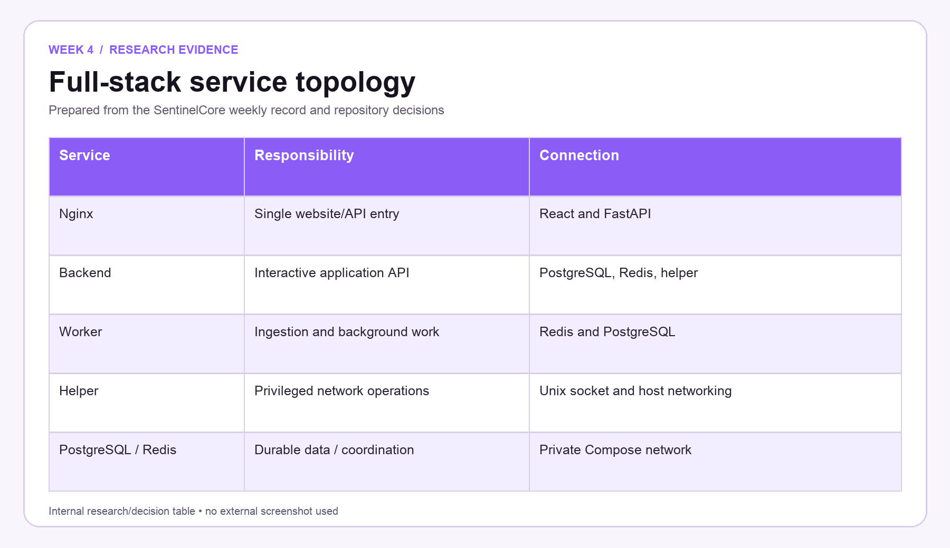
Figure W4.1 — Week-specific research/decision table prepared only from the SentinelCore weekly record.

SENTINELCORE • WEEK 4 • 10 August 2026
Implementation Record and Website Evidence
Section | Details to be filled by the team
Work Completed | Initialized SentinelCore, created backend/frontend/helper structures, added Docker Compose services, Nginx routing, PostgreSQL and Redis, environment configuration, and application health endpoints. Established the initial React shell and FastAPI service.
What the Website Shows | The authenticated overview shows the working application shell, role-aware sidebar, sensor warning, incident/event summary cards, and guided starting points.
Repository structure | Created distinct backend, frontend, helper, deployment, migration, and test areas so privileged and unprivileged responsibilities remained visible in the codebase.
Container topology | Added PostgreSQL, Redis, backend, worker, frontend, Nginx, helper, and Suricata-related configuration to the Compose-led development environment.
Week Mapping | This project-owned SentinelCore screen is assigned specifically to Week 4. Its labels, actions, status areas, and navigation correspond to the work recorded for this milestone.
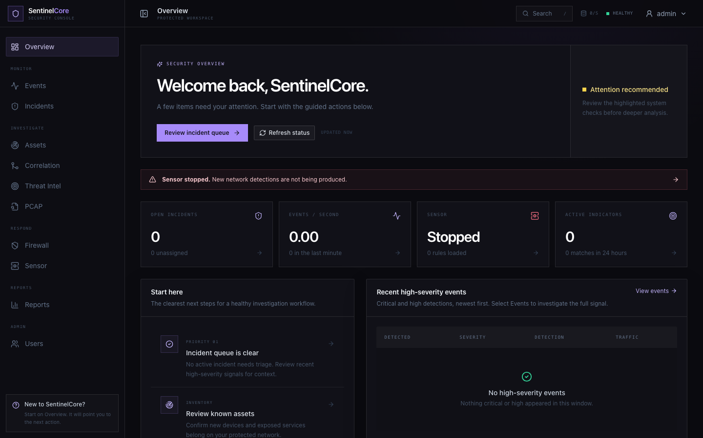
Figure W4.2 — Original 1440 × 900 SentinelCore website evidence for Week 4; shown once without repeated zooms.

SENTINELCORE • WEEK 4 • 10 August 2026
Repository and Architecture Evidence
Section | Details to be filled by the team
Artifact | Implemented service architecture
Repository Traceability | docker-compose.yml; backend/deployment/nginx/nginx.conf; frontend/src/layout/Layout.jsx; frontend/src/pages/overview/OverviewPage.jsx
Verification | Commit hashes were taken from repository history. Visible dashboard terms and navigation labels were checked against the implemented React components.
Routing and health | Nginx routes the website and API through one entry point. Service health checks and dependency ordering prevent application services from assuming the database or Redis is ready too early.
Application shell | The authenticated overview shell, sidebar, top bar, status indicators, and first dashboard cards established the common layout used by every later workspace.
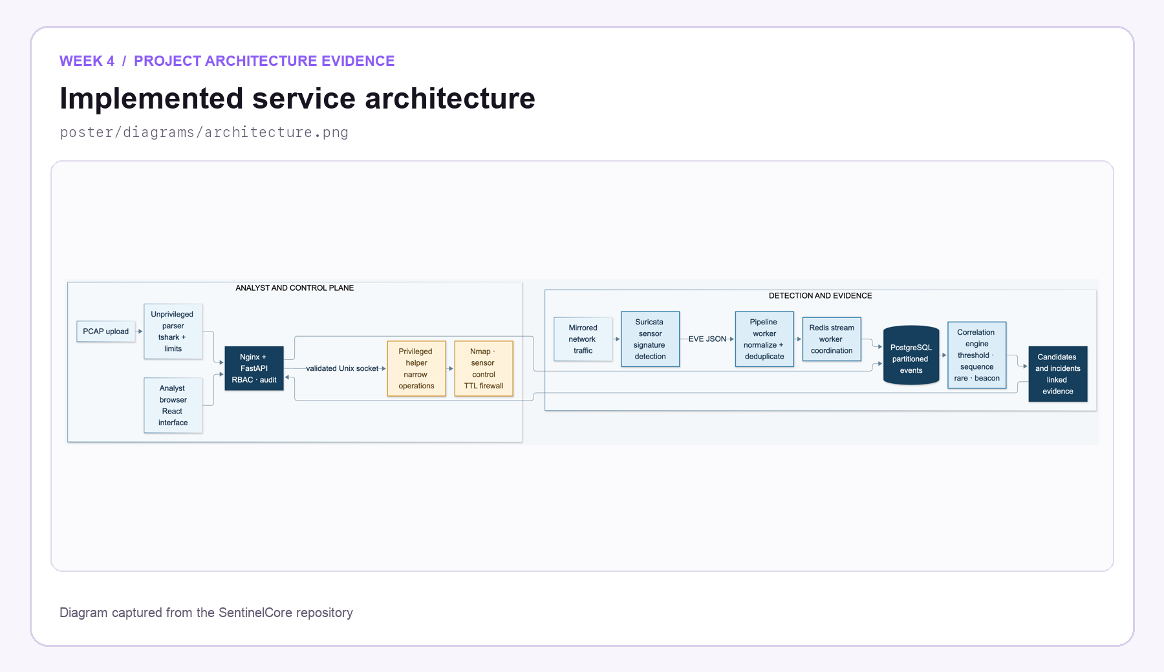
Figure W4.3 — Distinct internal project artifact used to verify the Week 4 implementation record.

SENTINELCORE • WEEK 4 • 10 August 2026
Weekly Closure and Faculty Assessment
Section | Details to be filled by the team
Detailed Work Completed | Initialized SentinelCore, created backend/frontend/helper structures, added Docker Compose services, Nginx routing, PostgreSQL and Redis, environment configuration, and application health endpoints. Established the initial React shell and FastAPI service.
Implementation Areas | Repository structure; Container topology; Routing and health; Application shell
Verification Note | Commit hashes were taken from repository history. Visible dashboard terms and navigation labels were checked against the implemented React components.
Challenges / Resolution | Container networking and host-port conflicts required separating internal service names from loopback-only host mappings.
Plan for Next Week | Complete container health, implement authentication/RBAC, seed an administrator, and add immutable auditing.
GitHub Repository | https://github.com/rashiyaom/SentinelCore
Faculty Assessment
Assessed By (Faculty) | Marks Awarded (5 marks) | Faculty Remarks

