Weekly Student Progress Performa
Team Id | CS26084 | Week no / Date | Week 5 17 August 2026
Project Title | SentinelCore: A Network Detection and Incident Response Platform
Members Present | Om Rashiya (24cs084), Yash Patel (24cs082)
Mentor | Akshita Kadam
Page 1 of 5 — Weekly Progress Summary: Authentication, RBAC, and Asset Workspace
Section | Details to be filled by the team
Planned Tasks (from last week) | Stabilize the Docker stack and implement secure authentication, role-based access, session refresh, and audit logging.
Tasks Completed This Week | Completed the container stack health flow, added Argon2 password hashing, JWT access tokens with HttpOnly refresh cookies, login throttling, seeded admin support, protected React routes, role-aware navigation, and audit-log services.
Commits Made | Total: 1 milestone commit. 9fc44f2 — “M0: Docker stack complete, health endpoint working”. Authentication work continued in the later consolidated M1–M5 commit.
Issues Created / Closed | Created: Access tokens must not persist in localStorage; repeated login attempts require throttling. Closed: Kept access tokens in memory, used rotating refresh cookies, and added server-side throttling and role checks.
Milestone Status | ~36% complete — on track. Secure access control and the deployment foundation were functional.
Blockers / Challenges Faced | Maintaining a session without exposing durable tokens to JavaScript storage. The refresh endpoint and in-memory access-token model resolved this.
Plan for Next Week | Implement asset discovery, scan parsing, device inventory, and the privileged helper protocol.

SENTINELCORE • WEEK 5 • 17 August 2026
Research and Technical Study
Section | Details to be filled by the team
Research Objective | Stabilize the Docker stack and implement secure authentication, role-based access, session refresh, and audit logging.
Study Conducted | Studied password hashing, short-lived bearer tokens, refresh-token cookies, RBAC enforcement, and tamper-evident audit design. Authorization is checked again in the backend even when navigation is hidden in the UI.
Decision Applied | The selected approach was carried into the SentinelCore workflow and implementation described for this week. The table below records the alternatives, project requirement, and the decision that was actually used.
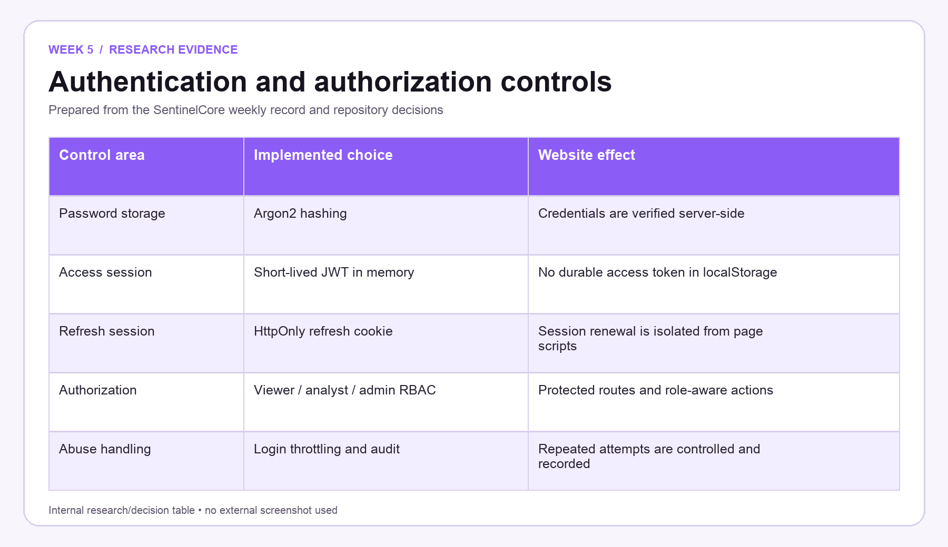
Figure W5.1 — Week-specific research/decision table prepared only from the SentinelCore weekly record.

SENTINELCORE • WEEK 5 • 17 August 2026
Implementation Record and Website Evidence
Section | Details to be filled by the team
Work Completed | Completed the container stack health flow, added Argon2 password hashing, JWT access tokens with HttpOnly refresh cookies, login throttling, seeded admin support, protected React routes, role-aware navigation, and audit-log services.
What the Website Shows | The Assets workspace shows inventory controls, scan access, active/open-port filters, and a clear empty state directing the operator to run discovery.
Authentication flow | Implemented password verification, short-lived access tokens held in memory, refresh handling through an HttpOnly cookie, logout, and bootstrap administrator support.
Role enforcement | Protected React routes and adjusted navigation for viewer, analyst, and admin roles, while retaining backend authorization as the controlling check for every protected action.
Week Mapping | This project-owned SentinelCore screen is assigned specifically to Week 5. Its labels, actions, status areas, and navigation correspond to the work recorded for this milestone.
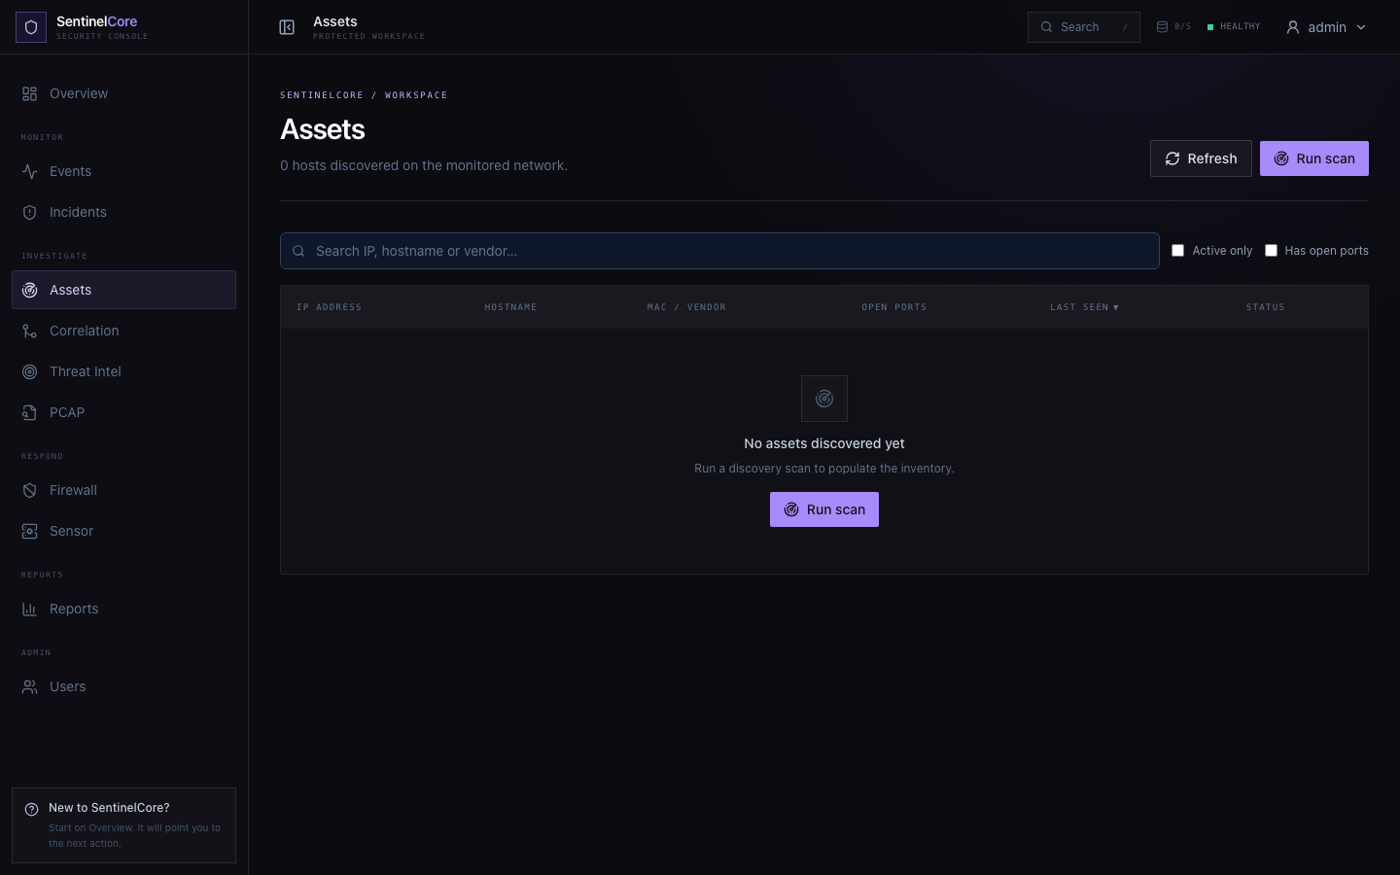
Figure W5.2 — Original 1440 × 900 SentinelCore website evidence for Week 5; shown once without repeated zooms.

SENTINELCORE • WEEK 5 • 17 August 2026
Repository and Architecture Evidence
Section | Details to be filled by the team
Artifact | Authentication context implementation
Repository Traceability | frontend/src/auth/AuthContext.jsx; frontend/src/routes/ProtectedRoute.jsx; frontend/src/pages/assets/AssetsPage.jsx; backend/app/api/routes/assets.py
Verification | The access model and asset controls were checked against the actual routes, frontend labels, authentication context, and the repository test coverage.
Abuse controls and audit | Added login throttling and audit services so authentication attempts and state-changing actions can be recorded without relying on the browser.
Asset workspace preparation | Built the role-protected inventory surface with search, active-only and open-port filters, refresh, scan entry point, and the empty-state instruction shown in the evidence.
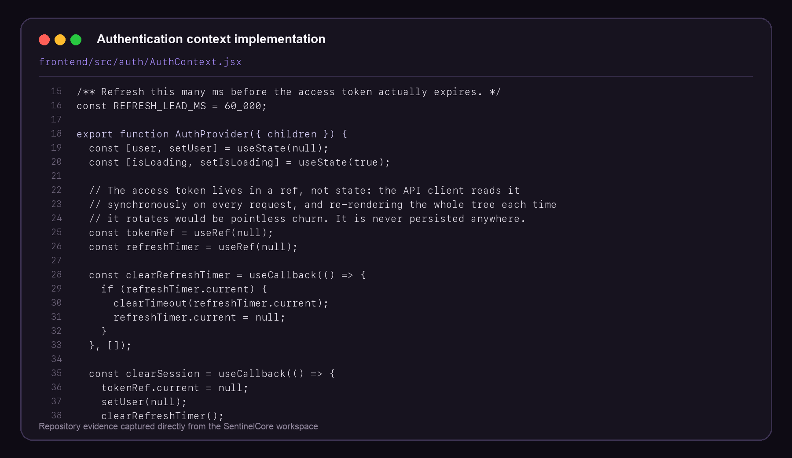
Figure W5.3 — Distinct internal project artifact used to verify the Week 5 implementation record.

SENTINELCORE • WEEK 5 • 17 August 2026
Weekly Closure and Faculty Assessment
Section | Details to be filled by the team
Detailed Work Completed | Completed the container stack health flow, added Argon2 password hashing, JWT access tokens with HttpOnly refresh cookies, login throttling, seeded admin support, protected React routes, role-aware navigation, and audit-log services.
Implementation Areas | Authentication flow; Role enforcement; Abuse controls and audit; Asset workspace preparation
Verification Note | The access model and asset controls were checked against the actual routes, frontend labels, authentication context, and the repository test coverage.
Challenges / Resolution | Maintaining a session without exposing durable tokens to JavaScript storage. The refresh endpoint and in-memory access-token model resolved this.
Plan for Next Week | Implement asset discovery, scan parsing, device inventory, and the privileged helper protocol.
GitHub Repository | https://github.com/rashiyaom/SentinelCore
Faculty Assessment
Assessed By (Faculty) | Marks Awarded (5 marks) | Faculty Remarks

