Weekly Student Progress Performa
Team Id | CS26084 | Week no / Date | Week 10  21 September 2026
Project Title | SentinelCore: A Network Detection and Incident Response Platform
Members Present | Om Rashiya (24cs084), Yash Patel (24cs082)

Section | Details to be filled by the team
Planned Tasks  (from last week) | Complete search, correlation, and incident management; start evidence reporting and response actions.
Tasks Completed This Week | Completed event search with facets/saved searches, four correlation evaluator types and live worker execution, and incident lifecycle management. Defined asynchronous report generation and a protected firewall response model with expiry and recovery behavior.
Commits Made  (count + 3 sample messages, e.g. 'Added Login Module') | Total: 3 feature commits.  567e05d — “M6: event search — keyset-paginated query API, facets, saved searches”  76d671a — “M7: correlation engine — rules-as-data, four evaluators, live worker task”  ba4c083 — “M8: incident management — lifecycle, promotion from candidates, history”
Issues Created / Closed (numbers or IDs) | Created: Long report jobs should not block API requests; containment must never block protected addresses.  Closed: Designed queued report generation and mandatory protection/TTL checks before firewall changes.
Milestone Status  (% complete, on-track / delayed) | ~82% complete — on track. Detection-to-incident workflow was complete and response/reporting work had begun.
Blockers / Challenges Faced | Keeping evaluator queries bounded and ensuring incident promotion remained idempotent under repeated worker execution.
Plan for Next Week | Finish PDF/CSV/JSON reports, schedules, firewall containment, PCAP upload/analysis, and threat intelligence.

Research & Technical Study
Studied asynchronous report pipelines, reproducible evidence exports, iptables containment, protected-IP guardrails, TTL-based rollback, and crash reconciliation. Response actions require explicit user intent and retain a complete audit trail.
Weekly Evidence — Week 10
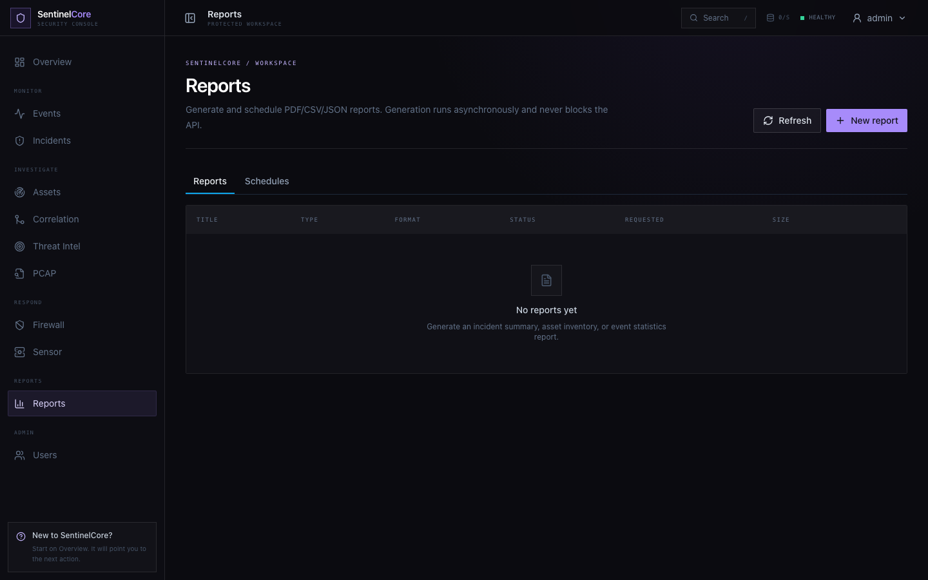
Live evidence: report generation and scheduling workspace for PDF, CSV, and JSON evidence.
GitHub Repository: https://github.com/rashiyaom/SentinelCore
Assessed By (Faculty) | Marks Awarded  (5 marks) | Faculty Remarks

