Weekly Student Progress Performa
Team Id | CS26084 | Week no / Date | Week 11  27 September 2026
Project Title | SentinelCore: A Network Detection and Incident Response Platform
Members Present | Om Rashiya (24cs084), Yash Patel (24cs082)

Section | Details to be filled by the team
Planned Tasks  (from last week) | Complete reporting, containment, PCAP analysis, and threat-intelligence enrichment.
Tasks Completed This Week | Implemented four asynchronous report types, report schedules, PDF/CSV/JSON outputs, protected and TTL-bounded firewall blocks, PCAP upload/parser isolation, flow/artifact extraction, IOC/source management, feed normalization, and event/incident enrichment.
Commits Made  (count + 3 sample messages, e.g. 'Added Login Module') | Total: 5 milestone commits.  87f7e20 — “M9: reporting backend — four report types, async PDF/CSV/JSON generation, scheduling”  e536b79 — “M9: reporting frontend — reports table, new-report form, admin schedules”  fe1ca48 — “M10: firewall containment — protection guard, iptables ops, TTL-bounded blocks”  7082a69 — “M5 to M10 work”  0c98a3e — “complte all modules” (M11/M12 integration and E2E coverage)
Issues Created / Closed (numbers or IDs) | Created: Uploaded captures and external feeds are untrusted; firewall operations are high impact.  Closed: Isolated parsing, bounded file/resource use, normalized IOCs, protected critical addresses, and enforced automatic unblock expiry.
Milestone Status  (% complete, on-track / delayed) | ~91% complete — on track. All planned functional modules were integrated end to end.
Blockers / Challenges Faced | Safely parsing large/malformed captures and feeds while keeping memory, database work, and external requests bounded.
Plan for Next Week | Run end-to-end validation, harden security controls, improve documentation/UI clarity, and prepare the final demonstration.

Research & Technical Study
Reviewed PCAP parser isolation, MIME/size validation, flow reconstruction, IOC normalization (IP/domain/hash), safe feed retrieval, SSRF controls, and reversible containment. External indicators remain attributable to their source and match evidence.
Weekly Evidence — Week 11
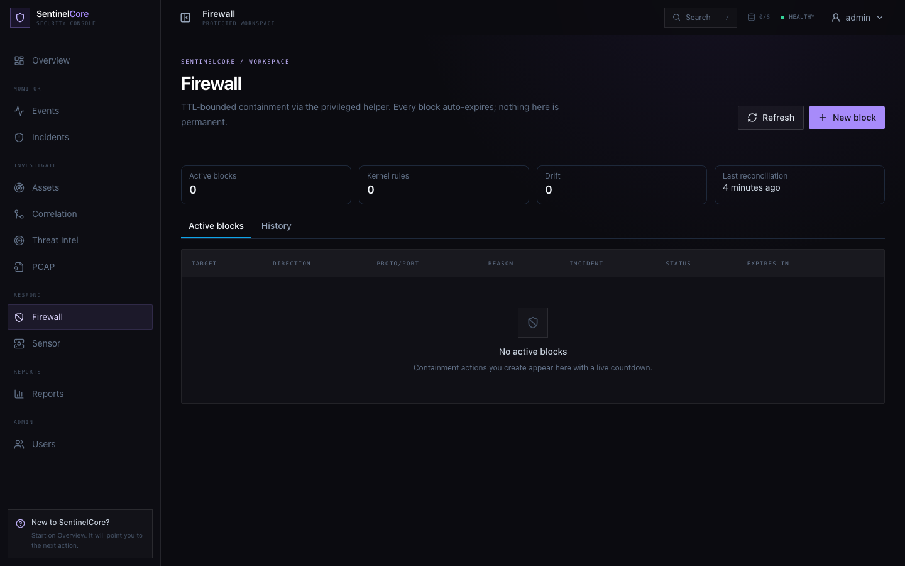
Live evidence: guarded containment console with active blocks, history, protected targets, and expiry controls.
GitHub Repository: https://github.com/rashiyaom/SentinelCore
Assessed By (Faculty) | Marks Awarded  (5 marks) | Faculty Remarks

