Weekly Student Progress Performa
Team Id | CS26084 | Week no / Date | Week 12  30 September 2026
Project Title | SentinelCore: A Network Detection and Incident Response Platform
Members Present | Om Rashiya (24cs084), Yash Patel (24cs082)

Section | Details to be filled by the team
Planned Tasks  (from last week) | Validate the complete platform, fix integration defects, polish documentation, and prepare the faculty demonstration.
Tasks Completed This Week | Ran backend, helper, pipeline, and browser-level checks; verified authentication, discovery, detection, search, incidents, reports, firewall, PCAP, and intelligence flows. Improved the README, test evidence, dashboard clarity, navigation, empty states, visual hierarchy, responsive behavior, and first-time-user guidance.
Commits Made  (count + 3 sample messages, e.g. 'Added Login Module') | Total: 2 completion commits.  6945e77 — “updated and tested”  19e4da8 — “Polish README with badges, TOC, and visual section dividers”  Later hardening commits continue transparently in the linked repository history.
Issues Created / Closed (numbers or IDs) | Created: Integration testing exposed confusing empty states and several edge cases around parser output, reporting, and request security.  Closed: Added clearer guidance, stronger validation, reproducible test documentation, and follow-up hardening tasks.
Milestone Status  (% complete, on-track / delayed) | 100% of the planned SGP scope demonstrated. Core platform complete; subsequent commits are maintenance, security hardening, and UI refinement.
Blockers / Challenges Faced | Docker networking/capture behavior varies by host OS, and realistic packet data is environment-dependent. The demonstration uses health checks, bounded test fixtures, and explicit setup guidance.
Plan for Next Week | Collect faculty feedback, continue security/performance hardening, expand realistic datasets, and prepare deployment documentation and final presentation material.

Research & Technical Study
Applied OWASP guidance for SSRF, spoofed client IPs, rate limits, request validation, race prevention, and secure defaults. Also reviewed dashboard information hierarchy and progressive disclosure so a first-time user can understand system health and the next action immediately.
Weekly Evidence — Week 12
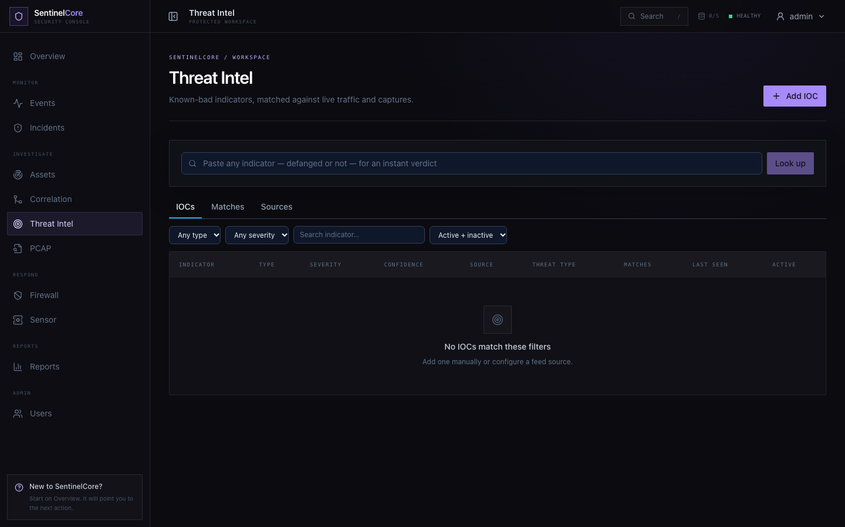
Live evidence: final threat-intelligence workspace for IOCs, matches, sources, and analyst filtering.
GitHub Repository: https://github.com/rashiyaom/SentinelCore
Assessed By (Faculty) | Marks Awarded  (5 marks) | Faculty Remarks

