Weekly Student Progress Performa
Team Id | CS26084 | Week no / Date | Week 2  27 July 2026
Project Title | SentinelCore: A Network Detection and Incident Response Platform
Members Present | Om Rashiya (24cs084), Yash Patel (24cs082)

Section | Details to be filled by the team
Planned Tasks  (from last week) | Create a threat model, define functional/non-functional requirements, and design a safe deployment architecture.
Tasks Completed This Week | Documented trust boundaries for the browser, API, database, Redis queue, sensor, and privileged network helper. Defined RBAC roles, auditability, retention, least privilege, local deployment, and recoverable operations as core requirements.
Commits Made  (count + 3 sample messages, e.g. 'Added Login Module') | Total: 0 commits (architecture and research week).  Outputs were the threat model, data-flow plan, and milestone breakdown used for later implementation.
Issues Created / Closed (numbers or IDs) | Created: Raw packet capture and firewall operations require privileges that the web API must not receive.  Closed: Introduced a narrow Unix-socket helper boundary so the API can remain unprivileged.
Milestone Status  (% complete, on-track / delayed) | ~10% complete — on track. Architecture and security constraints were established before coding.
Blockers / Challenges Faced | Balancing useful network visibility with safe privilege separation. The design isolates raw-socket operations and exposes only allow-listed helper commands.
Plan for Next Week | Design the database entities, API contracts, Docker topology, and initial repository structure.

Research & Technical Study
Studied container capability controls, Unix-domain socket permissions, secure refresh-token patterns, PostgreSQL transaction guarantees, and Redis-backed work coordination. The design adopted defense in depth: capability allowlists, unprivileged API execution, append-only audit records, and explicit role checks.
Weekly Evidence — Week 2
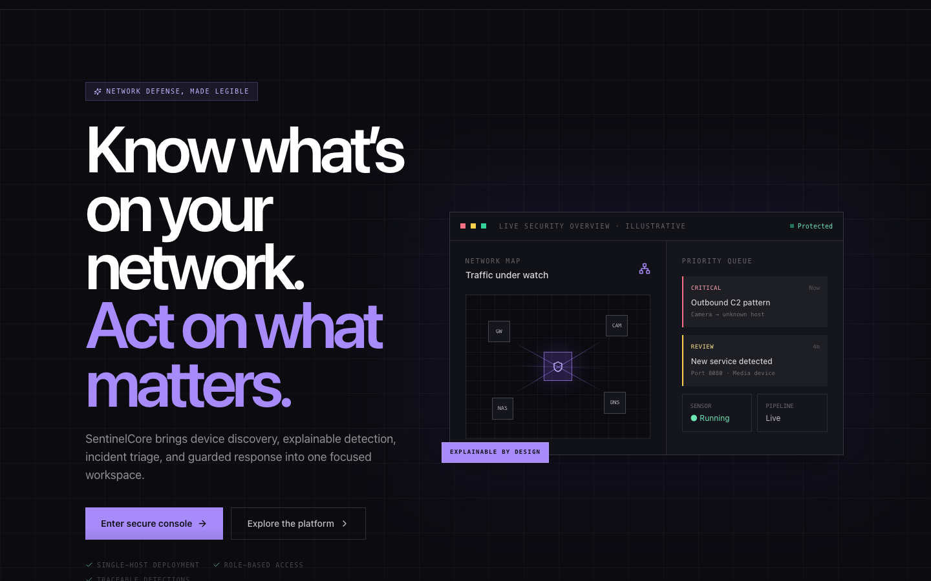
Live evidence: the public landing page explains discovery, detection, triage, and response in first-time-user language.
GitHub Repository: https://github.com/rashiyaom/SentinelCore
Assessed By (Faculty) | Marks Awarded  (5 marks) | Faculty Remarks

