Weekly Student Progress Performa
Team Id | CS26084 | Week no / Date | Week 3  03 August 2026
Project Title | SentinelCore: A Network Detection and Incident Response Platform
Members Present | Om Rashiya (24cs084), Yash Patel (24cs082)

Section | Details to be filled by the team
Planned Tasks  (from last week) | Translate the architecture into modules, database models, API routes, navigation, and a 12-week implementation plan.
Tasks Completed This Week | Split the platform into authentication, asset discovery, Suricata sensor, event pipeline, search, correlation, incidents, reports, firewall response, PCAP analysis, and threat intelligence. Defined FastAPI + SQLAlchemy/Alembic, PostgreSQL, Redis, React/Vite, Nginx, and Docker Compose as the implementation stack.
Commits Made  (count + 3 sample messages, e.g. 'Added Login Module') | Total: 0 commits (technical design week).  Prepared module specifications M03–M12 and acceptance criteria for each milestone.
Issues Created / Closed (numbers or IDs) | Created: A single service would mix privileged capture, API traffic, and long-running ingestion.  Closed: Separated API, worker, helper, frontend, proxy, PostgreSQL, and Redis responsibilities.
Milestone Status  (% complete, on-track / delayed) | ~18% complete — on track. Data model and module contracts were ready for implementation.
Blockers / Challenges Faced | The event data volume could make offset pagination and one large table slow. The plan adopted monthly partitions and keyset pagination.
Plan for Next Week | Initialize the repository, implement Docker services, health checks, migrations, and the first authentication screen.

Research & Technical Study
Evaluated synchronous versus asynchronous API/database access, migration strategies, partitioned event storage, and React routing approaches. Async FastAPI and asyncpg were selected for concurrent event/search workloads, while Alembic provides reproducible schema evolution.
Weekly Evidence — Week 3
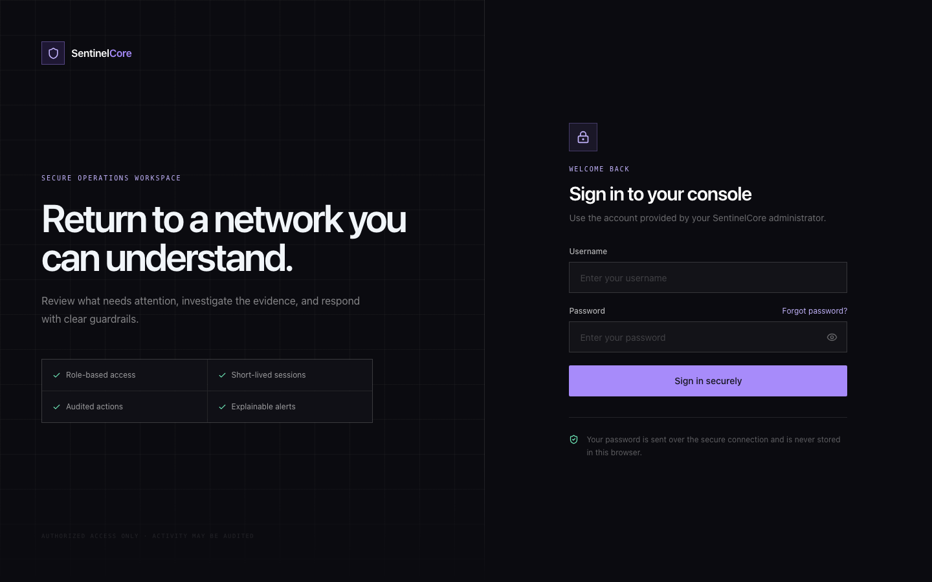
Live evidence: the secure sign-in interface produced from the authentication and role-access design.
GitHub Repository: https://github.com/rashiyaom/SentinelCore
Assessed By (Faculty) | Marks Awarded  (5 marks) | Faculty Remarks

