Weekly Student Progress Performa
Team Id | CS26084 | Week no / Date | Week 6  24 August 2026
Project Title | SentinelCore: A Network Detection and Incident Response Platform
Members Present | Om Rashiya (24cs084), Yash Patel (24cs082)

Section | Details to be filled by the team
Planned Tasks  (from last week) | Build asset discovery and begin integrating Suricata as the network sensor.
Tasks Completed This Week | Implemented allow-listed helper operations, Nmap scan execution/parsing, asset/port/scan models, scan history, validation, asset detail pages, Suricata configuration, rule sources, rule overrides, health metrics, and safe ruleset reload behavior.
Commits Made  (count + 3 sample messages, e.g. 'Added Login Module') | Total: 0 standalone commits this review period.  The feature branch was kept as a working milestone and later consolidated in d79a37c (“update the project to m5”).
Issues Created / Closed (numbers or IDs) | Created: Untrusted scan targets and rule text could cross the privilege boundary.  Closed: Added strict network/argument validation, allow-listed helper operations, and verify-before-activate rule staging.
Milestone Status  (% complete, on-track / delayed) | ~45% complete — on track. Discovery and sensor administration were operational in development.
Blockers / Challenges Faced | Nmap and Suricata require network access that differs across Linux and macOS Docker hosts. The helper owns capabilities while the API remains isolated.
Plan for Next Week | Normalize EVE JSON, persist events reliably, track offsets, create partitions, and expose pipeline health.

Research & Technical Study
Studied Nmap XML parsing, input validation for command execution, Suricata EVE JSON, rule update workflows, AF_PACKET capture, and atomic configuration activation. A staged ruleset is verified before replacing the active set to avoid sensor downtime.
Weekly Evidence — Week 6
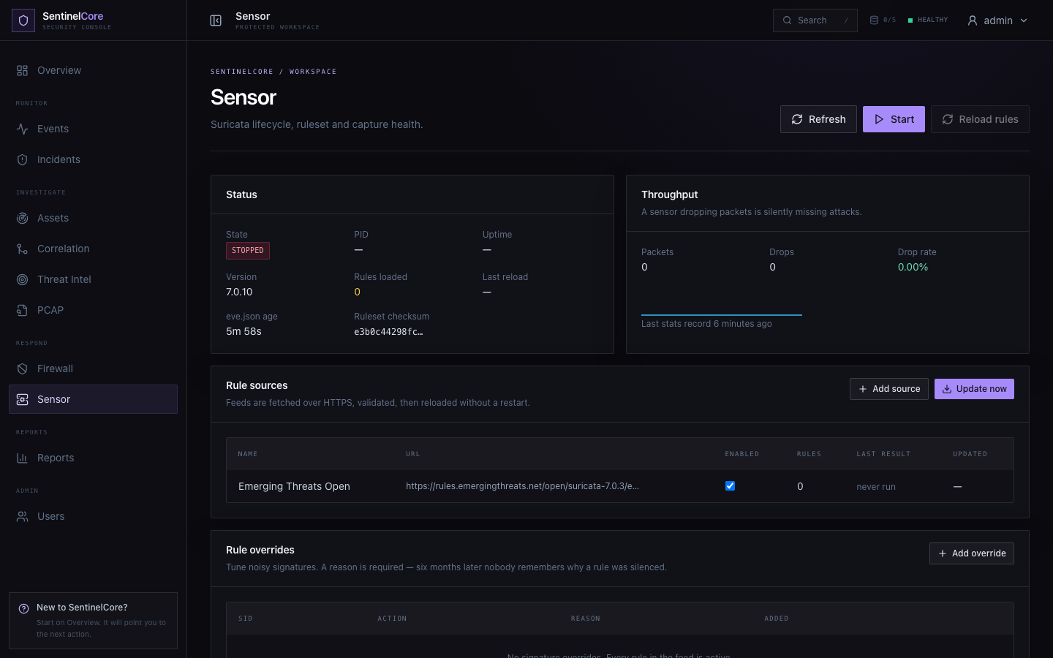
Live evidence: Suricata sensor health, throughput, rule sources, and override controls.
GitHub Repository: https://github.com/rashiyaom/SentinelCore
Assessed By (Faculty) | Marks Awarded  (5 marks) | Faculty Remarks

