Weekly Student Progress Performa
Team Id | CS26084 | Week no / Date | Week 7  31 August 2026
Project Title | SentinelCore: A Network Detection and Incident Response Platform
Members Present | Om Rashiya (24cs084), Yash Patel (24cs082)

Section | Details to be filled by the team
Planned Tasks  (from last week) | Create a resilient event-ingestion pipeline from Suricata EVE JSON to PostgreSQL.
Tasks Completed This Week | Built a dedicated worker, EVE tailer, event normalizer, batch writer, Redis-persisted read offsets, monthly PostgreSQL partitions, retention utilities, pipeline status endpoints, and event model validation. Kept ingestion outside the API process to prevent duplicate readers.
Commits Made  (count + 3 sample messages, e.g. 'Added Login Module') | Total: 0 standalone commits this review period.  Pipeline work was reviewed continuously and included in the consolidated M1–M5 milestone commit d79a37c.
Issues Created / Closed (numbers or IDs) | Created: Worker restarts could reread events or lose file position; multiple API replicas could duplicate ingestion.  Closed: Moved tailing to one worker and persisted offsets in Redis with idempotent database writes.
Milestone Status  (% complete, on-track / delayed) | ~54% complete — on track. Detection events could flow reliably from sensor output into partitioned storage.
Blockers / Challenges Faced | Handling log rotation, partial JSON lines, malformed events, and database backpressure without halting the pipeline.
Plan for Next Week | Implement fast event search, facets, saved searches, and rule-driven correlation.

Research & Technical Study
Compared file-tail reliability patterns, at-least-once delivery, checkpointing, batch insertion, and time-based partitioning. The worker acknowledges progress only after durable writes, and malformed lines are isolated rather than stopping ingestion.
Weekly Evidence — Week 7
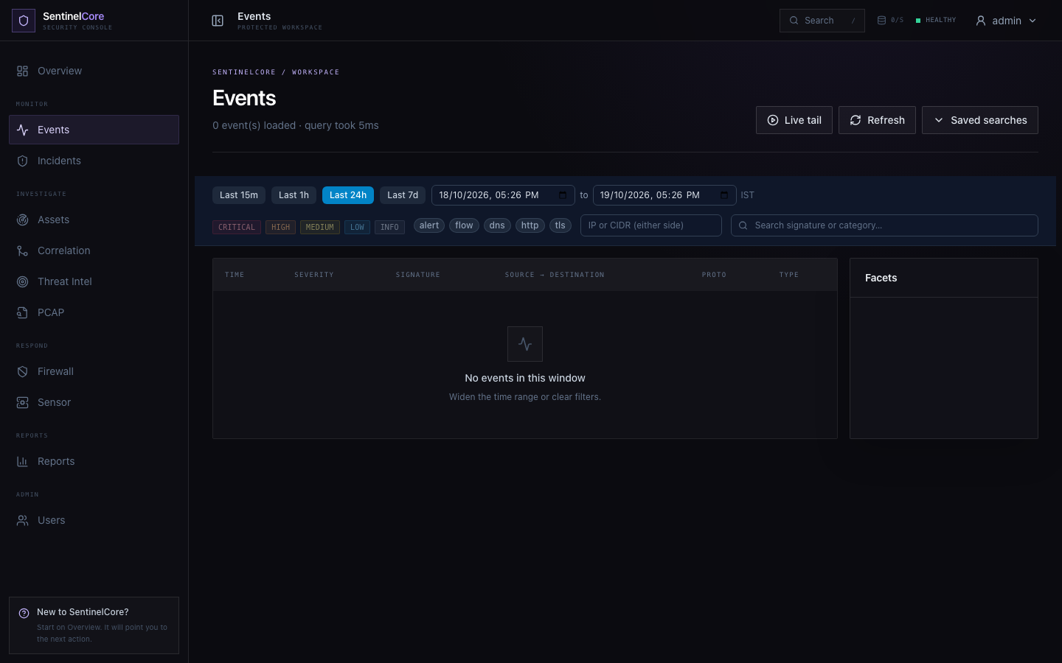
Live evidence: event explorer with time filters, severity/protocol controls, facets, and saved searches.
GitHub Repository: https://github.com/rashiyaom/SentinelCore
Assessed By (Faculty) | Marks Awarded  (5 marks) | Faculty Remarks

