Weekly Student Progress Performa
Team Id | CS26084 | Week no / Date | Week 8  07 September 2026
Project Title | SentinelCore: A Network Detection and Incident Response Platform
Members Present | Om Rashiya (24cs084), Yash Patel (24cs082)

Section | Details to be filled by the team
Planned Tasks  (from last week) | Add scalable event exploration and a correlation engine that can turn raw alerts into actionable findings.
Tasks Completed This Week | Designed keyset-paginated event queries, filter/facet contracts, saved searches, and correlation rules stored as data. Implemented evaluator patterns for threshold, sequence, rare-event, and beacon-like behavior, plus candidate creation and rule-run tracking.
Commits Made  (count + 3 sample messages, e.g. 'Added Login Module') | Total: 0 standalone commits this review period.  Search and correlation were integrated as feature milestones and committed after joint testing on 21 September.
Issues Created / Closed (numbers or IDs) | Created: Offset pagination degrades on large event tables; hard-coded detectors are difficult to tune.  Closed: Adopted indexed keyset pagination and editable rules-as-data with bounded evaluator inputs.
Milestone Status  (% complete, on-track / delayed) | ~63% complete — on track. Analysts could search evidence and define repeatable detections.
Blockers / Challenges Faced | Correlation needed deterministic windows and duplicate suppression so repeated worker passes would not create duplicate candidates.
Plan for Next Week | Complete incident promotion, assignment, status/severity changes, evidence linking, and immutable history.

Research & Technical Study
Studied keyset versus offset pagination, time-window correlation, threshold and sequence detection, beacon periodicity, and false-positive control. Rule state and runs are persisted so detections remain explainable and auditable.
Weekly Evidence — Week 8
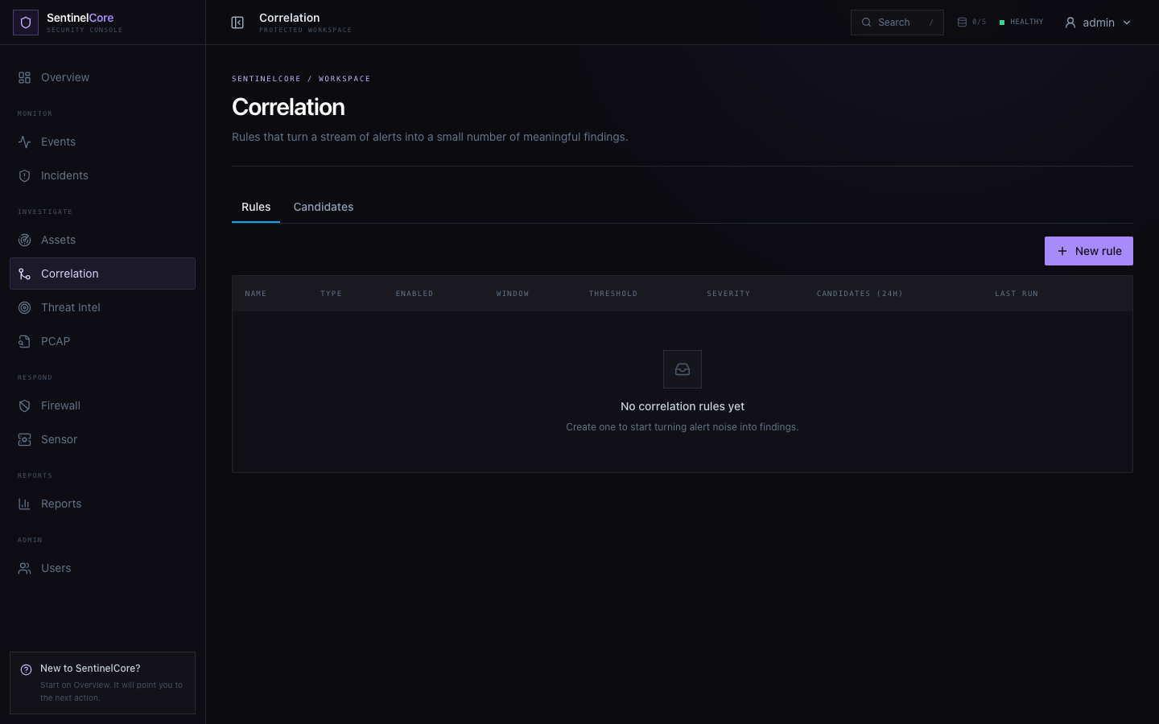
Live evidence: configurable correlation rule and candidate workspace.
GitHub Repository: https://github.com/rashiyaom/SentinelCore
Assessed By (Faculty) | Marks Awarded  (5 marks) | Faculty Remarks

