Weekly Student Progress Performa
Team Id | CS26084 | Week no / Date | Week 9  14 September 2026
Project Title | SentinelCore: A Network Detection and Incident Response Platform
Members Present | Om Rashiya (24cs084), Yash Patel (24cs082)

Section | Details to be filled by the team
Planned Tasks  (from last week) | Integrate M1–M5 work and implement the analyst incident lifecycle.
Tasks Completed This Week | Merged authentication, asset discovery, sensor, and event-pipeline foundations in one reviewed milestone. Added incident creation from candidates, human-readable numbering, status/severity/assignee changes, event attachment, comments, and append-only incident history.
Commits Made  (count + 3 sample messages, e.g. 'Added Login Module') | Total: 1 major consolidated commit.  d79a37c — “update the project to m5” (130 files; authentication, assets, sensor, pipeline, tests, and UI foundation).
Issues Created / Closed (numbers or IDs) | Created: Candidates needed traceable promotion without losing original evidence.  Closed: Incident records retain candidate/event relationships and record every lifecycle change in history.
Milestone Status  (% complete, on-track / delayed) | ~73% complete — on track. The platform supported discovery through investigation as one integrated workflow.
Blockers / Challenges Faced | The milestone was large because related database migrations, worker logic, API contracts, tests, and frontend screens had to land together.
Plan for Next Week | Finalize search/correlation commits, reporting, scheduled generation, and safe firewall containment.

Research & Technical Study
Reviewed incident-response case management, chain of custody, analyst assignment, evidence preservation, and append-only change history. The model separates machine-generated candidates from analyst-managed incidents while maintaining the source trail.
Weekly Evidence — Week 9
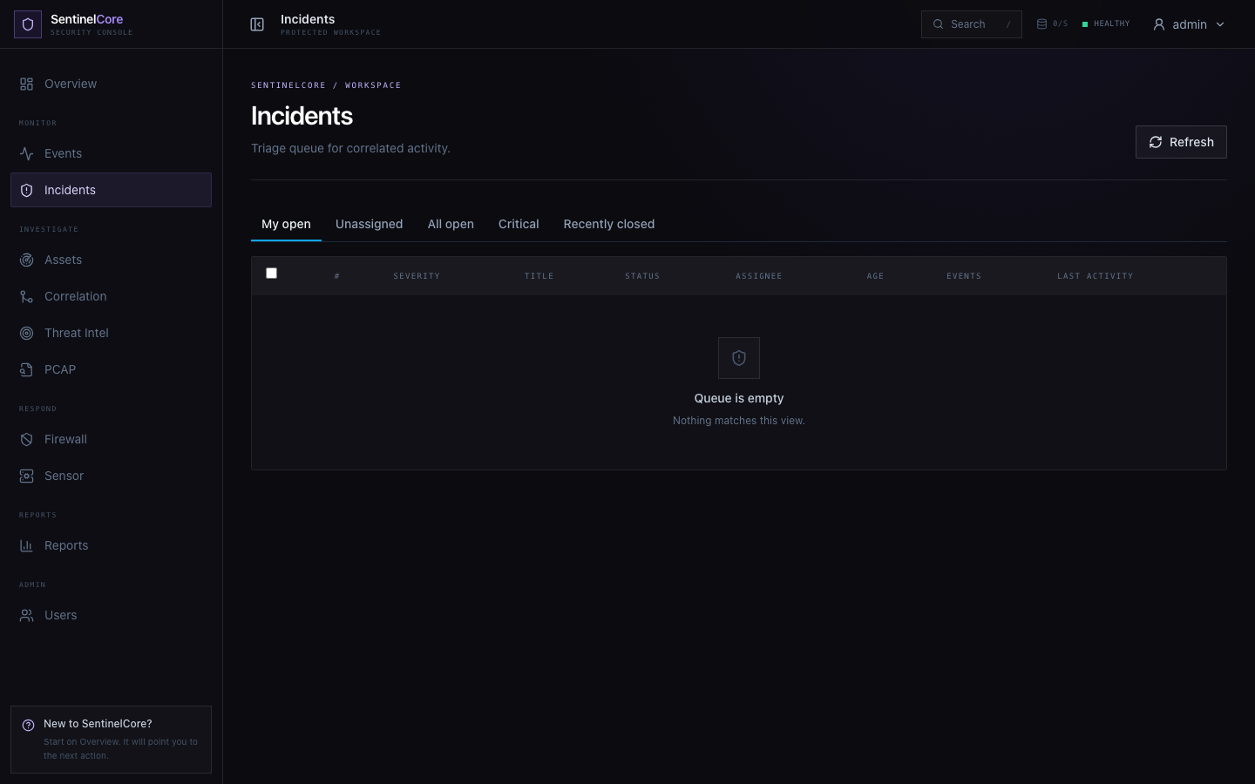
Live evidence: incident queue supporting triage, assignment, status, severity, and evidence review.
GitHub Repository: https://github.com/rashiyaom/SentinelCore
Assessed By (Faculty) | Marks Awarded  (5 marks) | Faculty Remarks

