AIC Dashboard Updates
Currency Exchange Rates Module Updates
- Add Filter options:
  - From Date
  - To Date
- Add an Export Report option to export the filtered Currency Exchange Rates data.
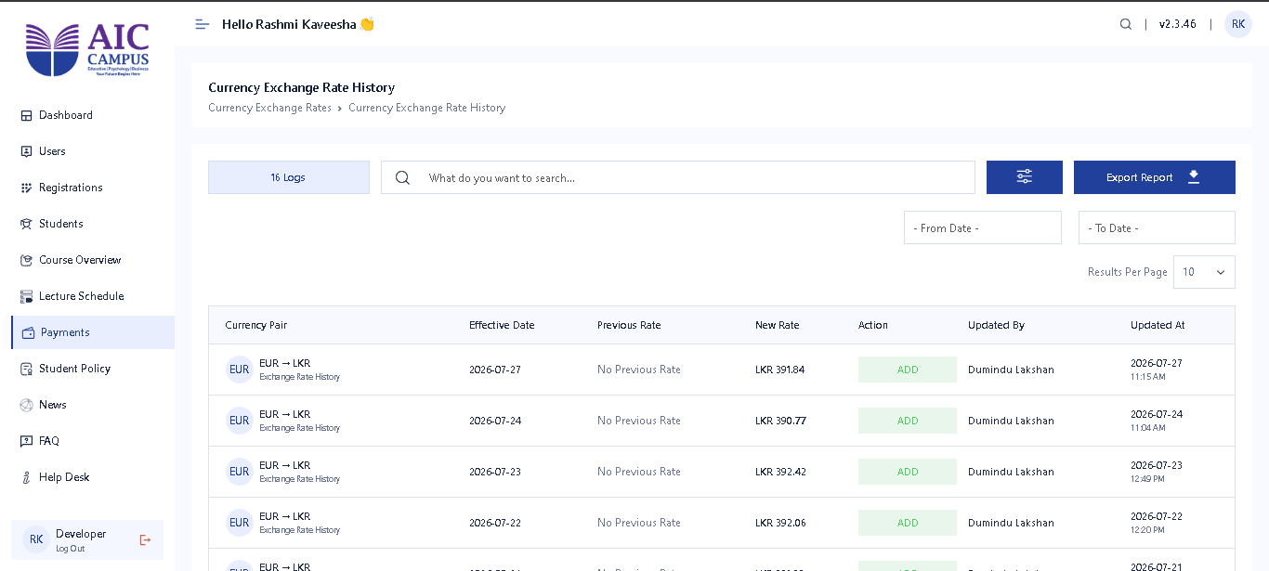
Due Payments Module Updates
- Load all Due Payments.
- Add the following filter options:
  - Branch
  - Faculty
  - Programme
  - Intake

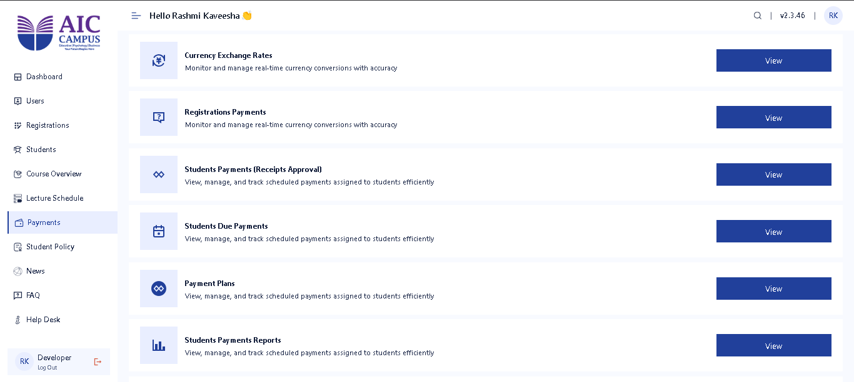

Registration Module Updates
- Rename the Inquiries tab to Registrations.
- Add a Programme column to the Registrations table.
- Highlight students with overdue payments in the Registrations table.
- Add the following filters to the Registrations page:
  - Branch
  - Faculty
  - Programme
  - Intake
  - Registration Status
  - Payment Status
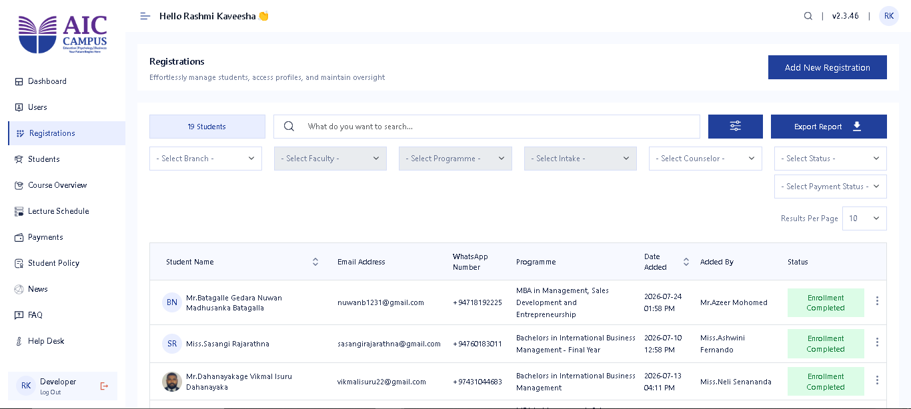
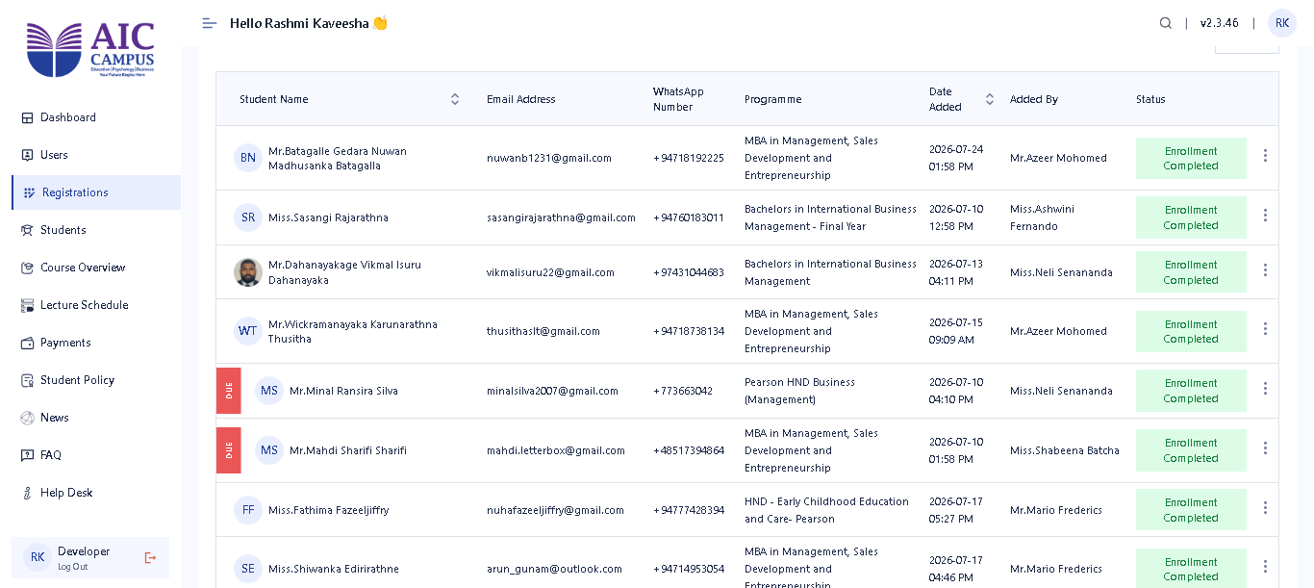

Branch Manager Role Updates
- When creating a user with the Branch Manager role, require the user to select the manager's assigned Branch.
- Add an Edit option for existing Branch Manager users to assign or update their branch.
- Branch Managers should only be able to view Registrations that belong to their assigned branch and their added.
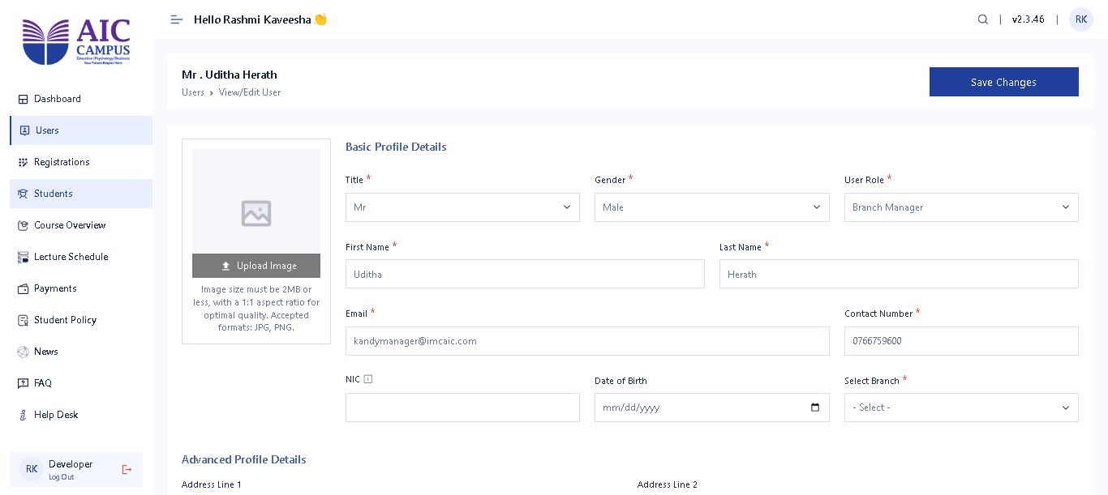
Students Module Updates
- Add a Counselor column to the Students table.
- Add the following filters to the Students page:
  - Branch
  - Faculty
  - Programme
  - Intake
  - Active Status
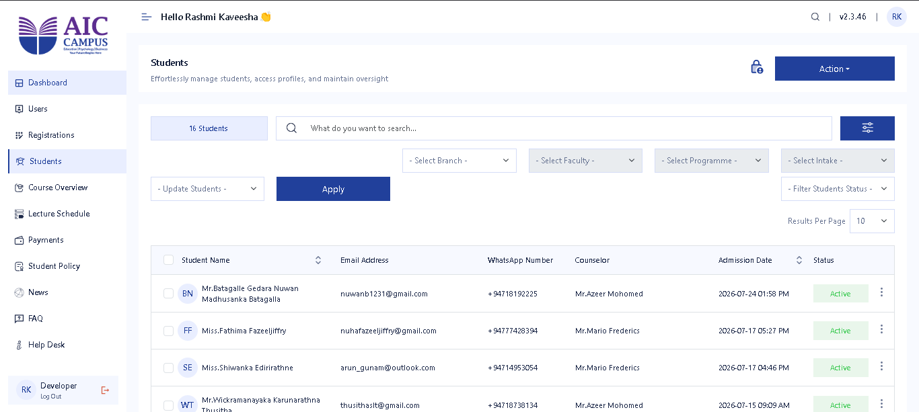
Student Form Updates
- Update the Full Name field label to:
  - Full Name (As it appears on the Certificate)
- Mark the AIC Application document as a required document during student registration.
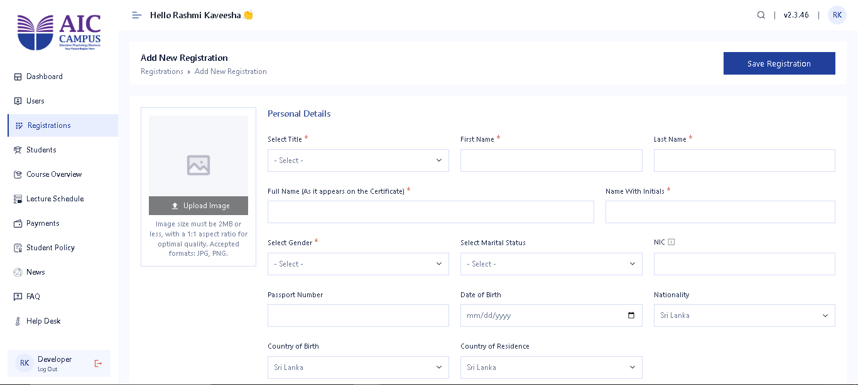
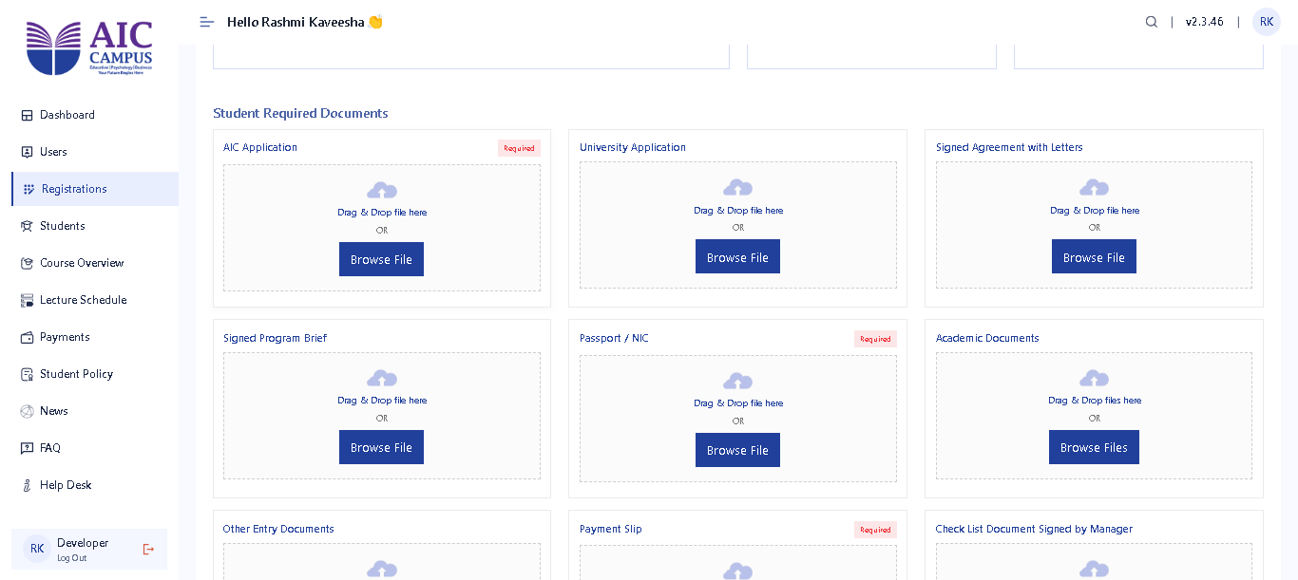

Student Payments Module Updates
- Add the following filter options to the Student Payments page:
  - Branch
  - Faculty
  - Programme
  - Intake
  - Payment Category
  - Payment Type
  - Payment Status
  - Year
  - Month
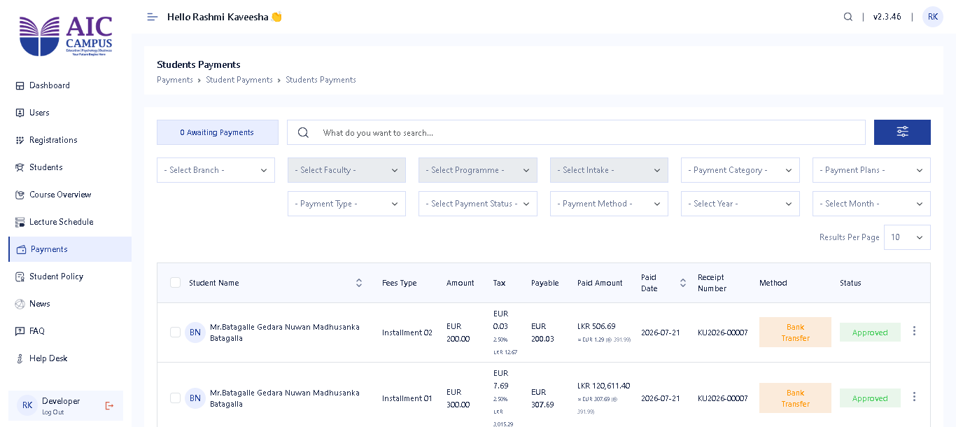
Bank Account Management Updates
- Add support for branch-wise bank accounts.
- Path: Payments → Actions → Manage Banks → Add Bank.
- Each bank account should be assigned to a specific Branch, allowing users to select only the bank accounts associated with their branch during payment processing.
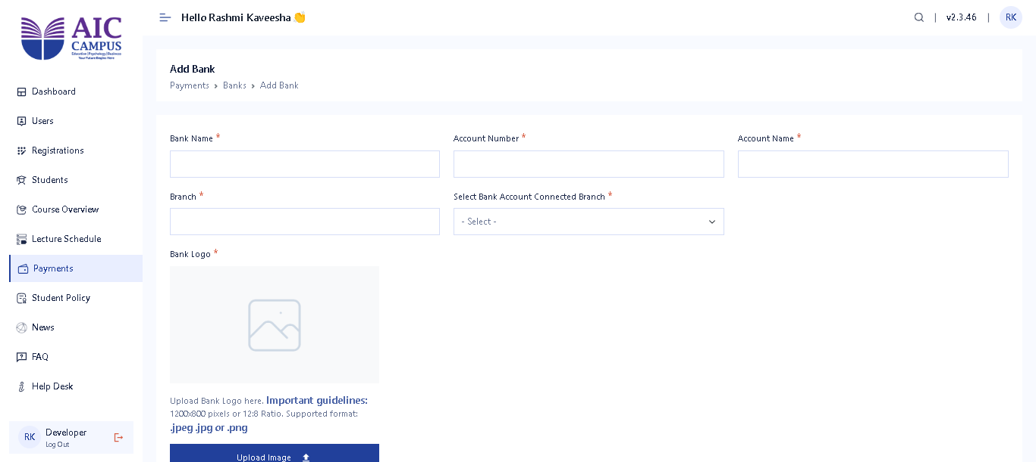
Email Notification Updates
- Update and improve the formatting of the Student Welcome Email.
- Send the Student Welcome Email with the assigned Counselor in CC.
- When sending the Enrollment Confirmation email to the Academic Team, include the assigned Counselor in CC as well.

AIC Portal Updates
Student My Profile Module Updates
- Update the My Profile page with a new design and improved user interface.
- Make all profile details view-only (students cannot edit their information).
- Email address and mobile number editing options are currently under development and will be enabled once completed.
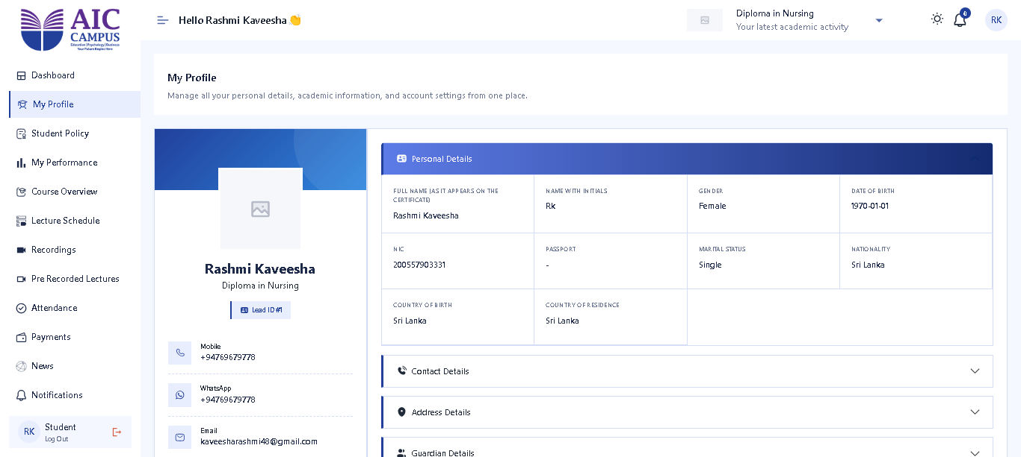
Student Payments Module Updates
- Update the Student Payments table column order as required.
- Update and display the Tax column in the payment details.

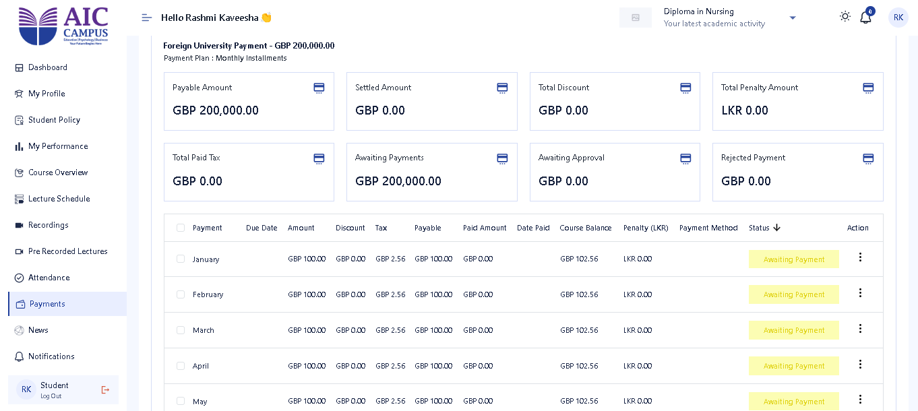
Student Payment Updates
- Add a "My Fees" option when selecting a payment to be paid.
- When selecting Bank Transfer as the payment method:
  - Load the bank account details based on the student's assigned Branch.
  - Add a Bank Account Selector option to select the relevant branch bank account.


