ServiceNow Incident Management – Client-Side Control Implementation

Problem Statement

Incident forms need reliable and consistent information so that support teams can classify, assign, and resolve issues efficiently. Manual checking alone may allow important fields to remain incomplete or contain inconsistent values. This can affect incident tracking, reporting, SLA handling, and the overall quality of service. This project addresses the issue by applying UI Policies and Client Scripts directly on the Incident form. These controls provide conditional field behavior, automatic updates, and validation before an Incident is submitted.

Objective

The main objective of this project is to demonstrate how ServiceNow client-side configuration can improve the accuracy and usability of Incident records. The implementation combines UI Policies with onChange, onSubmit, and onCellEdit Client Scripts to control fields based on Incident conditions. The solution makes selected information mandatory when required, updates values automatically, restricts unsuitable edits, and validates records before saving.

Skills
Incident Management
UI Policy
UI Policy Actions
Client Scripts
Form Validation

Phase 1: Set the Incident Form Control Rule

Step 1: Create and Define the Control Rule
- 1. Sign in to the ServiceNow instance using an account that has the required configuration privileges.
- 2. Open the UI Policy section from:
System UI → UI Policies
- 3. Select New to start creating the Incident UI Policy.
- 4. Enter the required policy information using the following settings:
  - Name: High Impact Control
This name identifies the policy and indicates that it is intended for incidents with a high-impact condition.
  - Table: Incident
This connects the policy to the Incident table so that its rules are applied on Incident forms.
  - Active: true
Activating the policy allows ServiceNow to apply its configured behavior when the condition is satisfied.
- 5. Configure the condition section with the following values:
  - Field: Impact
  - Operator: is
  - Value: 1 – High
- 6. With this condition, the policy becomes active only when the Incident Impact value is High.
- 7. Add the UI Policy Action for the Assignment group field.
- 8. Enable the Mandatory option for the field.
- 9. Set Reverse if false to true.
This allows the field behavior introduced by the policy to return to its normal state when the condition is no longer true.
- 10. Check the complete configuration and confirm that the selected values are correct.
- 11. Select Submit to create and save the UI Policy.
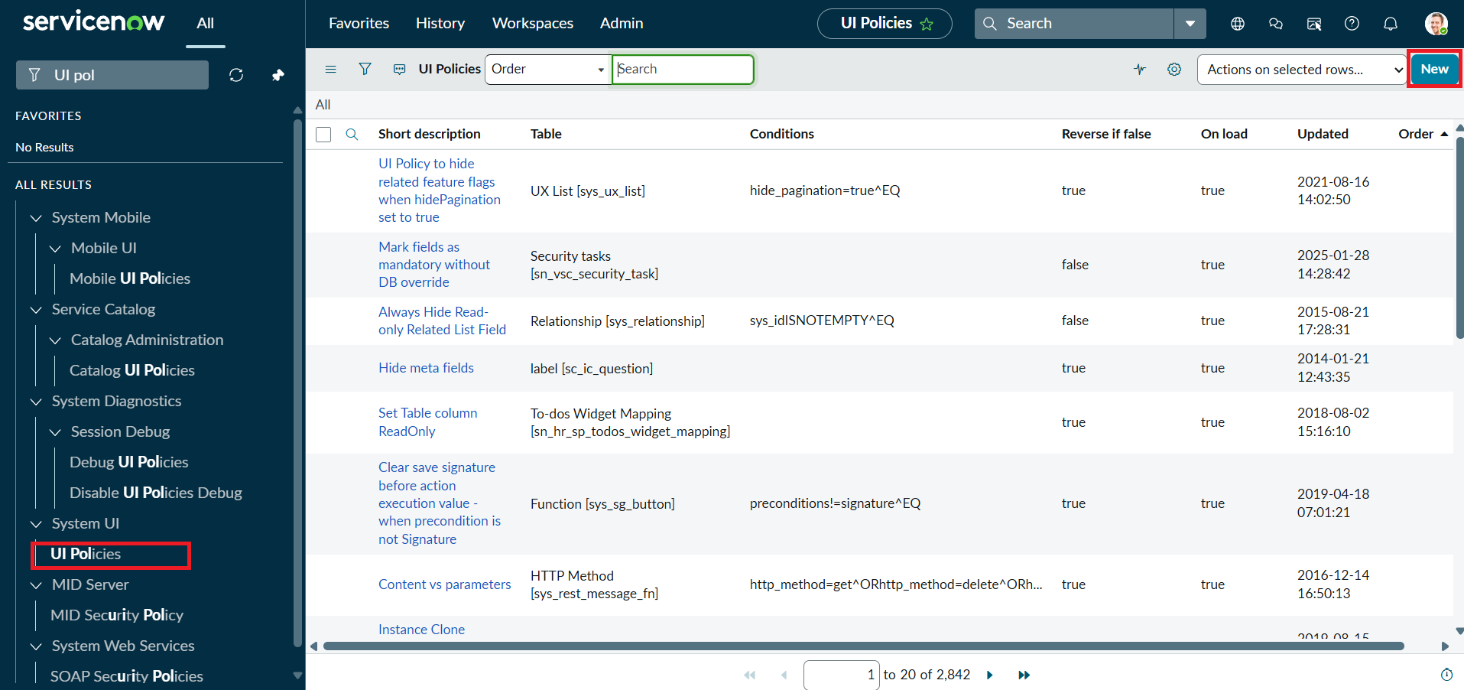
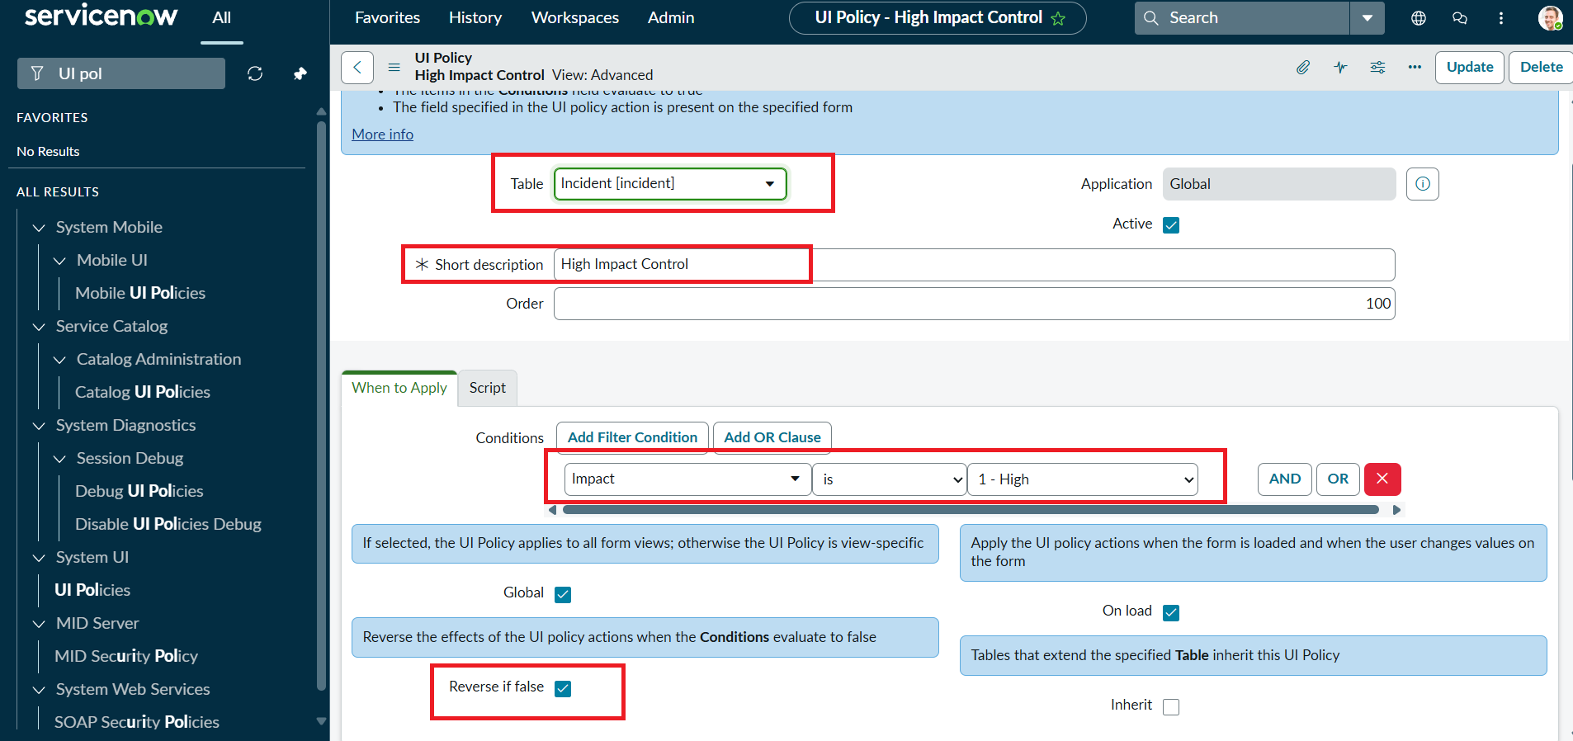

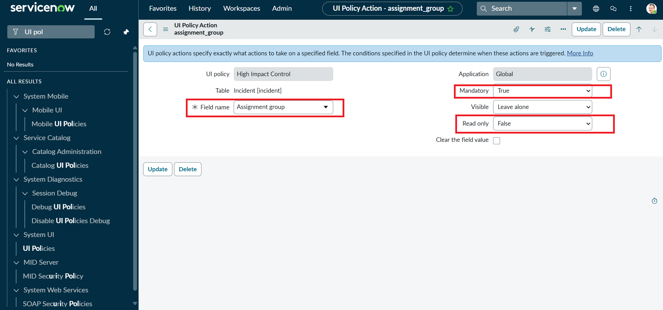
Phase 2: Apply Conditional Control to Urgency
Step 1: Define Urgency Field Behavior
- Open the UI Policy Actions section
Open the High Impact Control policy created in the previous task and move to its UI Policy Actions related list. This section is used to define how individual Incident fields should behave when the policy condition is active.
- Create a New Action
Select New to add a UI Policy Action. The action determines the behavior of a particular field when the UI Policy is triggered.
- Enter the Action Details
  - Field name: Urgency
Choose the Urgency field because its editing behavior will be controlled when Impact is High.
  - Read-only: true
Enable this option so that users can view the Urgency value but cannot manually modify it while the High Impact condition is active.
  - Visible: Leave this field unchanged.
The Urgency field should continue to appear on the form; only its editing permission is being controlled.
- Save the Action
Select Submit to store the action. It will remain associated with the High Impact Control policy and will take effect whenever the policy condition is satisfied.
- Optional Verification
Perform a quick check to confirm that the action behaves correctly:
  - Open an Incident record.
  - Set the Impact field to High.
  - Confirm that the Urgency field becomes read-only.
  - Change Impact to another value and verify that the field returns to its normal editable behavior.
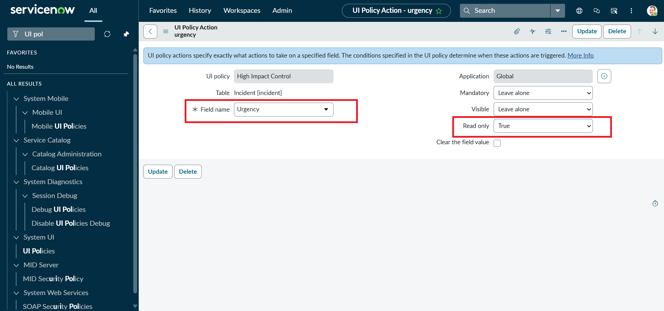

Phase 3: Add Automatic Urgency Handling
Step 1: Build the Change-Based Validation
- Navigate to Client Scripts:
Open System UI → Client Scripts to manage client-side scripts for the Incident form.
- Choose New to start a Client Script.
- Enter the following script configuration:
  - Name: Auto set urgency for high impact – the name describes the automatic Urgency update performed by the script.
  - Table: Incident – limits the script to Incident records.
  - Type: onChange – causes the script to run when the selected field value changes.
  - Field name: Impact – the script responds specifically to changes in the Impact field.
  - Active: true – keeps the script enabled for use on the Incident form.
- Add the provided script in the script editor.
- Choose Submit to store the Client Script.
- Expected Result: Open an Incident and change Impact to High. The script should automatically update the Urgency field.
Script:
function onChange(control, oldValue, newValue, isLoading) {
if (isLoading || newValue == '') {
return;
}

if (newValue == '1') {
g_form.setValue('urgency', '1');
g_form.addInfoMessage('Urgency set to High for High impact incident.');
}
}

- Select Submit after entering the script.
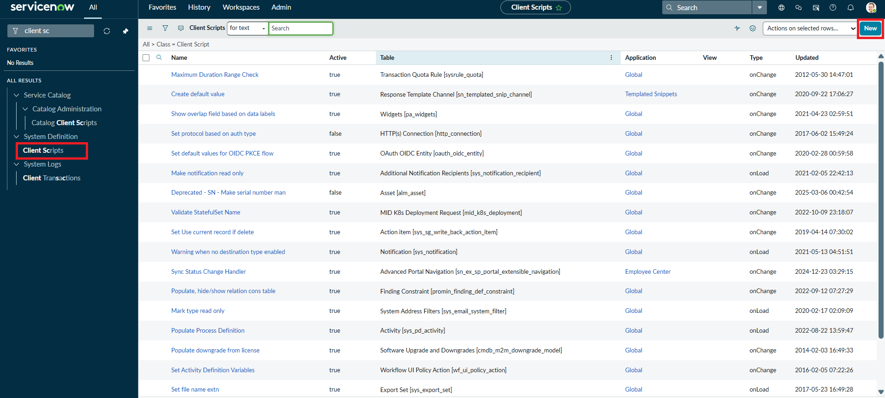
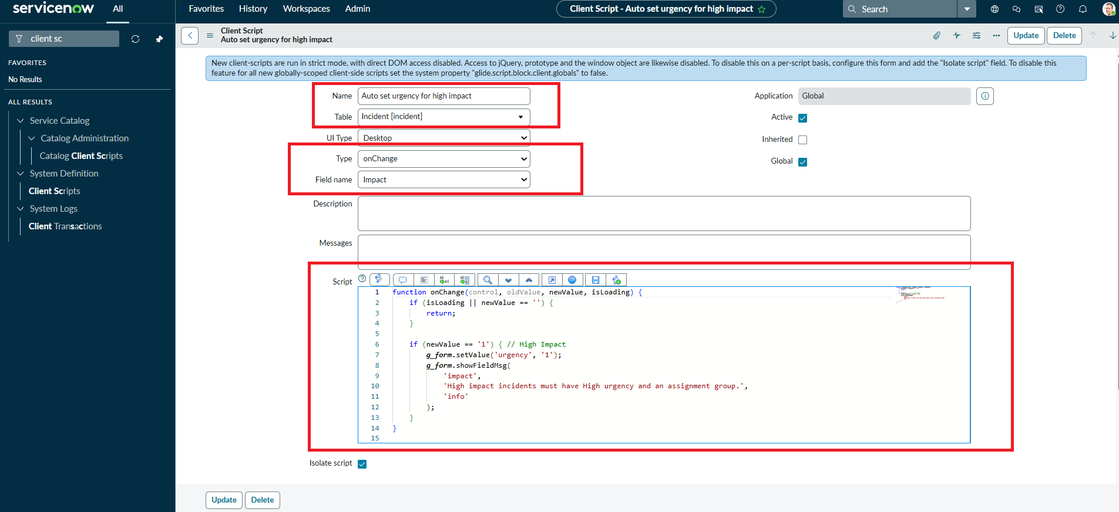

Phase 4: Add Save-Time Incident Validation
Step 1: Build the Submission Check
- Navigate to Client Scripts:
Go to System UI → Client Scripts in the ServiceNow instance.
- Choose New to start another Client Script.
- Enter the following configuration details:
  - Name: Prevent save if Assigned To missing – this identifies the validation that stops an Incident from being saved when the required assignment is missing.
  - Table: Incident – the validation is applied only to Incident records.
  - Type: onSubmit – runs when the user attempts to save or submit the record.
  - Active: true – enables the validation rule.
- Insert the validation script into the script editor. It checks the Impact and Assigned To values and blocks submission when the required condition is not satisfied.
- Choose Submit to store the Client Script.
- Expected Result: Attempt to save a High impact Incident without an Assigned To value. The script should stop the save operation and display an error.

- Paste the following validation script:
function onSubmit() {
if (g_form.getValue('impact') == '1' &&
g_form.getValue('assigned_to') == '') {

g_form.showErrorBox(
'assigned_to',
'Assigned To is mandatory for High impact incidents.'
);
return false;
}
return true;
}

8. Choose Submit to store the script.
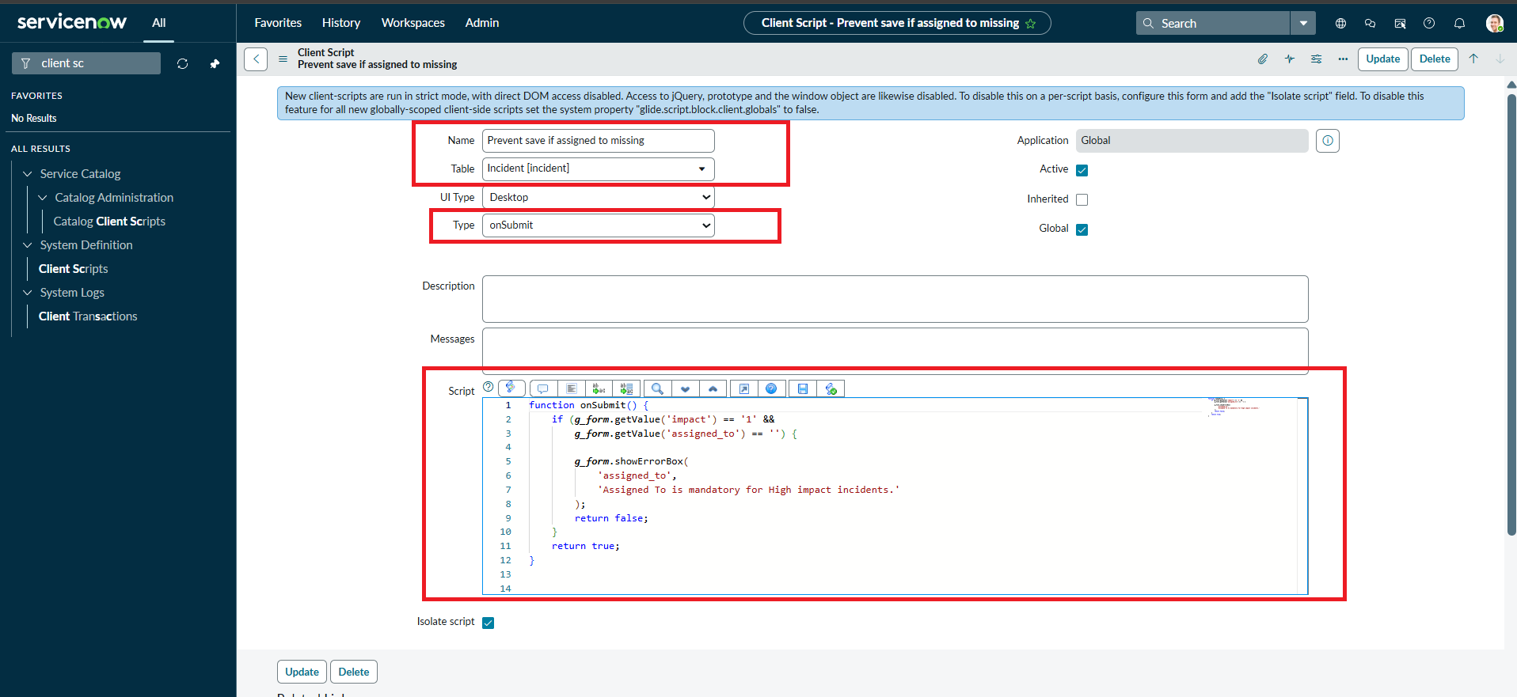

Phase 5: Restrict Direct List Editing
Step 1: Build the List Editing Restriction
- Navigate to Client Scripts:
Open System UI → Client Scripts in the ServiceNow instance.
- Choose New to start the Client Script.
- Enter the required script settings:
  - Name: Prevent state change via list edit – describes the restriction placed on direct State changes from the list view.
  - Table: Incident – applies the rule to Incident records.
  - Type: onCellEdit – runs when a field is edited directly within a list.
  - Field name: State – identifies the field whose list editing will be controlled.
  - Active: true – keeps the protection enabled.
- Add the script to the script editor. The purpose is to stop direct State modifications from the Incident list and require users to open the record instead.
- Choose Submit to store the Client Script.
- Expected Result: Open the Incident list and attempt to edit the State value directly. The script should reject the list-based change.

- In the Script field, enter the following code:
function onCellEdit(sysIDs, table, oldValues, newValue, callback) {

alert('State cannot be updated using list editing. Please open the Incident.');

callback(false);
}

8. Choose Submit to store the Client Script.
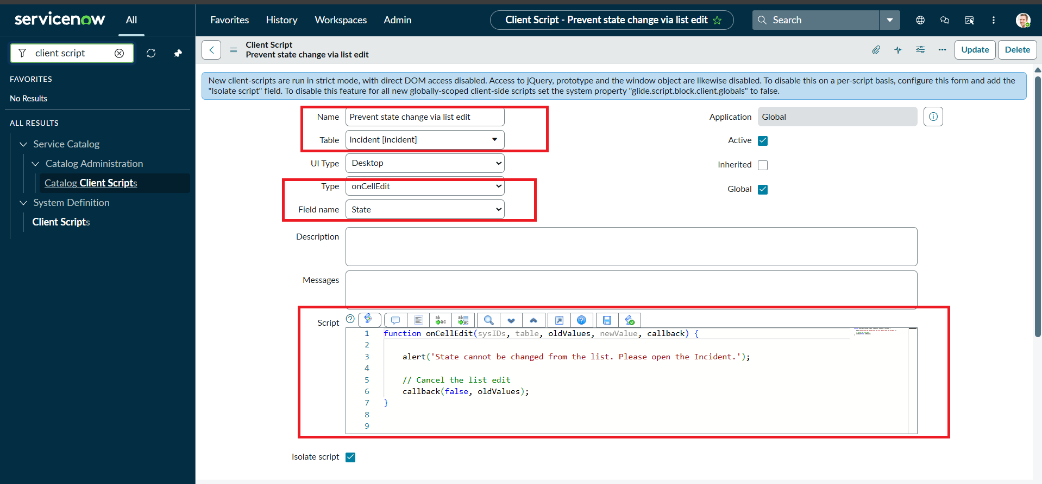

Phase 6: Perform Functional Verification
Step 1: Check Mandatory Field Behavior
- Navigate to Incident:
Open Incident → Create New to display a new Incident form.
- Set the Impact Field:
Choose High in the Impact field so that the configured UI Policy and Client Script rules become active.
- Leave Assigned To Empty:
Keep the Assigned To field blank to test the save-validation rule.
- Submit the record:
Try to save the Incident record.
- Verify the Result:
  - The Incident should remain unsaved because Assigned To is required when Impact is High.
  - An error should be displayed for the missing Assigned To value.
  - Check that the other configured behaviors, including the read-only control and automatic Urgency update, are also applied.

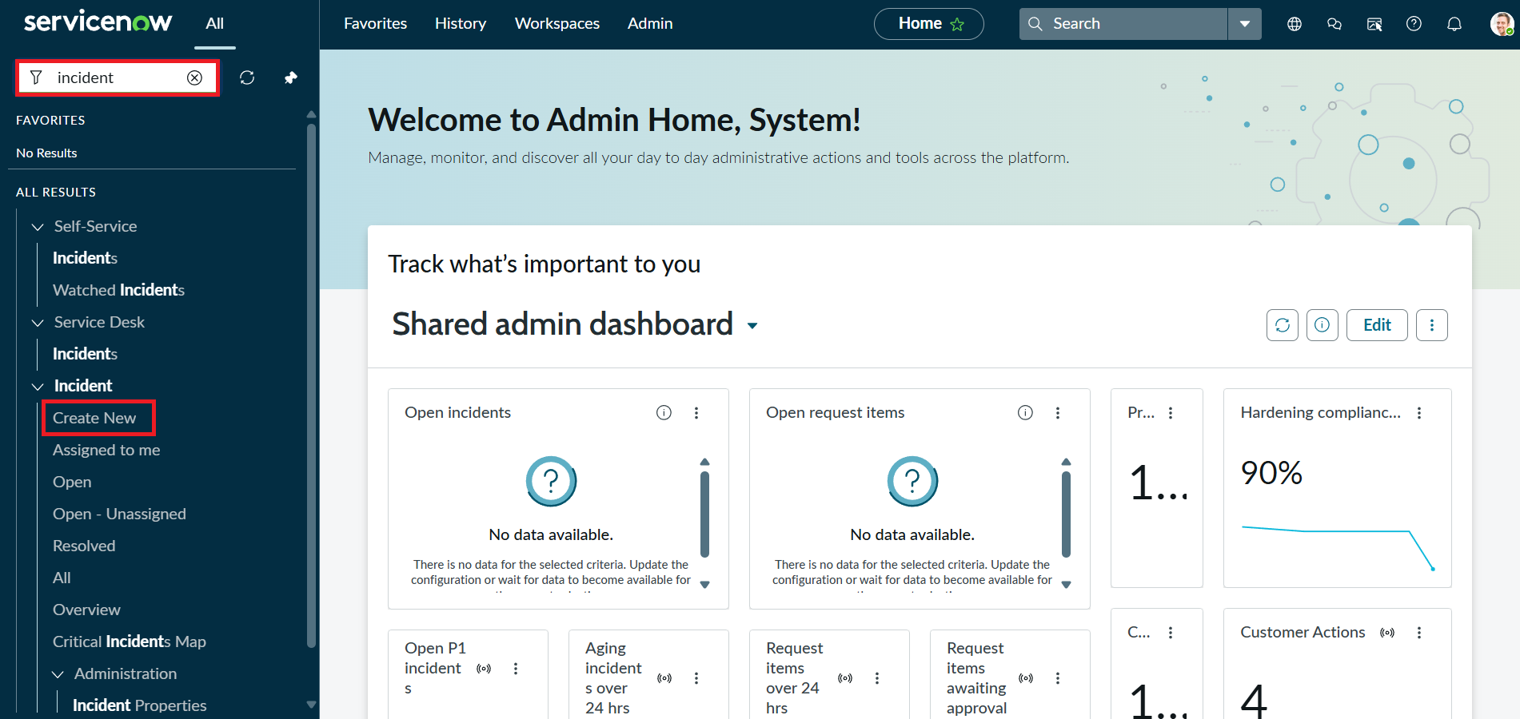
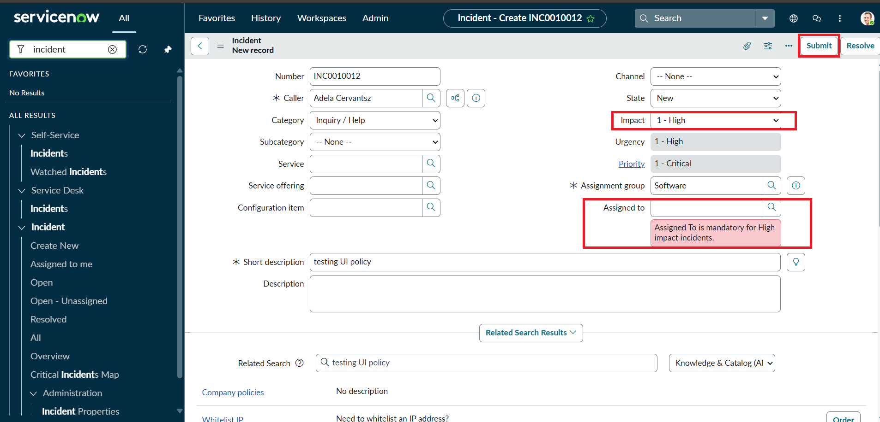
Step 2: Check Valid Record Submission
- Fill the Assigned To Field:
Return to the Incident form and select an appropriate user in Assigned To. This satisfies the condition checked by the onSubmit script.
- Submit the record:
Save the Incident record.
- Verify the Result:
  - The Incident should be saved successfully without the validation error.
  - Confirm that the remaining configured controls continue to operate:
    - Automatic Urgency update (from the onChange Client Script)
    - Read-only behavior (from the UI Policy Action)
    - State list-edit restriction (from the onCellEdit Client Script)
should all behave according to the configured rules.
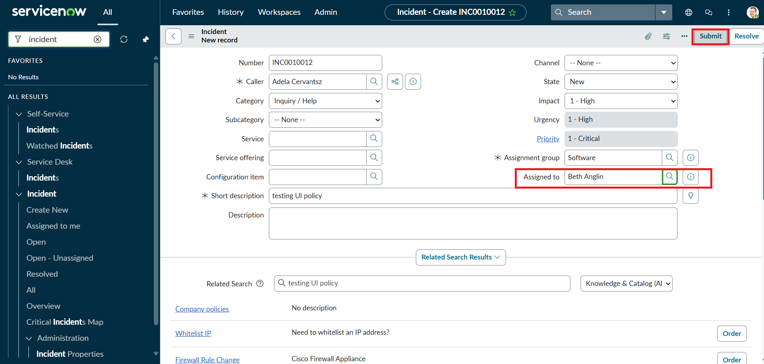

Step 3: Check Condition Reversal
- Open an Existing Incident:
Select an Incident record whose Impact is currently High.
- Change Impact:
Change the Impact value from High to Medium to check the Reverse if false behavior of the UI Policy.
- Verify the Field Behavior:
  - Assigned To should no longer be forced to mandatory by the policy.
  - Urgency should become editable again because the read-only action is no longer active.
- Save the Record:
Select Submit and confirm that the updated record can be saved successfully.
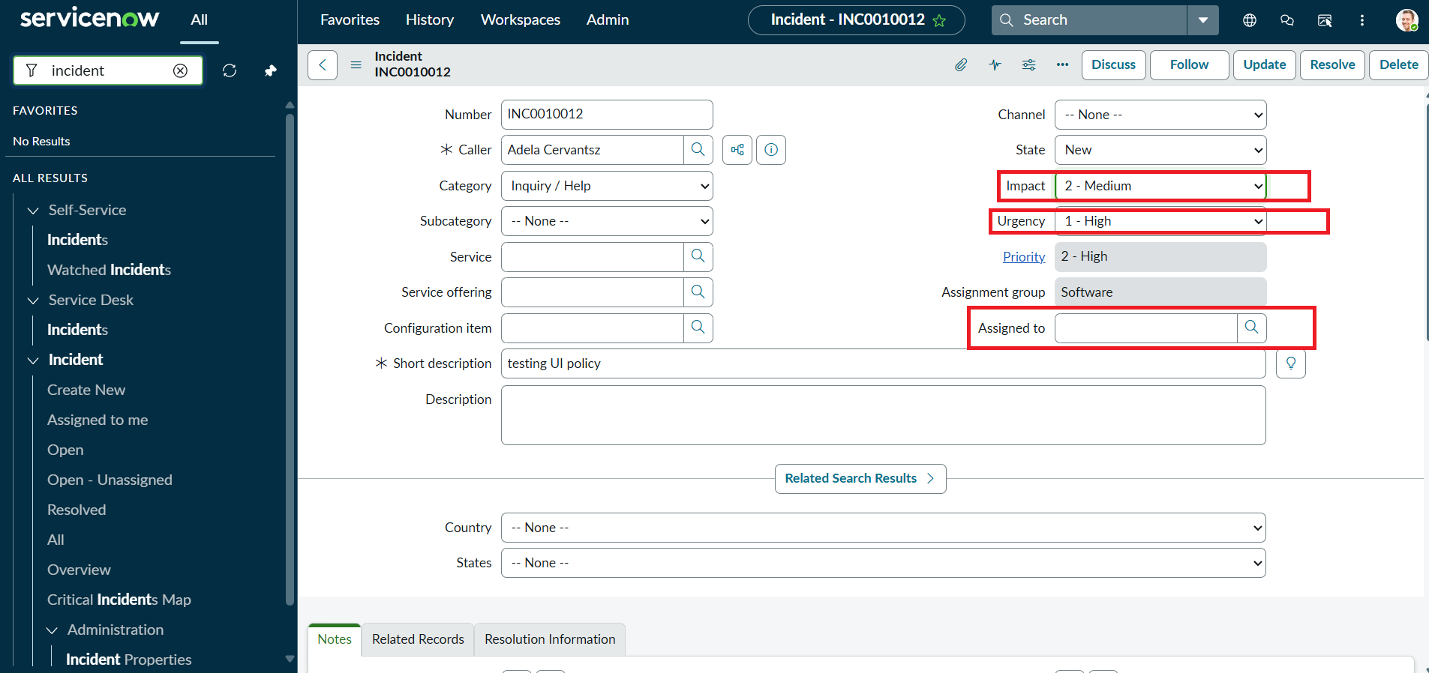

Step 4: Check List View Protection
- Navigate to the Incident List:
Open Incident → All to display the Incident records in list view.
- Attempt a List Edit:
  - Choose an Incident from the displayed records.
  - Double-click the State field and attempt to change it directly from the list.
- Verify the Behavior:
  - An alert should inform the user that the State field cannot be changed through list editing.
  - The original State value should remain unchanged, showing that the onCellEdit validation is active.
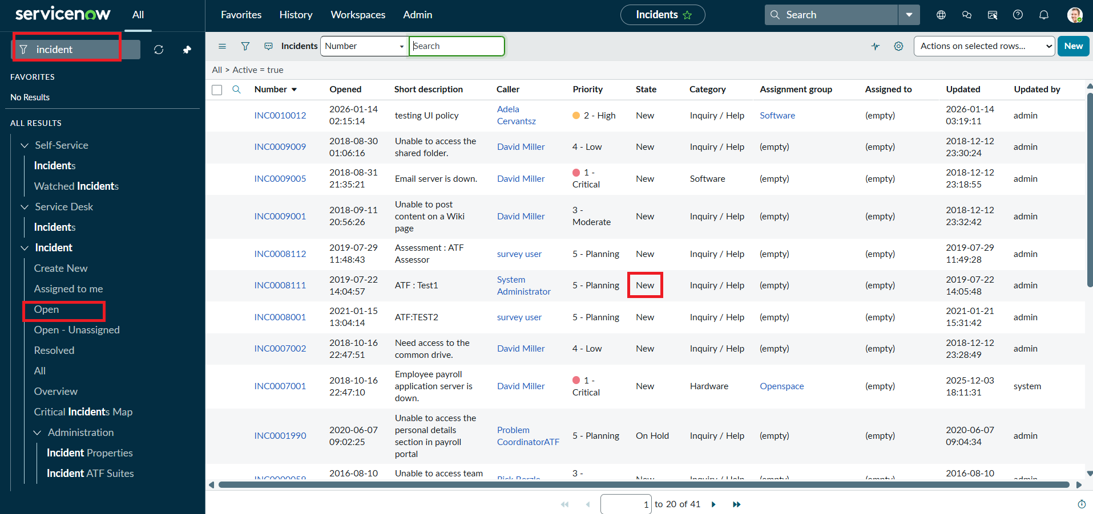

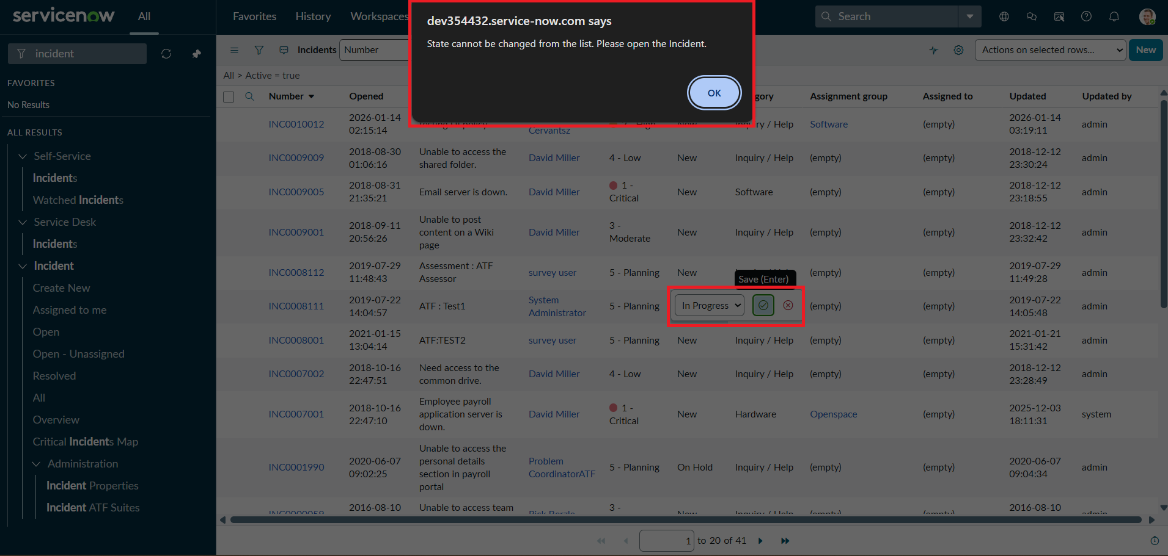

Step 5: Check Normal Form Updates
- Open the Incident Record:
Reopen the Incident record used during the earlier tests.
- Change the State:
Modify the State field from the Incident form. This confirms that form-based changes are still permitted.
- Update the record:
Save the modified Incident record using Update.
- Verify the Result:
  - The new State value should be stored successfully.
  - Check that Assigned To, Urgency, and the other configured fields continue to follow the UI Policy and Client Script rules.

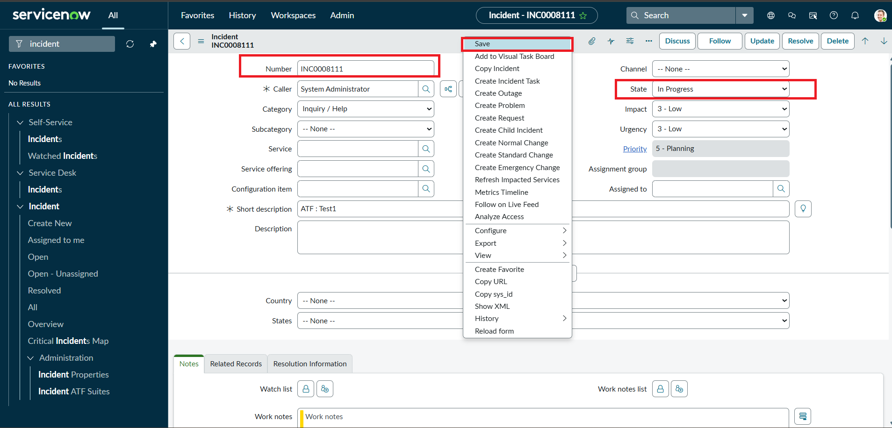

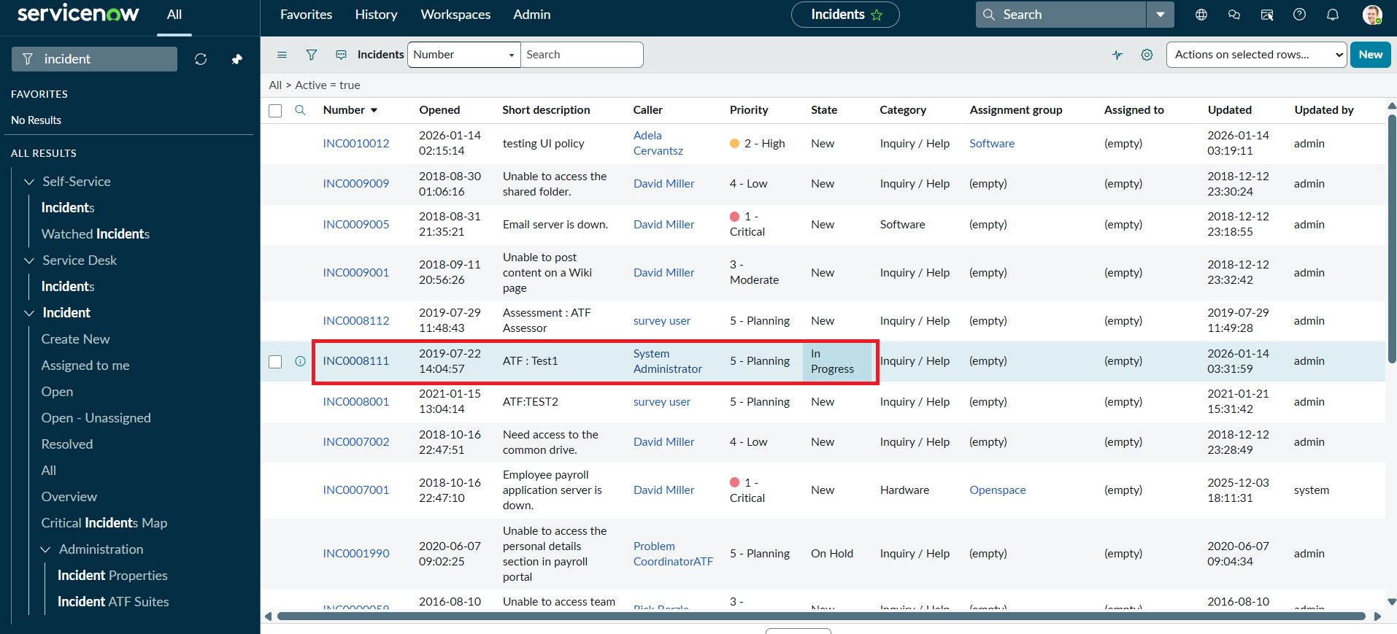

Conclusion
This ServiceNow micro project demonstrates how UI Policies and Client Scripts can be combined to control Incident form behavior and improve data consistency. The implementation uses an Impact-based UI Policy together with onChange, onSubmit, and onCellEdit Client Scripts. These controls can automatically update Urgency, enforce the required Assigned To value for High impact incidents, restrict direct State editing from lists, and restore normal field behavior when conditions change. Overall, the configuration provides a practical way to strengthen Incident data validation while keeping the form behavior clear and manageable.

