Module 1 Assignment

Link to GitHub repository: <https://github.com/rashmi-sathiyanarayanan/csd-340/>

Screenshot of GitHub repository:

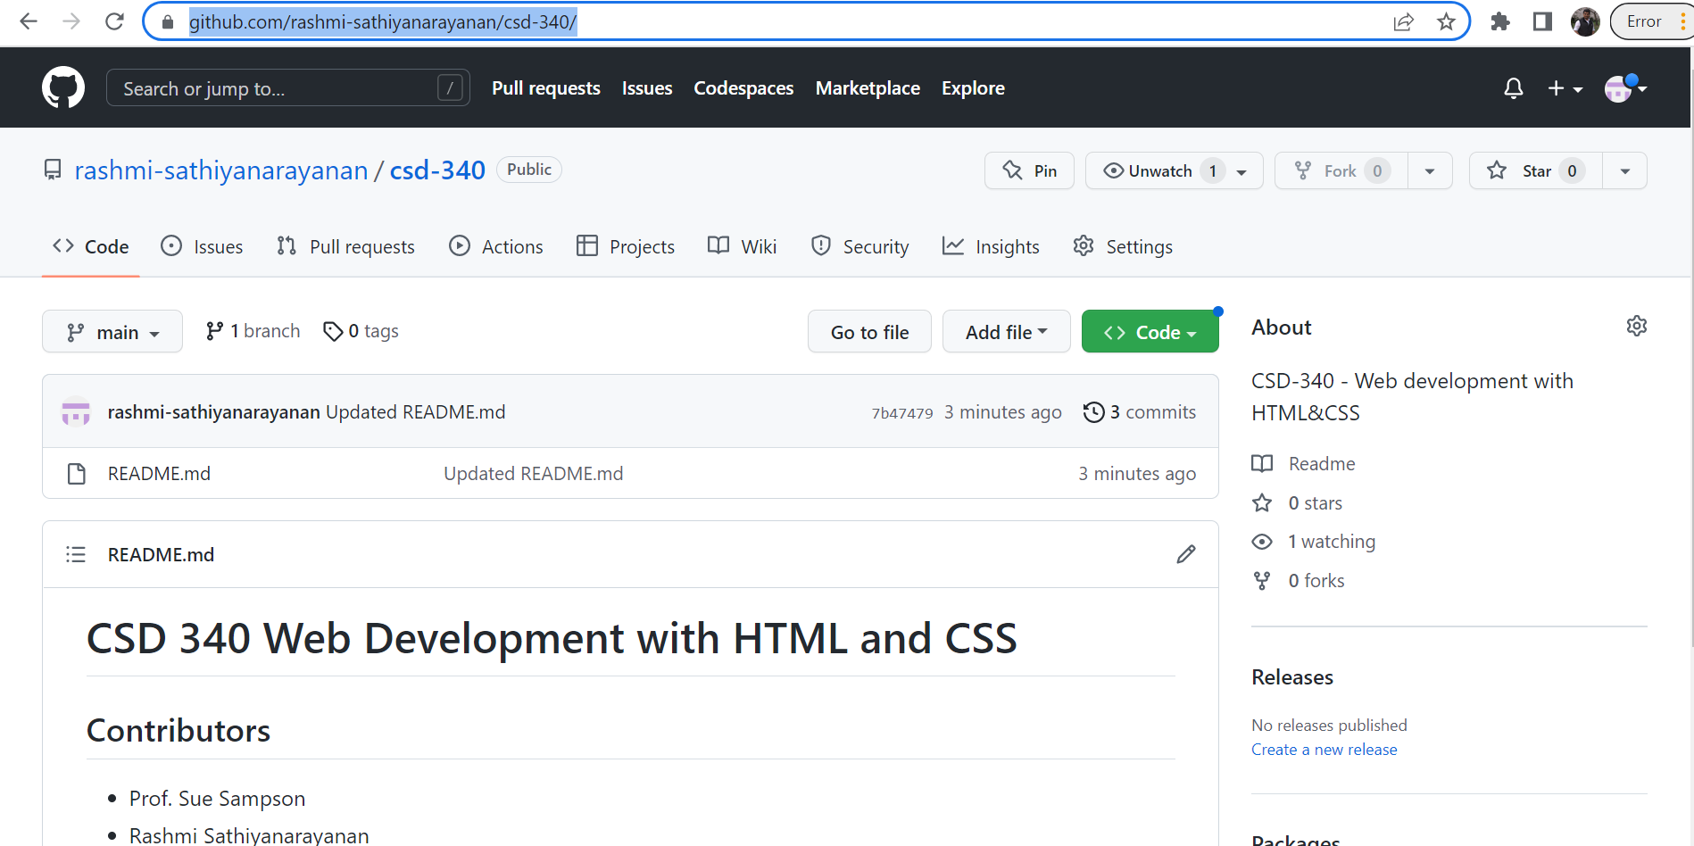

Screenshot of local directory:

