**Test Case**



# A. KPI’s

## 1. Total Sales:

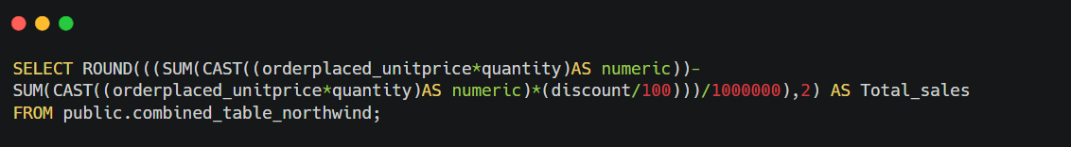

### Output:

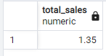

## 2. Total Customers:

### Output:

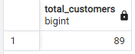

## 3. Total Products



### Output:

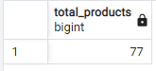

## 4. Countries



### Output:

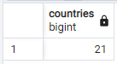

## 5. Total Quantity



### Output:

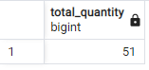

## 6. Avg. Shipping charges Per Order

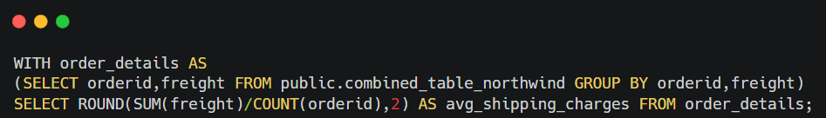

### Output:

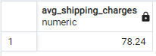

# B. Sales by Country

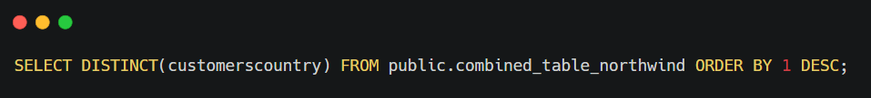

## Output:

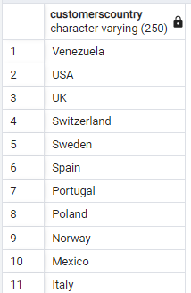

# C. Top 5 and bottom 5 Customer’s

## Output:

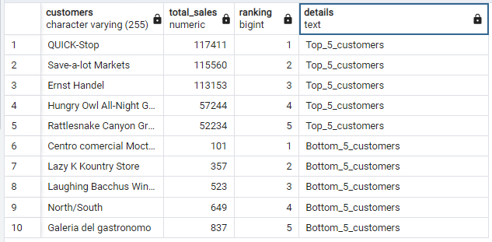

# D. Top 5 and bottom 5 Product’s

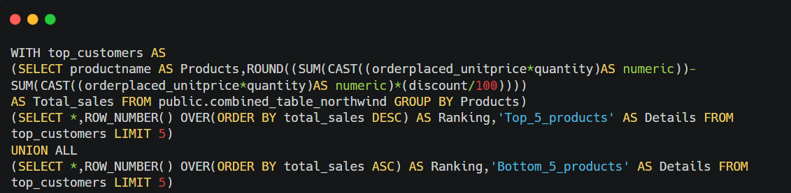

## Output:

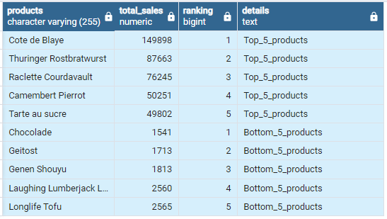

# E. Category wise Sales

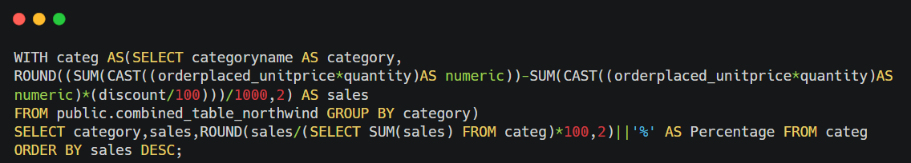

## Output:

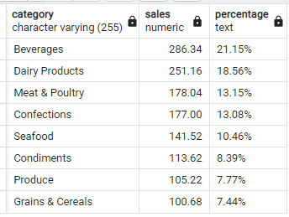

# F. Orders by Category

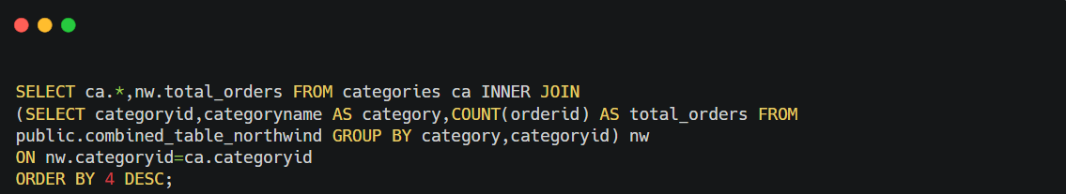

## Output:

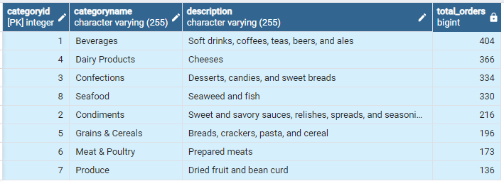

# G. Sales by Shipper

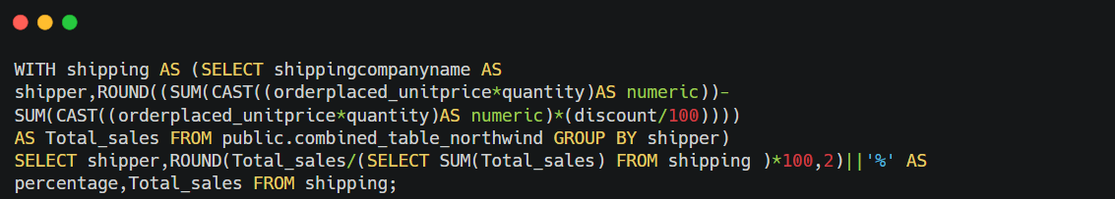

## Output:

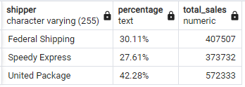

# H. Sales per Week

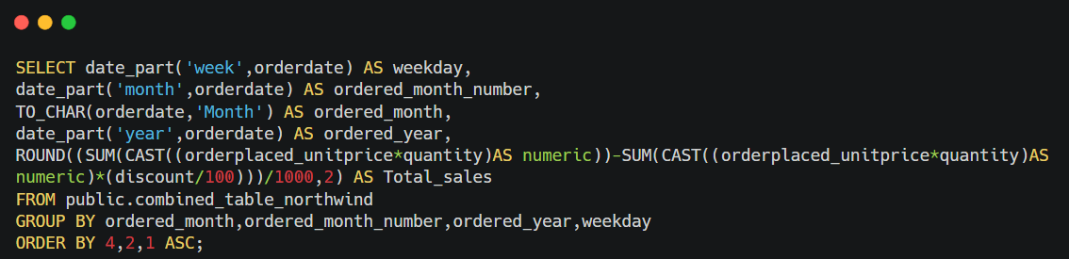

## Output:

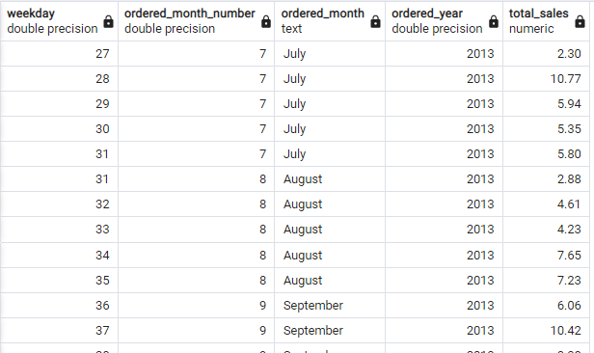

# I. Top 5 employee’ s distribution

## Output:

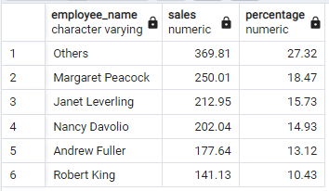

# J. Top Cities with Product

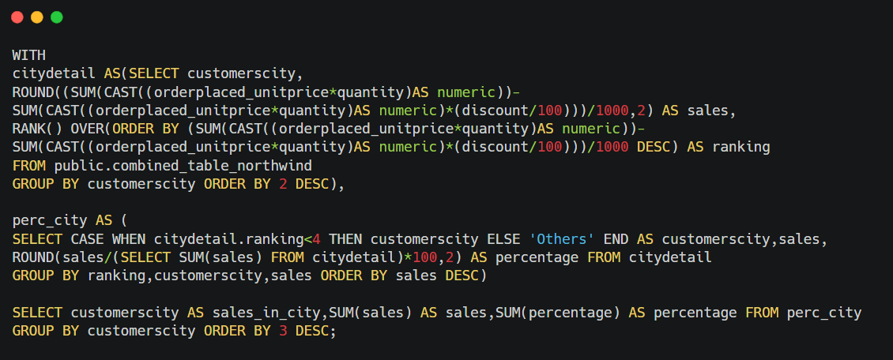

## Output:

