**SQL Queries for Pizza Sales**

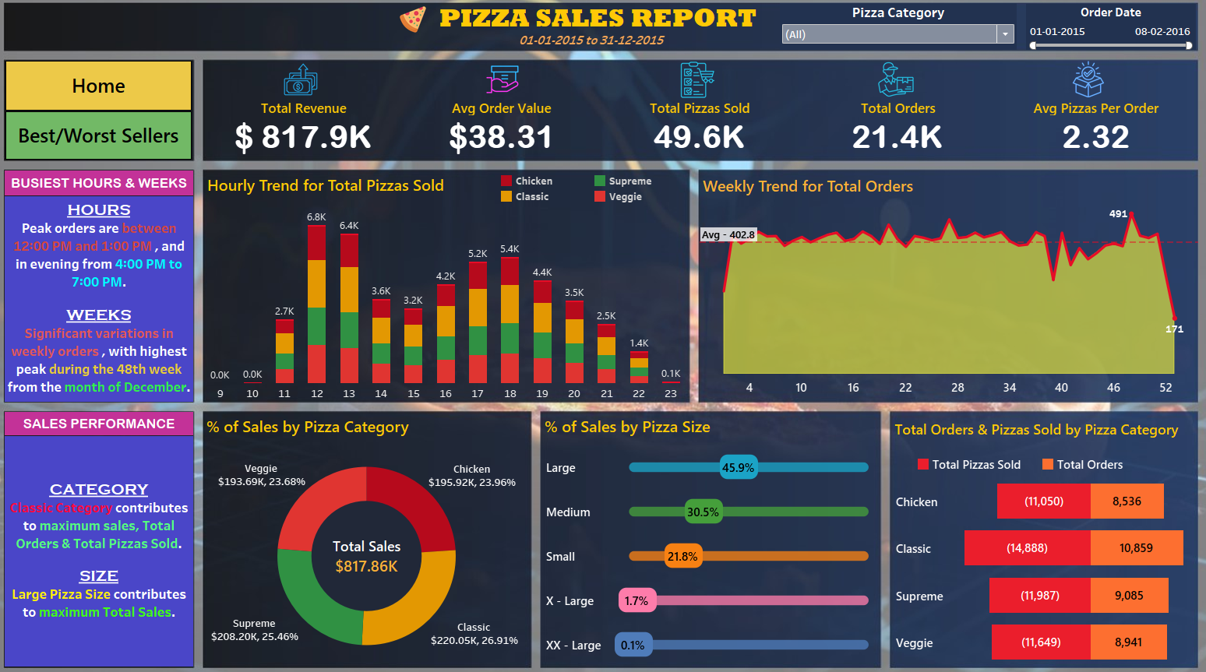

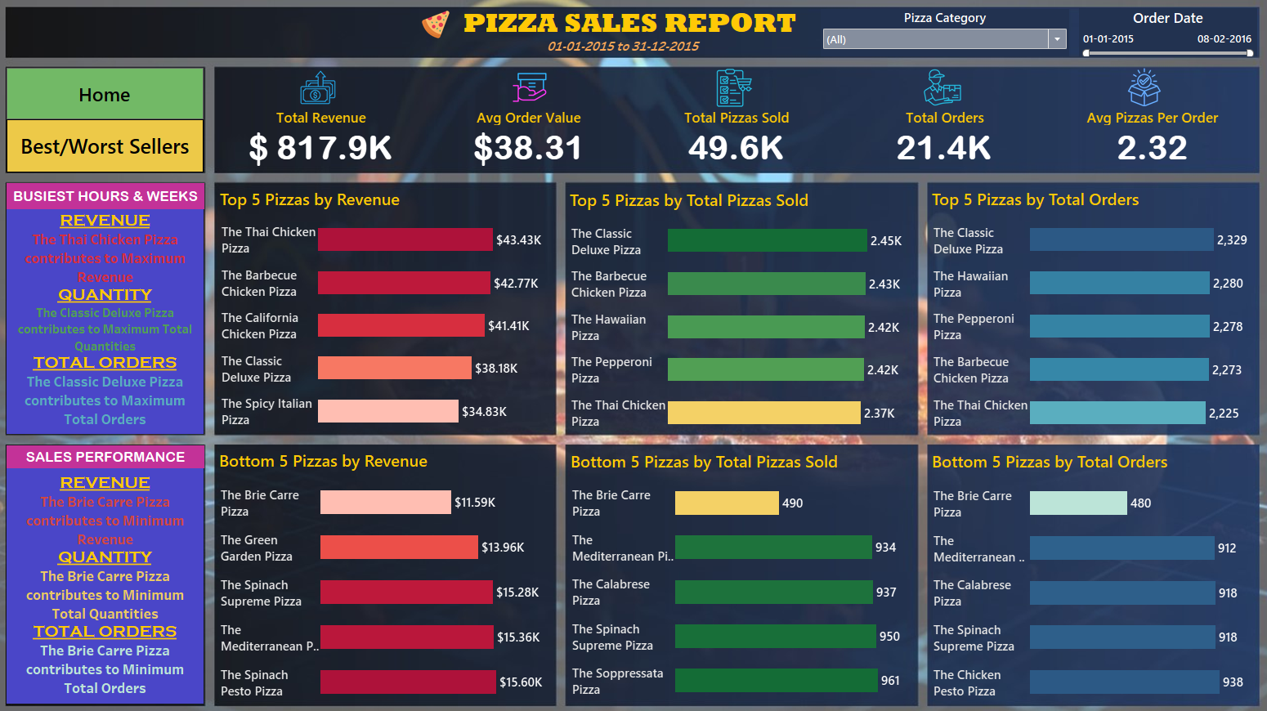

# A. KPI’s

**1. Total Revenue**

SELECT ROUND((SUM(total_price)/1000),1) AS Total_revenue FROM pizza_sales;

## Output 1:

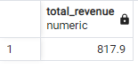

**2. Total Pizzas Sold**

## Output 2:

SELECT ROUND((SUM(quantity)/1000.0),1) AS Total_pizzas_sold FROM pizza_sales;

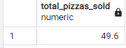

**3. Total Orders**

## Output 3:

SELECT ROUND((COUNT(DISTINCT(order_id))/1000.0),1) AS Total_orders FROM pizza_sales;

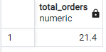

**4. Average Pizzas Per Order**

## Output 4:

SELECT ROUND((SUM(quantity)*1.0/COUNT(DISTINCT(order_id))),2) AS Avg_Pizzas_Per_order FROM pizza_sales;

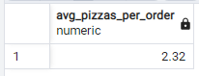

**5. Average Order Value**

## Output 5:

SELECT ROUND((SUM(total_price)*1.0/COUNT(DISTINCT(order_id))),2) AS Avg_Order_Value FROM pizza_sales;

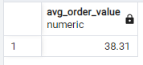

# B. Hourly Trend for Total Pizzas Sold

SELECT date_part('hour',order_time) AS Hour_in, ROUND(SUM(quantity)/1000.0,1) AS pizzas_sold FROM pizza_sales GROUP BY date_part('hour',order_time) ORDER BY 1;

## Output:

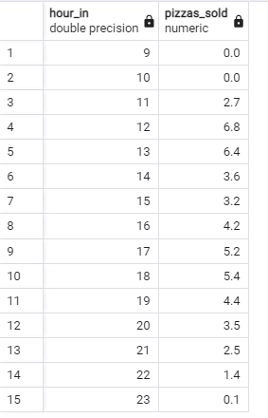

# C. Weekly Trend for Orders

SELECT date_part('week',order_date),date_part('year',order_date),COUNT(DISTINCT(order_id)) FROM pizza_sales GROUP BY date_part('week',order_date),date_part('year',order_date);

## Output :

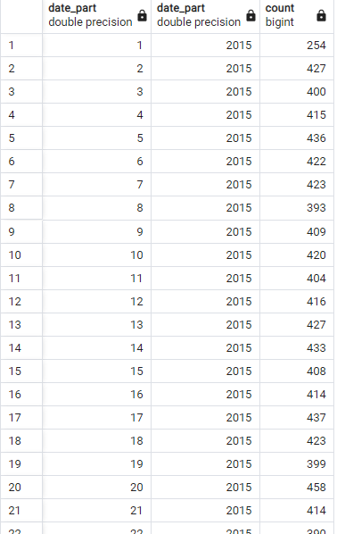

WITH valuess(week,yr,ord) AS (SELECT date_part('week',order_date),date_part('year',order_date),COUNT(DISTINCT(order_id)) FROM pizza_sales GROUP BY date_part('week',order_date),date_part('year',order_date)) SELECT ROUND(SUM(ord)*1.0/count(week),1) AS avge,MAX(ord) AS max_ord,MIN(ord) AS min_ord FROM valuess;

## Output :

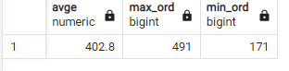

# D. % of sales by Pizza Category

SELECT pizza_category,ROUND(SUM(total_price)/1000,2) AS Total_revenue, CAST(ROUND((SUM(total_price)/(SELECT SUM(total_price) FROM pizza_sales))*100,2)AS VARCHAR(10))||'%' AS percent_of_sales FROM pizza_sales GROUP BY pizza_category;

## Output :

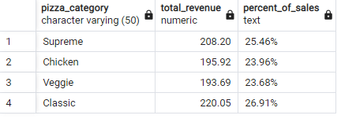

# E. % of sales by Pizza Size

SELECT CASE WHEN pizza_size='M' THEN 'Medium' WHEN pizza_size='L' THEN 'Large' WHEN pizza_size='S' THEN 'Small' WHEN pizza_size='XL' THEN 'X - Large' WHEN pizza_size='XXL' THEN 'XX - Large' END AS pizza_size, CAST(ROUND((SUM(total_price)/(SELECT SUM(total_price) FROM pizza_sales))*100,1)AS VARCHAR(10))||'%' AS percent_of_revenue FROM pizza_sales GROUP BY pizza_size ORDER BY 2 DESC;

## Output :

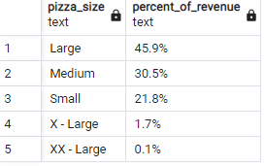

# F. Total Pizzas sold by Pizza category

SELECT pizza_category,SUM(quantity) AS Total_Pizzas_Sold, COUNT(DISTINCT(order_id)) AS Total_orders FROM pizza_sales GROUP BY pizza_category;

## Output :

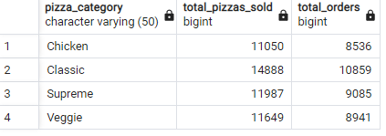

# G. Top 5 & Bottom 5 Pizzas by Revenue

SELECT pizza_name,ROUND(SUM(total_price)/1000.0,2) AS total_revenue FROM pizza_sales GROUP BY pizza_name ORDER BY total_revenue DESC LIMIT 5;

## Output :

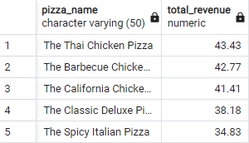

SELECT pizza_name,ROUND(SUM(total_price)/1000.0,2) AS total_revenue FROM pizza_sales GROUP BY pizza_name ORDER BY total_revenue ASC LIMIT 5;

## Output :

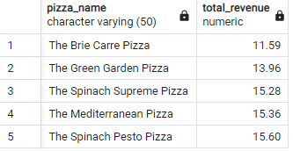

# H. Top 5 & Bottom 5 Pizzas by Quantity

SELECT pizza_name,ROUND((SUM(quantity)/1000.0),2) AS total_quantity FROM pizza_sales GROUP BY pizza_name ORDER BY total_quantity DESC LIMIT 5;

## Output :

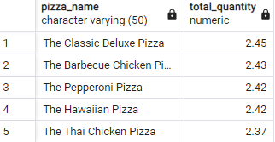

SELECT pizza_name,SUM(quantity) AS total_quantity FROM pizza_sales GROUP BY pizza_name ORDER BY total_quantity ASC LIMIT 5;

## Output :

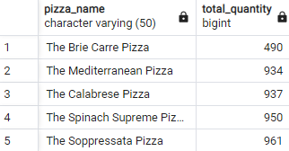

# I. Top 5 & Bottom 5 Pizzas by Total Orders

SELECT pizza_name,COUNT(DISTINCT(order_id)) AS total_orders FROM pizza_sales GROUP BY pizza_name ORDER BY total_orders DESC LIMIT 5;

## Output :

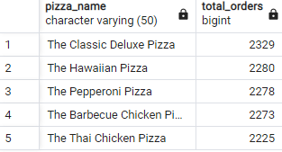

SELECT pizza_name,COUNT(DISTINCT(order_id)) AS total_orders FROM pizza_sales GROUP BY pizza_name ORDER BY total_orders ASC LIMIT 5;

## Output :

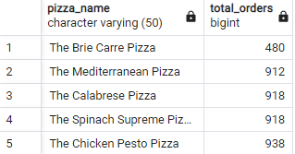

# J. Filter_Check

SELECT ROUND(SUM(quantity)/1000.0,1) AS pizzas_sold

FROM pizza_sales WHERE date_part('hour',order_time)=18 AND pizza_category='Chicken';

## Output :

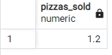

## Tableau Report :

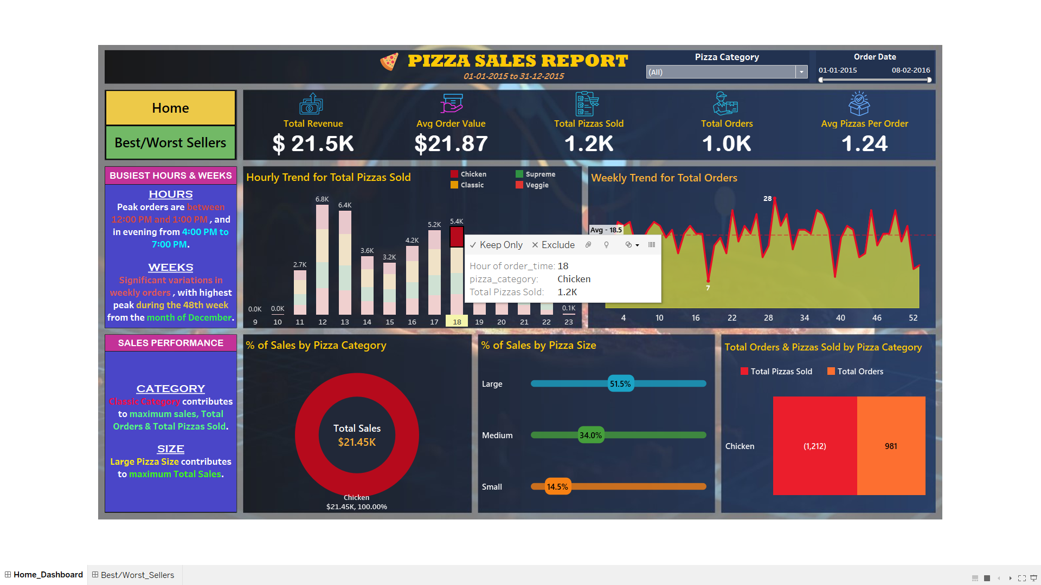

WITH valuess(week,yr,ord) AS

(SELECT date_part('week',order_date),date_part('year',order_date),COUNT(DISTINCT(order_id)) FROM pizza_sales WHERE date_part('hour',order_time)=18 AND pizza_category='Chicken' GROUP BY date_part('week',order_date),date_part('year',order_date)) SELECT ROUND(SUM(ord)*1.0/count(week),1) AS avge,MAX(ord) AS max_ord,MIN(ord) AS min_ord FROM valuess;

## Output :

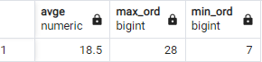

SELECT ROUND((SUM(total_price)/1000),2) AS Total_revenue FROM pizza_sales WHERE date_part('hour',order_time)=18 AND pizza_category='Chicken';

## Output :

