Weather ETL Pipeline
Full Build Guide
A complete, step-by-step guide to building this project from scratch: a daily-automated pipeline that pulls weather data from a free API, cleans it, stores it in PostgreSQL, and visualizes it in an interactive dashboard.

Architecture overview
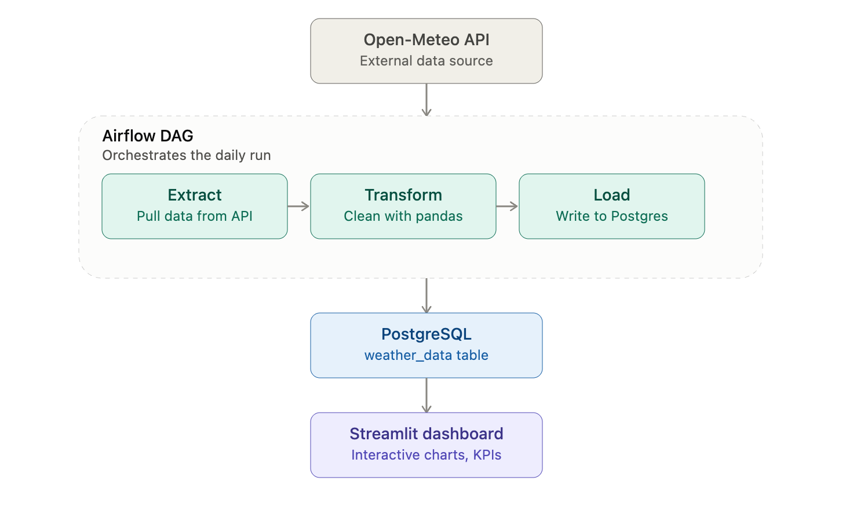
Stack: Python · PostgreSQL · Apache Airflow · Streamlit · Plotly

Step 0 — Install prerequisites
# Postgres (Mac)
brew install postgresql@16
brew services start postgresql@16

# Postgres (Windows): download installer from postgresql.org

# Python packages
pip install requests pandas sqlalchemy psycopg2-binary apache-airflow streamlit plotly --break-system-packages

Step 1 — Set up the project folder
mkdir weather-etl && cd weather-etl
mkdir dags scripts
Folder structure by the end of this guide:
weather-etl/
├── dags/
│ └── weather_dag.py
├── scripts/
│ ├── extract.py
│ ├── transform.py
│ └── load.py
├── dashboard.py
└── README.md

Step 2 — Extract: pull raw data from the API
Create scripts/extract.py:
import requests
import json
from datetime import datetime

def extract_weather():
url = "https://api.open-meteo.com/v1/forecast"
params = {
"latitude": 40.7128, # change to your city's coordinates
"longitude": -74.0060,
"hourly": "temperature_2m,relative_humidity_2m,precipitation",
"timezone": "auto"
}
response = requests.get(url, params=params)
response.raise_for_status()
data = response.json()

with open(f"raw_weather_{datetime.now().strftime('%Y%m%d')}.json", "w") as f:
json.dump(data, f)

return data

if __name__ == "__main__":
extract_weather()
Test it:
python scripts/extract.py
You should see a "raw_weather_YYYYMMDD.json" file appear in your folder.

Step 3 — Transform: clean the raw data
Create scripts/transform.py:
import pandas as pd
import json

def transform_weather(raw_data):
hourly = raw_data["hourly"]
df = pd.DataFrame({
"timestamp": hourly["time"],
"temperature_c": hourly["temperature_2m"],
"humidity_pct": hourly["relative_humidity_2m"],
"precipitation_mm": hourly["precipitation"]
})

df["timestamp"] = pd.to_datetime(df["timestamp"])
df = df.dropna()
df["temperature_f"] = df["temperature_c"] * 9/5 + 32

return df

if __name__ == "__main__":
with open("raw_weather_YOURDATE.json") as f: # match your actual file name
raw = json.load(f)
df = transform_weather(raw)
print(df.head())
print(f"Rows: {len(df)}")
What this step does: parses timestamps into real datetime objects, drops any missing rows, and converts Celsius to Fahrenheit for readability.

Step 4 — Load: write to PostgreSQL
Create the database:
createdb weather_db
Create scripts/load.py:
from sqlalchemy import create_engine

def load_weather(df, table_name="weather_data"):
engine = create_engine("postgresql://localhost/weather_db")
df.to_sql(table_name, engine, if_exists="replace", index=False)
print(f"Loaded {len(df)} rows into {table_name}")

if __name__ == "__main__":
from extract import extract_weather
from transform import transform_weather

raw = extract_weather()
df = transform_weather(raw)
load_weather(df)
Test the full chain:
python scripts/load.py
psql weather_db -c "SELECT * FROM weather_data LIMIT 5;"
If you see rows returned, extract → transform → load works end to end manually.

Step 5 — Orchestrate with Airflow
Initialize Airflow:
export AIRFLOW_HOME=~/airflow
airflow db init
airflow webserver -p 8080 &
airflow scheduler &
Create dags/weather_dag.py:
from airflow import DAG
from airflow.operators.python import PythonOperator
from datetime import datetime
import sys
sys.path.append('/full/path/to/weather-etl/scripts') # use your actual absolute path

from extract import extract_weather
from transform import transform_weather
from load import load_weather

def run_pipeline():
raw = extract_weather()
df = transform_weather(raw)
load_weather(df)

with DAG(
"weather_etl",
start_date=datetime(2026, 1, 1),
schedule_interval="@daily",
catchup=False
) as dag:

run_etl = PythonOperator(
task_id="run_weather_etl",
python_callable=run_pipeline
)
Copy this file into ~/airflow/dags/. Open http://localhost:8080, find "weather_etl" in the DAG list, turn it on, and click Trigger.

Verify success
- Green checkmark on the run = success
- Check the Audit Log tab to confirm "success" events
- Re-run the row count query to confirm fresh data landed

If it fails
Click the red square → the task → "Log", and check for:
Error | Fix
ModuleNotFoundError: No module named 'extract' | Fix the sys.path.append(...) to the correct absolute path
could not connect to server | Postgres isn't running — brew services start postgresql@16
database "weather_db" does not exist | Run createdb weather_db again

Step 6 — Build the interactive dashboard
Create dashboard.py in the project root:
import streamlit as st
import pandas as pd
import plotly.express as px
from sqlalchemy import create_engine

st.set_page_config(page_title="Weather ETL Dashboard", layout="wide")
st.title("Weather ETL Dashboard")
st.caption("Live data from Postgres, loaded by the Airflow weather_etl DAG")

@st.cache_resource
def get_engine():
return create_engine("postgresql://localhost/weather_db")

@st.cache_data(ttl=60)
def load_data():
engine = get_engine()
df = pd.read_sql("SELECT * FROM weather_data ORDER BY timestamp", engine)
df["timestamp"] = pd.to_datetime(df["timestamp"])
return df

df = load_data()

if df.empty:
st.warning("No data found yet. Run the Airflow DAG first.")
st.stop()

st.sidebar.header("Filters")
# ... date range filter, metric picker, KPI cards, charts
# (see dashboard.py in your repo for the full version)
Run it:
streamlit run dashboard.py
It opens at http://localhost:8501 with KPI cards, filters, and three interactive charts.

Step 7 — Write the README
Every project needs a README with: architecture, tech stack, how to run it, and trade-offs. Keep a README.md in the project root alongside this guide.

Step 8 — Push to GitHub
cd weather-etl
git init

# Prevent committing junk/credentials
echo "*.json
__pycache__/
.venv/
venv/
*.pyc
.DS_Store" > .gitignore

git add .
git commit -m "Initial commit: weather ETL pipeline with Airflow and Streamlit dashboard"
Create a new repo on GitHub (don't initialize with a README, you already have one), then:
git remote add origin https://github.com/YOUR_USERNAME/weather-etl-pipeline.git
git branch -M main
git push -u origin main
Pin the repo on your GitHub profile so it's visible first.

Step 9 — Be ready to explain it

2-minute plain-language summary
I built an end-to-end data pipeline that pulls live weather data from a public API daily, cleans it in Python, and loads it into PostgreSQL. Apache Airflow orchestrates the whole thing on a schedule, with retries and logging if something fails. On top of that, I built an interactive Streamlit dashboard that reads live from the database so anyone can explore trends by date range. One trade-off I made deliberately: the table gets replaced on each run rather than appended, which is fine at this scale but wouldn't scale to a production system without adding deduplication.

Trade-offs worth naming out loud
- if_exists="replace" — simple, but loses history; a real system would append + dedupe
- Single hardcoded location — fine for a demo, would need a location dimension for multi-city support
- No data validation layer yet — nulls are dropped but out-of-range values aren't caught

Done — what you've built
A live, running system with:
- An automated data pipeline (not just a one-off script)
- A real orchestrator managing schedule, retries, and logging
- A relational database storing structured data
- An interactive dashboard a non-technical person could use
- Documented, defensible engineering trade-offs

