Part1: Use histogram-based approach to assign the class label for the given images

Steps:

1.Use HBCE approach to get centroids for the images by using following algo:

Reference paper: https://www.sciencedirect.com/science/article/pii/S1568494619307124

2. Apply k-means clustering or Otsu to get the segmentation of the image

Input Image1:

Input image1 Histogram:

Instead of getting beta_intesity, beta_frequency from GA algorithm, I am taking it manually

beta_intesity = 40

beta_frequency = 34

output centroid: [170, 174, 177, 182, 250]

Output Image1:

Using Manual thresholding

Histogram of manual thresholding output:

Using k-means o/p:

Centroid values: [110.35921715718986, 152.28576151755917, 180.58552349213562, 207.35910263022177, 241.40362564551108]

Histogram of kmean:

**Observations**: 1. kmeans is giving centroid which is clustered among different intensities, using hbce is making the convergence of kmeans faster.

2. Since I have not taken beta_intensity and beta_frequency from GA algorithm, seems like the centroid is nearer to each other

Part 2: Apply graph cut method to optimize the delineation of the gland from the background using minimization algorithms: alpha-expansion and alpha-beta swap

Have implemented alpha-beta swap and tried to implement alpha expansion.

Using alpha-beta swap o/p:

Cycle No:1 value of energy 177

Have got the segmentation using built-in alpha-beta and alpha expansion:

Alpha-Beta swap O/P:

Alpha Expansion O/P:

**Observations**: 1. While giving the unique pixels intensity got from the part1 code in Graph-cut method, alpha-beta swap is converging fast.

2. alpha-beta swap and alpha expansion is giving better segmentation result than kmeans clustering

3. In my image both alpha expansion and alpha-beta swap is giving same result

Part 3: Compare the segmentation results with the ground truth using metrics like accuracy, Dice similarity coefficient, Jaccard index (JAC), sensitivity, specificity

Ground Truth image1:

Accuracy: 1.0

Dice Similarity: 1.3509183042887158

Jaccard index(JAC): 2.08

Sensitivity: 0.6754591521443579

Specificity: 1.0

**Results for Image2:**

Part1:

Image2 input:

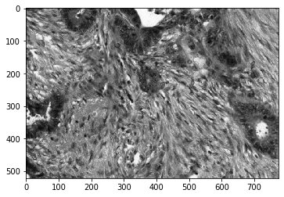

Histogram of image2:

beta_intesity = 10

beta_frequency = -34

Manual threshold output:

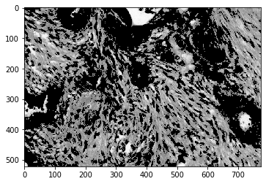

Histogram of output:

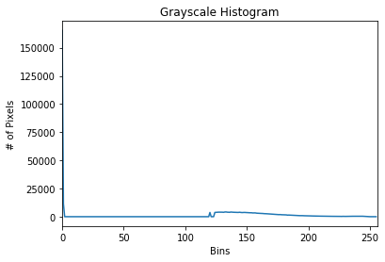

Kmeans output:

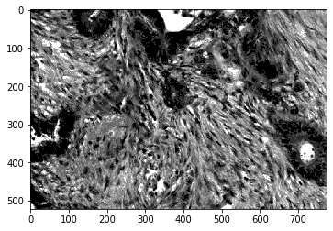

Histogram of output:

Part2:

Alpha-beta swap:

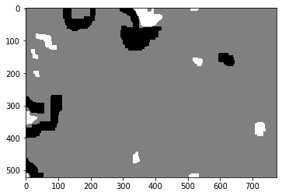

Alpha expansion:



Ground Truth:

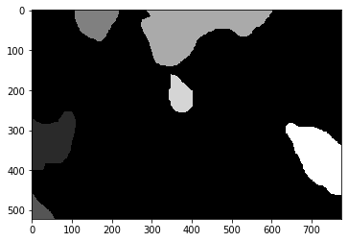

Accuracy: 0.15977505870720554

Sensitivity: 0.15977505870720554

Specificity: 1.0

Dice: 0.3195501174144111

Jaccard: 0.1901574814732005

**Results for Image3:**

**Input image:**

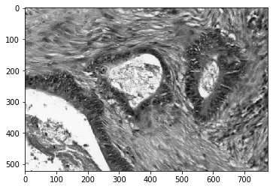

Output Otsu:

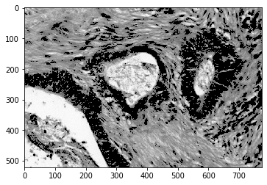

Output Graph cut:

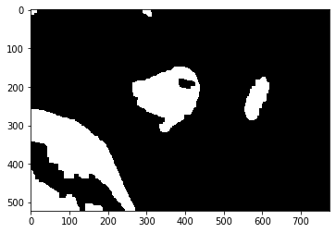

***********************************************************

**Image4 outputs:**

**Input image:**

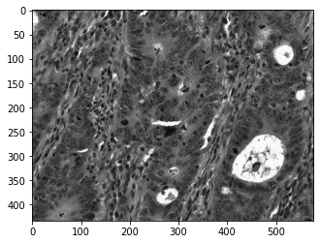

**Kmeans output:**

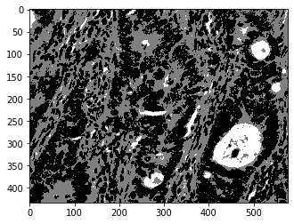

**Graph cut output:**

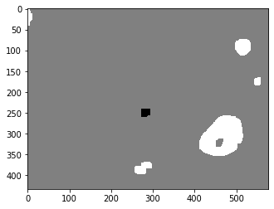

**Image 5 outputs:**

**Input:**

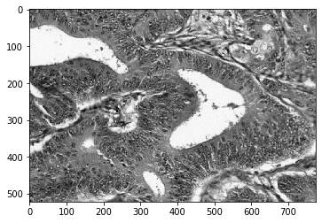

**Kmeans:**

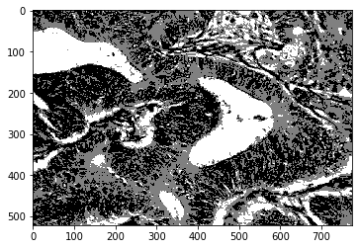

**Graph cut output:**

