Data Preparation:

1. **Importing Libraries:**

- Import Pandas and NumPy for data manipulation.

```python

import pandas as pd

import numpy as np

```

2. **Loading the Dataset:**

- Read the dataset from a CSV file into a Pandas DataFrame.

```python

df = pd.read_csv("Weather.csv")

```

3. **Checking Data Overview:**

- Print the entire DataFrame and the first five rows.

```python

print(df)

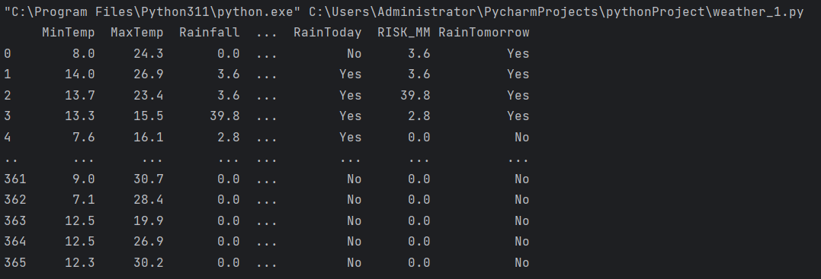 print(df.head())

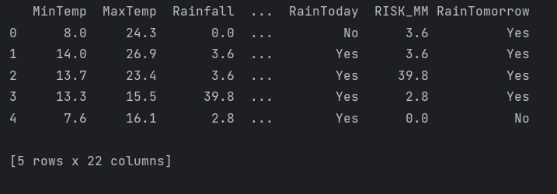

4. **Checking Data Structure:**

- Print the shape, index, column names, data types, unique values, number of unique values, and non-null counts.

```python

print(df.shape)



print(df.index)



print(df.columns)

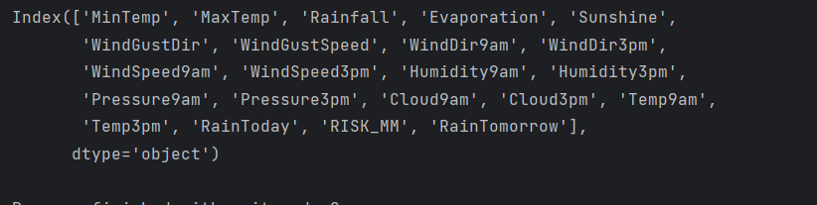

print(df.dtypes)

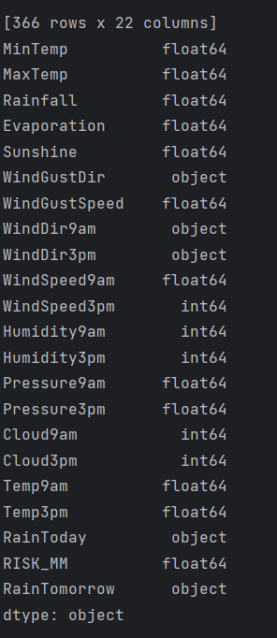

print(df['WindGustDir'].unique())

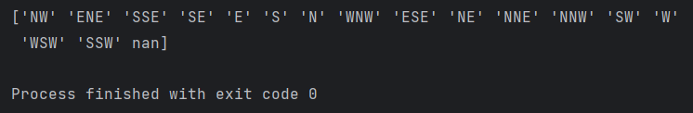

print(df.nunique())

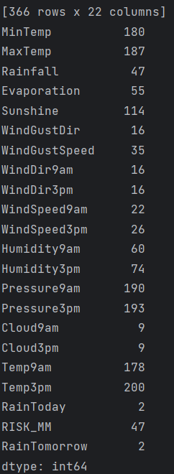

print(df.count())

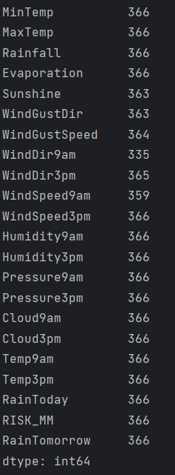

**Data Analysis:**

5. **Exploring Specific Columns:**

- Print unique values and their counts for the 'WindGustDir' column.

```python

print(df['WindGustDir'].value_counts())

```

6. Grouping Data:

Use groupby() to group data by 'WindGustDir' and get the group where it's 'E'.

print(df[df.WindGustDir == 'E'])

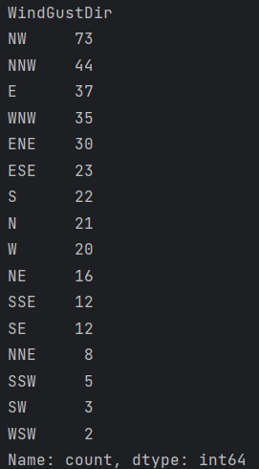

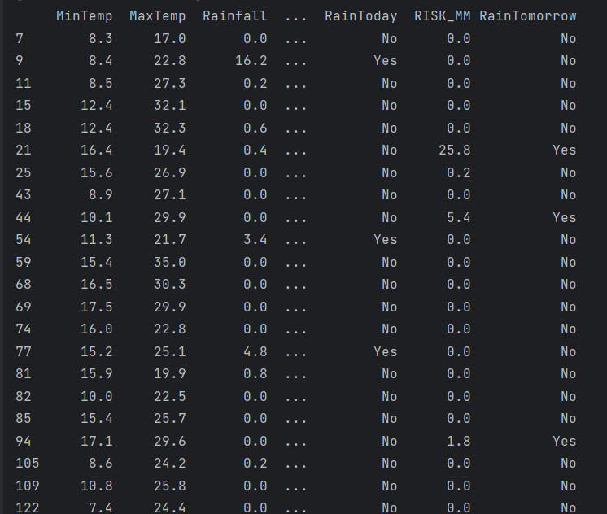

**Filtering Data Based on Numeric Condition ('WindSpeed9am'):**

Filter data where 'WindSpeed9am' is exactly 4 km/hr.

print(df[df['WindSpeed9am'] == 4])

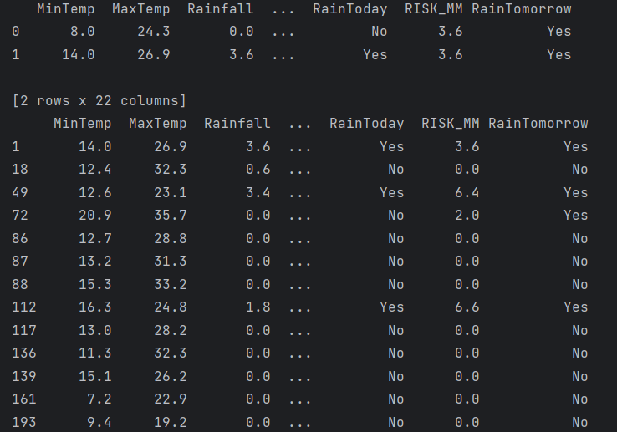

Handling Null Values:

Print the count of null values in each column.

print(df.isnull().sum())

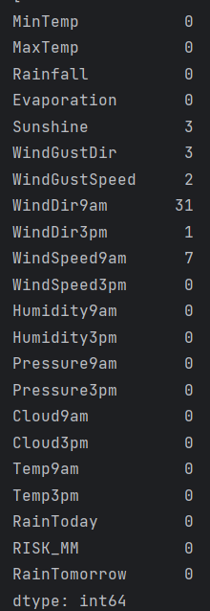

Additional Analysis:

Calculating Mean, Standard Deviation, and Variance:

Print mean 'WindGustSpeed', standard deviation of 'Pressure3pm', and variance of 'Humidity9am'.

print(df.WindGustSpeed.mean())

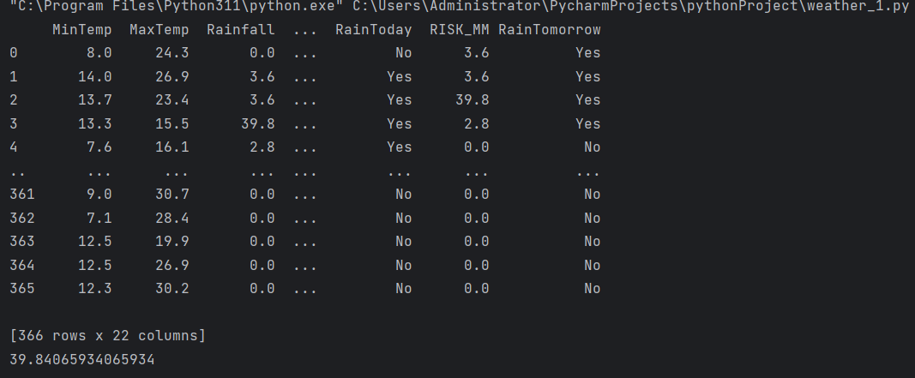

print(df.Pressure3pm.std())

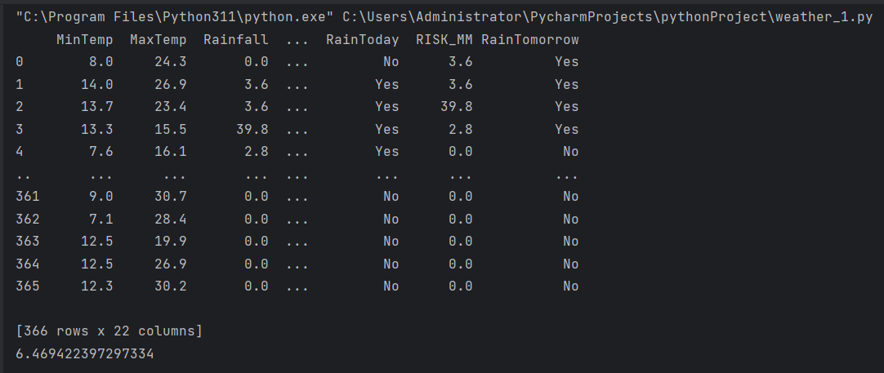

print(df['Humidity9am'].var())

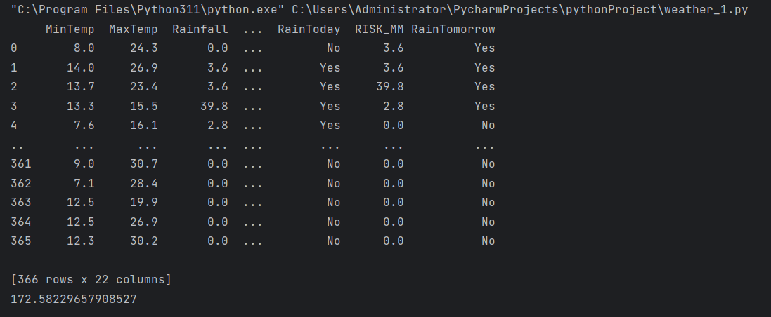

Filtering Data Based on Conditions ('WindDir9am', 'WindSpeed3pm', 'Cloud9am'):

Filter data where 'WindDir9am' is 'WNW', 'WindSpeed3pm' is above 24, and 'Cloud9am' is 8.

print(df[df['WindDir9am'] == 'WNW'])

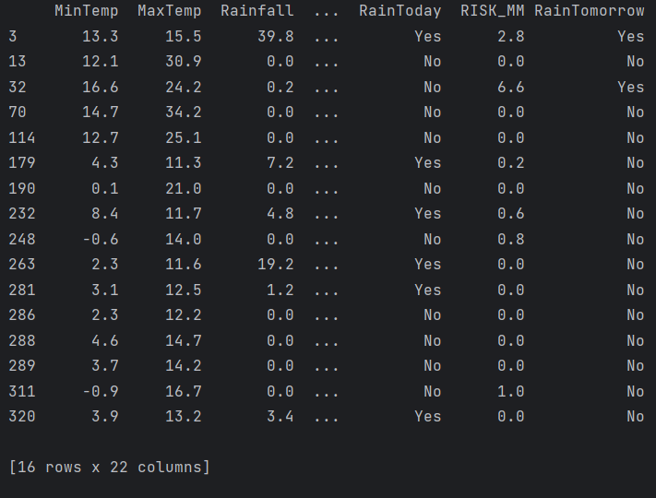

print(df[(df['WindSpeed3pm'] > 24) & (df['Cloud9am'] == 8)])

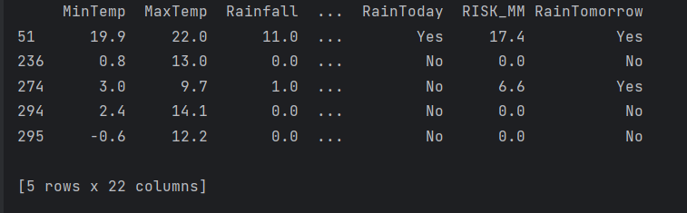

Filtering Data for Rain Prediction ('RainTomorrow' and 'RainToday'):

Filter data where 'RainTomorrow' is 'Yes' and where 'RainToday' is 'No' or 'RISK_MM' is above 22.6.

print(df[df['RainTomorrow'] == 'Yes'])

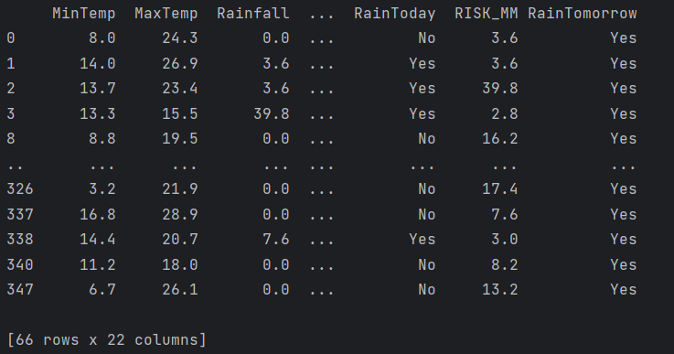

print(df[(df['RainToday'] == 'No') | (df['RISK_MM'] > 22.6)])

