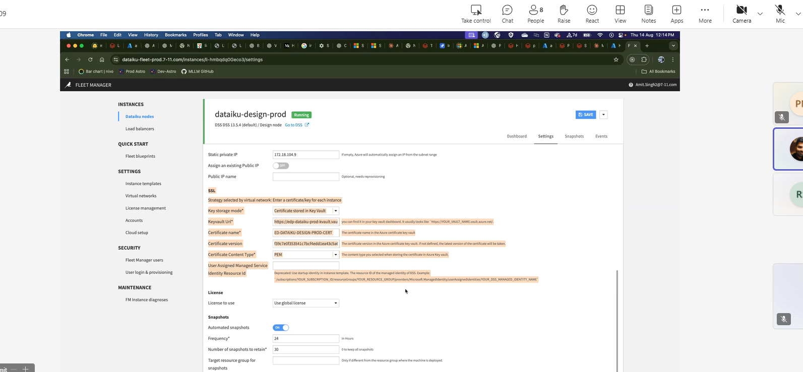

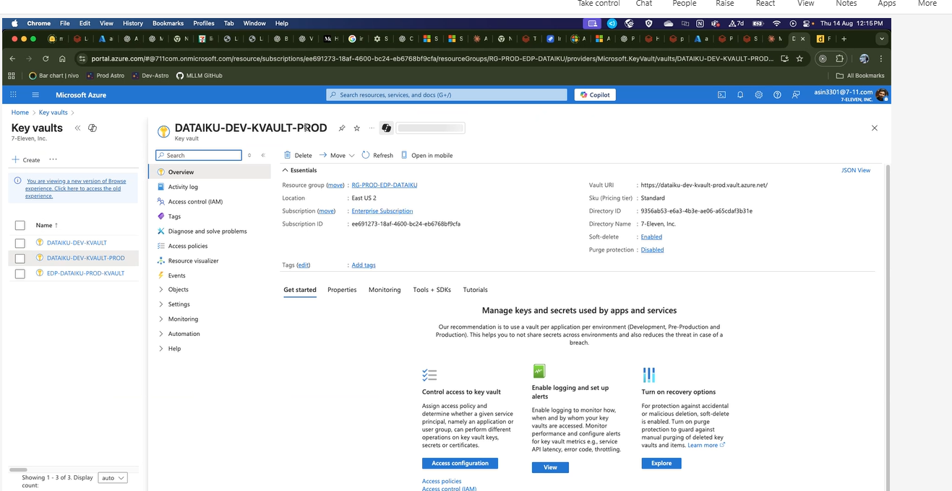

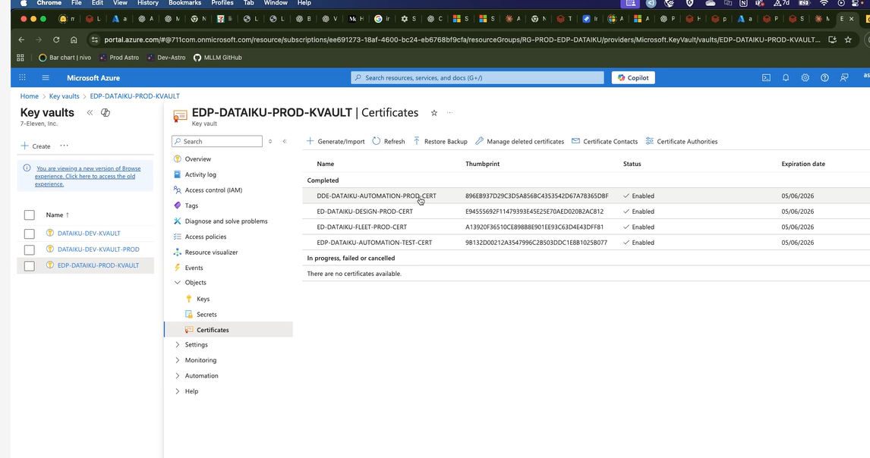

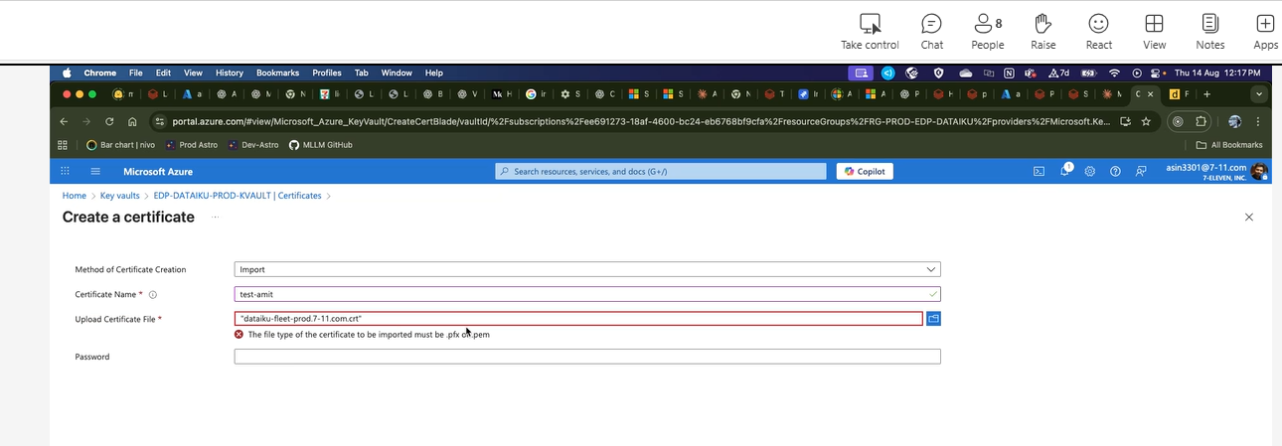

We need combine cert and key
Creating key and out pem file

Cleaning the

Appending the pem key

SSL Cert Dataiku

Step 1:
openssl pkcs8 -topk8 -inform PEM -outform PEM -in dataiku-design-prod.7-11.com.key -out key_pkcs8.pem -nocrypt

Step 2
awk '/BEGIN CERTIFICATE/,/END CERTIFICATE/' dataiku-design-prod.7-11.com.crt > cert_chain_clean.pem

Step 3
cat cert_chain_clean.pem key_pkcs8.pem > azure_upload.pem

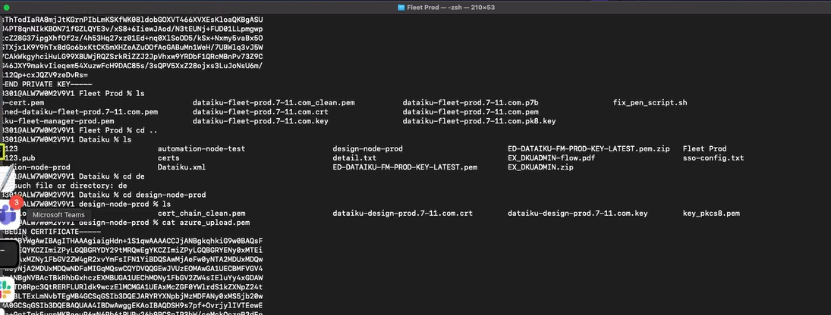

Key and p7b will combine

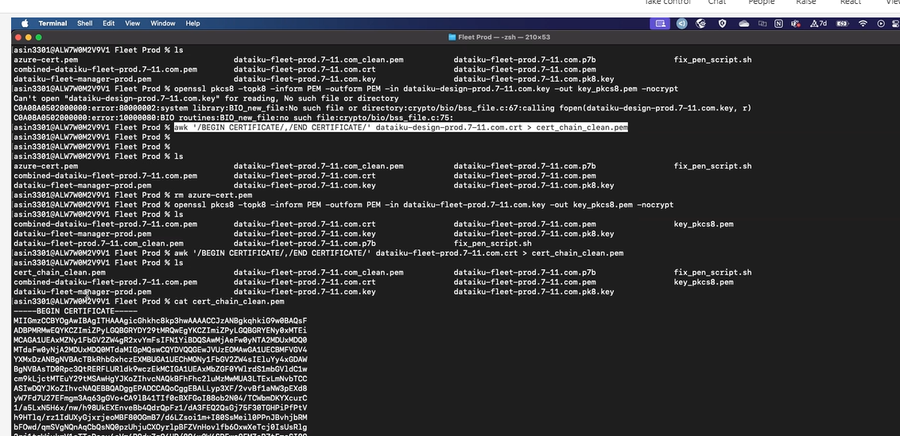

RSA convert to private key

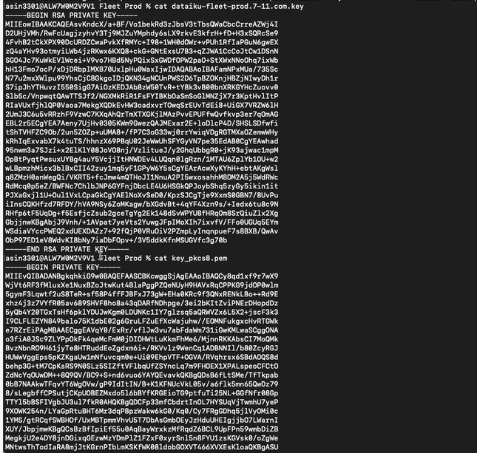

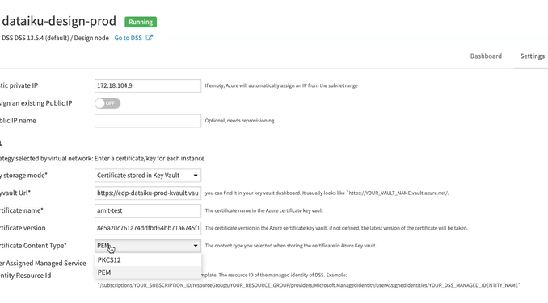
CR window
