This document basically will guide , how we can update the Kubernetes version of AKS Cluster. Kindly go through the below steps in details.

Login to Azure portal— https://portal.azure.com/#home
Search Kubernetes services
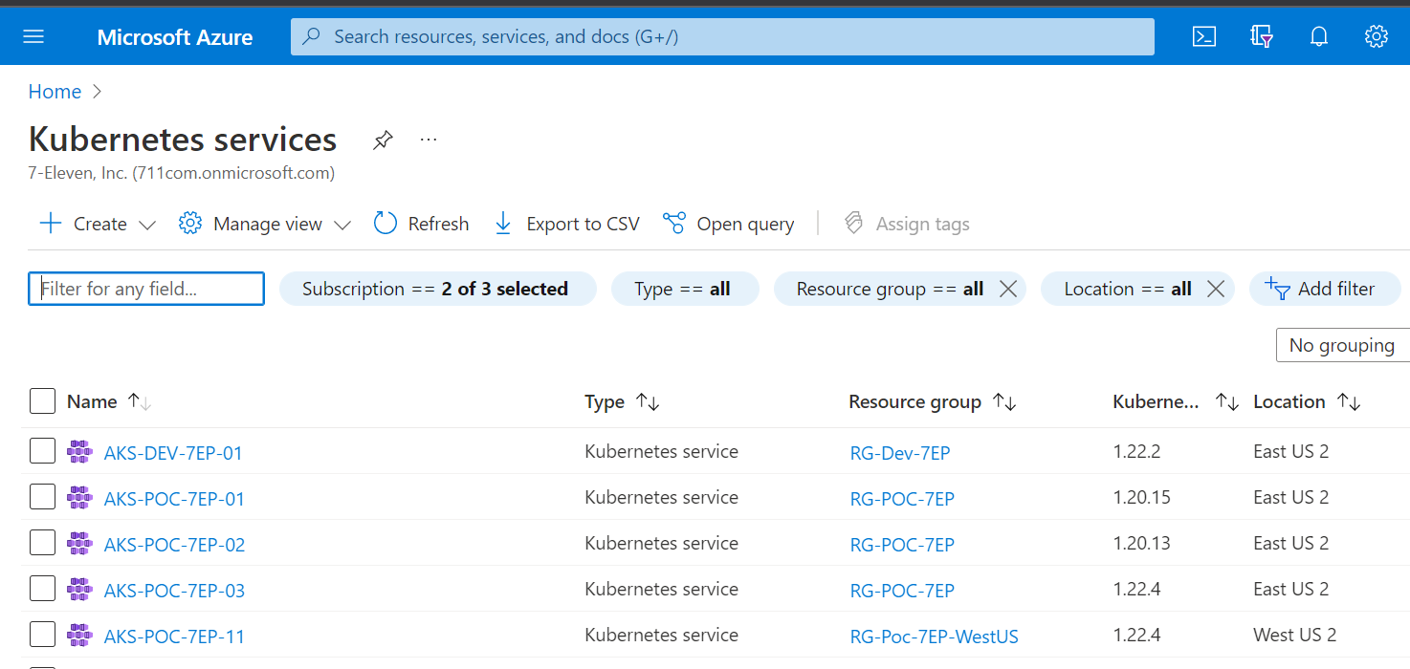
Navigate to filter and select the cluster which needs to be upgrade
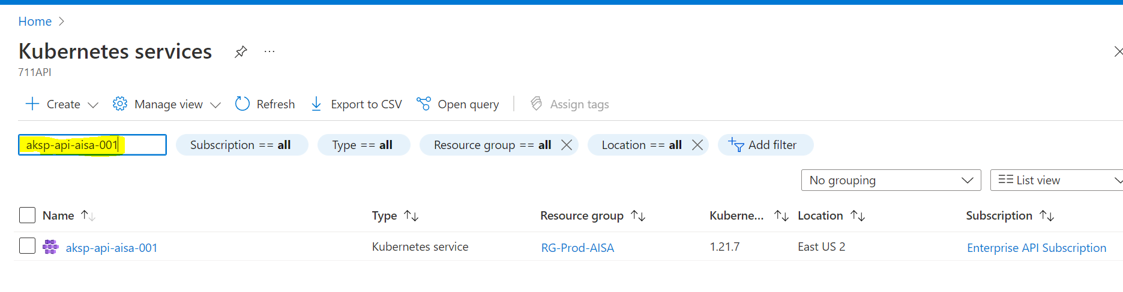
Go Inside the cluster and check the current version. Now here it is 1.15.10.
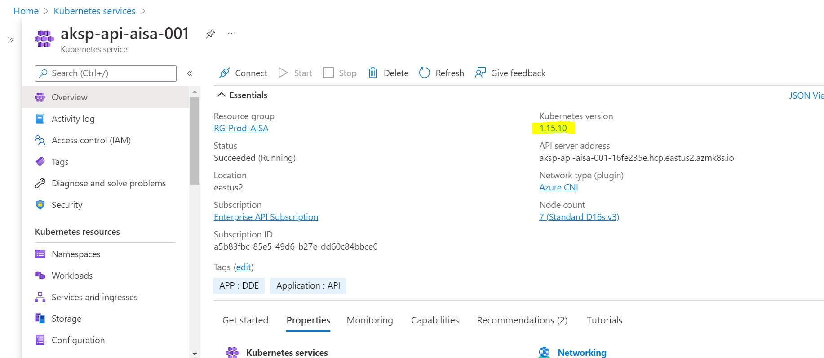
Navigate to Nodes section and verify it
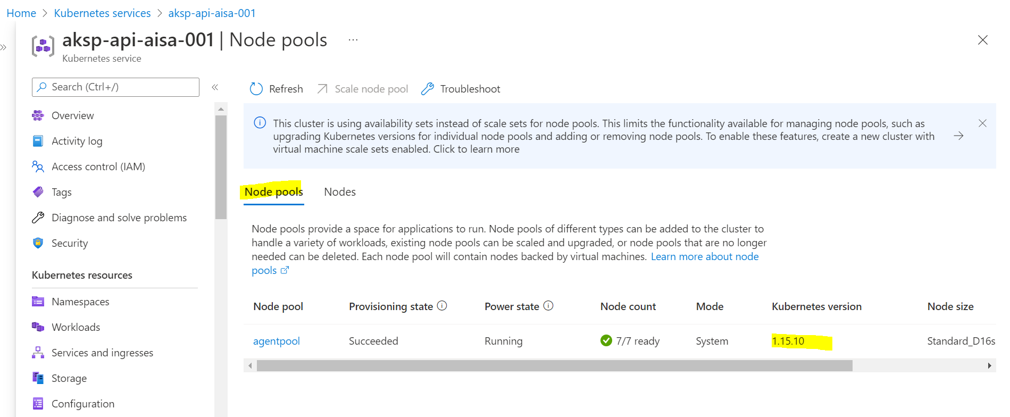
Verify the nodes, here 7 nodes needs to be upgrade
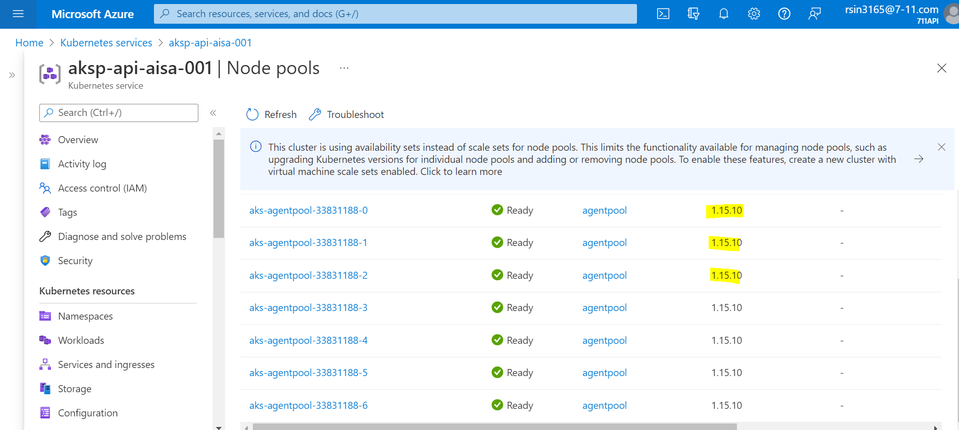
Login to particular cluster by command line
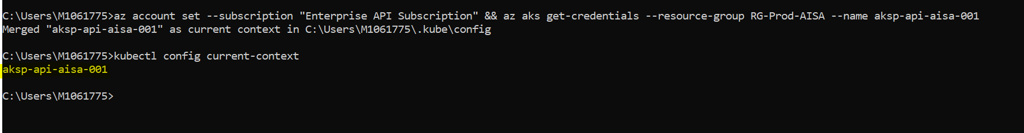
Click on kubernetes version

Click on Upgrade version, select the version
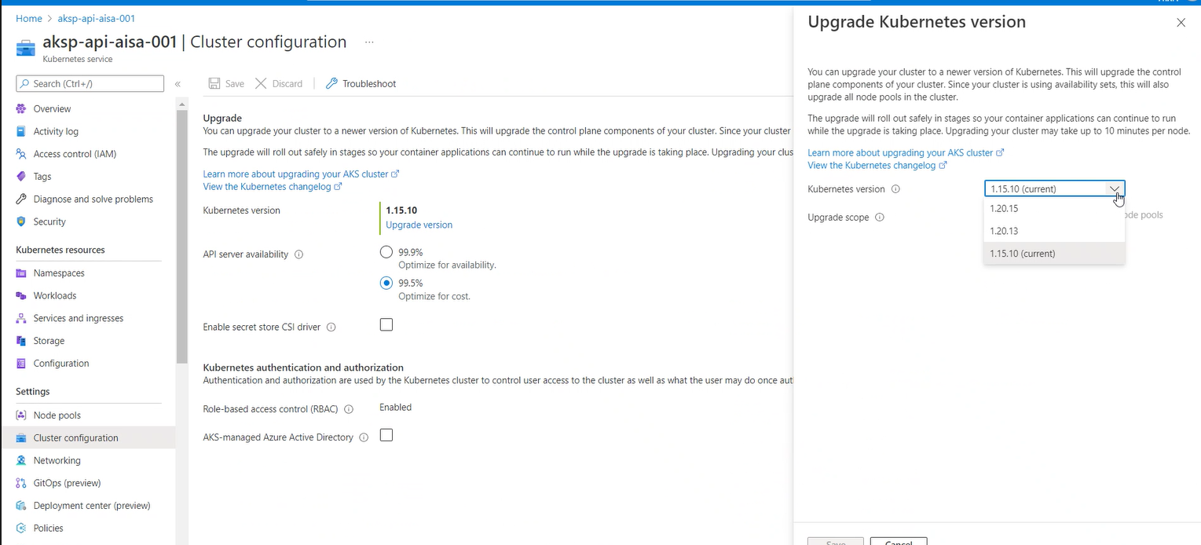
Select the option “Upgrade control plane + all node pools”
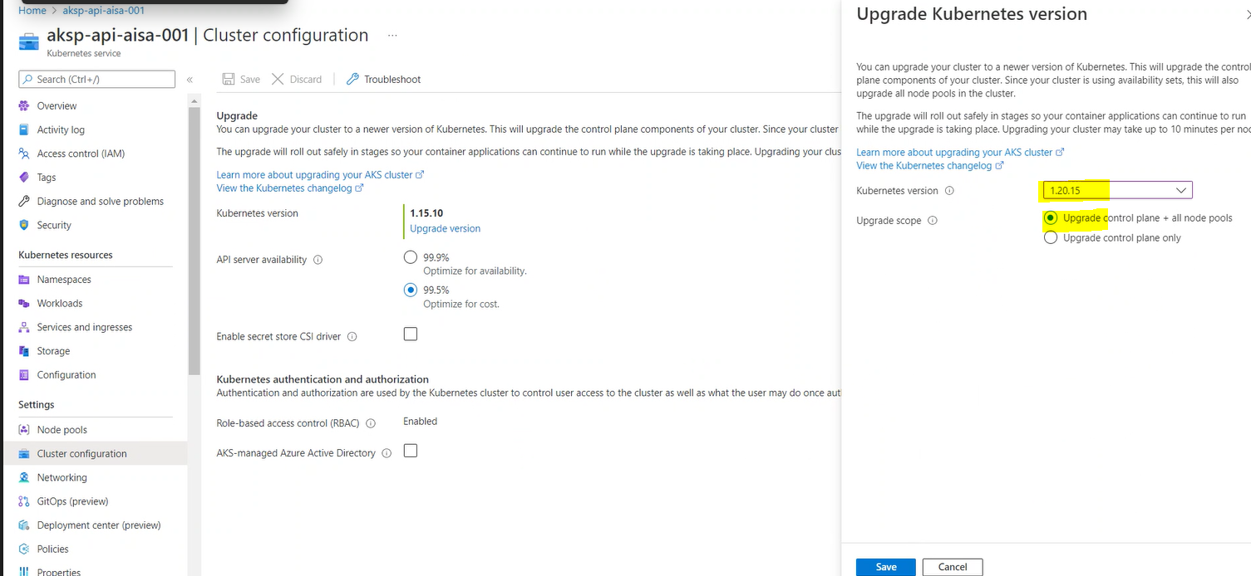

In the command line run the below command to check the status
az aks show --resource-group RG-Prod-AISA --name aksp-api-aisa-001 --output table
Here Provisioningstate= Upgrading that means it’s in progress

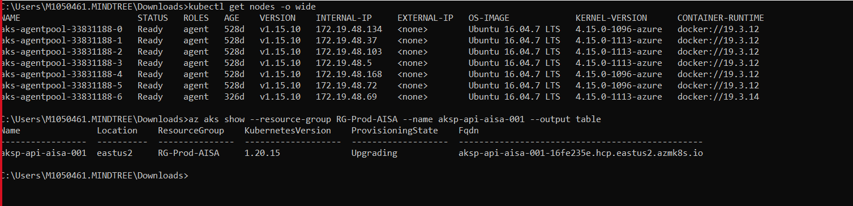
We can also check the status of nodes while upgrading, here few got upgraded
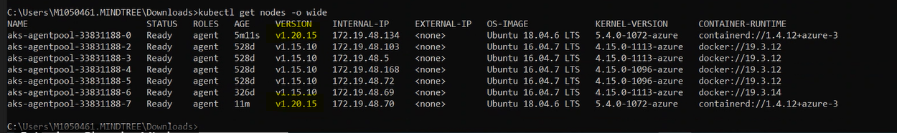

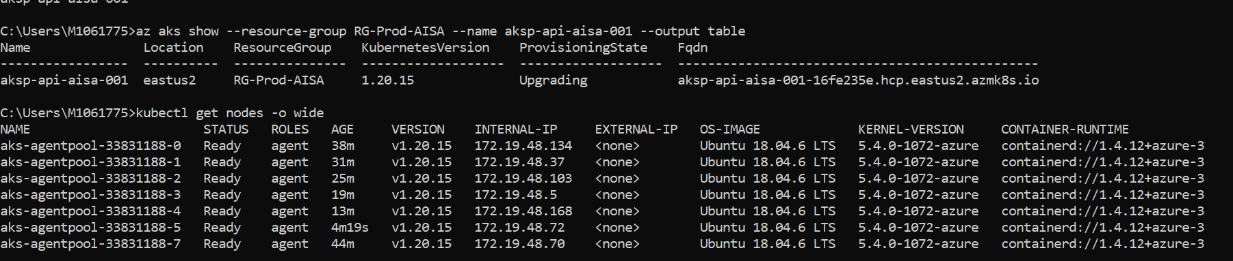
Cluster got upgraded to 1.20.15, status changed to “Succeeded”. We can see nodes got upgraded

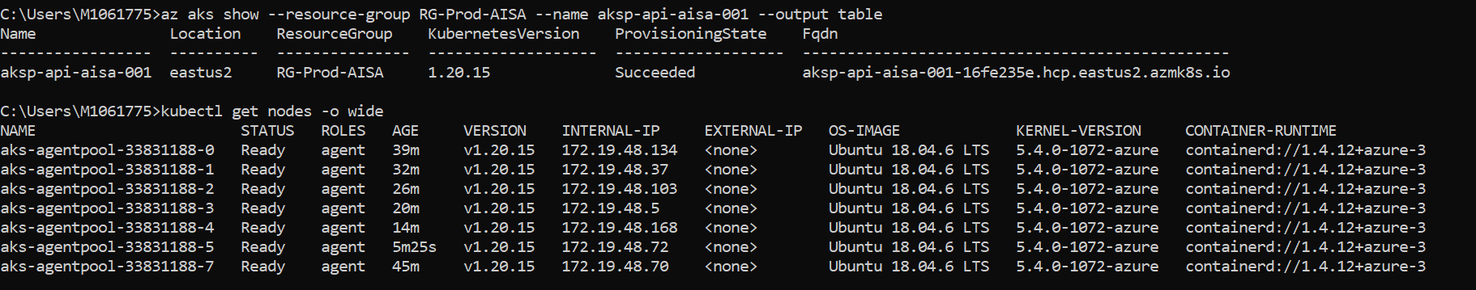

Navigate to UI and see the status
Kubernetes version updated to 1.20.15
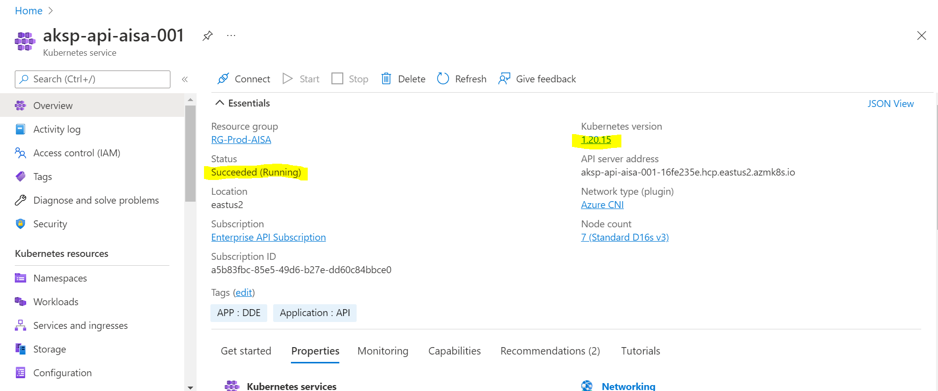

Note- Sometimes we see Kubernetes version will get upgrade to latest but nodes will keep get upgrading. So let’s wait and once the node pools status change to succeeded then proceed further.
Refer below
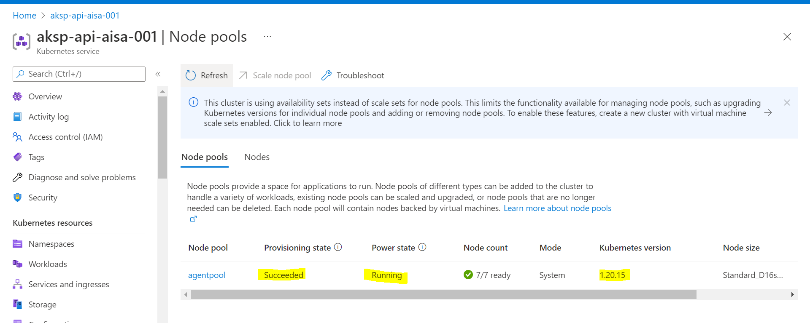
Nodes are updated to 1.20.15
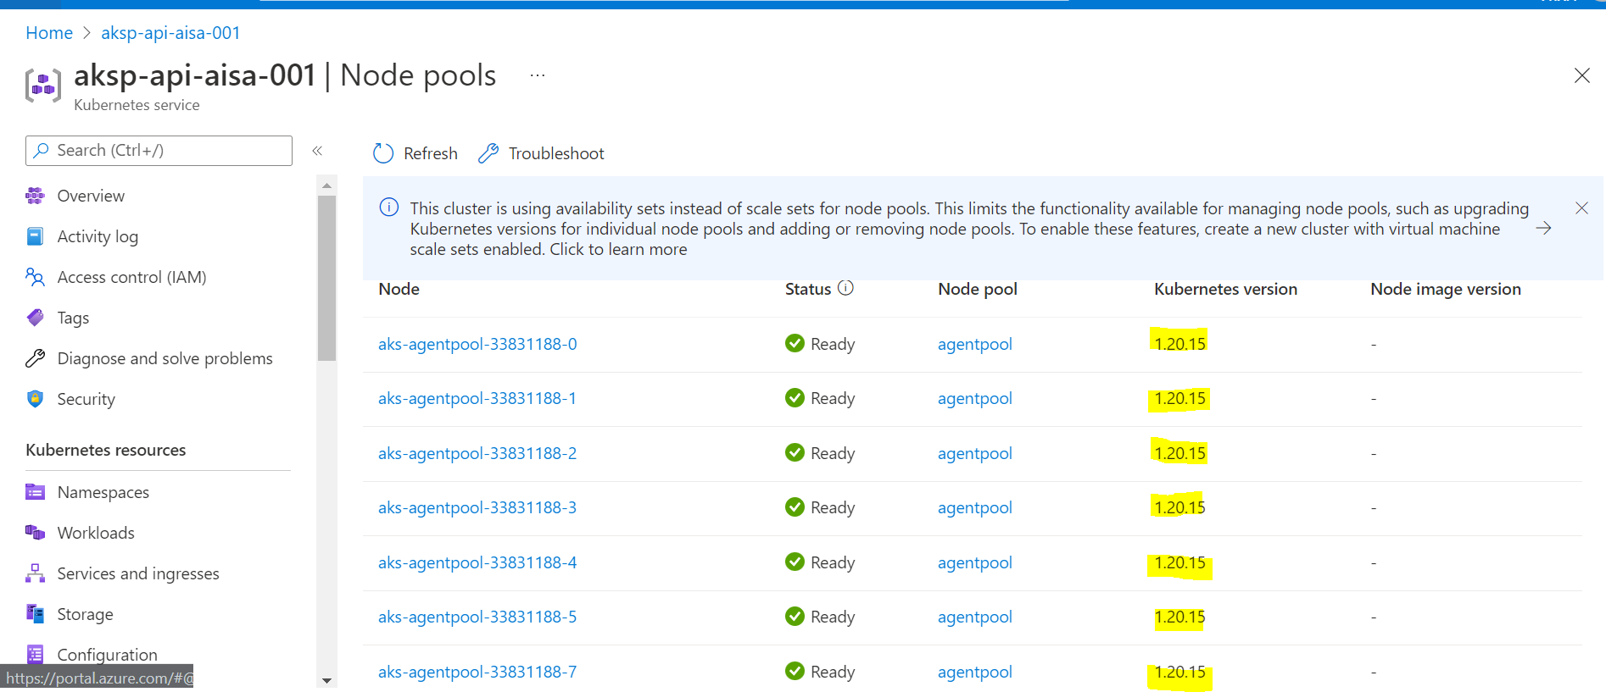

Now we can upgrade to next higher version, here selected 1.21.7
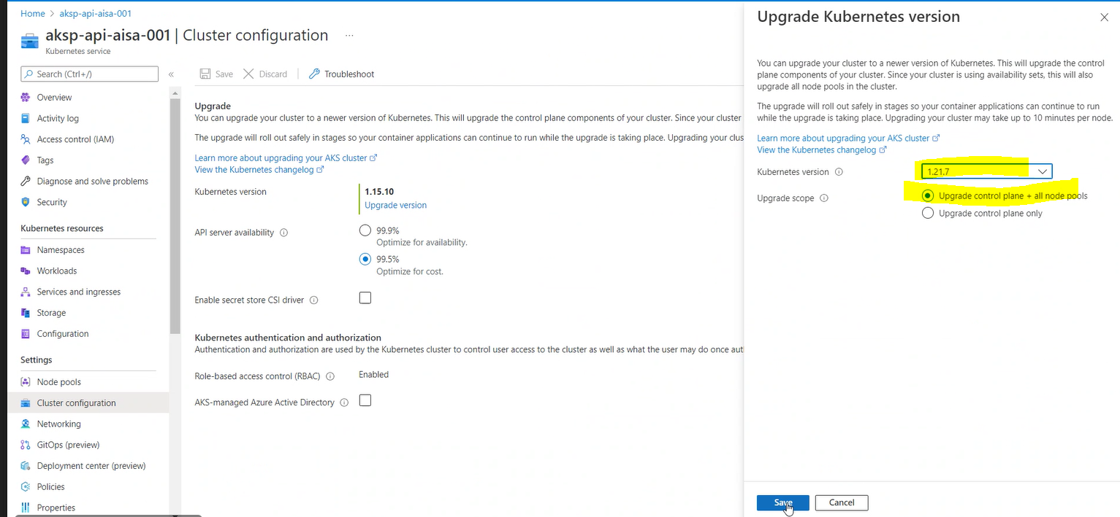

It’s getting upgraded
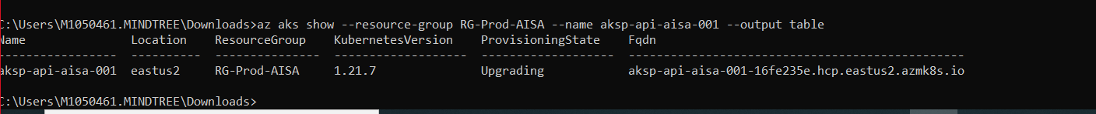

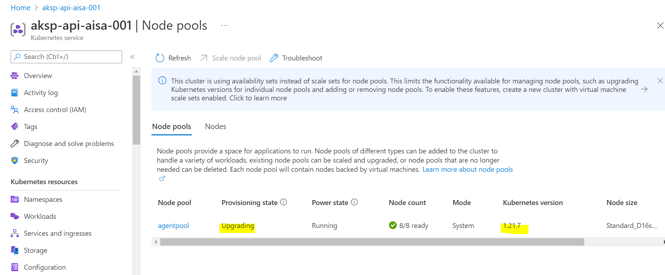
Few nodes got upgraded, few still upgrading.
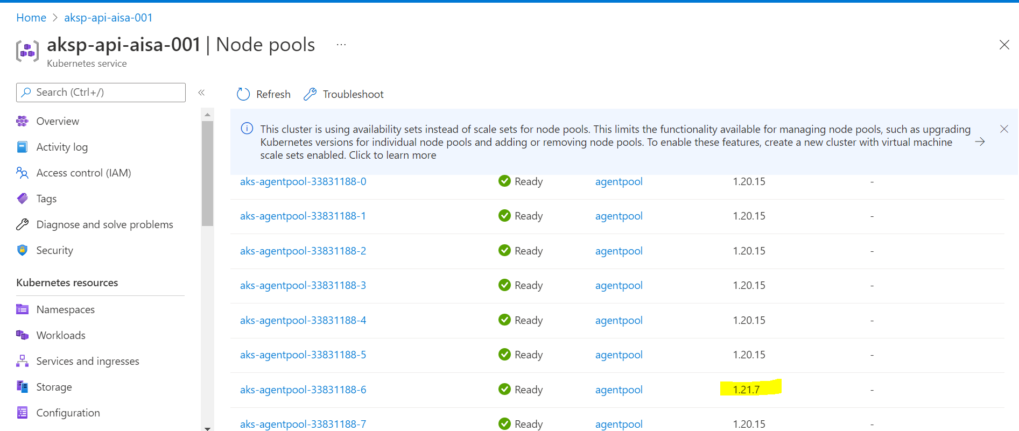

All done, status changes to Succeeded
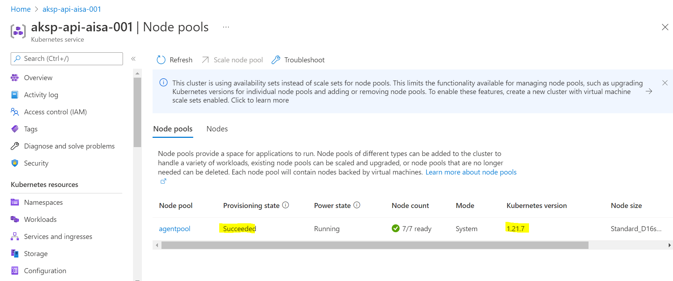
Verify the nodes
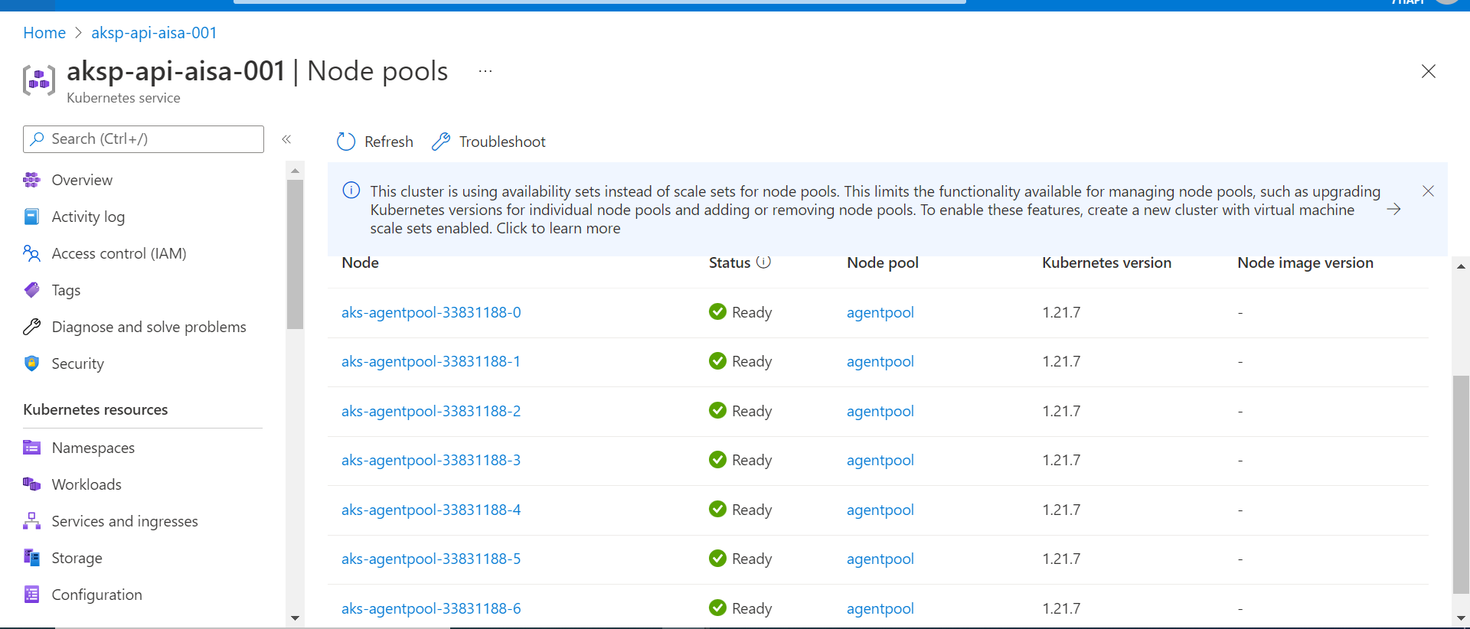

Kubectl commands to upgrade the cluster
To login to cluster-> az account set --subscription "Enterprise API Subscription" && az aks get-credentials --resource-group RG-Prod-AISA --name aksp-api-aisa-001
To get the upgrades-> az aks get-upgrades --resource-group RG-Prod-AISA --name aksp-api-aisa-001 --output table---
To upgrade the cluster-> az aks upgrade --resource-group RG-Prod-APIC --name aksp-apic-001 --kubernetes-version 1.19.13 (Let’s use this command only when facing any problem while upgrading from Azure portal)
To show the status-> az aks show --resource-group RG-Prod-AISA --name aksp-api-aisa-003 --output table

This command will use when Kubernetes version got upgraded but nodes still shows as older version. Let’s run this command to upgrade the node
aks nodepool upgrade --cluster-name aksp-api-aisa-001 --name agentpool --resource-group RG-Prod-AISA --kubernetes-version 1.21.7

