

Stock Price Prediction using LSTM

(INT 247)

|  |  |  |
| --- | --- | --- |
| Name | ROLL NO. | Registration no. |
| Harsh Dalal | 39 | 11903444 |
| Rashmeet Kaur | 09 | 11903463 |

**Submitted to:** Ms. Niharika Thakur

# Abstract –

The prediction of stock value is a complex task which needs a robust algorithm background in order to compute the longer term share prices. Stock prices are correlated within the nature of market; hence it will be difficult to predict the costs. The proposed algorithm using the market data to predict the share price using machine learning techniques like recurrent neural network named as Long Short Term Memory, in that process weights are corrected for each data points using stochastic gradient descent. This system will provide accurate outcomes in comparison to currently available stock price predictor algorithms. The network is trained and evaluated with various sizes of input data to urge the graphical outcomes.

# INTRODUCTION –

The share market is a place where the shares of a public company are traded. As discussed the volatile nature of the stock market makes it an area which needs an abundance of analysis with the old data predicated. The previous stock trend prediction algorithms use the historic time series stock data. the typical scientific stock price forecasting procedures are focused on the statistical analysis of stock data. In the paper will develop a stock data predictor program that uses previous stock prices and data will be treated as training sets for the program to predict the stock prices of a particular share this program develops a procedure.

# Libraries for Data Analysis –

**Pandas:** It is a powerful open-source tool used for data analysis and data manipulation operations such as data cleaning, merging, selecting wrangling as well.

**Sklearn:** This python library is helpful for building machine learning and statistical models such as clustering, classification, regression etc**.**

**NumPy:** It adds powerful data structures to Python that guarantee efficient calculations with arrays and matrices, and it supplies an enormous library of high-level mathematical functions that operate on these arrays and matrices.

**Keras**: Keras is a high-level, deep learning API developed by Google for implementing neural networks.

# PROPOSED MODEL –

This system predict whether the loan is approve or reject. This System refers the following things or ways.

1. Data Collection
2. Feature Extraction
3. Data Analysis
4. Divide in testing and training data
5. Training
6. Visualize the data

**FLOW CHART:**



# Parameters Used:

List of parameters/Symbols used in this paper is listed in Table

|  |  |
| --- | --- |
| Parameter used | Meaning |
| Date | Date of stock price |
| Open | Open price of a share |
| Close | Closing price of a share |
| Volume/ trade quantity | Number of shares traded |
| High | Highest share value for the day |
| Low | Lowest share value for the day |

# MODEL USED –

1. **Sequential:** The core idea of Sequential API is simply arranging the Keras layers in a sequential order and so, it is called Sequential API. Most of the ANN also has layers in sequential order and the data flows from one layer to another layer in the given order until the data finally reaches the output layer.

# PROPOSED ALGORITHM –

Step 1: Start.

Step 2: Data Preprocessing after getting the historic data from the market for a particular share.

Step 3: import the dataset to the data structure and read the open price.

Step 4: do a feature scaling on the data so that the data values will vary from 0 and 1.

Step 5: Creating a data structure with 60 timestamps and 1 output.

Step 6: Building the RNN (Recurrent neural network) for Step 5 data set and Initialize the RNN by using sequential repressor.

Step 7: Adding the first LSTM layer and some Dropout regularization for removing unwanted values.

Step 8: Adding the output layer.

Step 9: Compiling the RNN by adding adam optimization and the loss as mean_squared_error.

Step 10: Making the predictions and visualizing the results using plotting techniques.

# Code –

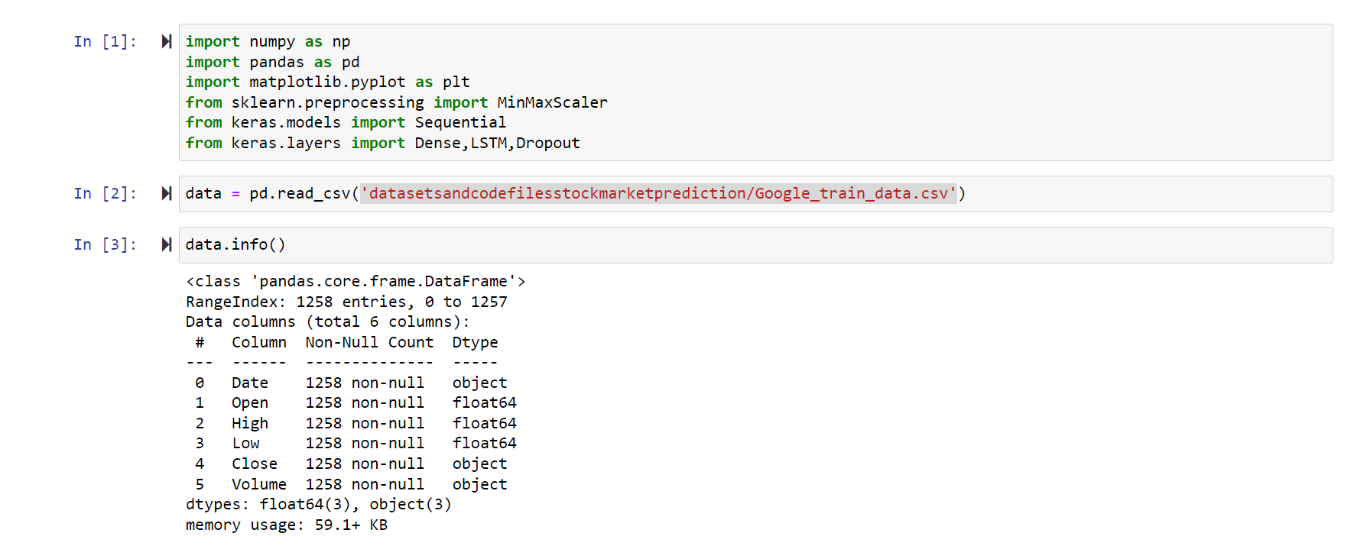

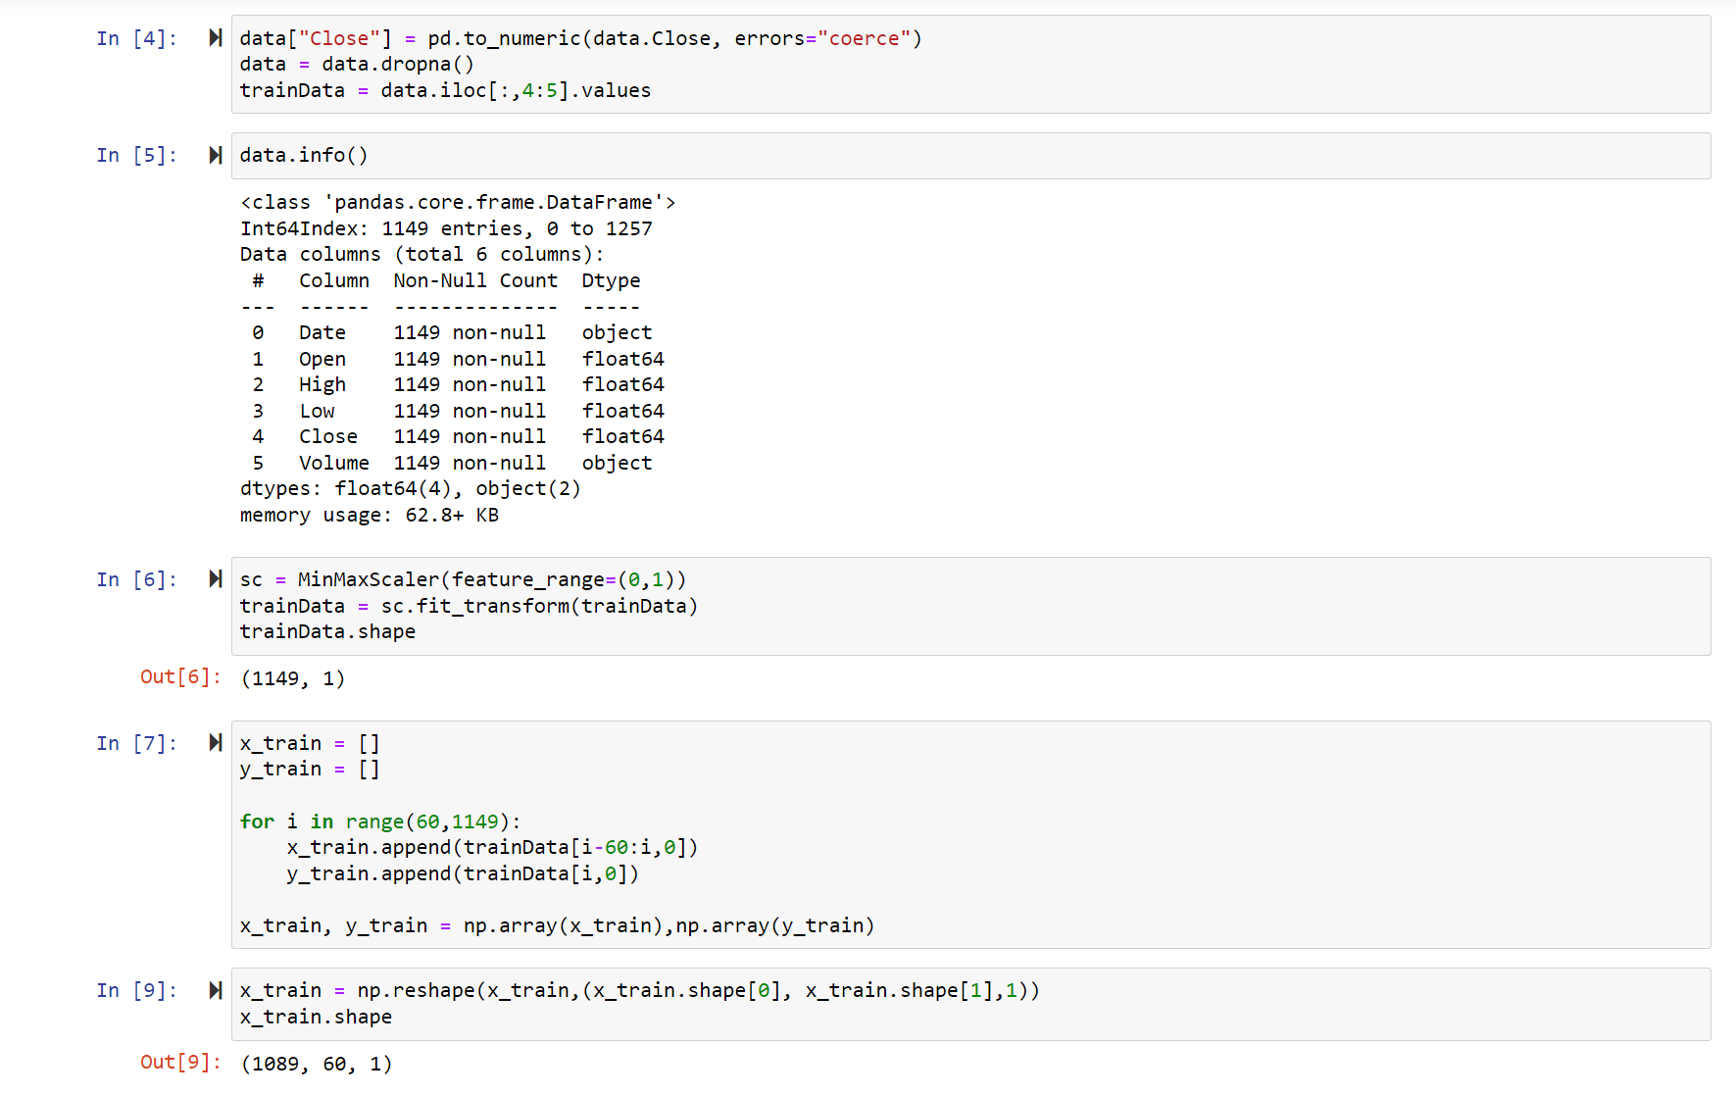

**Model-**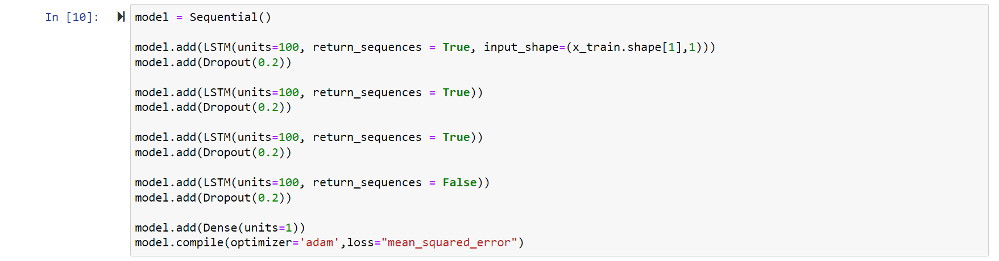

**Training**-

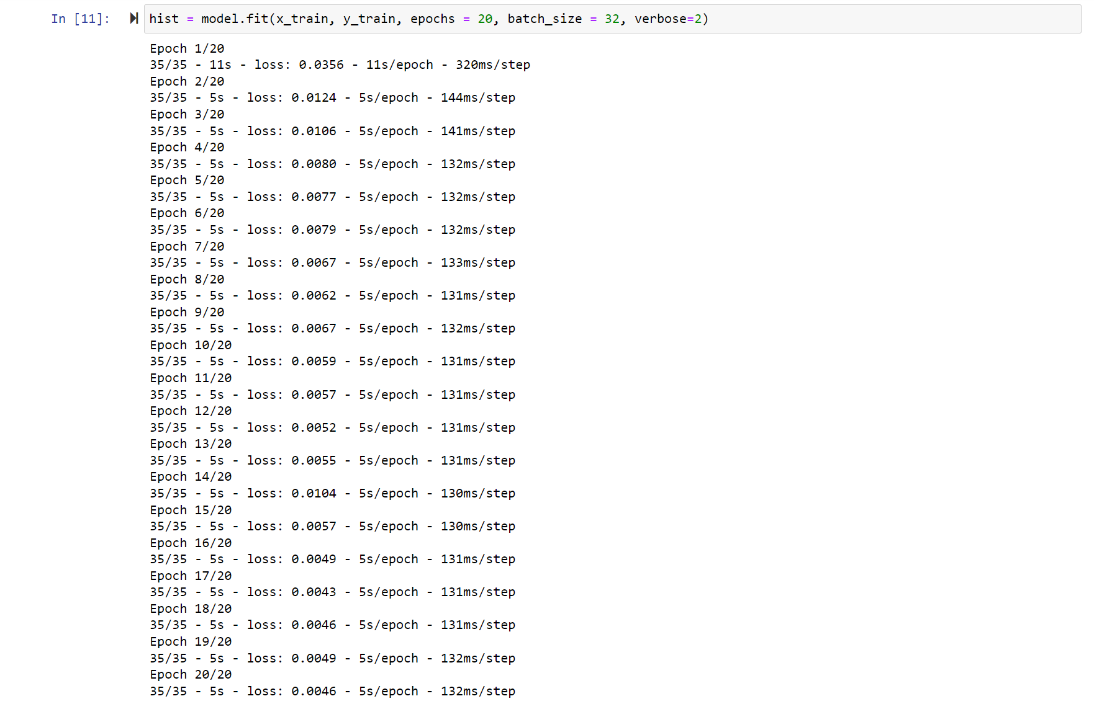 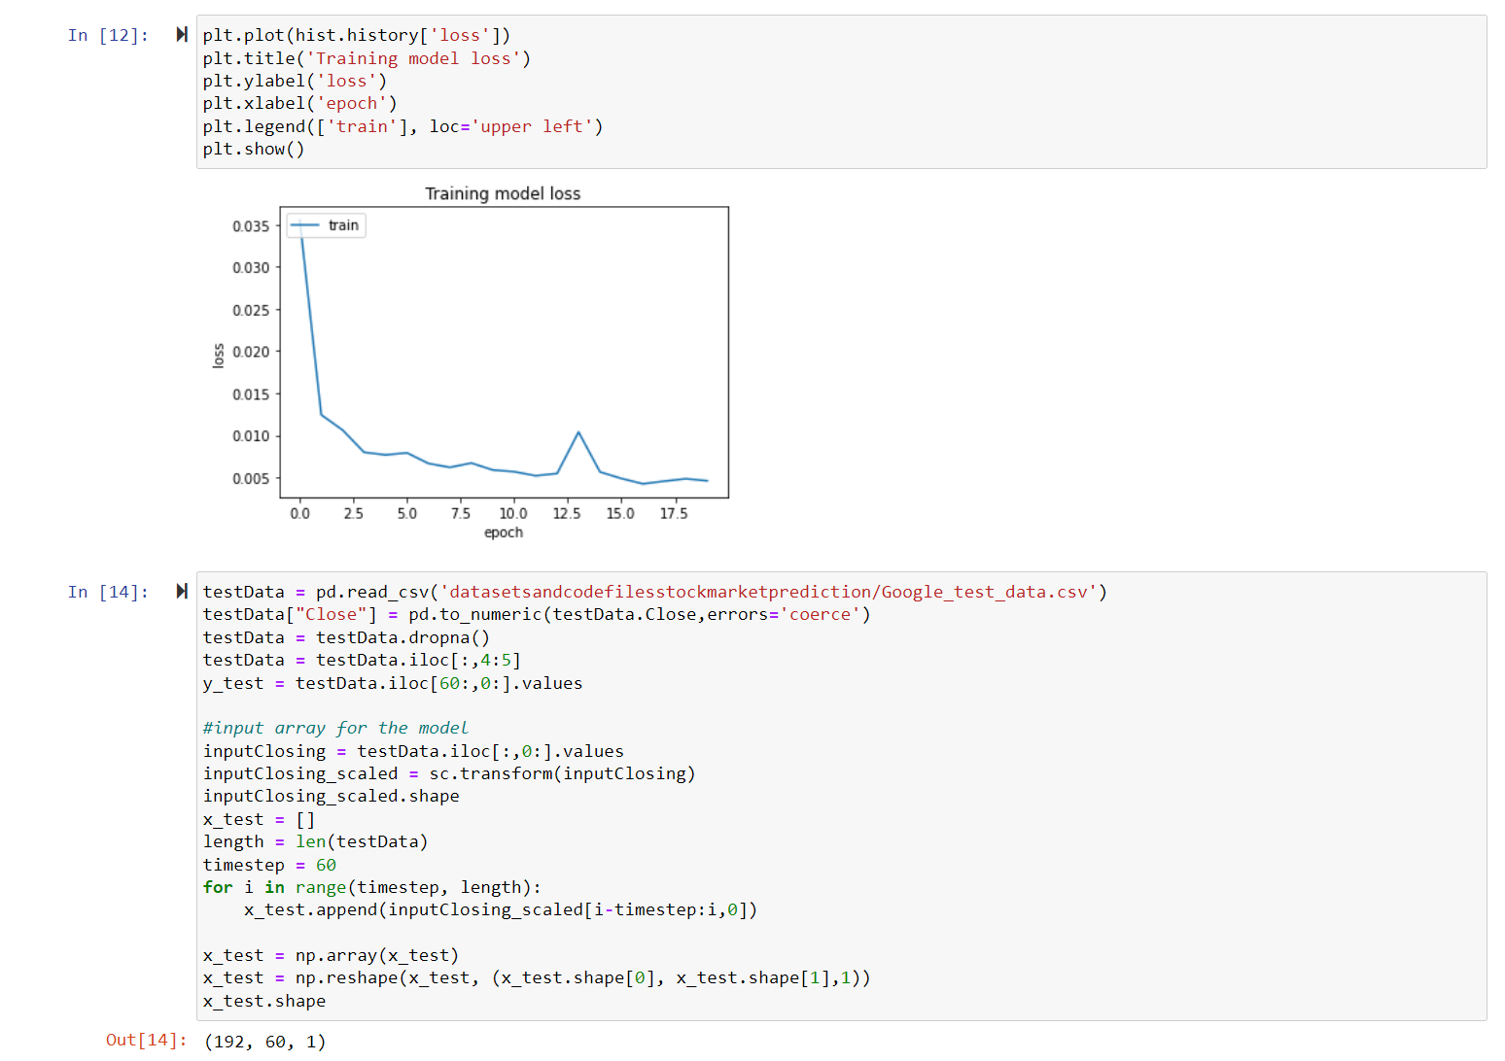

**Output-**

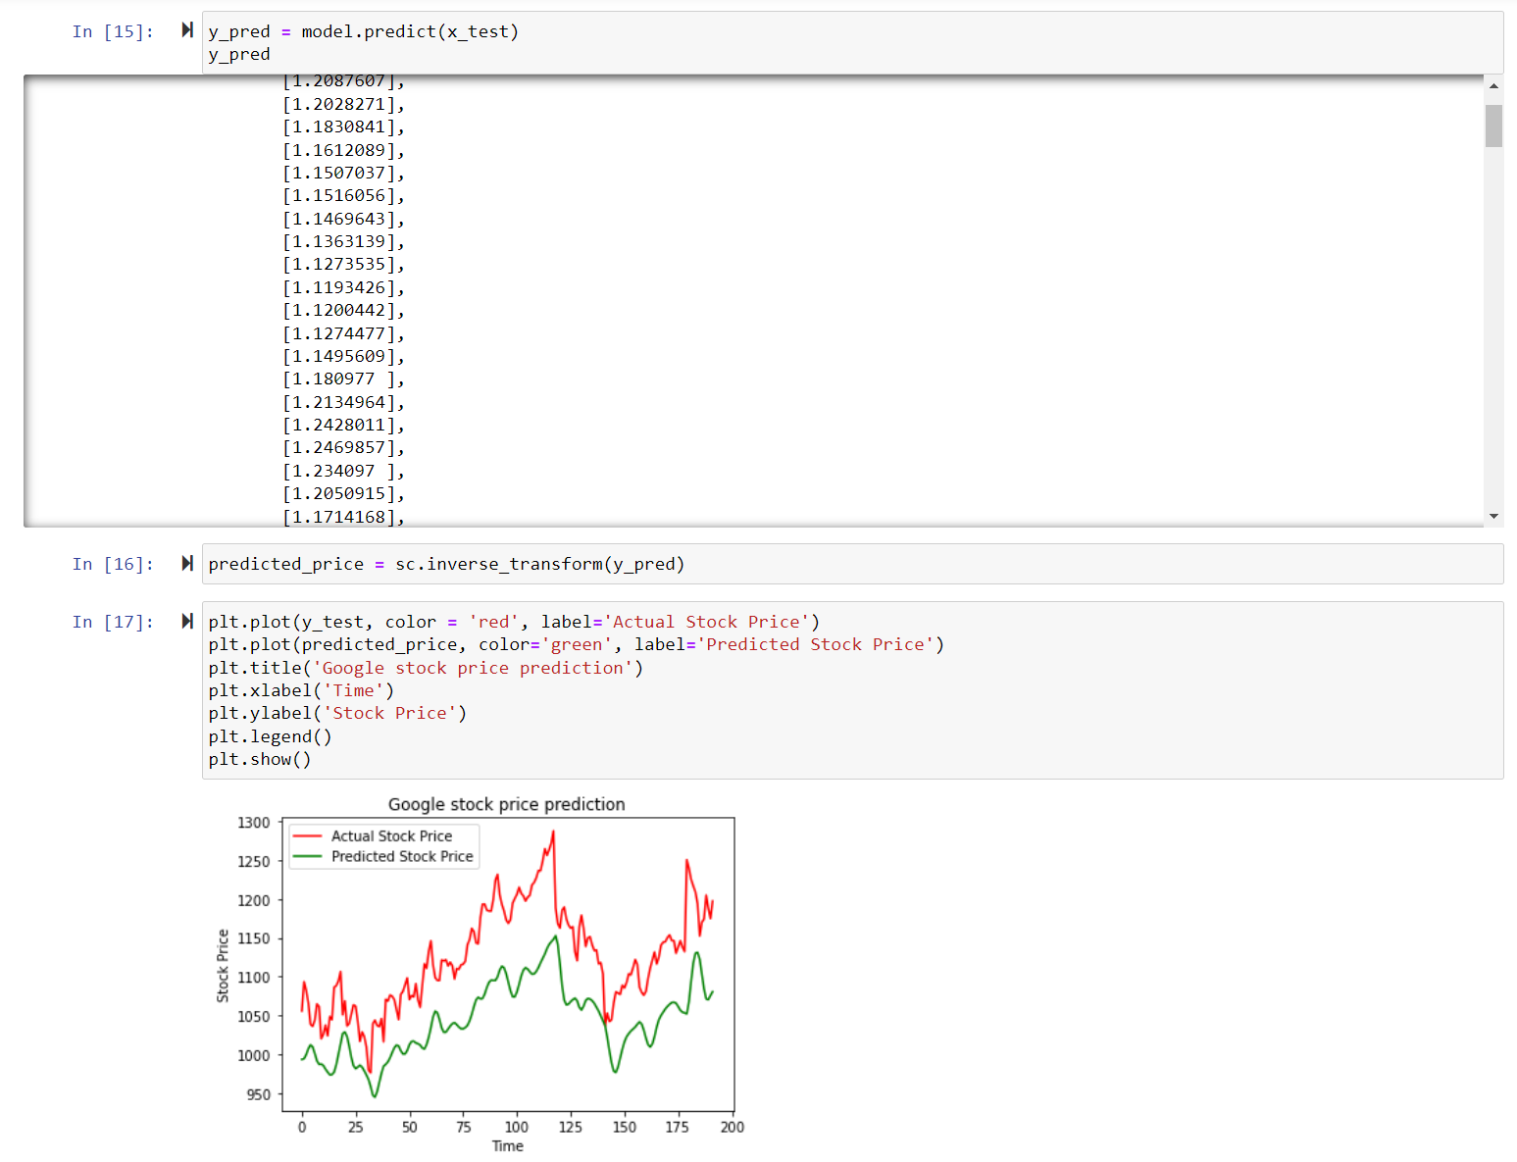

# CONCLUSION –

The study of the share is carried out in this paper and it can be carried out for several shares in the future. Prediction could be more reliable if the model trains a greater number of data sets using higher computing capacities, an increased number of layers, and LSTM modules.

In future enhancement the inclusion of sentiment analysis from social media to understand what the market thinks about the price variation for a particular share and it can be implement this by adding twitter and Facebook API to our program as Facebook is a leading social media which has lots of market trend information posted by users.

Reference to code: [mrharsh15/Stock-Price-Prediction-LSTM (github.com)](https://github.com/mrharsh15/Stock-Price-Prediction-LSTM)