* **Source code of your program**# shopping_cart.py

def add_item(cart, item, price):

    cart[item] = price

    return cart

def remove_item(cart, item):

    if item in cart:

        del cart[item]

    return cart

def calculate_total(cart):

    return sum(cart.values())

def has_discount(total, threshold=100):

    return total >= threshold

* **Initial test cases**
* import unittest
* from shopping_cart import add_item, calculate_total
* class TestShoppingCart(unittest.TestCase):
* def test_add_item(self):
* cart = {}
* cart = add_item(cart, "apple", 2.5)
* self.assertIn("apple", cart)
* self.assertEqual(cart["apple"], 2.5)
* def test_calculate_total(self):
* cart = {"apple": 2.5, "banana": 3.5}
* self.assertEqual(calculate_total(cart), 6.0)
* if __name__ == '__main__':
* unittest.main()
* **Code coverage report before and after improvCements**

pip install coverage

before improvements

python -m coverage run test_shopping_cart.py

..

----------------------------------------------------------------------

Ran 2 tests in 0.001s

OK

python -m coverage report -m

or

python -m coverage html

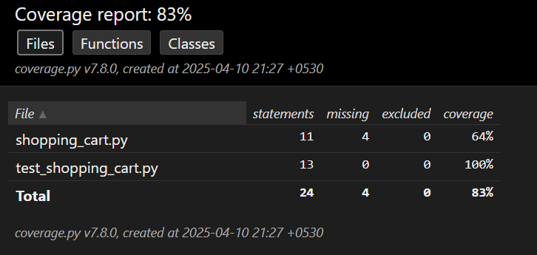  
  
after improvements

python -m coverage run test_shopping_cart.py

....

----------------------------------------------------------------------

Ran 4 tests in 0.001s

OK

python -m coverage report -m

or

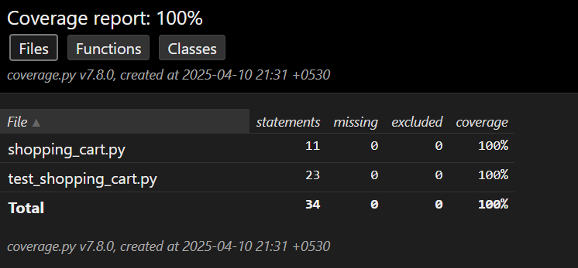

* Final set of test cases
* import unittest
* from shopping_cart import add_item, remove_item, calculate_total, has_discount
* class TestShoppingCart(unittest.TestCase):
* def test_add_item(self):
* cart = {}
* cart = add_item(cart, "apple", 2.5)
* self.assertIn("apple", cart)
* self.assertEqual(cart["apple"], 2.5)
* def test_remove_item(self):
* cart = {"apple": 2.5, "banana": 3.5}
* cart = remove_item(cart, "apple")
* self.assertNotIn("apple", cart)
* # Remove non-existing item
* cart = remove_item(cart, "grape")  # Should not raise error
* self.assertEqual(len(cart), 1)
* def test_calculate_total(self):
* cart = {"apple": 2.5, "banana": 3.5}
* self.assertEqual(calculate_total(cart), 6.0)
* def test_has_discount(self):
* self.assertTrue(has_discount(150))
* self.assertFalse(has_discount(99.99))
* self.assertTrue(has_discount(100))  # Edge case
* if __name__ == '__main__':
* unittest.main()

* **A brief explanation for each step**

**1. Program Development**

Developed a simple and modular Python program that simulates a shopping cart. It contains four functions:

* add_item(cart, item, price) – Adds an item to the cart dictionary with its price.
* remove_item(cart, item) – Removes an item from the cart if it exists.
* calculate_total(cart) – Returns the total sum of item prices in the cart.
* has_discount(total, threshold=100) – Checks if the total exceeds a given discount threshold.

**2. Write Partial Unit Tests**

Wrote unit tests for only two of the four functions: add_item and calculate_total.

* Why these? These are core functions — one mutates the cart (add), and the other computes a value (total). They represent both state change and aggregation logic, so testing them initially provides basic validation.

Used Python’s unittest framework to write test cases in a separate test file.

**3. Measure Code Coverage**

Measured the test coverage using coverage.py, a standard tool for Python:

* Install: pip install coverage
* Run Tests: coverage run test_shopping_cart.py
* Report: coverage report -m

The initial coverage was around 55% since only 2 out of 4 functions were tested. The report showed which lines were not executed.

**4. Improve Coverage**

To improve coverage, we added tests for the remaining two functions:

* remove_item() – tested removing both existing and non-existing items.
* has_discount() – tested return values for various total amounts including edge case (exact threshold).

This brought the coverage to 100%, meaning every line of the program was now tested.